YEAR 12 TDD WEEK 5 LESSON (21-25)
Course Plotting

Lesson: 21
Lesson outcome: Define piloting course plotting and term in course plotting .

INTRODUCTION

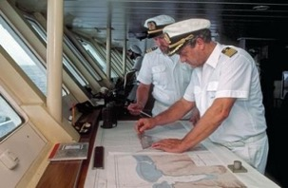

Course plotting is basically used by a navigator to plot a course around a coast line and a temper to find the way across country. Both methods involve map reading and compass work.
Coastal navigation (piloting) is the ability to find a vessel's position and lay out safe courses, within sight of land, to get to any destination desired. The following features play a vital role in plotting the course of a vessel; buoys, lights, landmarks, islands, wreck, the compass, chart, etc.
Course Plotting tools and terms of a modern navigator include:

The Compass
A compass is marked in 360º. 000º is North, 090º is East, 180º is South, 270º is West. Compass readings use three figures, e.g. 040º are spoken as zero four zero degrees and they are called bearings. Sixteen main points are named which are normally used to indicate direction of wind, tide, fixed features, etc.
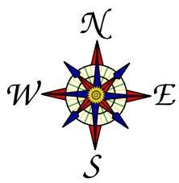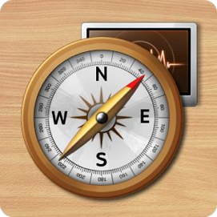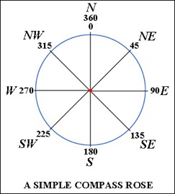

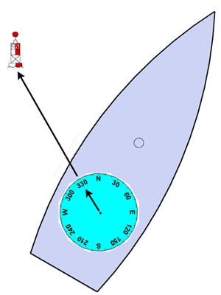
Bearing

A true bearing is the direction from the ship relating to True North with North being 000° and south 180°.
The ship in the diagram on the right is heading on a bearing of 030°. We wish to take a bearing to the buoy. We see through the binoculars it is labeled with "BB". To take the bearing we look over the compass toward the buoy and try to visually line up the center of the compass with it and note what we see on the compass. Here, the buoy has a bearing of 330°. Since the buoy has been located on the chart, now it is possible to locate the ship on the chart.

Lesson: 22
Lesson outcome: Define the term heading and fix in course plotting.
Define the terms running fix and two bearing fix in course plotting.

Heading

According to the compass the ship is on a heading of 060°. North is straight up and when the boat is turned, the compass does not turn, it will always points to North. If the ship wants to steer a course of 30° then turn the ship to port (left) by 30°. Or, if the ship wants to steer a course of due east then turn to starboard (right) towards E (due east or 90°). A course of 030° will turn the ship to due East.

A Fix

It is taking two or three bearing fixes. These fixes can be used to establish a ships position.

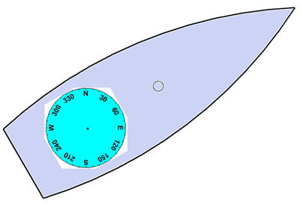

The Running Fix

A ship is going by a lighthouse that can be seen for a period of time and there is no other buoy or landmark to give a fix. Two sighting of the lighthouse at two different times will give a running fix.

Two Bearing Fix

Two bearing fix is when two bearings are taken from two positions or landmark.
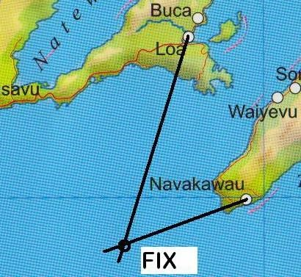

Example: Bearings taken from Loa and Navakawau to locate the ship’s position.

Lesson: 23
Lesson outcome: Define the terms three bearing fix in course plotting.
Define the terms a beam bearing and transit bearing in course plotting.

A Three Bearing Fix

A three bearing fix is the most accurate method of locating the position of a ship. The three bearings often do not cross exactly at a point, but forms a small triangle. This is called a ‘Cocked Hat’. The position of the ship is taken in the center of the triangle. On bearings and fixes, the arrowheads are placed in the direction of movement.

Example: Bearings taken from three positions; Savusavu, Namatalata and Thavanga to locate the ship.

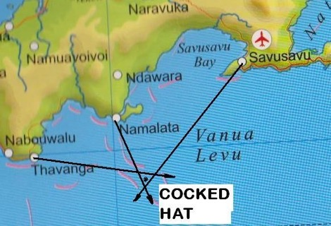

A Beam Bearing

A beam bearing is at right angle (90º) to the ship.

Example: The ship changes direction when Suva point is abeam.
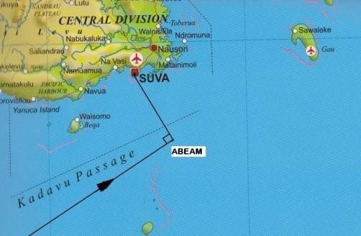

Transit Bearing

Two beacons, land marks or lights kept in line. This is frequently used by ships while entering or leaving the harbor. Lights are used at night and land marks during the day.
Example: The ship changes course when Levuka Airstrip and Gau Airstrip are in transit.

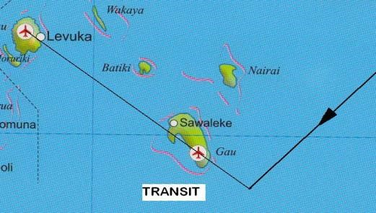

Lesson: 24
Lesson outcome: Define the terms clearance course, starboard and portside in course plotting.
Define the terms knots, speed and cable and solve using calculation.

Clearance course

The ship need to clear the rock or wreck by some distance. The course is tangential to the arc or
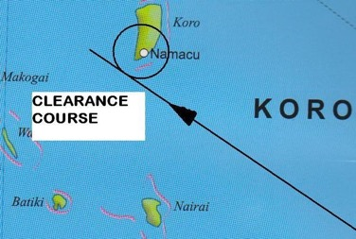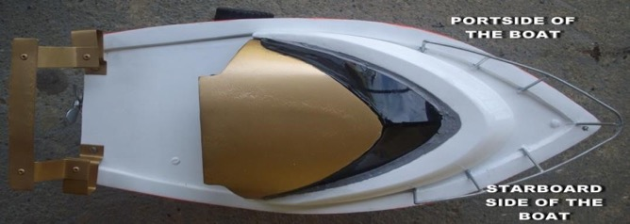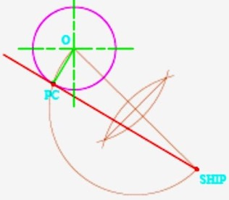
clearance circle.

Example: The ship clears
Namacu Point by certain
cables.

The point of

contact (PC)
should be located for a
clearance course.

Starboard

The right side of a boat is the
starboard side when it is facing
forward.

Portside

The left side of a boat is the portside
side when it is facing forward. The
boat mostly berths at the
port on the portside.

Knots
The speed of a ship is measured in knots, distance in Nautical miles (Nm) and time in hours.
Speed = Distance
Time

Cable
One cable is a tenth of a nautical mile.

Lesson: 25
Lesson outcome: Define the terms drift and anchor in course plotting.
identify course plotting tools and devices.

Drift
A ship can drift because of the Tide, Current, Wind, Speed of Ship, etc. Keeping the information on the tide will be very helpful in planning a trip. There are areas which need to be navigated only with a falling tide or a rising tide.

Anchor
A heavy metal object, fastened to a chain or line, to hold a vessel in position, partly because of its weight, but chiefly because of the designed shape which digs into the bottom of the sea bed.

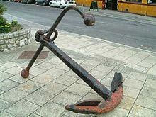

Leg
A leg is one course steered when there are several courses set. Bearing, distance and direction of travel are very important information required to complete a Leg of a ship.

Coast Pilot and Light List
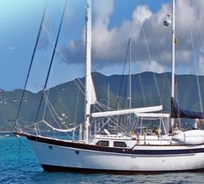
These are references which can be used while negotiating a harbor entrance or while changing direction of travel.

Binoculars
A Binoculars is extremely useful for identifying buoys and landmarks.

GPS
The GPS system is extremely accurate and almost never goes down.

Depth sounder
A depth sounder can provide an accurate reading of the water depth.

REVIEW QUESTIONS
1. Briefly explain what is meant by piloting course plotting?
2. Draw and label the sixteen parts of a compass.
3. Find the speed of a cargo vessel, Fiona, if it covered 25Nm in 75 minutes.

THERE ARE 6 ACTIVITIES (PAGE 1 HAS TWO ACTIVITIES) AND THE LAST PAGE IS A WORK SHEET

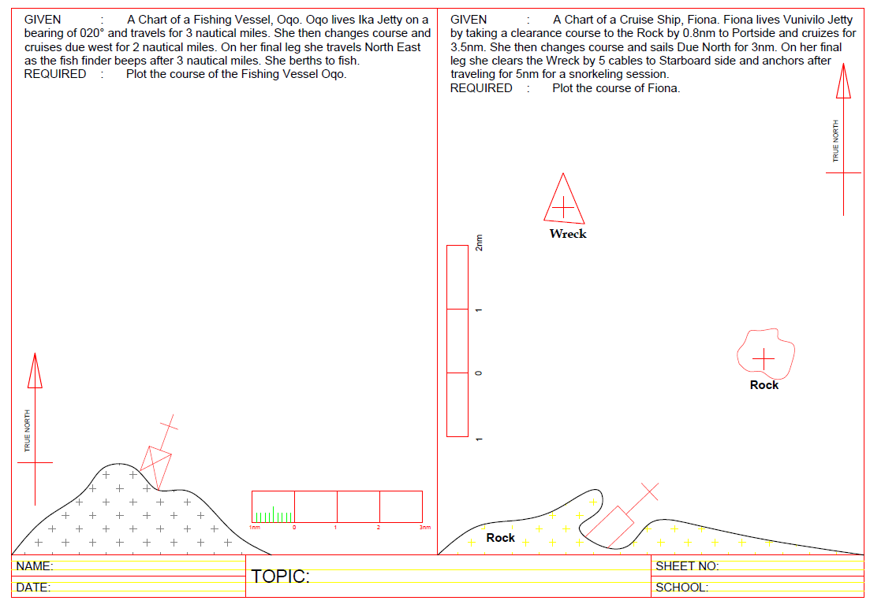
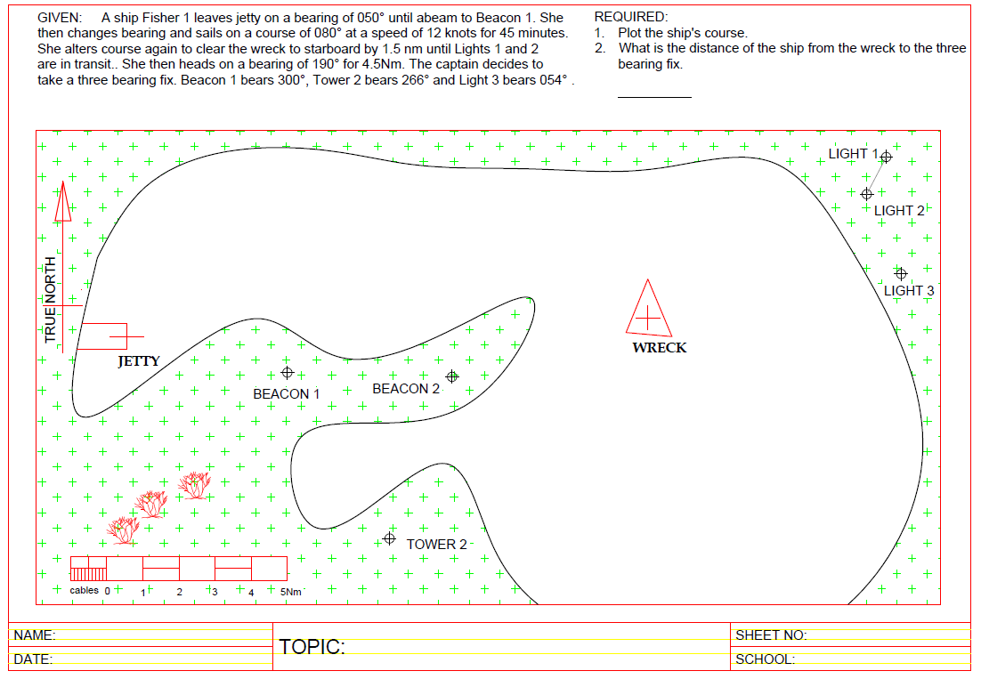
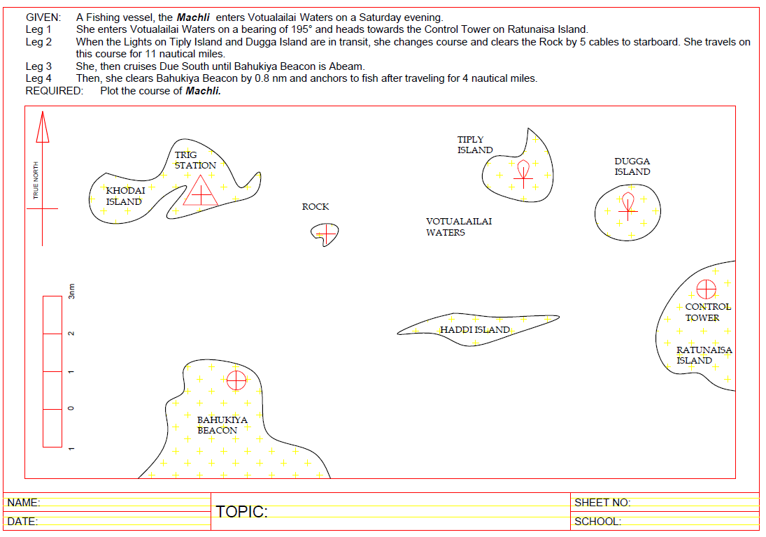
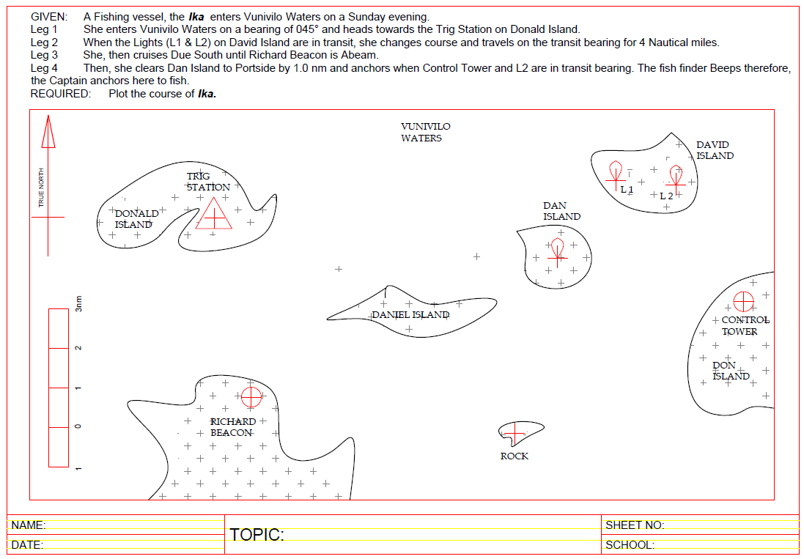
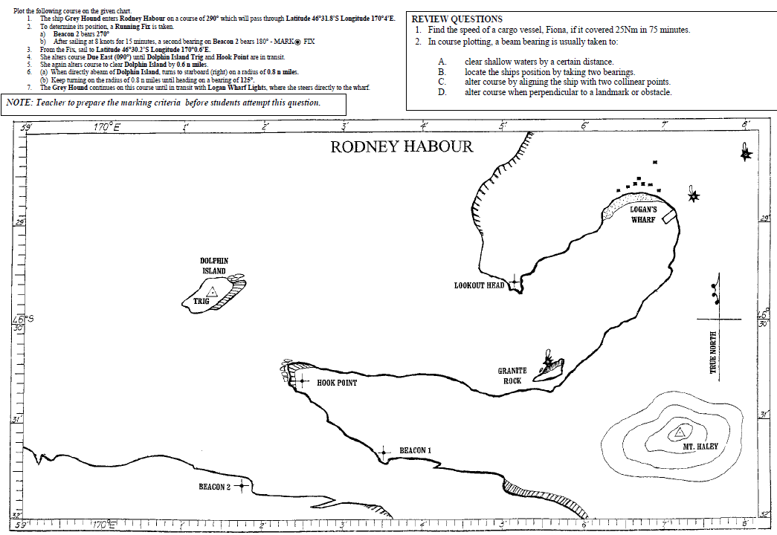
WORK SHEET ON COURSE PLOTTING