***WEEK 4 Y12 TDD (lesson 16-20)***

***LESSON: 16***

***Lesson outcome: • identify the different types of engineering components.***

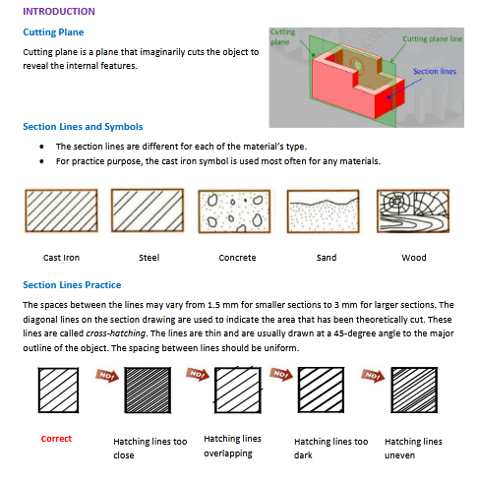

***Lesson 17***

***Lesson out come***

***• identify offset sectioning methods.***

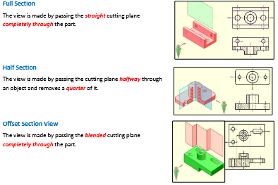

***Lesson 18***

***Lesson out come***

***• identify revolved and removed sectioning method.***

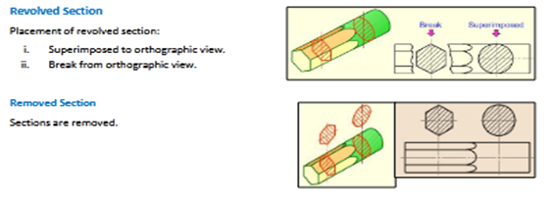

***Lesson 19***

***Lesson out come • identify aligned sectioning method.***

**Aligned Section**

Aligned sections use an angled cutting plane to pass through angled features. The plane and feature are then imagined to be removed into the original plane and the section projected from there.



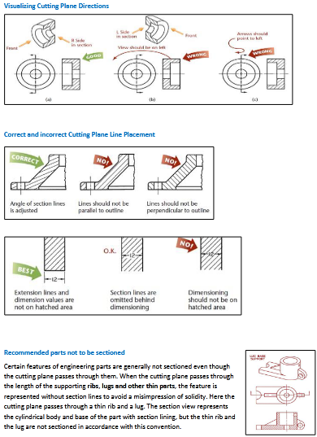

***Lesson 20***

***Lesson out come • identify parts of assemble drawing .***

