YEAR 12

HISTORY

HOME LEARNING KIT

WEEK 4

|  |  |
| --- | --- |
| See the source image | See the source image |
| See the source image | See the source image |

|  |  |
| --- | --- |
| NAME |  |
| LEVEL |  |
| S/ID |  |

**Lesson 36**

**Strand**: Time, Continuity and Change

**Sub Strand:** International Relations

**Learning Outcome**:

1. Discuss the Treaties signed in the 1930s to maintain Peace.

LESSON NOTES

**PACT OF LONDON 1930**

|  |
| --- |
| **Pact of London** (1930): Also known as the London Naval Treaty / Treaty for the limitation and reduction of Naval Armament. |
| **Members**: Britain, France, Japan, USA and Italy |
| **Provision:**   * To prevent naval arms race in Europe/ to limit the Naval Race. * Regulated submarine warfare and limited naval shipbuilding. |

**THE SECOND NAVAL TREATY 1936**

|  |
| --- |
| **The Second London Pact/ Naval Treaty** |
| **Members**: Britain, France and USA. Italy and Japan withdrew from the Conference because of their aggressive nature. Japan invaded Manchuria while Italy invaded Abyssinia. |
| **Provisions**:   * To limit growth in the naval armaments |

**The World Disarmament Conference/ Geneva Disarmament Conference 1932.**

|  |
| --- |
| The League of Nations held many disarmaments conference but none of it succeeded because the super powers had their own views. They believed in rearming themselves so that they can defend themselves better from their enemies. |
| **Provision**:   * Realize the ideology of disarmament – meant the limiting reducing or total banning of arms and military forces of a nation. (Reduction in arms, weapons, military and naval warships. |
| The Disarmament Conference failed. Countries were more concerned with their own security. World spending on arms trebled. It became a major cause of WW2.  Germany withdrew from the Conference when it failed to agree on disarmament. |

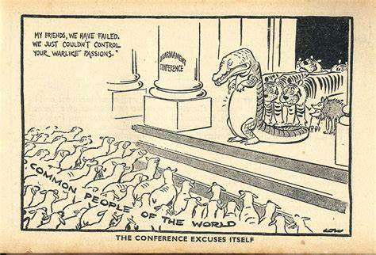

The cartoon depicts the failure of the Disarmament Conference. Few countries like USA and Britain were eager to pursue disarmament policy but ither countries were not interested in the disarmament.

**Activity: (Resource Interpretation**)



1. Name the country represented by the figure in the starred jacket and state

the position it took before World War II.

1. Explain the significance of the figures playing cards as shown above.

**Lesson 37**

**Strand**: Time, Continuity and Change

**Sub Strand:** International Relations

**Learning Outcome**:

1. Discuss how Hitler violates the Treaty of Versailles

LESSON NOTES

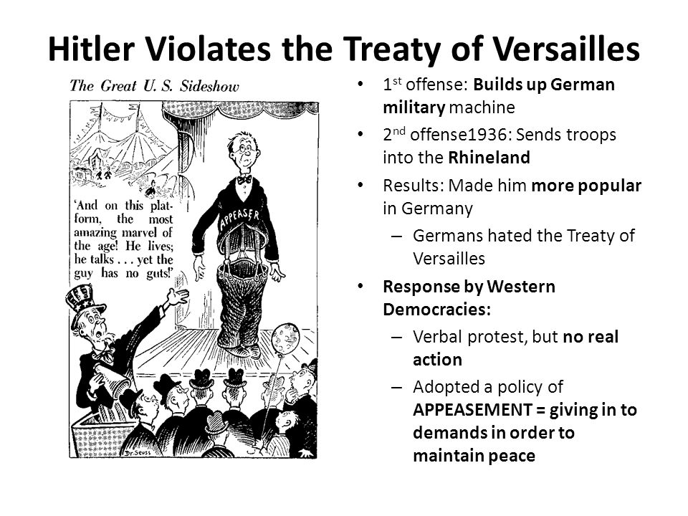

**Germany Rearms**

1. Hitler withdrew Germany from the Disarmament Conference and from the League of Nations.

2. Germany began to rearm at great speed.

In 1935, Hitler announced that Germany already had a “luftware”(airforce) and he was introducing a conscription in order to increase the size of the German army to 500,000 men.

**The Re- Occupation of Rhineland**

* In March 1936, Hitler ordered his troops to occupy the Rhineland.
* There was no French retaliation and Germans living in the Rhineland welcomed the Germans. 98% voted in favour of German occupation.

**Activity:**

1. Discuss how Hitler violated the Treaty of Versailles.
2. State the significance of demilitarising the Rhineland.
3. State the purpose and year Hitler marched the German troops into the Rhineland.

**Lesson 38**

**Strand**: Time, Continuity and Change

**Sub Strand:** International Relations

**Learning Outcome**:

1. Discuss the purpose for the Stressa Front

LESSON NOTES

**THE STRESSA FRONT – 1935**

1. Germany’s rearmament soon alarmed the other European power. In a move to keep check on Germany, France, Britain and Italy met at Stressa (a small town in Italy) in April, 1935.

2. Together they protested against German rearmament and at same time, they promised to safeguard the Peace of Europe.

3. The Stressa Front lasted less than 6 months when Italy made their war on Abyssinia in the late 1935.

|  |
| --- |
| **Signatories**: France, Britain and Italy  **Provision**: to go against Germany’s rearmament policy |
| **State one reason for why the Stressa Front failed.**   * Italy withdrew from the front after Mussolini ordered the invasion of Abyssinia. Italy was classified as an aggressor. |

Activity

1. **Why was the Stresa Front created?**
2. **When was the Stresa Front created?**
3. **What were the reasons why the Stresa Front ended?**
4. **What was significant about the Stresa Front?**

**Lesson 39**

**Strand**: Time, Continuity and Change

**Sub Strand:** International Relations

**Learning Outcome**:

1. Discuss the occupation of Saarland by Germany and the Re- Occupation of Rhineland

LESSON NOTES

Unification of German Speaking People

**THE SAAR**

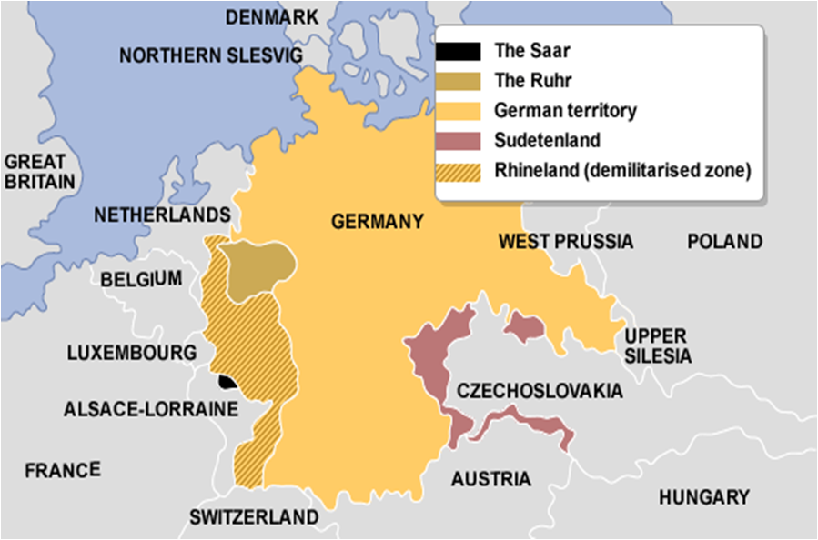

* The Saar. (Rich in coal mining area) was taken from Germany and placed under the League of Nations since the Treaty of Versailles.
* In 1935, a plebiscite (vote) was made by the people of the Saar to choose between a union with France, union with Germany or remain under the League.
* Over 90% voted to return to Germany, the unification of German speaking people begun.
* This was a morale booster for Adolf Hitler.

|  |  |
| --- | --- |
| **THE RE-OCCUPATION OF RHINELAND** | |
| **Treaties Violated** | Locarno Treaties (1925)  Treaty of Versailles (1919) |
| **Year** | 1936 |
| **Event** | Hitler ordered his troops to march into Rhineland. Hitler was able to reoccupy Rhineland.  Hitler was able to build the Siegfried line – a line of German fortifications on the French boarder. |
| **Reasons that Hitler gave when reoccupying Rhineland** | * Claimed French encirclement that is Germany was surrounded by hostile French and its allies. * He needed to secure the frontiers of Germany. * He wanted to create more living space for the Germans. |
| **Reaction of the LONs** | * The LONs did not take any action on Germany. * Hitler was encouraged that he could take/invade other territories in Europe.   **#Note**: Britain and France did not take any action. Britain thought that Germany claimed the area that belonged to them. France did not take any action. Hitler played a risk game by sending troops to Rhineland. If France would have sent troops to stop the German soldiers than Germany had to retrieve. Since France did not stop Hitler was able to reoccupy Rhineland. |

**Activity:**

**Resource Interpretation**

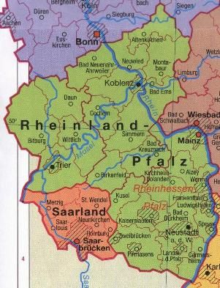

1. Mention a reason why the Rhineland was demilitarised and state the year

Hitler reoccupied the area.

2. Describe how Germany reoccupied the Saar valley.

**Lesson 40**

**Strand**: Time, Continuity and Change

**Sub Strand:** International Relations

**Learning Outcome**:

1. Discuss the Anschluss with Austria

LESSON NOTES

Unification of German Speaking People

**ANSCHULUSS (UNION) WITH AUSTRIA (1938)**

**Lebensraum** (living space)

* By 1938, the time had come for Hitler to put into practice his plan to add living space to Germany.
* His first target was Austria. 96% of Austrians were German speaking.
* Under the Treaty of Versailles, Germany was forbidden to unite with Austria.
* Hitler ordered the Austrian Nazis to bomb a public building and stage a mass parade.
* The Austrian Chancellor, Schussing held a plebiscite (vote) where most of the Austrians did not want a union with Germany.
* Hitler got Schussing to resign.
* On the 16th of March, 1938 Austria was made a province of Germany as part of the New Reich.

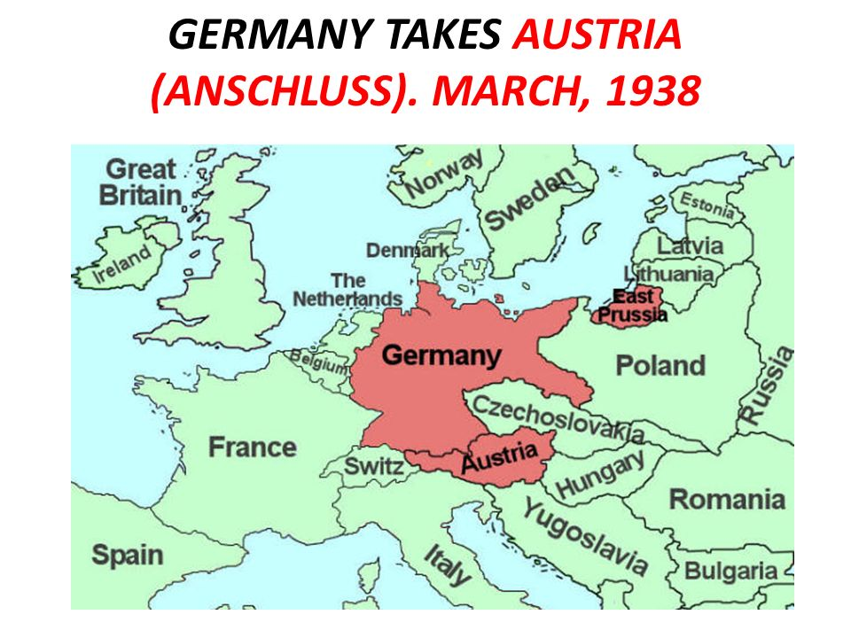

**Activity:**

1. Define *Lebensraum* and state how Hitler planned to achieve this.
2. State **two** reasons why Hitler wanted to form a union with Austria through Anchluss.
3. Define ***anschluss*** and state **one** way in which it could be achieved.
4. Describe the strategy used by Hitler to control Austria.
5. Explain the idea of ‘*anschluss*’ in 1938.