YEAR 12
HISTORY
HOME LEARNING KIT
WEEK 9
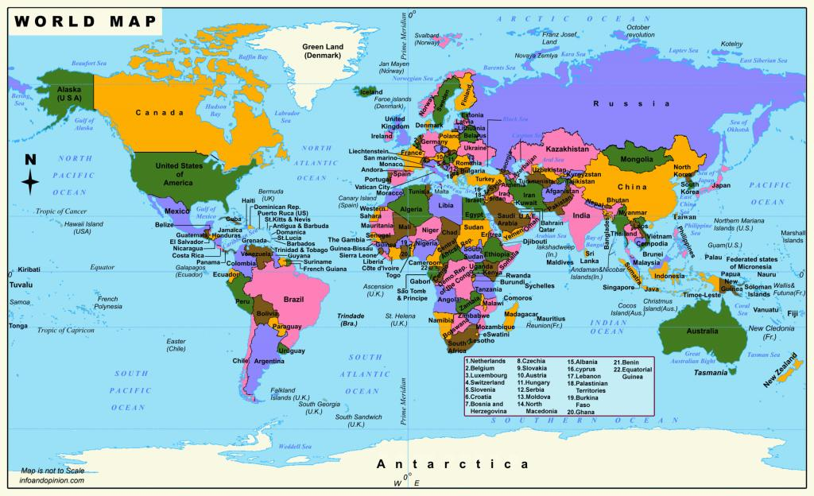
NAME
LEVEL
S/ID

Lesson 61
Strand: Time, Continuity and Change
Sub Strand: Diplomacy
Learning Outcome:
1. Describe the relationship between Fiji and Australia
LESSON NOTES

Definitions
Big Brother Usually meaning Australia as a rich and powerful neighbour, usually a negative comment
Policy A statement by a nation about how it will treat another nation, or act in global events
Trade A main feature of relations between nations
Aid Monies given by donor nations to help neighbours and less wealthy nations
Regionalism The idea that Pacific island nations could have a strong voice and improved
Social and Economic futures if they worked together in a single regional organization.
Diplomacy (i) The skill of making the correct decision in foreign policy
(ii) The formal and informal meetings between nations
Migration One of the major forms of relationship creating links between nations
Cartoon a visual message; form of political commentary using pictures and short captions.

INTRODUCTION A LONG AND CLOSE RELATIONSHIP
- In 1970, Fiji gained independence and Australia was one of the neighbours who immediately offered congratulations, and financial assistance.
- Film Australia, a government film production company in Australia, made a film in 1970 about Fiji as a new Pacific nation. The film was called “Independence for Fiji”.
- Relations between Fiji and Australia were very close in the 1960s and 1970s.
- Australia was a prosperous democratic nation, itself only 70 years old as a nation (formed in 1901). Australia wanted to see Fiji share in this prosperity.
- It wanted Fiji to be a stable, peaceful friend to the western democratic alliance
The links in the 1960s were extensive;
• Colonial Sugar refinery (CSR) dominated the sugar industry
• Emperor Gold Mine at Vatukoula was a profitable Australian owned industry
• Australian banks were the main banks (Westpac and ANZ)
• The Australian curriculum was taught in private schools
• Australians dominated the annual inflow of tourists
• Australia was the main funding agent for the new university in 1968 (USP)
• Suva was a hub for shipping to and from Australia
• Nadi was a hub for flights to and from Australia
• Australia was Fiji’s main aid donor

Australians were also active at the grassroots as volunteers, or in charity, women’s and church groups coming to work on small projects in villages.

Fiji as an independent nation, continued its close relations with Australia after 1970. These included;
• links between Trade Unions, Churches, and schools,
• sporting visits each way
• links between political parties
• medical exchange programs.
• trade, tourism and migration
• joint membership of regional organizations
• scholarships for Fijians to study in Australia
• Fiji and Australian newspapers reported on events in the other nation
• during the 2000 Olympics Australia provided a $6 million dollar sporting, cultural and exchange program to Pacific Island nations, including Fiji.

This unit examines two key events in Fiji’s recent relationship with Australia by using cartoons to reveal how events unfolded. The two events are the coups of 1987 and the attempted coup of 2000.

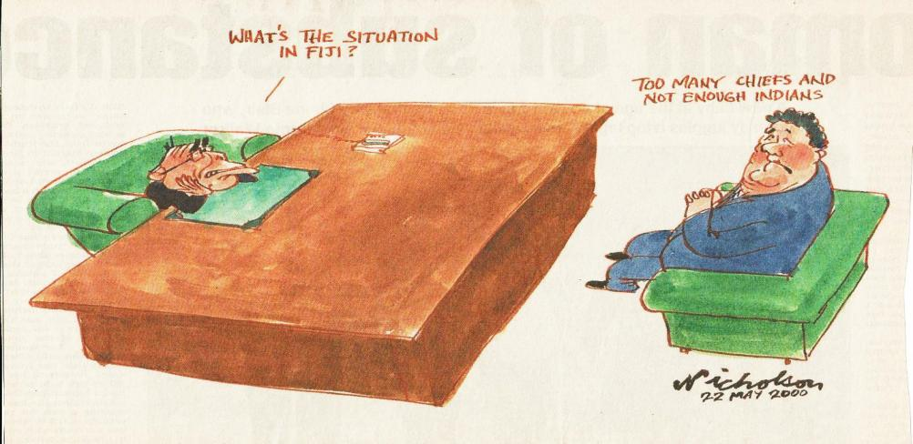
Australian Prime Minister (John Howard) talking to Foreign Affairs Minister (Alexander Downer) when politicians were taken hostage in Fiji in 2000. Source: The Australian, 22 May 2000

ACTIVITY 1 QUESTIONS BASED ON SOURCE (1)
1 Answer yes or no to these questions:

Yes ( ) or No ( ) The Prime Minister looks interested in the topic
Yes ( ) or No ( ) The Prime Minister has read many reports and submissions on the situation in Fiji
Yes ( ) or No ( ) The hostage crisis is depicted as a racial problem
Yes ( ) or No ( ) Australia seems to understand the causes and events in Fiji
Yes ( ) or No ( ) The Foreign Minister looks worried
Yes ( ) or No ( ) The Foreign Minister looks like he knows what was happening

2 Based on this cartoon, which is the best word to describe Australia’s relations with Fiji in 2000 when the coup occurred (tick the word that you choose)

( ) afraid
( ) like a big brother
( ) equal partner
( ) trusted friend
( ) bossy
( ) uninterested
( ) worried

3 Now use that word in a sentence to describe Australia’s attitude towards Fiji in 2000.

4 The expression “Too many chiefs and not enough Indians”, is usually about bosses and
workers. Here the cartoonist uses it as humour. What is the cartoonist trying to suggest is the problem with Fiji’s politics?

Lesson 62
Strand: Time, Continuity and Change
Sub Strand: Diplomacy
Learning Outcome:
1. Describe the relationship between Fiji and Australia
LESSON NOTES
TOPIC A THE 1987 COUP AND FIJI-AUSTRALIA RELATIONS
The two coups in 1987 took Australia by surprise. Australia had assumed the Alliance or the Labour party were able to govern Fiji effectively. Fijians and Australians were surprised that Labour won the election early in 1987, but Fiji seemed stable and in good hands. Australia also respected and relied on the Great Council of Chiefs to give wise advice to the politicians. The coups proved that Australia had not kept up close diplomatic links with Fiji and indeed the government was poorly informed about local events in Fiji.

The cartoons in Australian newspapers in 1987 therefore offered Australian readers a series of confusing messages. These messages did not capture what was really happening in Fiji.
Cartoonists made fun of the event, suggesting Fiji was a banana republic (a new nation with a strong economy but poor leaders), that prayer was used to solve problems, that the Governor General was not rushing to get help and advice from Britain (the former colonial ruler) and that Indians leaving Fiji would find Australia to be a unfriendly new home.
SOURCE 2 CARTOONS FROM 1987
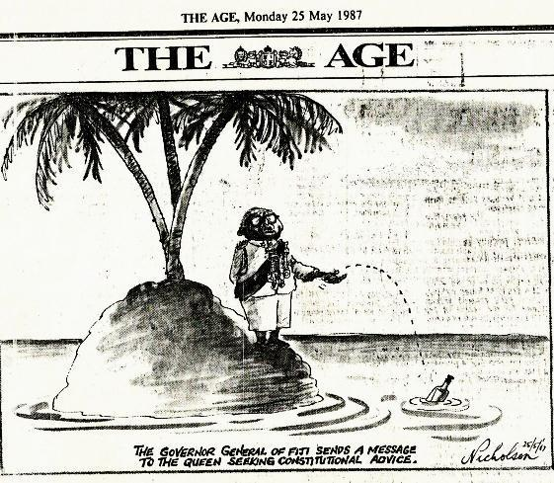
(a) “Governor General …, The Age, 25 May 1987;
1. In cartoon (a) what two symbols are used to show readers the topic is Fiji?

i. _______________________
II. _______________________
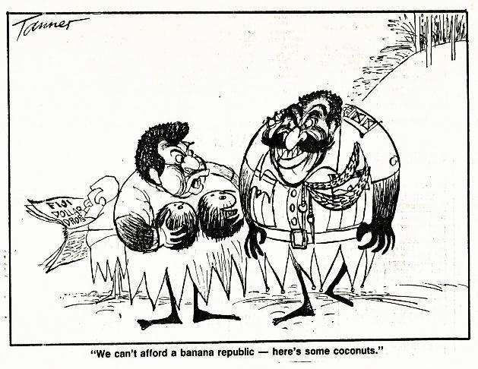
(b) We can’t afford …, The Age, 27 May 1987;
2. In cartoon (b), describe how the men are dressed.
_________________________________________________________________________
_________________________________________________________________________
_________________________________________________________________________
_________________________________________________________________________
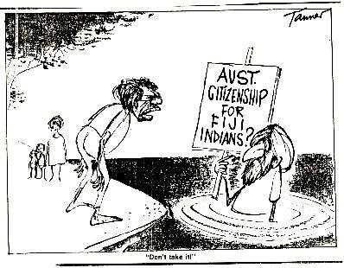
(c) “Australian citizenship …” The Age, 28 May 1987;
3. In cartoon (c) who is giving the Indian migrant advice?
_____________________________________________________________________
4. In cartoon (c) the Indian migrant is being given advice – what is the meaning of the statement, “Don’t take it”?
_________________________________________________________________________
_________________________________________________________________________
_________________________________________________________________________
_________________________________________________________________________
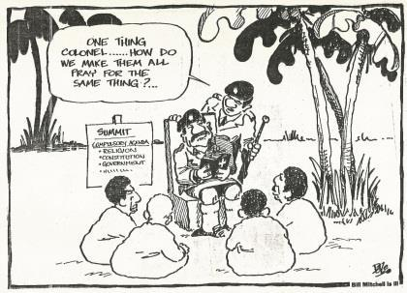
d) “One thing Colonel…”, Sydney Morning Herald 25 May 1987.
5. In cartoon (d) who is the person leading the prayer session?
_______________________________________________
6 In cartoon (d) what does the cartoon suggest is the main problem in Fiji?
_________________________________________________________________________
_________________________________________________________________________
_________________________________________________________________________

Lesson 63
Strand: Time, Continuity and Change
Sub Strand: Diplomacy
Learning Outcome:
1. Describe the relationship between Fiji and Australia
LESSON NOTES
TOPIC C IMPACT OF THE 2000 COUP; AUSTRALIA’S OPINION
Fiji’s relationship with Australia was tense during 1987.
-Travel advice warned of dangers to tourists.
-Trade Unions placed bans on trade.
-Diplomatic links were “strained” – a word used to say that nations were unhappy with each other’s policies.
However, relations soon returned to normal between 1988 and 2000. The two nations worked together on regional organizations, and trade, tourism and aid continued to be the main links, until 2000.
The attempted coup in 2000 and the following two month hostage crisis took Australia by surprise. The events in Fiji, generated a large number of cartoons (and columns, editorials and reports). Cartoonists tried to make sense of what was happening inside Fiji.
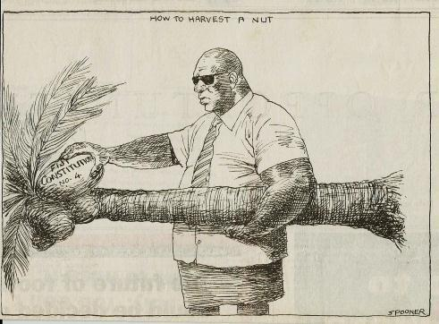
(a) How to Harvest a nut”;
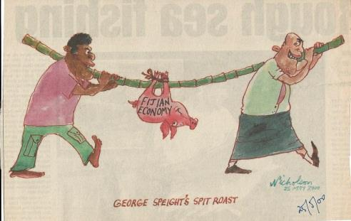
(b) George Speight’s spit roast/Fijian economy”, 25 May 2000;
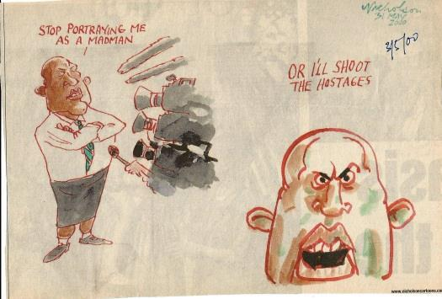
(c) “Stop portraying me as a madman …”, 3 May 2000;

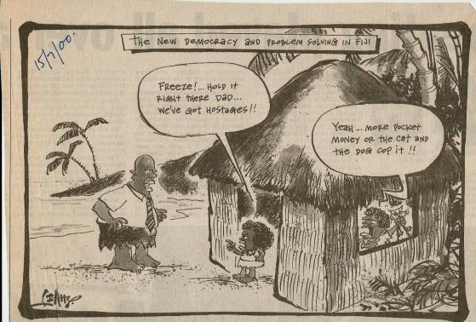
(d) “The new democracy and problem solving in Fiji”, 15 May 2000;

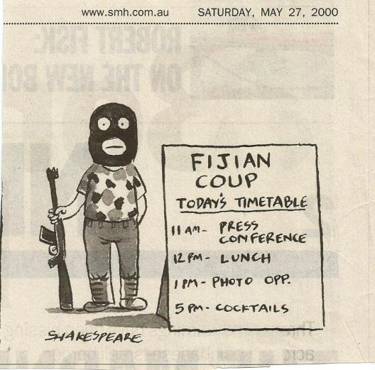
(e) “Fijian coup, Today’s timetable…”, 27 May 2000;
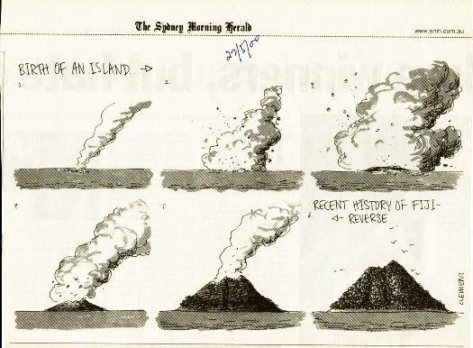
(f) Recent history of Fiji, reverse” , 27 May 2000.
ACTIVITY 3 QUESTIONS BASED ON TOPICS C

1. Cartoons (a) to (d) offer several opinions about the attempted coup and hostage crisis – what is your opinion about the cartoonist’s description of events?

( ) Yes or ( ) No You must chop a coconut tree down to get the coconuts
( ) Yes or ( ) No You can get a coconut from a tree without chopping it down
( ) Yes or ( ) No You have to weaken the economy to change the nation’s politics
( ) Yes or ( ) No You should avoid weakening the economy while trying to make
political changes
( ) Yes or ( ) No Coups cause ordinary people to copy the actions of the coup
leaders – see cartoon (d)
( ) Yes or ( ) No Australia thought the coup was ridiculous - see cartoon (e)
( ) Yes or ( ) No Australia misunderstood the coup leader’s actions and plans
( ) Yes or ( ) No In the hostage crisis, food was more important than political
negotiations and planning – see cartoon (e)
( ) Yes or ( ) No Australia thought Fiji was going backwards – see cartoon (f)
• Now discuss your answers with one classmate, and then with the whole class.

2. Examine cartoon (c) and write a different caption that explains what is happening.

_____________________________________________________________________

3. Summarize the six cartoons (a) to (f); for Australian readers, what do they suggest was happening in Fiji in May 2000?

__________________________________________________________________________________________________________________________________________________
__________________________________________________________________________________________________________________________________________________
_____________________________________________________________________________________________________________________________________________________________________________________________________________________________________________________________________________________________________________________________________________________________________________

4. Summarize the six cartoons (a) to (f) again; this time say what Fijian readers might have thought about the Australian cartoon version of events.

__________________________________________________________________________________________________________________________________________________
__________________________________________________________________________________________________________________________________________________
_____________________________________________________________________________________________________________________________________________________________________________________________________________________________________________________________________________________________________________________________________________________________________________
Lesson 64
Strand: Time, Continuity and Change
Sub Strand: Diplomacy
Learning Outcome:
1. Describe the relationship between Fiji and Australia in regards to the Great Council of Chiefs
LESSON NOTES
TOPIC D THE GREAT COUNCIL OF CHIEFS
-The Great Council of Chiefs (GCC) was regarded in Australia as a safeguard against problems.
-It was assumed the GCC would give strong and sound advice to the Fijian parliament and politicians.
-Australia believed the GCC would intervene directly and quickly if domestic affairs became unstable.
-Australia believed the GCC would protect the elected parliament, the government and democracy.

Fiji and Australia had been members of the British Empire and therefore shared a belief in democracy. Australian cartoonists portrayed the attempted coup and hostage crisis in 2000 as an attack on democracy.

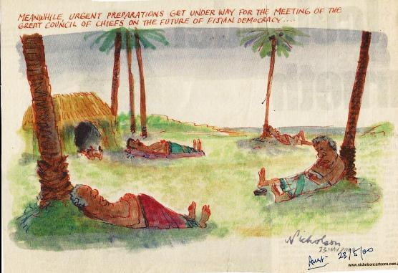
(a) The Australian newspaper, “Meanwhile, urgent preparations …”, 23 May 2000;
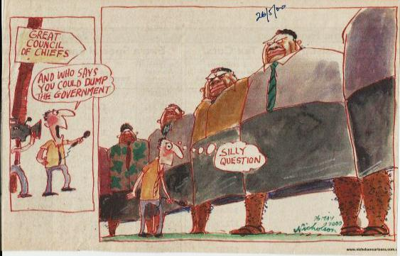
(b) The Australian newspaper, “Silly question”, 26 May 2000;
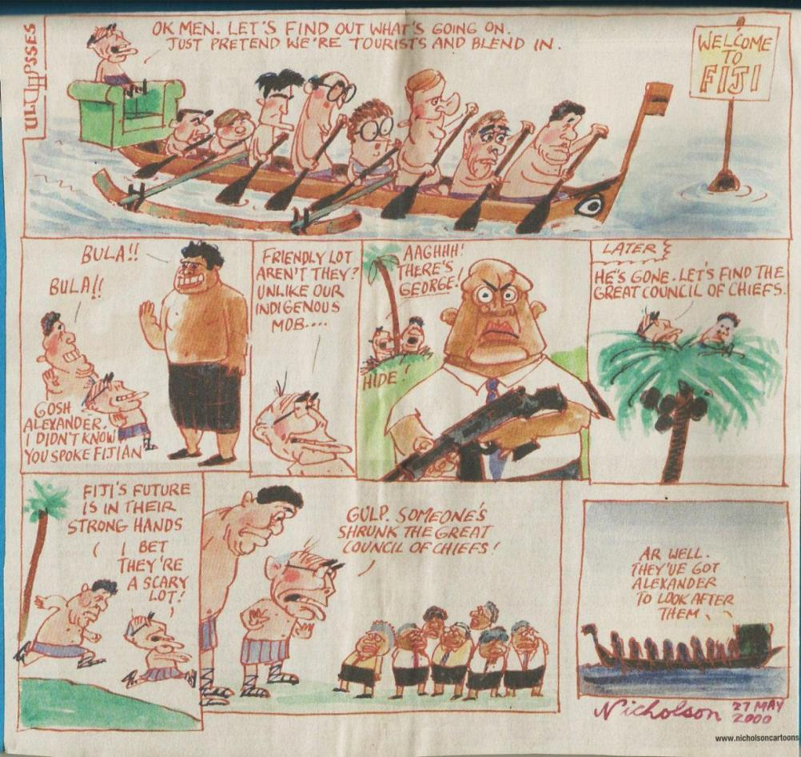
(c) The Australian, “OK men let’s find out what’s going on …”, 27 May 2000.
The men in the canoe are Australian politicians and Ministers in Prime Minister John Howard’s cabinet. “Alexander” is Mr Alexander Downer, the Australian Minister for Foreign Affairs. Mr Howard and Mr Downer did not visit Fiji during the hostage crisis. “George”, dressed in a tie and shirt and carrying a gun, is Mr George Speight, an ambitious Fijian, who led and continued the hostage crisis for two months.
The GCC is depicted as a group of strong leaders, but who are now ineffective and lacking influence. Eventually the canoe and Australia sail away and lose interest in Fiji’s affairs.
ACTIVITY 4 QUESTIONS BASED ON TOPIC D
1. How are the GCC depicted by the cartoonists? Tick the words that Australian readers might have assumed were accurate.

( ) Strong
( ) Huge and influential in Fiji’s affairs
( ) Ready to dump the democratically elected government
( ) Powerless
( ) Not influential
( ) Rushing in to sort out affairs
( ) Relaxing and waiting to see how events would unfold
( ) Willing to take advice from Mr Downer, the Australian Minister for Foreign Affairs
• Now discuss your answers with one classmate, and then with the whole class.

2. Write a paragraph (five sentences) on the Australian cartoonist’s view of the GCC.

Lesson 65
Strand: Time, Continuity and Change
Sub Strand: Diplomacy
Learning Outcome:
1. Describe the relationship between Fiji and Australia in regards to Tourism.
LESSON NOTES
F IMPACT ON TOURISM
-Tourism was the main form of contact between Fijians and Australians.
-Tourism had boomed after 1970, with the introduction of the Boeing 747 “Jumbo”, regular flights from Nadi to Australia, and the building of resorts on the Coral Coast, Nadi/Denarau, Yasawas and the islands off Lautoka.
-Fijians also visited Australia regularly to see friends and relatives, or for study, medical appointments and attending meetings.
-Cruise ships continued to visit Lautoka and Suva. For Australians, a “trip to the islands” usually meant Fiji.
-For Fijians, tourism meant jobs.
-For the Fiji government, tourism was an important supplement to relying only on the sugar, gold and timber industries.
-Economic progress was therefore in danger if there was a military coup.
Cartoonists responded by linking the coup with both democracy and tourism. Coup leaders with guns were depicted as still being friendly and travel agencies promoted “extreme sports” (as a joke), flak jackets and provided curfew times.
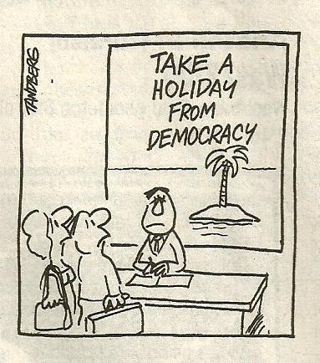
(a) “Take a holiday …”, Sydney Morning Herald, May 25 2000;

(b) “Don’t worry …”, The Australian, 24 May 2000;
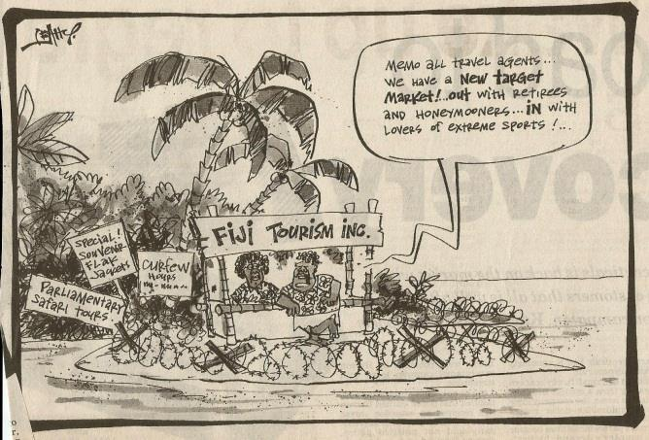
(c) “Fiji Tourism Inc …”, Courier Mail (Brisbane), 23 May 2000.
ACTIVITY 5 QUESTIONS BASED ON TOPICS F
1 In cartoon (a) what symbol is used to suggest the destination is Fiji?

________________________________________

2 In cartoon (b) “don’t worry it’s not loaded”, make a photocopy of the cartoon but write a
different caption.
New caption ______________________________________________

3 In cartoon (b) readers are given three hints that the topic is Fiji – list the three visual
hints
a. ________________________________________
b. ________________________________________
c. ________________________________________

4 In cartoon (c) what visual signs are that Fiji is having a military coup or could be a
dangerous place? List three visual hints;
a. ________________________________________
b. ________________________________________
c. ________________________________________

5 In your own words write a short statement (a paragraph, 5 sentences) from the Fijian Ministry of Foreign Affairs telling Australian tourists what Fiji is really like in 1987.

