YEAR 12
HISTORY
HOME LEARNING KIT
WEEK 7
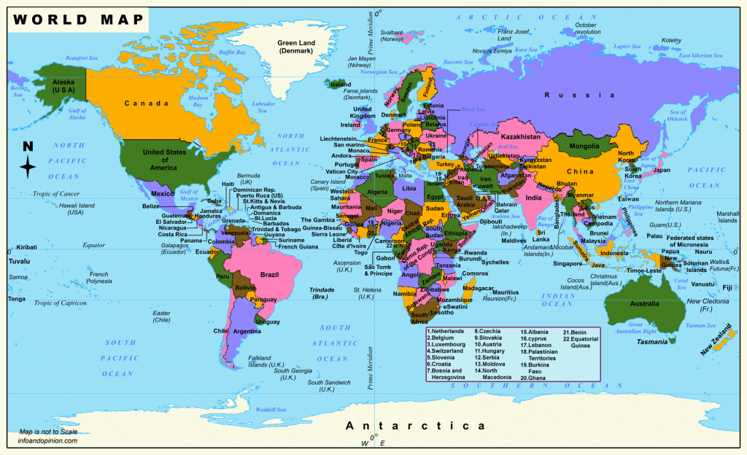

NAME
LEVEL
S/ID

Lesson 51
Strand: Time, Continuity and Change
Sub Strand: Diplomacy
Learning Outcome:
1. Discuss the role of New Zealanders at Nadi.
LESSON NOTES
NEW ZEALANDERS AT NADI
Importance of Nadi Airport:
- Vital staging post on the post – war transpacific route
- Centre for Air Traffic Control
- Centre of communications
- Centre for search and rescue
- Centre for Meteorological infrastructure
A lot of basic equipment was left behind by the US forces when they departed from the region but there were no suitably qualified Fijians who were able to operate it.
The first air traffic controllers, meteorologists, technicians, communication operators had to be provided by NZ and supplemented by a few from the UK and Australia.
The New Zealand and Australian Department of Civil aviation continued to play an important role in the running and development of Nadi Airport in the 1950s and 1960s.
Staff were accompanied with their families and housing was constructed for the expatriates to live within the airport boundary. The area of Nadi Airport became an expatriate enclave within Fiji.
Amenities included:
- Elementary level school
- Social club
- Golf course
- Boat club
- Tennis courts
- Football fields.
The airport had its own electrical power station, drainage and water supply.
In the 1970s, tourism was a major form of contact between Fijians and New Zealanders.
Nadi became the first airport in the region capable of handling larger aircraft.
Nadi Airport was developed in the 1960s to cater for the large aircrafts such as Boeing 707 and Douglas DC8.
1971 – Nadi welcomed its first “Jumbo Jet”the Boeing 746.
Nadi bloomed into a tourist town and tourism grew rapidly in the 1960s and New Zealanders became the major source of visitors for Fiji.
ACTIVITY 3 QUESTIONS BASED ON TOPIC D
1. Nadi became an aviation “hub”; explain why this occurred;

____________________________________________________________________
____________________________________________________________________
____________________________________________________________________
____________________________________________________________________
2. A New Zealand community expanded at Nadi airport. Name some of the facilities available to this community.

________________________
________________________
________________________
________________________
________________________
________________________
3 What is an enclave? Why do historians use this term to describe New Zealanders living at Nadi?

____________________________________________________________________
____________________________________________________________________
Lesson 52
Strand: Time, Continuity and Change
Sub Strand: Diplomacy
Learning Outcome:
1. Discuss Rugby in Fiji
LESSON NOTES
NEW ZEALAND AND RUGBY
Rugby was first introduced by Rt. Jone Tabaiwalu who studied at Whaganui College, NZ. He first taught the sport to the Roman Catholic Mission at Nalili, Rewa.
Fij rugby Union for the European Community had formed in 1913.
In February 1900, a Nalilili team captained by Rt. Jone journeyed to Suva and defeated the Europeans by a score of 8 -3.
In the second match in July, 1901, Nalilili prevailed over Suva by a score 11-3. Fijians had realized they had beaten the Empire in a game they had learnt from the Britain.
Rugby was referred to as “veicaqe vaka – Peritania” or “veicaqe vaka Nalilili”.
European Rugby faded out as it attracted less spectators.
# Rt. Epeli Ganilau upon his return from NZ in 1913 taught Fijians to play rugby. He convinced the football clubs of Suva to change over from soccer to rugby union code in 1914.
Some first teams were: Taipou, Tarirece, Hill and Ofisa.
#Rt. Sukuna returned in 1914 with more knowledge about the game. He organized Fijian competition. Native Union was not recognized until 1932. Despite being discriminated and given less desirable places to play, the native competition flourished.
In 1938, a NZ Maori team toured Fiji.
1939 the Fijian Schools Union was established to govern school rugby.
1939 – Fiji toured NZ and the team became famous for becoming the first side to visit NZ without losing a match – winning seven and drawing one out of the eight fixtures.
The Fijians impressed the crowds with their unpredictable and free – flowing style of rugby.
Fiji toured NZ again in 1951, and was successful with most of their fixtures winning 8, losing 5 and drawing twice.
ACTIVITY 5 QUESTIONS BASED ON TOPIC E, FIJIAN RUGBY
1. Who was the Bauan who went to New Zealand and returned to teach the game?

______________________________________________________________
2. Where did he go in New Zealand?

________________________________________________________________
3. When did he return to Fiji?

______________
4. When were the first games played?

_____________
5. What was the outcome?

_______________________________________________________________
6. Who dominated the administration of Fiji Rugby Union up to the 1930s?

_______________________________________________________________
7. Name two Fijians of chiefly status who were instrumental in introducing rugby.
(1) ______________________
(2) ______________________
8. Name four rugby clubs that were amongst the first to be formed.
(1) ______________________
(2) ______________________
(3) ______________________
(4) ______________________

(9) An important year for Fiji rugby was 1939. List two key events.
(a) ___________________________________
(b) ___________________________________

GLOSSARY
Aid Monies given by donor nations to help neighbours and less wealthy nations
Big Brother Usually meaning Australia as a rich and powerful neighbour
Colonial a relationship between a colonial ruler and its colony
Enclave A small, closed, isolated community existing within a nation
Ethnographer A social scientist who records details of indigenous customs and life
Neo-colonial a relationship between a large nation and a smaller former colony
Diplomacy The skill of making the correct decision in foreign policy; also means the actual formal and informal meetings between nations
Humanitarian Aid given to help less fortunate nations
Localisation The process of shifting jobs from Europeans to citizens of a new nation
Migration One of the major forms of relationship creating links between nations
Policy A statement by a nation about how it will treat another nation, or act in global events
Regionalism The idea that Pacific island nations could have a strong voice and improved Social and Economic futures if they worked together in a single regional organization.
Trade One of the major forms of relationship between nations
Lesson 53
Strand: Time, Continuity and Change
Sub Strand: Diplomacy
Learning Outcome:
1. Write an Essay on the relationship between Fiji and New Zealand.
Essay Question:
Discuss Fiji’s relationship with NZ from 1970 to 2000.
- Regionalism
- Education
- Sport – Rugby
- Civil Aviation
________________________________________________________________________________________________________________________________________________________________________________________________________________________________________________________________________________________________________________________________________________________________________________________________________________________________________________________________________________________________________________________________________________________________________________________________________________________________________________________________________________________________________________________________________________________________________________________________________________________________________________________________________________________________________________________________________________________________________________________________________________________________________________________________________________________________________________________________________________________________________________________________________________________________________________________________________________________________________________________________________________________________________________________________________________________________________________________________________________________________________________________________________________________________________________________________________________________________________________________________________________________________________________________________________________________________________________________________________________________________________________________________________________________________________________________________________________________________________________________________________________________________________________________________________________________________________________________________________________________________________________________________________________________________________________________________________________________________________________________________________________________________________________________________________________________________________________________________________________________________________________________________________________________________________________________________________________________________________________________________________________________________________________________________
Lesson 54
Strand: Time, Continuity and Change
Sub Strand: Diplomacy
Learning Outcome:
1. Describe the relationship between Fiji and the Two Chinas.
LESSON NOTES
UNIT 3 FIJI AND THE TWO CHINAS
-tourism -migration -trade -economic development
-aid -“Cheque Book Diplomacy” -foreign policy
Definitions  Trade | The buying and selling of goods and services
Aid | An assistant or help
Policy | An official government position or decision on a topic
Migration | Movement of people from one country to another
Development | Improvement in social, cultural, economic prospects and wellbeing.
Cheque Book Diplomacy | Means one country attempting to be friends with another country by offering aid and soft loans (low or interest free fu
TWO CHINAS
1. THE PEOPLES REPUBLIC OF CHINA (PRC)
-is the communist state founded after the civil war in 1949 and ruled by the Communist Party.
- it occupies vast mainland territories including Tibet and Manchuria.
2. REPUBLIC OF CHINA (ROC)
-formed in 1949 when the Nationalists (Kuamintang) retreated to an offshore island of Tormoso (now called Taiwan)
- Fiji was the first Pacific Island Country to establish Diplomatic relations with PRC.
- November 5th, 1975 a “joint communique” was signed.
- A Chinese Embassy was established at Nasese in Suva, May, 1976.
- Fiji reorganizes and is committed to uphold the “one child policy” and continuing official and diplomatic relations with PRC.
- Trade and economic relations continue to be maintained with ROC (Taiwan) after the formation of the Communist rule by the PRC over mainland China in 1949.
- PRC and ROC students have taken advantage of University and pre – university courses available in Fiji.
- Since 1970, there have been many high level delegation visits and meetings between PRC and ROC and Fiji.
Topic 1: The First Chinese in Fiji
The first Chinese arrived in Fiji almost two centuries ago. Luis and Saoo were on board Eliza, which was shipwrecked on Mocea Reef, nine miles south of Nairai in 1808. One can only surmise how they came to be aboard Eliza. Like their compatriots on board the numerous trading ships that piled the southern seas in search of sandalwood and later beche-de-mer, they may have been employed as cooks or carpenters. On the island of Bau, where they remained for five years after the ship wreck, they may have been handy men, maintaining and repairing musketry for the chiefs and beachcombers. They lived in Bau until 1813 when they sailed with Charles savage and others on Bauan canoes to the waters off Bua to meet Hunter, there to collect sandalwood for transport to China. With some men from Hunter, led by Peter Dillon, Savage and his companion landed at Black Rock in Bua. The small boats and canoes that had brought them to Bua were sent back into deep waters to wait transporting the men back to Hunter. Upon landing on the island, Dillon urged everyone to remain together as a group, but his advice was ignored. The men splintered into groups of two to four. Ambushed by the Wailea people, the men scattered in panic and were killed. Dillon managed to lead his small group to the base of a steep rock, which they scaled. Here, under siege and running low on ammunition, Dillon’s companion again panicked and ignored his exhortations not to leave the rock. Savage confident of his relationship with the Fijians fell for their ruse. He was enticed off the rock and killed. Meanwhile Luis, unnoticed by Dillon, slid down the side of the rock hoping to seek the assistance of a chief “with whom he was intimately acquainted and to who he had rendered important services in former wars”. He was clubbed to death. Luis was quite enterprising because he chose to accompany Savage and Dillon ashore, and not remain on board Hunter as did Saoo. According to R.A. Derrick in A History of Fiji, it is not known what happened to Saoo. He probably returned to China, because he chose toremain on board Hunter, which according to Dillon was scheduled to set sail for China the next day. Other than Luis and Saoo, there is no recorded reference to any other Chines arrivals in Fiji for several decades. Some elderly Chinese, however, believe that their predecessors actually first settled in Fiji in the 1850s. This claim can be substantiated. In a 1846 letter to Colonial Secretary J.F. Nicoll, then Vice Consul for China based in Melbourne, Victoria, Van Chi Tsiang, stated that the Chinese had arrived in Fiji in 1852. He did not mention numbers or names. Deryck Scarr, in his description of Fiji around 1875, refers to “a nucleus of a small Chinese business community – from storekeepers in Macuata, some of them left over from the beche-de-mer days and still trading.” According to R.A. Derrick, the beche-de-mer trade began to gather momentum by 1829 and was at its height in the 1840s. We can infer from these statements that a few Chinese very probably came to Fiji early in the 1800s on trading ships, as did Luis and Saoo, and remained behind either voluntarily or through force of circumstance.
Source – Bessie Ng Kumlin Ali, The Chinese in Fiji, Suva: IPS Press 2002.
ACTIVITY 1: QUESTIONS BASED ON READING
1. Name the first two Chinese that arrived in Fiji.

______________________________ ________________________________
2. What was their aim in coming to Fiji?

_________________________________________________________________
3. Which island in Fiji was their home until 1813?

_____________________________________

4. Name the early Chinese who made it back to China.

________________________________________________________________
5. Which other place in Fiji could you find early Chinese community?

Lesson 55
Strand: Time, Continuity and Change
Sub Strand: Diplomacy
Learning Outcome:
1. Describe the relationship between Fiji and the Two Chinas in regards to Trade.
LESSON NOTES
TOPIC 2 TRADE
- Fiji’s relations with the PRC and ROC are part of Fiji’s broader “multilateral” relationships with large and small nations.
- Some of Fiji’s relations with PRC and the ROC are “bilateral”
- Some are part of a wider multinational trade agreement and diplomacy.
Popular Slogans used in the relationship between Fiji and the PRC and the ROC are:
- LOOK NORTH POLICY
- ONE CHINA POLICY
- TWO CHINA POLICY
Trade relations tend to change according to which government is in power or according to the world demand.
Formal trade agreements between countries are usually prepared by a “Trade Mission” when trade and diplomacy experts and officials visit each other’s country.
Extract 2: from the Australian Broadcasting Commission (ABC News, Sydney)
Fiji Prime Minister’s Visit to China in 2013
Commodore Bainimarama (at the time, the head of the government following a Military coup) has held talks with China's Premier Li Keqiang and President Xi Jinping on a visit to Beijing. He's reiterated the country's 'Look North Policy”, which sees Fiji moving trade ties away from Australia and New Zealand towards regional powers such as China and India. Following the meeting with Le Keqiang, Commodore Bainimarama praised China as a friend to Fiji and the Pacific."[China] has been instrumental in facilitating the solidarity of the region," he said. "With your significant level of support, the peculiarities and special case for Pacific Islands and small island states are continually advocated in international forum. Commodore Bainimarama says he is confident the relationship between the two countries will strengthen, through mutual political trust and non-interference in internal affairs. He also reiterated his support for the 'One China Policy', in reference to competition between China and Taiwan to have influence in the Pacific. Chinese Premier Li Keqiang says Fiji has been a good friend and partner to China since the two countries first forged diplomatic ties in 1975"As Asian and Pacific countries, China and Fiji are committed to safeguarding regional and world peace and stability," he said. Mr Li called on both countries to develop agreements on fishing and visa exemptions in a bid to promote further cooperation.
Source:http://www.abc.net.au/news/2013-05-30/an-fiji-pm-on-china-visit/4722110

Extract 3: from the Fiji Government blog (“fijiblog”)
CHINESE TRADE DELEGATION VISITS FIJI in 2012 TO EXPLORE OPPORTUNITIES
Attorney-General and the Minister for Industry and Trade, Mr. Aiyaz Sayed-Khaiyum met with the Minister for Commerce, Mr. Chen Deming from the People’s Republic of China (PRC), to discuss opportunities for strengthening trade and economic relations between the two nations.
The visit was welcomed by the Fijian Government amidst Fiji’s efforts to expand its relations with the international community for strategic and economic development. This is Minister Deming’s first visit to the region, and Fiji is his first stop. “There are many areas of common interest between China and Fiji, and we look forward to exploring the potential that exists for us,” said Mr. Sayed-Khaiyum. Mr. Sayed-Khaiyum conveyed appreciation to the Chinese Government for its developmental collaboration and provision of the needed assistance through various means to Fijians. “For better economic and trade relations between Fiji and China, necessary measures need to be instituted which can be pursued through further dialogue”, said Mr. Sayed-Khaiyum. In terms of investment, Fiji provides the necessary platform and invites investors from China in areas such as agriculture, construction, tourism and audio visual”, added the Minister. The tourist numbers from China to Fiji has grown tremendously over the past few years and there is potential for this to grow further considering the huge market China represents.
The Permanent Secretary for Industry and Trade, Mr. Shaheen Ali regarded the meeting as fruitful considering relevant issues were discussed to foster and develop the economic and trade relations between the two nations.
Source: http://fijiblog.gov.fj/blog/2012/4/16/chinese-trade-delegation-visits-fiji-to-explore-opportunitie.html
ACTIVITY 2: BASED ON EXTRACTS 1, 2 AND 3 (Trade)
1. What are the two facets or types of trading relationship that Fiji has established?

a. ___________________________________
b. ___________________________________

2. What is a BTA?
a. ___________________________________

3. Which two countries are included in Fiji’s “Look north” policy?
a. ___________________________________
b. ___________________________________

4. Later, the Fiji Prime Minister changed this definition (extract 2) and added another country to the “Look North” Policy – which country was added?
a. ___________________________________

5. As well as global targets and general statements, which two specific polices were mentioned?
a. ___________________________________
b. ___________________________________

6. During a visit in 2012, four specific areas of relationships were mentioned – what were they?
a. ___________________________________
b. ___________________________________
c. ___________________________________
d. ___________________________________

7. After reading these three extracts of policy between 2012 and 2013 (when Fiji was governed by a Military Administration) in your own opinion what was the most important relationship between Fiji and the PRC mentioned in the extracts?
a. ___________________________________

