YEAR 12

HISTORY

HOME LEARNING KIT

WEEK 6

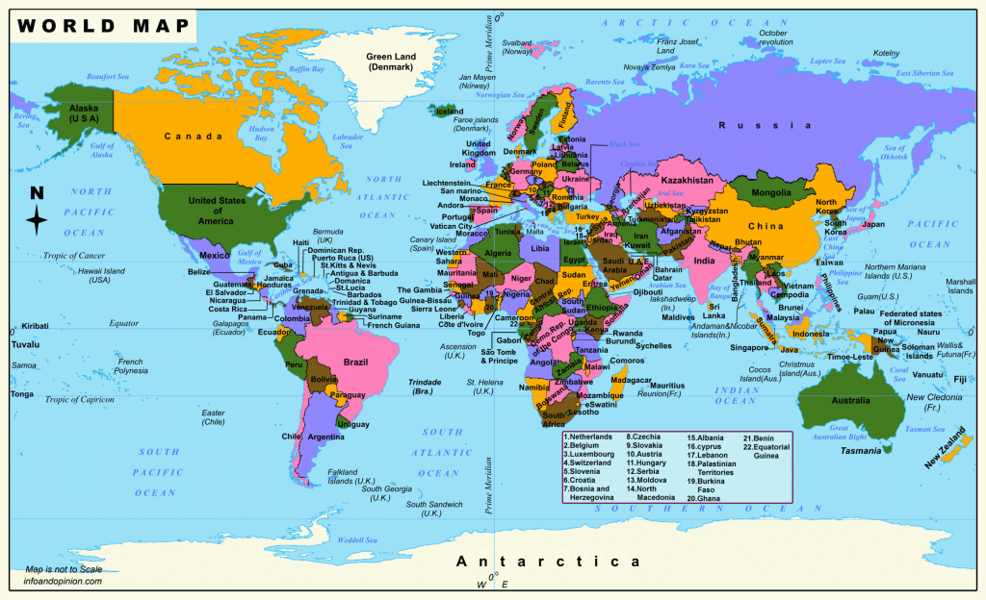

|  |  |
| --- | --- |
| NAME |  |
| LEVEL |  |
| S/ID |  |

SUB STRAND: **DIPLOMACY**

**Lesson 46**

**Strand:** Time, Continuity and Change

**Sub Strand**: Diplomacy

**Learning Outcome:**

1. Describe the relationship Fiji has with the World

2. Discuss the function of the Ministry of Foreign Affairs

LESSON NOTES

**DIPLOMACY**- skills of making correct decisions in foreign policy; also mean the actual formal and informal meeting between nations.

**INTERNATIONAL AFFAIRS:**

-AID -MIGRATION

-REGIONALISM -MULTILATERAL

-FOREIGN POLICY -UNILATERAL

-TRADE -FOREIGN AFFAIRS

-DIPLOMACY

**Definitions**

**Aid** Monies given by donor nations to help neighbours and less wealthy nations

**Regionalism** The idea that Pacific island nations could have a strong voice and improved social and economic futures if they worked together in a single regional organization.

**Foreign Policy** A government’s formal relationship towards foreign nations

**Foreign Affairs** Name given to policies, incidents, events and relationships between nations

**Multilateral** Meaning relations between several nations

**Unilateral** meaning relations with one other nation

**Trade** Imports and exports: One of the major forms of relationship between nations

**Diplomacy** The skill of making the correct decision in foreign policy; also means the actual formal and informal meetings between nations

**Migration** Moving to settle in another country: One of the major forms of relationship creating links between nations

**Fiji’s relationship with the World**

-member of the United Nations.

Because of their small size, they have to deal with:

* **super-powers** from Asia, America and Europe,
* large **neighbours** such as Australia and New Zealand,
* Thirteen other large and small neighbouring nations in the Pacific.
* giant **corporations** and international organizations e.g. World Bank,UN and non – government organizations such as Red Cross, WWF,World Rugby etc

**Ministry of Foreign Affairs**

-manages Fiji’s relationship with other nations nearby and faraway.

-manages Fiji’s signatory role (meaning to sign and agree to a treaty) in many international laws, treaties and conventions.

-Once a nation “signs up” it must follow the rules and regulations set out these agreements.

**For example:** in 2013 Levuka became a World Heritage site so the Fiji government is now responsible to maintain the site according to World Heritage rules. Fiji is also a signatory nation to the *International Law of the Sea*, the *Committee on the Elimination of Discrimination against Women*, the *Pacific Plan* and the UN’s *Millennium Development Goals* and others.

There are also informal relationships outside of government-to-government links. These include volunteer, charity, aid and friendship groups that visit Fiji to carry out small local projects.

Fiji is also a member of two very important regional organisations – the Pacific Forum and the Melanesian Spearhead Group.

Nations always act in the national interest “meaning they try to create relationships with other nations that are friendly and beneficial to each other, to the world generally, but primarily to themselves – IN FIJI’S INTEREST.

**READING 1**

Part (a) **List of major events in Fiji’s foreign affairs** (July 10th 2013) from the homepage of the Ministry of Foreign Affairs and International Cooperation. of the

• *Public invited to farewell soldiers to Golan Heights*

• *Fiji presents* ***credentials*** *to Nepal*

• *Fiji envoy meets Egyptian Agriculture Minister*

• *PM Bainimarama is chief guest at Solomon Independence celebrations*

• *MSG leaders sign three treaties*

• *Fijian peacekeepers to deploy to UNDOF*

• *New Caledonian Government welcomes MSG leaders*

• *Impart traditional knowledge: says Prime Minister*

• *West Papua issue in MSG agenda*

• *FLNKS commends Fiji’s leadership*

Part (b) **Description of Ministry of Foreign Affairs** (home page, in July 2013) and policy ad

*The Ministry of Foreign Affairs & International Cooperation is the ministry responsible for handling the Republic of Fiji's external relations …. The ministry states that its objective is "the provision of policy advice to the Government [of Fiji] regarding the formulation and implementation of its foreign policies," and it maintains the country's various diplomatic missions based domestically in Suva, those attributed to Fiji in Canberra, Australia and Wellington, New Zealand, as well as those based internationally.*

ACTIVITY 1 QUESTIONS BASED ON THE READING (a) AND (b)

1. For each location identify the region (Asia, Africa, Europe, Middle East, or Melanesia)

Golan Heights _________________________

Nepal _________________________

New Caledonia _________________________

Egypt _________________________

Solomon Islands _________________________

West Papua _________________________

2. What do these acronyms mean?

MSG _________________________

UNDOF _________________________

FLNKS _________________________

3. What is the main purpose of the Ministry of Foreign Affairs?

____________________________________________________________________________________________________________________________________________________________________

4. Describe a “policy” that you know about that involves Fiji’s relationship with a foreign nation?

_____________________________________________________________________________________________________________________________________________________________________________________________________________________________________________________________________________________________________________________________________________________________________________

5. Explain the difference between “foreign affairs” and “International cooperation”

____________________________________________________________________________________________________________________________________________________________________________________________________________________________________________________________________________________________________________________________________________________________________________________________________________________________________________________________________________________________________________

**Lesson 47**

**Strand:** Time, Continuity and Change

**Sub Strand**: Diplomacy

**Learning Outcome:**

1. Describe the relationship Fiji and the Region

LESSON NOTES

**TOPIC A: FIJI AND THE REGION**

**1970** – Fiji was the first Pacific Island nation to gain independence. The first new nations were Western Samoa (now called Samoa)

**Independent nation:**

W.Samoa – 1962 Cook Islands – 1965

Nauru – 1969 Fiji – 1970

These new nations decided to form a political organization called the **South Pacific Forum** to work collectively on common interests.

They invited their friendly neighbors Australia and New Zealand to be members also.

Later they included more independent nations to the expanded South Pacific Forum.

It is now called the **Pacific Forum Secretariat.**



**WHY WAS THE SOUTH PACIFIC FORUM(SPF) FORMED?**

It was formed to protest against the rules of the biggest regional; organisations called the South Pacific Commission (Secretariat for the Pacific Community)

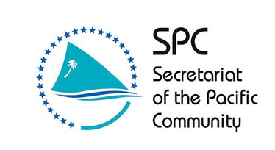

The SPC was focused on regional development in Education, Agriculture, trade, fishing, tourism and health.

It held annual regional meetings but politics, political issues and policies were not allowed to be discussed.

**MEMBERSHIP**

Regional Agencies that Fiji is a member of:

|  |  |
| --- | --- |
| Pacific Forum | See the source image |
| SOPAC | See the source image |
| SPREP | See the source image |
| MSG |  |
| Forum fisheries Agency | See the source image |

**RESPONSIBITLITES FIJI WAS PART OF:**

* Chair of the MSG in 2012 – 2013
* Convenient hub for airlines, shipping and communication
* Hosted regional sporting events like the SPG and the Festival of Pacific Arts.

**TOPIC B FIJI AND THE RIM**

The ‘**RIM**’ refers to nations that are not in the Pacific but do share a boarder that is the Pacific Ocean.

The **East Rim** is North America, Canada and the USA. They have relationship with Fiji which goes back to the Colonialism times of Britain and USA in the Pacific.

The **West Rim** is the Asian countries. Fiji has a close and regular link with Japan, South Korea, The People Republic of China, Taiwan (ROC) through trade, aid and migration.

In the **South West Pacific Rim** are two most important rim nations, Australia and New Zealand.

Fiji have a close relationship before and after independence. Though they disagreed with Fiji during the four coups (1987 – 2006), they still formed a ‘bloc’ or single voice in support of or against regional or international problems such as French nuclear testing in the Pacific in 1985 or the military intervention (RAMSI) in the Solomon Islands in 2003.

# Relationships between nations are described as **Diplomacy.**

ACTIVITY 2 QUESTIONS BASED ON TOPICS A AND B

1. Which is most important work of diplomacy – this is your own opinion!!! (rank from first (1) to fifth (5)

( ) relations with near neighbours (e.g. Tonga)

( ) relations with the Rim nations Australia and New Zealand

( ) relations with Superpowers (e.g., USA and China)

( ) relations with Europe (e.g., European Union and Great Britain)

( ) relations with Asian nations

Now, discuss your choice with the rest of the class.

2. Give the full name for these organization

UN ______________________________________________

MSG ______________________________________________

SPC ______________________________________________

SPREP ______________________________________________

SOPAC ______________________________________________

FFA ______________________________________________

3. Why was the South Pacific Forum created in 1970?

____________________________________________________________________________

____________________________________________________________________________

____________________________________________________________________________

4. Describe Fiji’s role in international organizations (one sentence)

______________________________________________________________________________________________________________________________________________________________________________________________________________________________________________________

5. What is a “Rim” nation

____________________________________________________________________________

____________________________________________________________________________

____________________________________________________________________________

6. In your own words describe “good diplomacy”.

____________________________________________________________________________

____________________________________________________________________________

____________________________________________________________________________

____________________________________________________________________________

**READING 2 THE MELANESIAN SPEARHEAD GROUP** (MSG) HOMEPAGE

(JULY 2013) (NOTE, THIS DESCRIPTION WAS WRITTEN IN 2011)

***Our Organisation*** *The Melanesian Spearhead Group (MSG) is a dynamic and rising regional organization grouping together the Republic of Fiji, the Independent State of Papua New Guinea, the Solomon Islands, the Republic of Vanuatu and the Front de Libération Nationale Kanak et Socialiste (FLNKS) of New Caledonia. Altogether MSG has Five Members that share similar cultural heritage and ties and are in agreement to work together for the common interests and solidarity of their people in Melanesia.* ***Our Population:*** *The region of Melanesia is home to almost 8 million people. It is also known as the most resourceful region in the South Pacific.* ***Our Origins*** *The birth of the MSG took its origins in late 1970s-early 1980s from a visionary concept of 'Melanesian* ***Solidarity'*** *backed by the strong political desire to strive for the entire* ***decolonization*** *and freedom of Melanesian countries and territories that are still dealing with some remnants of the colonial rule in the South Pacific.*

ACTIVITY 3 QUESTIONS - INTERPRETING THE MSG HOME PAGE

1 Why does MSG describe itself as a “rising” organisation?

______________________________________________________________________

______________________________________________________________________

2 Do the five MSG member nations;

Yes ( ) or No ( ) speak the same language?

Yes ( ) or No ( ) have a common border (adjacent to each other)?

Yes ( ) or No ( ) fly the same flag?

Yes ( ) or No ( ) have a common military enemy

Yes ( ) or No ( ) have the same former colonial power

3 Define the word “solidarity”.

____________________________________________________________________

4 Write a sentence about the MSG using the word ‘solidarity”.

____________________________________________________________________

____________________________________________________________________

5 What are the major economic resources of the MSG region? List six resources.

1) ______________________

2) ______________________

3) ______________________

4) ______________________

5) ______________________

6) ______________________

6 In the wider region known as Melanesia, list the two countries that are still ruled by foreign powers. (One is a member or Observer at MSG, the other is not a member)

1 ______________________

2 ______________________

**Lesson 48**

**Strand:** Time, Continuity and Change

**Sub Strand**: Diplomacy

**Learning Outcome:**

1. Describe the relationship Fiji and the International Arena

LESSON NOTES

**TOPIC C FIJI AND THE INTERNATIONAL ARENA**

1. Fiji is not a major player in the international foreign affairs. Since it is a small nation in terms of population and trade. It is not placed in a “hot spot” or critical location.

2. Singapore in South East Asia is a small nation but lies across many trade route and is a financial dynamic.

Switzerland in Europe is also small. It is important in global banking and trade while it shares boarders with France, Italy, Austria and Germany.

Fiji is in a peaceful zone in world politics.

**Membership**

1. Fiji does have a vote in the UN

2. Fiji is a member of the Commonwealth

3. In 2013, Fiji hosted the G77

4. ACP,FAO, BP, IAGA, IBRD, IRB, SPC, UNESCO, WHO, WTO etc.

**Why involved?**

1. Diplomacy or conduct of foreign affairs

2. Health

3. Banking and foreign loans

4. Labour and workplace condition

5. Sports

# Foreign Affairs only become controversial when nations disagree on policies or try to influence another country’s affairs.

* Japan trying to get Fiji’s support in Japan’s campaign to continue hunting whales.
* Australia tried to make sure the new head of the Pacific Forum was an Australian.
* Taiwan (ROC) has tried to get Fiji’s support in its struggle with the People’s Republic of China.
* Fiji tried to influence Tonga to send back a senior military officer who deserted and fled in a ship across the sea to Tonga.

“These friendship, accusation and criticisms becomes headlines and medic ‘incidents’”

The G77 group is an intergovernmental organization that works with member of the United Nations on development issues. It began in 1964.

ACTIVITY 4 QUESTIONS BASED ON TOPIC C

1 Which of these events would you consider to be a controversial “incident” (Write yes or no in the bracket)

( ) Fiji opens a new Embassy in Brazil

( ) Australia bans Fiji’s military officers from flying to or through Australia

( ) Fiji signs the international convention on *Elimination of Discrimination against*

*Women*

( ) Fiji is expelled from the British Commonwealth organization

( ) Fiji hosts G77 meeting

2 Is Fiji a minor or major player in international affairs? In your answer, mention two reasons for or against.

____________________________________________________________________

____________________________________________________________________

3 Fiji was made a member of the British Commonwealth in 1970 – why?

____________________________________________________________________

____________________________________________________________________

4 What do these acronyms in the CIA Fact Book stand for?

IMF _____________________________________________________

ADB _____________________________________________________

UNESCO _____________________________________________________

IOC _____________________________________________________

IRB _____________________________________________________

**GLOSSARY**

**Aid** Monies given by donor nations to help neighbours and less wealthy nations

**Corporation** A huge business or company, often present in many nations, worldwide

**Credentials** The papers a diplomats presents when they serve in a foreign nation

**Decolonization** the gaining of independence from a colonial power

**Diplomacy (i)** the skill of making the correct decision in foreign policy

**(ii)** the actual formal and informal meetings between nations

**Diplomat** Person who conducts meetings with other nations

**Diplomatic** The correct or most advantageous decision for your nation

**Foreign Policy** A government’s formal relationship towards foreign nations

**Foreign Affairs** Name given to incidents, events and relationships between nations

**Migration** Moving to settle in another country: One of the major forms of relationship creating links between nations

**Multilateral** Relations between several nations

**Regionalism** The idea that Pacific island nations could have a strong voice and improved social and economic futures if they worked together in a single regional organization.

**Remnant** Anything that remains (for example, a country that is still under colonial rule) 19

**Rim** Nations on the border of the Pacific Ocean

**Signatory** To sign and agree to a treaty

**Solidarity** Common action, support and friendship between nations (usually on a single issue)

**Superpower** A rich, powerful and most influential nation.

**Trade** Imports and exports: One of the major forms of relationship between nations

**Unilateral** Relations with one other nation

**READING 3 FIJI AND THE NUCLEAR FREE AND INDEPENDENT** (NFIP) MOVEMENT; REPORT OF THE 8TH CONFERENCE, 1999

*“Warmest greetings from the Pacific Concerns Resource Centre (PCRC) the secretariat of the Nuclear Free and Independent Pacific movement, based in Suva, Fiji Islands.From20-24 September 1999,over ll0 delegates and observers from 28 countries and territories around the Pacific came together for the 8th nuclear free and independent Pacific conference at Arue, Tahiti, Te Aomaohi (French Polynesia). The official delegates were joined by international observers, secretariat staff and scores of visitors and supporters from around Tahiti, in the shadow of Mount Erima, on the shores of Matavai Bay. Since1975, the nuclear free and independent Pacific movement has met in conference, bringing together peoples' representatives from around the Pacific region, indigenous people's organizations, Church, trade union and peace activists; environmentalists; and movements for sovereignty and self-determination. The first nuclear free Pacific conference was held at the University of the South Pacific (USP) in Suva, Fiji in 1975.*

***Source: Report of the 8th NFIP Conference,* Pacific Concerns Resource Centre, Suva, 1999,p6**

ACTIVITY 5 BASED ON READING 3 (NFIP REPORT)

1 List the nine (9) organizations and interest groups who attended the NFIP conference in Tahiti.

1 _______________

2 _______________

3 _______________

4 _______________

5 _______________

6 _______________

7 _______________

8 _______________

9 _______________

2 What role did Fiji play in this international campaign?

____________________________________________________________________

____________________________________________________________________

____________________________________________________________________

____________________________________________________________________

**Lesson 49**

**Strand:** Time, Continuity and Change

**Sub Strand**: Diplomacy

**Learning Outcome:**

1. Describe the relationship Fiji and New Zealand

LESSON NOTES

UNIT 2: **FIJI AND NEW ZEALAND**

-Regionalism -Transport

-Post War -Migration

-Tourism -Education

-Trade -Sports

**Definitions**

**Post-War era** The immediate period after WWII when changes were occurring world-wide

**Education** A major activity creating linkages between nations.

**Trade** A major activity – imports and exports – linking nations

**Regionalism** The idea that Pacific island nations could have a strong voice and improved Social and Economic futures if they worked together in a single regional organization.

**Transport** Shipping and aviation systems that link nations

**Tourism** An industry based on the history, people and natural beauty of a site

**Migration** A major form of personal relationship between nations

**Sport** A major activity both private and commercial forging relations between nations

**1. Introduction: Along, Close Relationship**

1. Fiji and NZ relationship goes back into the 1870s. It later on was strengthened after independence in 1970 as the Fiji school Curriculum was patterned on the NZ Curriculum and also taught in English.

Therefore most of the government teachers were recruited from NZ and some of the brightest Fijian students continued their schooling in NZ.

2. Prominent leaders that went to study in NZ include:

a) Rt. Jone Tabaiwalu

b) Rt. Epeli Ganilau

c) Rt. Sukuna

d) Rt. Edward Cakobau

e) Rt. Kamisese Mara

f) The Brown – Toganivalu brothers

# they returned with NZ, English and a love for the game of rugby.

3. Until 2006, relations between nations were very friendly as NZ could enter Fiji without visa and NZ has long been a significant source of development, aid,tourism and economic partner.

-Fiji has been a steady source of workers for the NZ labour market and athletes for their contract sport such as rugby.

4. Relationship were based on : i) education

ii) airports

iii) transport

iv) rugby

**2. FIJIANS IN NEW ZEALAND; NEW ZEALANDERS IN FIJI**

-WWI many Fijians went to New Zealand to fight in the war in Europe.

- two different groups of Fijians who went as ‘exhibits’ to represent Fiji at international Exhibitions

“Colonial exhibitions in the Australasian colonies also presented indigenous men, three Fijian men recruited from Levuka resided at the ‘Fiji House’ set up at the Sydney International Exhibition of 1879.

- Fiji Rush’ of the 1860s when hopeful New Zealand planters rushed to Fiji to plant cotton. This was the start of a regular link between New Zealand and Fiji,

The **Bank of New Zealand** recognized this link and moved to Levuka in 1877. By the 1950s, it was Fiji’s main bank.

The BNZ closed operations in 1990 and was sold to the ANZ.

**3 FIJIANS EDUCATED IN NEW ZEALAND**

The first Fijians to be educated in New Zealand were chiefs like **Ratu Sir Lala Sukuna**, (22 April 1888 - 30 May 1958). He is regarded as the forerunner of the post-independence leadership of Fiji. He died a dozen years before independence was achieved but his vision set the course that Fiji was to follow in the years to come.

**RATU SIR LALA SUKUNA**

Sukuna’s father had enrolled him at the Wairuku Indian School in Ra. One of the teachers at the school was the Rev. Charles Andrew. Rev Andrew was a colourful character, an Oxford-educated Anglican clergyman who had converted to Roman Catholicism and then back again, before sailing for the mission field in Fiji. He was a private tutor at Wairuku and a strict teacher, beating Sukuna on occasion.

Sukuna proved to be an exceptionally able student. Largely as a result of Rev. Andrew's influence, the young Ratu Sukuna was sent to the prestigious Wanganui Collegiate School in Wanganui, New Zealand. He proved to be a bright pupil. He was a strong debater, played rugby and cricket, and became the Wanganui Collegiate boxing champion.

Sukuna hoped to remain in New Zealand to pursue a university degree, but his source of funds dried up and he was forced to return to Fiji, where, in 1907, he joined the civil service as a fifth class clerk. His superb command of English, however, ensured his rapid promotion and it was not long before he became the chief translator for the government. In 1909 he was invited by his uncle, Ratu Alfred Finau Ulukalala, to return to the Lau Islands to become assistant master of the Lau Provincial School at Lakeba. He also became visiting examiner at Queen Victoria School and Levuka Public School, at the age of 21. In Lau, Sukuna became an assistant master to A. C. Hocart, the headmaster of Lau Provincial School. Hocart was a keen **ethnographer** and between 1909-1912, he mapped out the house sites in Tubou village, Lakeba. Many of the house site names came from different parts of Fiji. It also included names from outside of Fiji. For example, Manono, Samoa, Niu Kini, Ta’iti, Wanganui, and Niu Silandi. Manono refers to an island in Samoa; Niu Kini was suggested by the fact that a Fijian Pastor (teacher) was in New Guinea; Wanganui recorded the fact that the chief’s sister’s son (probably Sukuna) had been to school in Wanganui, New Zealand.1

ACTIVITY 1

1. Using the library and the web, locate Wanganui in a map of New Zealand and describe its location.

____________________________________________________________________

____________________________________________________________________

2. Where was Sukuna’s first school?

____________________________________________________________________

3. Look up the word ethnographer in your dictionary. What does it mean?

____________________________________________________________________

4. The chief’s sister’s son is an important kinship relationship in Fiji. Name the Fijian word for the chief’s sister’s son and describe the nature of the relationship between the son (nephew) and chief (uncle).

____________________________________________________________________

____________________________________________________________________

____________________________________________________________________

____________________________________________________________________

5. Using the library and web and your own family and friends, make a list of five Fijians who have lived, studied or worked in New Zealand.

1 ____________________________________________________________

2 ____________________________________________________________

3 ____________________________________________________________

4 ____________________________________________________________

5 ____________________________________________________________

**Lesson 50**

**Strand:** Time, Continuity and Change

**Sub Strand**: Diplomacy

**Learning Outcome:**

1. Describe the establishments of the first airports in Fiji

LESSON NOTES

**TRANS – PACIFIC ROUTES FROM EUROPE TO AUSTRALASIA**

**1939** – Royal New Zealand Air Force (RNZAF) opened at Laucala Bay with facilities for civil use.

There occasional flights between Auckland and Laucala Bay by the NZ Airline TEAL Services also went to Palmyra Island and Honolulu but all stopped at the start of the Pacific War in 1941.

USA also built airfields around the Pacific for its war aircrafts. After the war in 1946 the British government granted the United States airline operating rights through Nadi under the terms of the bilateral air service agreement. (Agreement between Britain and the US)



The Royal New Zealand Air Force Base, Laucala Bay, Suva, 1940s.

**THE ORIGINS OF NADI AIRPORT, FIJI**

During the Wellington Conference it was decided that NZ will construct two airfields in Fiji.

**REASON:**

-US had revised its strategy on the war.

-They had identified Japan as an enemy.

-There was a need for airfields with improved aircrafts like the long range bomber aircraft, aircraft carriers and naval fighter planes.

Namaka was chosen because it was near Nadi. The other site was to be Nausori about 15 miles from Suva.

**WHY WAS NADI SELECTED?**

Nadi was selected because:

-it was flatter

-had better weather conditions for flying

-less rainfall and a consistently long and pronounced ‘dry’ season

**In March 1941** a small grass air base for the use by DH-89 aircraft was completed at Nadi.

At a another meeting in Wellington in November, 1941 the US agreed to finance the construction of two 7000foot runaways at Nadi by a NZ firm, The Southern Cross Construction Company. The new runaway/airports was completed by **April, 1942.**

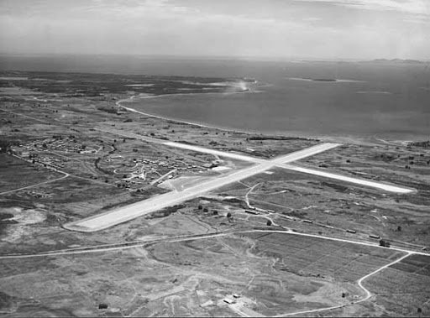

Source: Photograph by Rob Wright

# The Japanese attack at Pearl Harbour forced contractors to redouble their efforts.

**January 1942** – 3: Boeing B17 Flying Fortress completed a trip from Hawaii via Canton island, Nadi and Tontouta, New Caledonia to Townsville, Australia.

The landing of the Boeing B17 at Nadi Airport marked the emergence of Nadi Airport as an international airport.

Nadi was taken over by the US Military Air Transport Service as their main base in the Southwest Pacific.

**In December, 1946** the US handed operation of the airport to New Zealand Department of Civil Aviation.

**From 1947** onwards the airport area became an enclave administered by the NZDCA.

ACTIVITY 2

1. On a map of the Pacific, locate the following and draw straight lines linking each airport;:

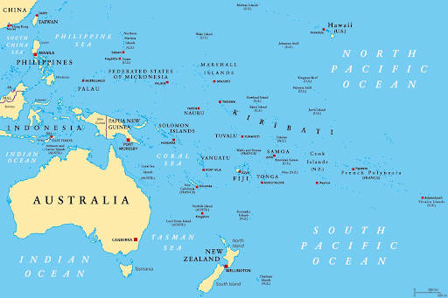

Laucala Bay

Auckland

Palmyra Island

Canton

Honolulu

Nadi

Nausori

San Francisco

2. Who built the Laucala Bay air base?

____________________________________________________________________

3. Why were the Nadi and Nausori bases constructed?

_________________________________________________________________

4. Who were the two major powers in the decision making about air bases in Fiji.

________________ ________________

5. List three reasons why Nadi was chosen over Suva.

I. ___________________________________________________________

II. ___________________________________________________________

III. ___________________________________________________________

6. Why do you think that control was not passed over to the British Colonial authorities?

____________________________________________________________________

____________________________________________________________________

7. What is the most important reason for building air bases in 1941-1942? List these in order of importance; Most important (1) and Least important (5)

( ) To defend Fiji

( ) To improve USA military access to Australia and New Zealand

( ) To fight Japan

( ) As a back-up if the USA lost air bases in Asia and Southeast Asia

( ) To promote tourism