YEAR 12

HISTORY

HOME LEARNING KIT

WEEK 5

|  |  |
| --- | --- |
| See the source image | See the source image |
| See the source image | See the source image |

|  |  |
| --- | --- |
| NAME |  |
| LEVEL |  |
| S/ID |  |

**Lesson 41**

**Strand**: Time, Continuity and Change

**Sub Strand:** International Relations

**Learning Outcome**:

1. Discuss the Aggression and Appeasement of the League of Nations

LESSON NOTES

**AGGRESION AND APPEASEMENT**

**Aggression** – feelings of anger resulting in hostile or violent behavior, readiness to attack or confront.

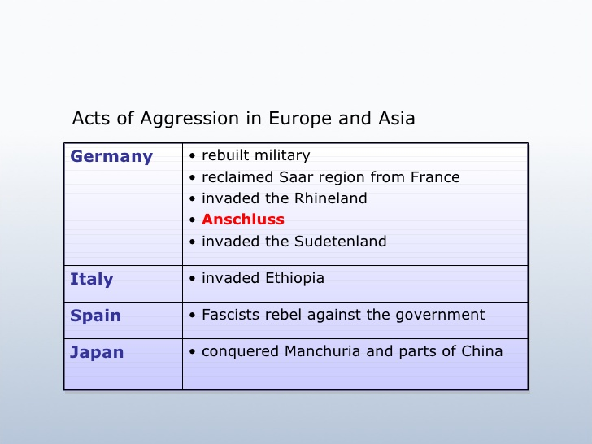

**Spanish Civil War: 1936 – 1939**

* Civil war erupted in Spain between Republicans and Nationalists.
* Hitler and Mussolini helped the Nationalists.
* France and Britain stayed out of the war. (Italy betrayed Britain and France over the agreement made in Stressa.)

**Rome Berlin Axis**

* The Spanish war brought Hitler and Mussolini closer together and in 1936, they formed the Rome Berlin Axis.
* A month later, Germany signed on an Anti – Communist Pact with Japan to keep Russia in check.
* When Italy joined the pact in 1937, Rome- Berlin-Tokyo Axis was formed

|  |  |
| --- | --- |
| **Anti- Comintern (1936)** | |
| Members | Germany and Japan |
| Provision | -It was an anti-communist pact. Designed to prevent soviet expansion.  -It was designed to go against international communism. |
| New Member | Italy joined in 1937. It became known as Rome-Berlin-Tokyo Axis |

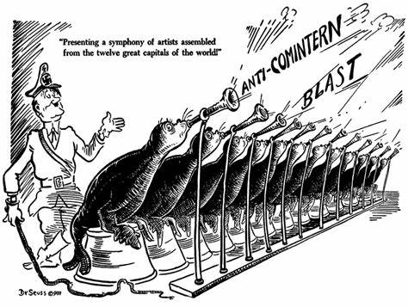

The man with a hat resembles Adolf Hitler of Germany. The sign on the hat is the symbol of the Nazi Party (A swastika). Hitler was agist communism and feared Russian expansion in Europe. Hitler is seen as an overseer who is in charge of anti – communism in Europe.

**Activity:**

**1.**

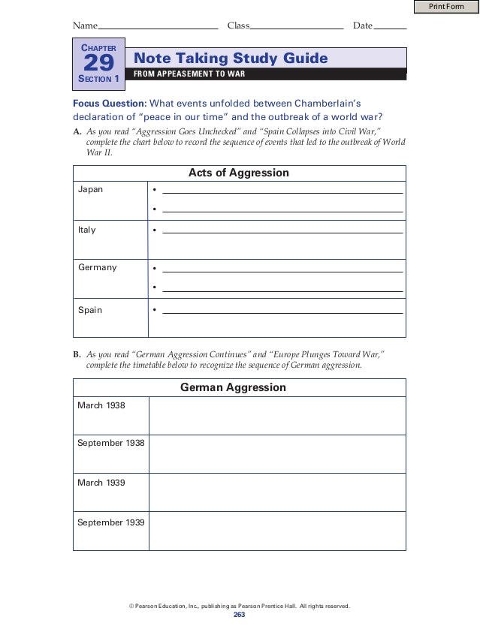

**Lesson 42**

**Strand**: Time, Continuity and Change

**Sub Strand:** International Relations

**Learning Outcome**:

1. Discuss the Appeasement Policy

LESSON NOTES

**THE APPEASEMENT POLICY**

|  |  |
| --- | --- |
| **Definition** | **Appeasement** – is a foreign policy which seeks to satisfy those states with grievances by making concessions, thus avoiding war. |
| **Who initiated the Appeasement Policy** | Neville Chamberlin the Prime Minister of Great Britain. Referred to as the champion of appeasement policy. All was done to prevent another major war. |
| **How did the appeasement policy help Hitler?** | -Hitler was able to acquire self – confidence and prestige.  -He was able to conquer or invade other treaties such as militarization of Rhineland (Clear violation of the Locarno Treaties), Anschluss with Austria ( a clear violation of the Treaty of Versailles), the occupation of Czechoslovakia and so on. |
| **Reaction of Britain and France** | -Neville Chamberlin believed some Germans claims were just.  -Fear of communism was greater than Nazism.  -Britain wanted to avoid war.  -France was unable to follow an independent policy.  -The British military was ill prepared for the war. |

**Resource Interpretation**



1. Name the political party and its leader that are symbolised as beasts in the

resource given above.

**2**. Explain the significance of the quote above “***Remember…One More Lollypop and then You All Go Home***!”

|  |  |
| --- | --- |
| See the source image | 1.What does it mean “**He lives; he talks…yet the guy has no guts!**” |

**Lesson 43**

**Strand**: Time, Continuity and Change

**Sub Strand:** International Relations

**Learning Outcome**:

1. Discuss the Munich Crisis and Agreement

LESSON NOTES

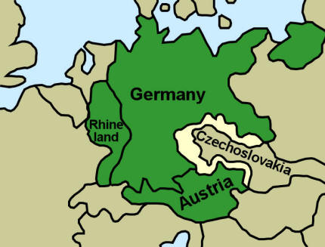 **Sudetenland**

* Hitler’s new target was Czechoslovakia within the Sudetenland, an area of Czechoslovakia with 3million Germans.
* Hitler instructed the German Sudeten leader to demand separation from Czechoslovakia. It would give himself time to prepare to “smash Czechoslovakia”

**MUNICH CONFERENCE**

1. France, Great Britain, Italy and Germany met in Munich, Germany, on September 29th, 1938 to discuss Hitler’s demand.

2. Czechoslovakia was not invited.

3. **MUNICH AGREEMENT** – choose to APPEASE Hitler and gave him Sudetenland if he promised not to take anything more. Gave into the demand of the aggressor (Hitler)

* Sudetenland was given to Germany on the 1st of October, 1938

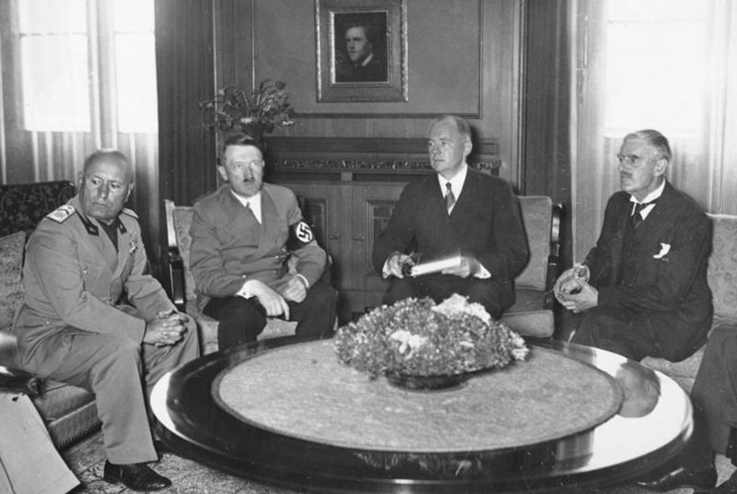

**Activity:**

1. Explain the Sudeten crisis of 1938.

2. State the year the Munich Conference was held and mention a purpose

of the conference

3. **Resource Interpretation**

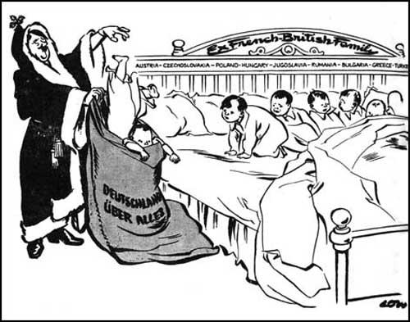

i) Name the leader represented by “father Christmas” and explain what is he doing.

ii) Describe how this leader was able to get what he wanted.

iii) State the Treaty he is violating by his actions.

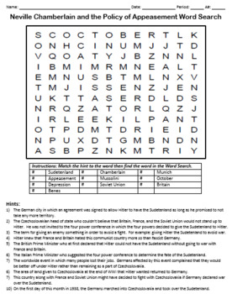

|  |  |  |  |  |  |
| --- | --- | --- | --- | --- | --- |
| 1 | Sudetenland | 2 | Chamberlain | 3 | Munich |
| 4 | Appeasement | 5 | Mussolini | 6 | October |
| 7 | Depression | 8 | Soviet Union | 9 | Britain |
| 10 | Benes |  |  |  |  |

**Lesson 44**

**Strand**: Time, Continuity and Change

**Sub Strand:** International Relations

**Learning Outcome**:

1. Discuss the invasion of Danzig

2. Discuss the reasons behind the Nazi-Soviet Pact

LESSON NOTES

POLAND and THE COMING OF WAR

DANZIG

|  |  |
| --- | --- |
| Free City of Danzig - Wikipedia | -In the early 1939, it was clear to Chamberlain that Hitler had lied on the 24th November, 1938.  -Hitler issued an order to his armed forces to prepare to occupy the free city of Danzig.  -Danzig was taken from Germany and placed under the Polish control under the Treaty of Versailles.  -When Hitler invaded Danzig, Britain and France pledged their support to Poland on 31st March, 1939. |

PACT OF STEEL (1939)

* Germany (Hitler) and Italy (Mussolini). The two Dictators in Europe
* It was a military alliance/ agreement between Germany and Italy.
* They promised to help each other if war broke out.

THE NAZI – SOVIET PACT

* In August 1939, Nazi Germany and Communist Russia signed a friendship on non – aggression pact.
* It was surprising when once mortal enemies promised not to make war on each

Other.

. 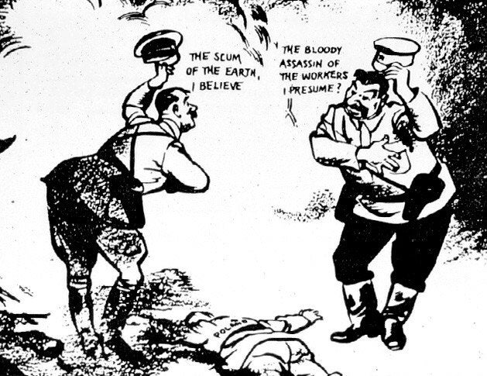

* The cartoon above shows the real reason for the Pact. Even though they are friendly towards each other. They are both hoping to get something out of this pact and that is the taking over of Poland. The dead person on the ground represents Poland. While they postures are exaggerated showing friendly gestures. They are both ready to pull out their guns on each other. (refer: <https://www.youtube.com/watch?v=DDnGk_rnCgY>)

**Activity**:

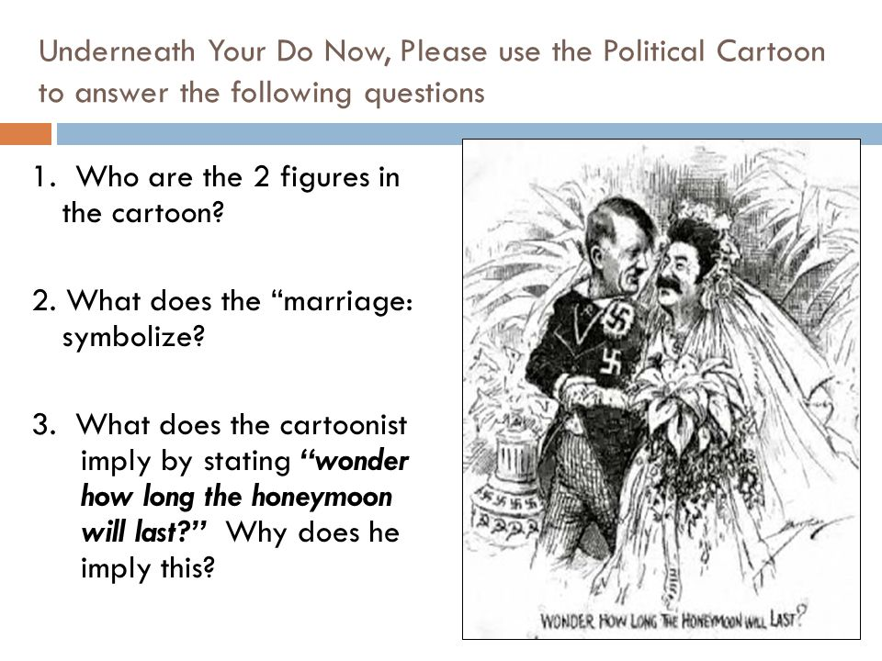

|  |  |
| --- | --- |
| The Eye-Opener of 1939: Or How The World Saw the Nazi-Soviet Pact ... | ) Identify the two countries that signed a non-aggression pact in 1939.  ii) State what Stalin thought Hitler’s goals were.  iii) State the reason for the guns behind their backs. |

**Lesson 45**

**Strand**: Time, Continuity and Change

**Sub Strand:** International Relations

**Learning Outcome**:

1. State the causes for the start of World War II

LESSON NOTES

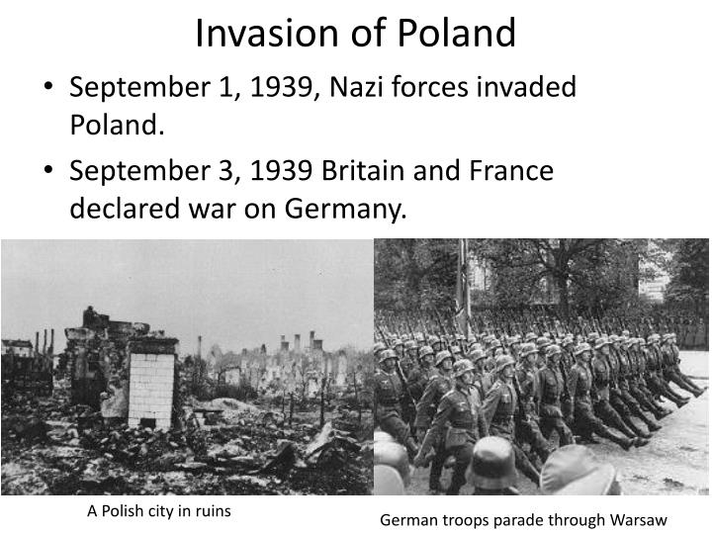

**CAUSES OF THE WAR**

* By mid-1941 of mainland Europe, except Portugal and Switzerland was in German hands.
* In June 1941, the Germans attacked Russia despite the Nazi – Soviet Pact.
* In December, 1941 the Japanese attacked the American Naval fleet in Pearl Harbour. USA joined the war and with their huge resources the chances of an allied defeat was less.
* On 7th May, 1945, the Germans surrendered.
* 3 months later, on 14th August 1945, the Japanese surrendered after the atomic bomb had been dropped at Hiroshima and Nagasaki.

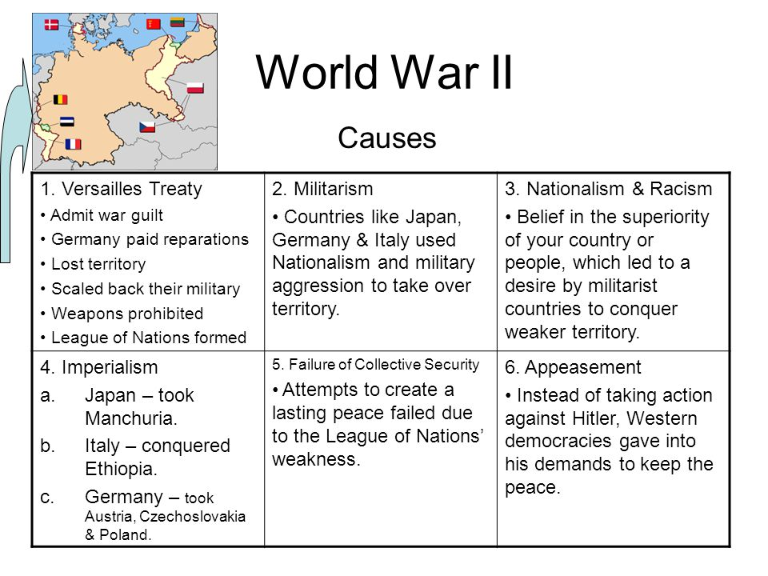

**When did the US enter the War?**

* USA entered the War in 1941.
* This was after the Japanese under the Command of Admiral Tojo bombed / attacked Pearl Harbour – an American Naval Base in Hawaii.
* The Japanese used Kamikazes (suicide pilots who were used during the operations) to destroy the American Naval fleets berthed at Pearl Harbour.

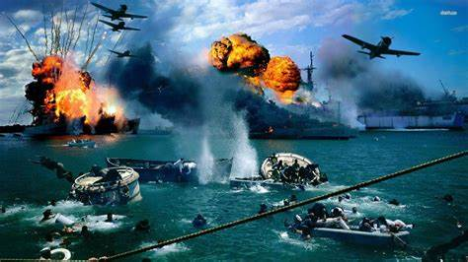

**Activity:**

**World War II TIMELINE**

**Directions:** Correctly label the year each event occurred.

____________ Treaty of Versailles dealing with Germany signed

___________League of Nations founded

___________Dawes Plan to stabilize Germanys economy

___________Kellogg – Briand Pact agreed never to use war to settle disputes

___________ The Young Plan help reduce Germany’s reparation

___________The Great Depression

___________Japan invade Manchuria

__________Hitler named Chancellor of Germany

___________Germany Re Arms , Hitler announced their new ‘Luftwaffe’

___________The Stressa Front

___________ Abyssinian Crisis

___________Germany takes over The Saar

___________Re-Occupation of Rhineland

__________Rome – Berlin Axis

__________Anschluss with Austria

__________Spanish Civil War

__________Germany takes over Sudetenland

__________The Munich Agreement

_________Hitler invaded Danzig

_________Nazi – Soviet Pact

_________Germany invades Poland

_________Britain and France declare war on Germany/START OF WORLD WAR II