YEAR 12

HISTORY

HOME LEARNING KIT

WEEK 3

|  |  |
| --- | --- |
| See the source image | See the source image |
| See the source image | See the source image |

|  |  |
| --- | --- |
| NAME |  |
| LEVEL |  |
| S/ID |  |

**Lesson 31**

**Strand**: Time, Continuity and Change

**Sub Strand:** International Relations

**Learning Outcome**:

1. Discuss Hitler’s Policies

LESSON NOTES

**HITLER’S ECONOMIC POLICY**

**Three main aims**:

1. To cut unemployment by adopting a policy of massive spending and providing jobs for the people especially in public works.

2. To rearm Germany and prepare her for war. Employment provided for making weapons.

3. “***Autarky***” – economic self-sufficiency. No Import. Make their own. Encouraged businessmen, workers and farmers to solve the need of the State.

**HITLER’S FOREIGN POLICY (Weltpolitik)**

In 1923 he attempted a coup and was sent to Prison for five years. In 1925, he wrote a book “ Mein Kampf” in prison whereby he outlined his foreign policies.

Through his foreign policy, Hitler planned to:

1. **WELTPOLITIK** – means Domination. Make Germany great again, by becoming the number one power in Europe. World domination for Germans.

2. **GROSDERITSCH** - Unite all Germans in Central Europe under his rule in an enlarged Germany

3. **LEBENSRAUM** – means living space. Conquer land in the east to provide living space by subduing “inferior “people such as the Poles and Russians. Overthrow the Treaty of Versailles and recover the land lost during World War 1.

4. **HERRENVOLK** – means master race (Aryan Race). Believed that Germans were the superior race/ people. Also he developed the anti – Semitic feelings – the extreme hatred towards Jews / opposition or hostility towards Jews.

* He claimed that Jews as racially inferior and immoral, disloyal people who caused Germany to lose WW1.
* He promised to Germany from corruption of Jews.
* Hitler banned Jews from holding Government offices or working as teachers or to be farmers.
* German citizenship was taken away from Jews.
* He decided the “ final solution” to the Jewish problem – that is all Jewish men, women and children were to be killed.
* This became known as HOLOCAUST – the wholesale destruction of life or Genocide – the extermination of a racial group.

**The Collapse of the Collective Security in the 1930s and Hitler’s contribution towards WW2.**

* The decade of the 1920s had seen great efforts to keep peace. However, in the 1930s saw one act of aggression after another, accompanied by the remaining of Europe, until the war was bound to happen.
* From 1930 -1939 many events unfolded. It was time of violent events that eventually led to WW2.

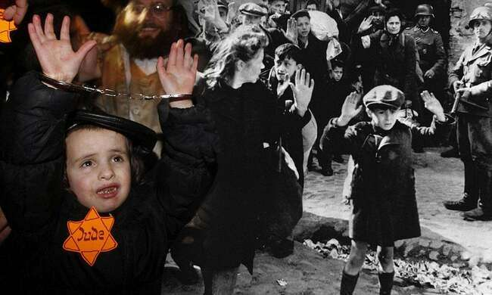

The above resource depicts holocaust – the wholesale destruction of life/ the extermination of a particular race. The mass killing of Jewish people took place during Holocaust. Hitler adopted the policy of extermination of Jewish people from Germany and Europe. More than 6 million Jews lost their lives.

**Activity:**

1. Define *Lebensraum* and state how Hitler planned to achieve this.

2. Define *Autarky* and state how Hitler planned to achieve this.

3. State how Hitler planned to overthrow the Treaty of Versailles.

4.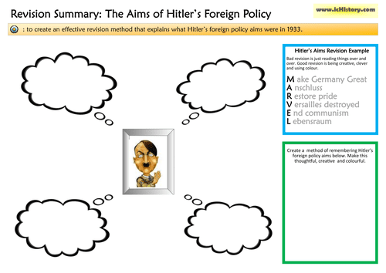

5. State **three** strategies adopted by Hitler in trying to solve Germany’s problems.

6. Discuss Hitler’s Autarky policy to help solve Germany’s problem.

7. Discuss Hitler’s Weltpolitik policy to help solve Germany’s problem.

**Lesson 32**

**Strand**: Time, Continuity and Change

**Sub Strand:** International Relations

**Learning Outcome**:

1. Discuss the reasons for the failure of the League of Nations

LESSON NOTES

|  |  |
| --- | --- |
| **The failure of the League of Nations**   * Signed in 1920. It was unable to solve the problems arising from Great Depression that gave rise to extremists and nationalist. | **Reasons for the failure of the League of Nations**   1. USA was not a member of the LONs and it weakened the LONs by signing treaties outside of the League undermining its authority. 2. Countries joined the League and left as they wished or as it pleased them. **Examples include**:  * Russia joined very late (in 1934) and was expelled in 1939 for attacking England. * Germany joined in 1926 but withdrew in 1935 after Hitler became the leader and after the failure of the Disarmament policy. * Italy joined in 1920 but withdrew in 1937 after the Abyssinian Crisis. * Japan joined in 1920 but withdrew in 1933 after invading Manchuria.  1. The burden of the LONs fell on Britain and France. They were unwilling and unable to carry the burden. 2. The LONs had no military force to enforce its decision. 3. The LONs was unable to stop aggression shown by major powers. 4. It failed to uphold its disarmament policy. Disarmament is a reduction in the arms, weapons and naval ships (Germany started to rearm herself once again) |
| **The Collapse of Collective Security in the 1930s** | The failure of the LONs to stop aggression was a contributing factor towards WW2. |

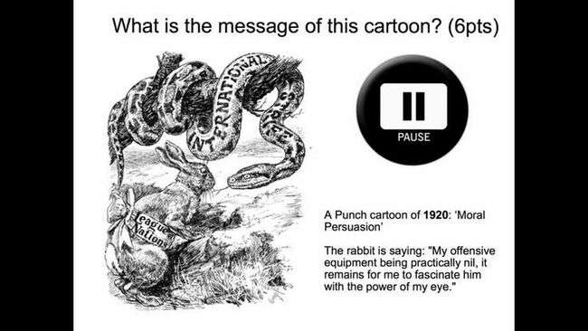

The above cartoon satirizes the perceived weaknesses of the League of nations. The rabbit represents the LONs and the snake represents the international serpent or international conflicts. The LONs was unable to solve major conflicts involving Japan, Italy and Germany.

**Activity:**

In your own words analyze the cartoon below.

|  |
| --- |
| See the source image |

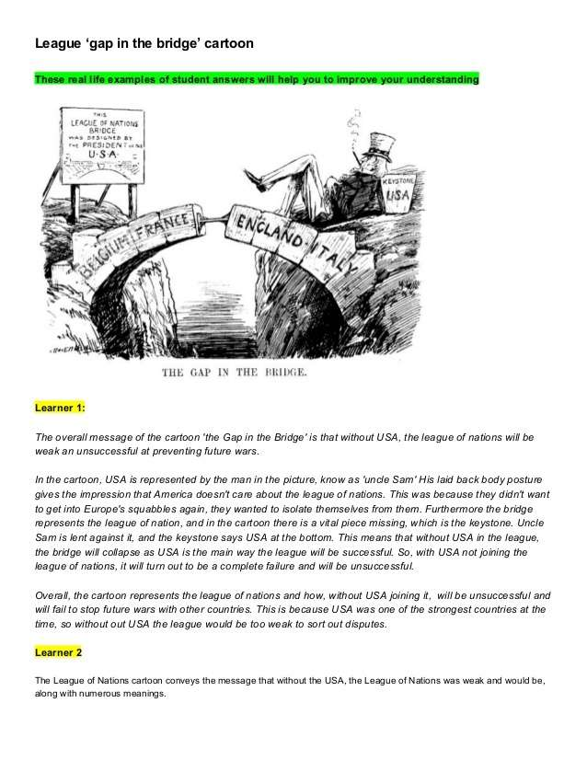

**Lesson 33**

**Strand**: Time, Continuity and Change

**Sub Strand:** International Relations

**Learning Outcome**:

1. Discuss the result of the Great Depression on Japan

LESSON NOTES

* Japan was hit hard by the Depression
* Export price for her vital silk fell by 50% and by 1931, half of the factories closed
* Among the people there were widespread unrest and this spread to the army.
* Most of the army felt that the answer to the depression was a strong government at home and expansion overseas. Japan was pursuing its policy to extend its Empire.

1. **The Invasion of Manchuria – 1931**

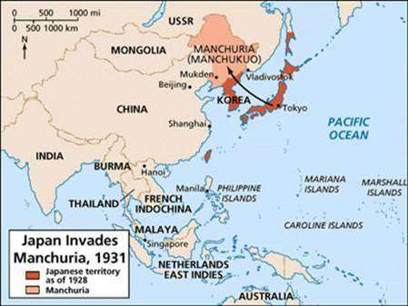

* The ideal target was China. Japan invaded Manchuria to get the raw materials and provide a location for population resettlement.
* Japan already owned industries in the Northern Province of Manchuria

**What did the League do?**

Most countries were horrified at what Japan had done. China asked the League of Nations for help.

The League:

* Condemned Japan’s actions and ordered the withdrawal of Japanese troops.
* The Japanese government agreed but their army refused.
* Appointed the Lytton Commission to investigate the crisis. This took over a year to report, by which time the invasion and occupation was complete.
* It instructed all its members not to recognize Manchukuo and invited Japan to hand Manchuria back to China.

*#Manchuria was renamed Manchukuo by the Japanese.*

The Japanese government kept Manchuria and then left the League in 1933. The League did not stop Japanese aggression. Japan went on to occupy other cities.

**Why did the League fail?**

The League failed for several reasons:

1. Members were unwilling to impose economic sanctions on Japan because the Depression had already damaged world trade.

2. The Great Powers were unwilling to take military action. Britain feared Japanese attacks on its colonies in the Far East.

3. The USA was the most powerful country with interest in the Far East was not prepared to take any further action.

**Results of the Crisis**

1. This was the first major failure of the League. It showed that it was weak in the face of great power.

2. The world learnt that it paid to be aggressive. It encouraged other acts of aggression such as Italy in Abyssinia.

3. Japan continued its aggression. It took over more provinces in North China.

4. The Japanese withdrew from the League and eventually drew closer to dictators such Mussolini and Hitler.

**Activity:**

**1. Resource Interpretation**



i) Name the countries represented by the **two** characters depicted in the

resource.

ii) Explain why the League of Nations was not able to help the figure on

the left.

2. State the year the Manchurian crisis occurred and mention a reason

why Japan invaded Manchuria.

**Lesson 34**

**Strand**: Time, Continuity and Change

**Sub Strand:** International Relations

**Learning Outcome**:

1. Discuss the Abyssinian Crisis.

LESSON NOTES

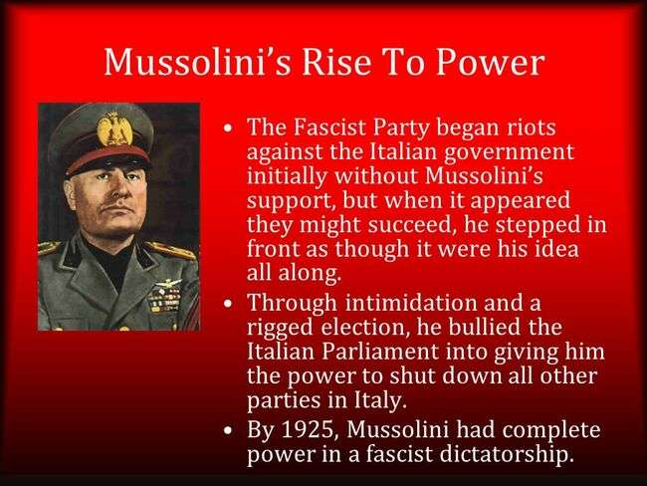

1. **THE ABYSSINIAN CRISIS -1935**

Italy invaded Abyssinia (Present Day Ethiopia), the only independent nation in Africa. The King of Ethiopia asked for the Leagues help.

1. Since Mussolini of Italy came into power in 1925, he planned to create a large Italian overseas Empire.

2. Already there were 3 Italian colonies North of Africa; Libya, Eritea and Somalia.

3. Abyssinian was a weak and backward neighbour that was easily overun by Italy.

**What did the LONs do?**

* Declared Mussolini as an aggressor.
* Decided to impose sanctions on Italy (weapons sale to Italy was prohibited)
* Decided to give part of Abyssinia to Italy ( this was done in secret under the so called Hoare and Laval Plan) in return to stop fighting.
* However this plan was later dropped.

**How did the League of Nations fail?**

* Mussolini invaded whole of Abyssinia and withdrew from the LONs.
* The sanctions did not work.
* The LONs was unable to stop aggression shown by Italy.

It appeared that acts of aggression would go unchecked. ( Hitler was givena free hand in Europe)

|  |  |
| --- | --- |
| See the source image | The cartoon depicts the defiance of the LONs by Italy. The centre character depicts Mussolini the leader of Italy. The lady represents LONs, Great Britain and France make no effort to stop Italy’s aggression in Abyssinia. |

**Activity:**

1. Musolinni was a leader in the Fascist Party. Define Fascism.

2. State the year Musolinni came into power in Italy.

3. Explain the cause of the **Abyssinian Crisis**.

**Resource Interpretation**



(i) Identify **two** of the characters represented as Goliath in the resource

above.

(ii) State a characteristic that all three individuals represented as Goliath

have in common.

(iii) Explain the significance of the aeroplane held by the figure in the far

left of the resource.

**Lesson 35**

**Strand**: Time, Continuity and Change

**Sub Strand:** International Relations

**Learning Outcome**1. Discuss the Spanish Civil War and the reaction of the LONs.

LESSON NOTES

3. **The Spanish Civil War (1936)**

In 1936 the Spanish army led by General Franco, attempted to overthrow the Spain’s Republican Government. General Franco was supported by both Italy and Germany. The government asked the LONs for help.

|  |  |  |
| --- | --- | --- |
| **Cause** | **Reaction of the LONs** | **How did the LONs fail? / Outcome** |
| To overthrow a democratic government and establish an authoritarian government/ military government.  The failure of the Spanish Government to overcome its economic problems. | Adopted a policy of non – intervention. It believed that the Civil War was an internal dispute. | LONs failed to intervene and stop the rebellious act against an elected government.  Germany got an opportunity to test its weapons and strength of its army during the civil war. |

**Activity:**

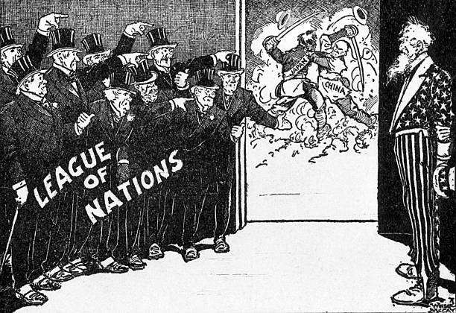

1. Outline what is being depicted about the League of Nations.
2. Name the country represented in the star suit on the right of the resource.
3. Explain a reason why the figure that you have identified in (viii) stands alone.