YEAR 12
HISTORY
HOME LEARNING KIT
WEEK 2
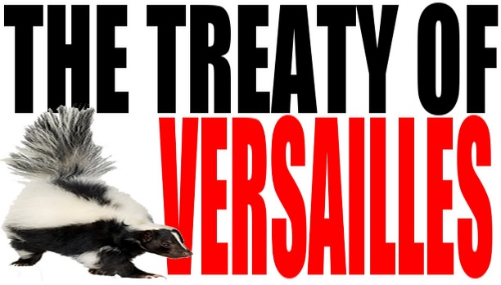 | 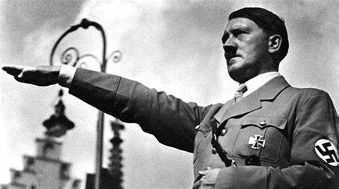
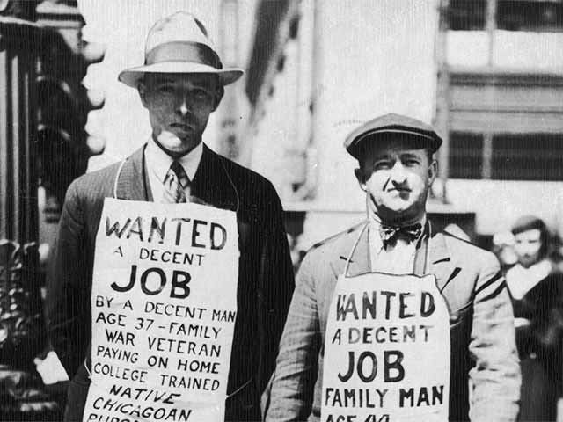

NAME
LEVEL
S/ID

Lesson 26
Strand: Time, Continuity and Change
Sub Strand: International Relations
Learning Outcome: 1. Explain what happened during the Great Depression
LESSON NOTES
THE GREAT DEPRESSION 1930
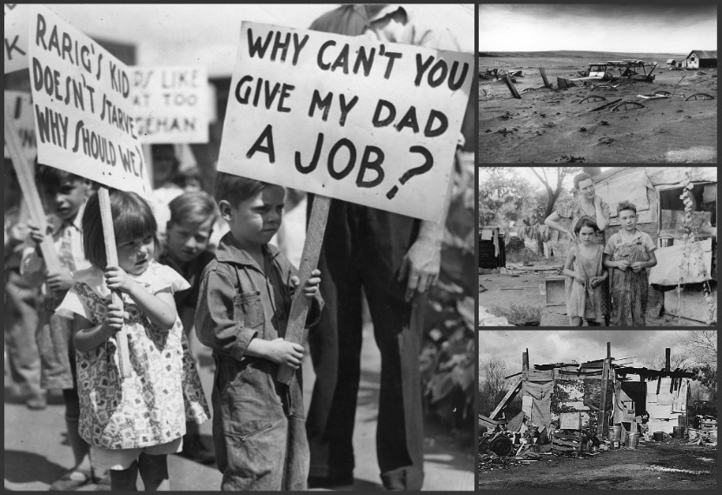 | -Lasted from 1929 to 1939  -worst economic downturn in history of the industrialized world.  -Living standards fell  -businesses closed  -unemployment was on the rise. 15 million Americans were unemployed.  -consumer spending dropped  -investment dropped  -nearly half the banks closed
End of the Economic Boom
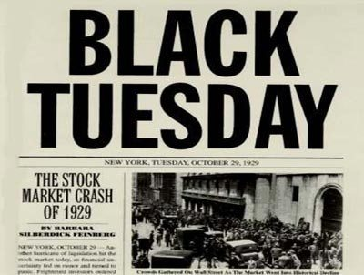 | In October, 1929 the American Stock market crashed in what is called the WALL STREET CRASH.

- America lost confidence
- America called on the European Countries to pay back their loans. It resulted in the collapse of large European banks
- Losses meant people had little to spend
- Businesses were not able to sell their goods and so had to cut production
- Many firms closed
- Unemployment rose
- People felt threatened and insecure
- People were ready to listen to anyone who would offer a solution
Activity:
1. Explain a cause of the Great Depression.
2. State the year WALL STREET CRASHED.
3. Discuss how the stock market crash led to high rates of unemployment.
4. State reasons why people felt threatened and insecure.
Lesson 27
Strand: Time, Continuity and Change
Sub Strand: International Relations
Learning Outcome:
1. Discuss the causes and effects of the Great Depression
LESSON NOTES
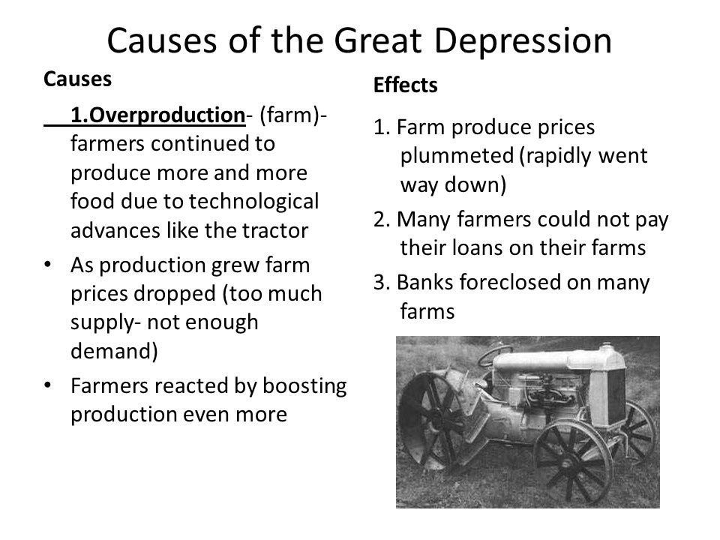
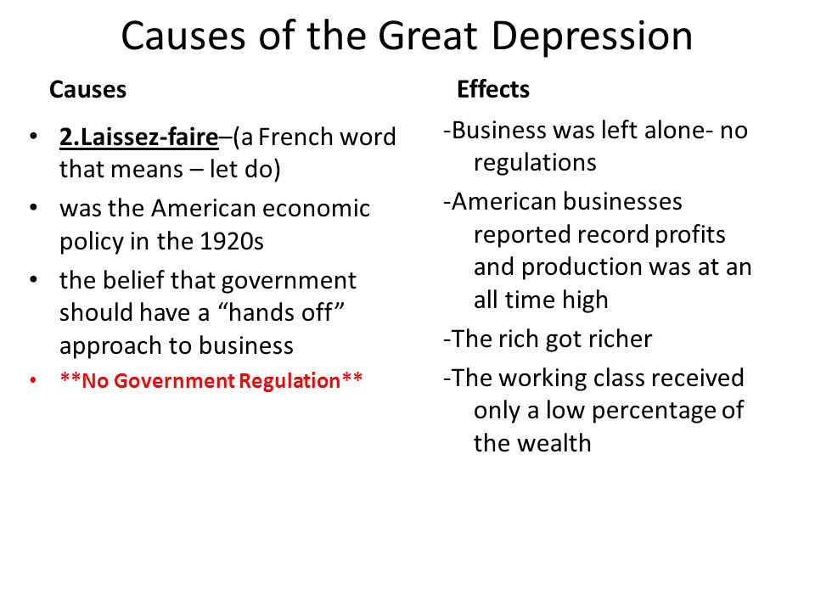
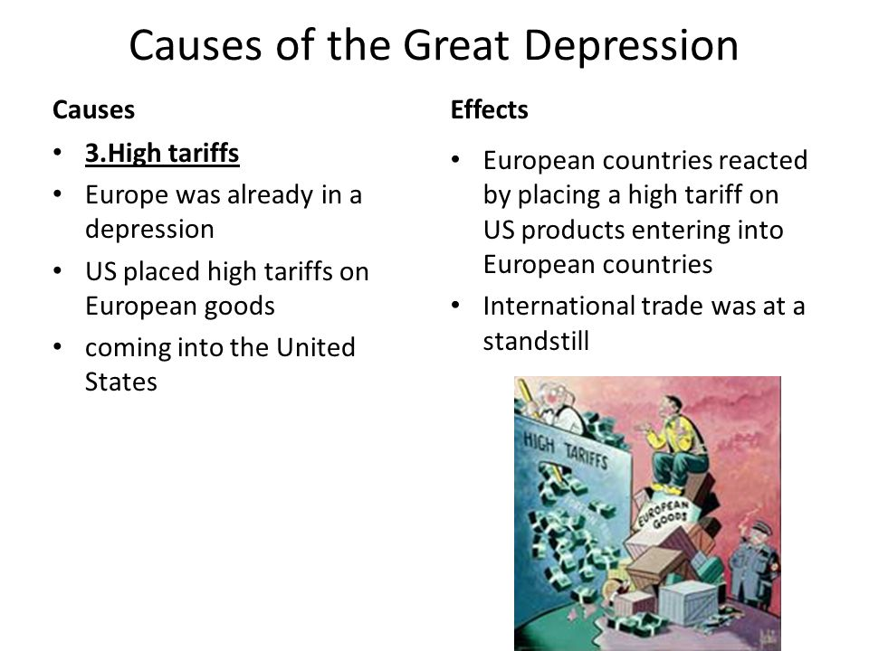

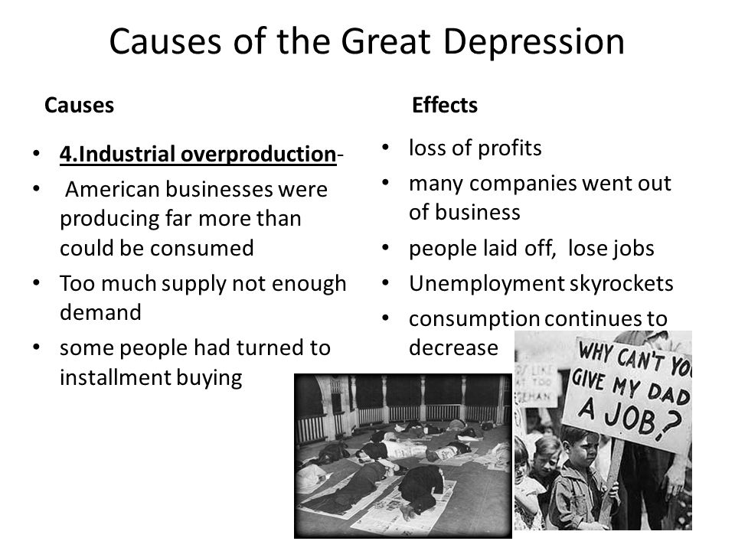
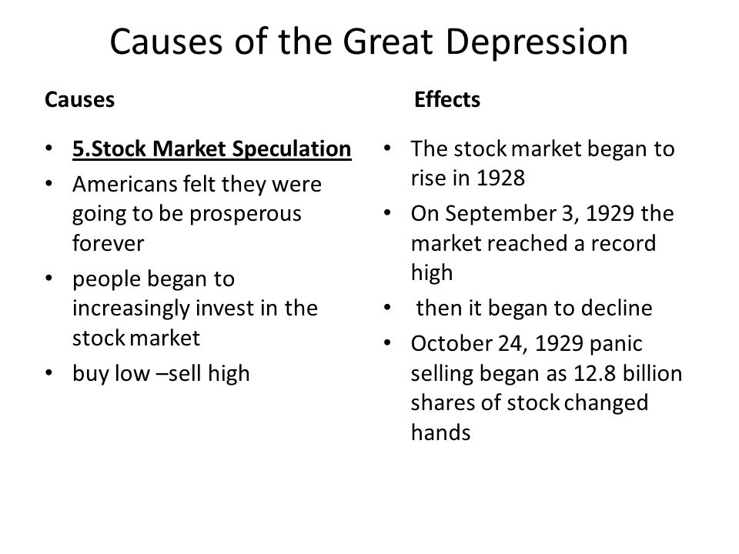
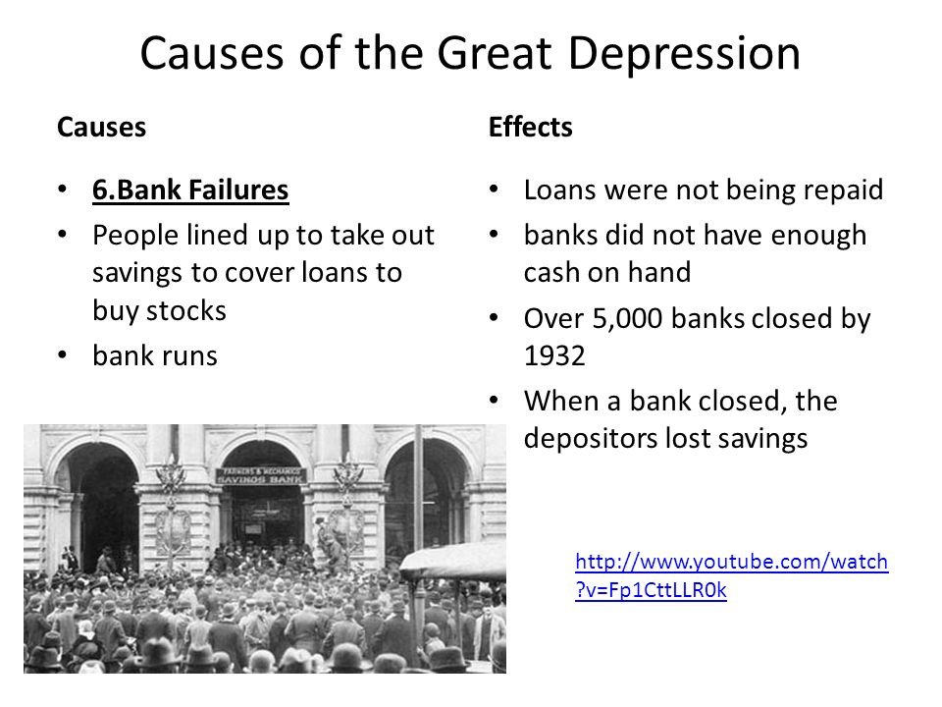
Activity:
1. Explain two causes of the Great Depression.
2. Discuss two effects of the Great Depression on the economy.
3. Discuss the effect of the Great Depression on the working people.
4. Describe how the Great Depression worked against peace effort.
5. State the year the Great Depression began and mention a social impact.
6. Describe how the Great Depression affected the work of the League of Nations.
7. Describe one effect of the Great Depression on the world economy.
8. Explain one reason why government planning during the Great Depression
increased tension between countries.

Lesson 28
Strand: Time, Continuity and Change
Sub Strand: International Relations
Learning Outcome:
1. Discuss the result of the Great Depression on Germany.
2. Discuss the Rise of Hitler
LESSON NOTES
THE RISE OF HITLER
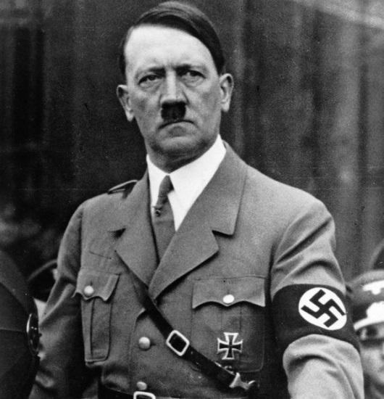 | - Adolf Hitler was born in 1889 in Branach, Juna, Austria.  - Nicknamed – “Der Fuhrer”(The Leader)  - He was good in arts and history.  - He volunteered for the German army in 1914  - After the war Hitler joined the small right wing German Workers Party.  - In 1920, the party was renamed the National Socialist German Workers or Nazi – Pact.  - In 1921, Hitler became the party leader.  - He wanted to overthrow the Weimar Republic and make Germany great again.  - He was a great speaker.

The SchutzStaffel or SS was formed in April 1925 as a section of the SA and functioned as a personal bodyguard for the NSDAP leader, Adolf Hitler.
The SS was considered to be an elite force and membership was restricted to those who were pure Aryan Germans.
In 1933, Hitler decided that the time was right to seize powers.
Germany was suffering runaway inflation and thousands of Germans were hungry.
He and his followers tried to overthrow the Barorian State in Munich which was known as the Munich Putch (coup). This was a failure.

Activity:
1. State the year Adolf Hitler was born.
2. Name the small right political party Hitler joined.
3. Name the political party Hitler became leader of in 1921.
4. Research and discuss what is Weimar Republic.

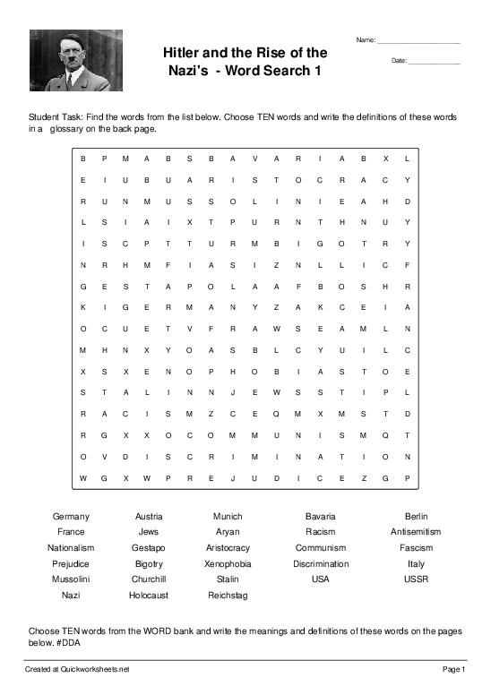
Lesson 29
Strand: Time, Continuity and Change
Sub Strand: International Relations
Learning Outcome:
1. Discuss the main points in Hitler’s book and the views he attacked
LESSON NOTES

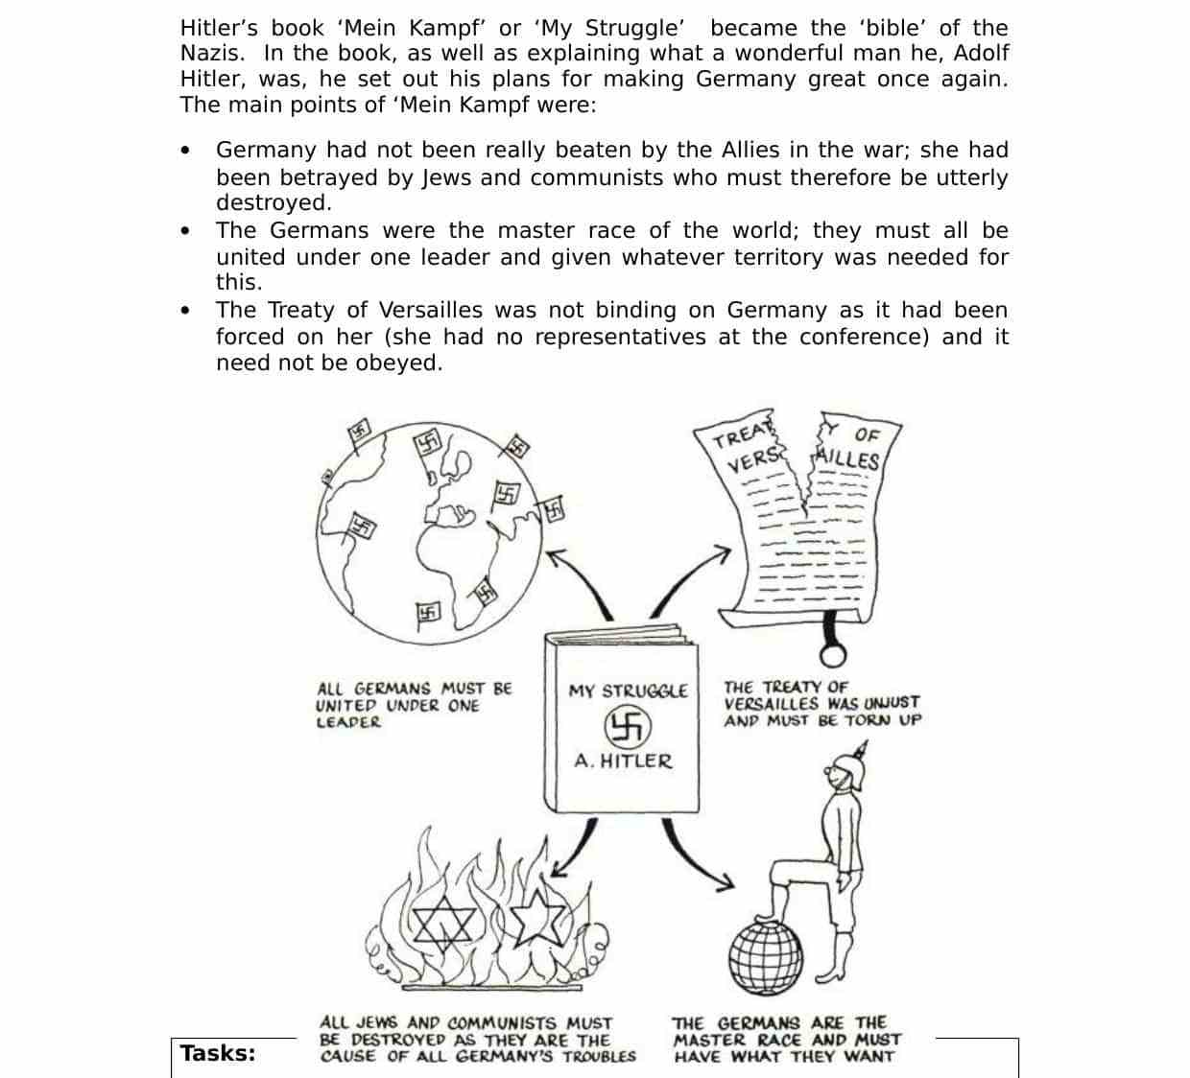
Activity:
1. Why does Hitler write “Mein Kampf”

Lesson 30
Strand: Time, Continuity and Change
Sub Strand: International Relations
Learning Outcome:
1. Discuss the rise of Hitler as a result of the Depression
LESSON NOTES
Depression and the Rise of Hitler
- The Great Depression caused unemployment, hunger and unhappiness throughout Europe, particularly in Germany, where unemployment rose from 0.9 million in 1924 to 5 million in 1932.
- The failure of several German governments to deal with depression increased the popularity of the Nationalist Socialist Workers Party (Nazi Party) and gave rise to Hitler.
Effect on Germany | - Massive Unemployment  - High Inflation rate (Germany currency became valueless)  - Many industries closed, thus the German economy collapsed.
Rise of Hitler  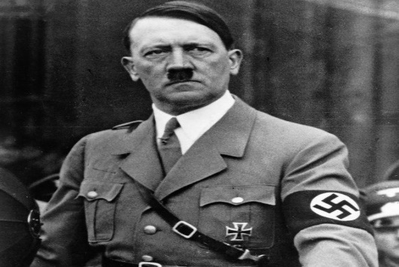  Hitler became the Dictator of Germany | Note: The Germans wanted a strong leader, one who could solve their problems and return the country to strength and wealth.  - Hitler saw this as an opportune time to gain power.  - Hitler travelled all over Germany to convince people that he was the person who could lead Germany out if the Great Depression.  - He promised people of economic activity.  - He promised middle class people with employment.  - Hitler was able to gain more power when the full impact of Depression was felt on Germans.
Hitler Gains Power | - Discontented workers and middle class voted for the Nazi Party. Nazi Party became the second largest Party in the REICHSTAG (is the name of the German parliament established by the Weimar constitution of 1920.  - In January 1933 President Von Hindenburg appointed Hitler as Chancellor (equivalent to PM)  - He became a TOTALITARIAN RULER in 1934 after the death of Von Hindenburg. He declared himself as the der fuhrer (leader) who would bring THIRD REICH to the world. (Third Reich was the Third Empire of Gemans)
