HISTORY - YEAR 12 - WEEK 1
Lesson:20
Strand: Time, Continuity and Change
Sub Strand: International Relations (Origins of WW2)
Learning Outcome: Discuss the other Peace Treaties.
LESSON NOTES
THE OTHER PEACE TREATIES THAT WERE SIGNED WITH THE CENTRAL POWERS.
TREATY | PROVISIONS
- Treaty of St. Germain with Austria (1919) | -Austria was prohibited to enter into a union (Anschluss) with Germany. (It became a separate country)  -Hungary became independent. It got separated from Austria.  -Austria was to pay reparations (was unable to pay since its economy was weak)  -It was to reduce its army.
- Treaty of Trianon with Hungary (1920) | It was to:  -surrender its territories  -pay reparations  -remain an independent country  -reduce its army
- Treaty of Servres (1920) was replaced by the Treaty of Lausanne in 1922 with Turkey | -It took away Turkish Territories in Europe  -The Turkish Empire was broken up
- Treaty of Neuilly (1919) with Bulgaria. | -To pay reparations  -To limit its army  -Give away its territories

Territorial Changes in Europe after the Peace Treaties
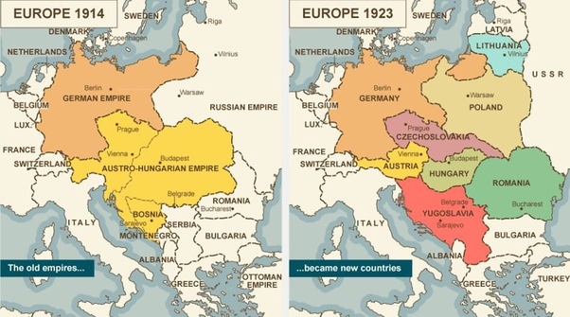
Lesson:21
Strand: Time, Continuity and Change
Sub Strand: International Relations (Origins of WW2)
Learning Outcome: Discuss the Germans reaction to the Peace Treaty.
LESSON NOTES
German Reactions
Germans were horrified when they discovered the terms of the Treaty of Versailles.
They called the Treaty the “DIKTAT” or Dictated Peace. They were upset for several reasons:
- The territorial losses. Germans complained that the loss of seven million subjects and 13.5% of her territory was too harsh. In particular they resented the losses to Poland in the east. Germany was now split in two by the Polish Corridor.
- The Germans claimed that the Allies were trying to bankrupt Germany with their high reparations claims.
- The terms were worked out in secret and forced upon the Germans.
- All of Germany’s colonies were taken away from her but the Allies kept theirs.
- The Germans hated having to accept full blame for the war.
- Above all, Germans hated having to disarm because this left the country defenceless against neighbouring states.

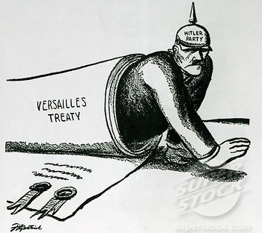 | Activity:  - Name two countries that were responsible for the formulation of the Treaty of Versailles.  - Explain the significance of the man crawling out of the Treaty of Versailles document as shown on the left.

Short Answers:
- State two ways Germany was affected from the military restriction
clause of the Treaty of Versailles.
- Mention one of the main terms of the Treaty of Versailles.
- State the year the Treaty of Versailles was signed and mention the
decision made during the Conference on Armaments.
- Explain why Germany was harshly punished by the Paris Peace Conference.
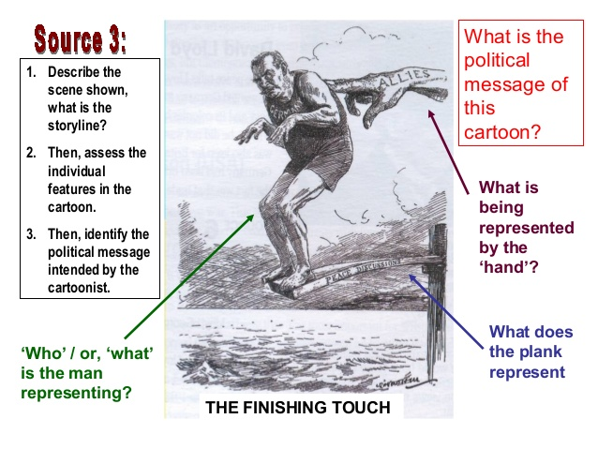
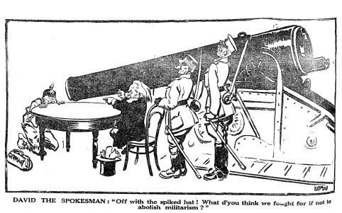
A
- State what A and B represents.
B
- Discuss what you think is happening in this cartoon.

Lesson:22
Strand: Time, Continuity and Change
Sub Strand: International Relations (Origins of WW2)
Learning Outcome: Discuss the search for Securities in the 1920s from Wilson’s 14 points.
LESSON NOTES
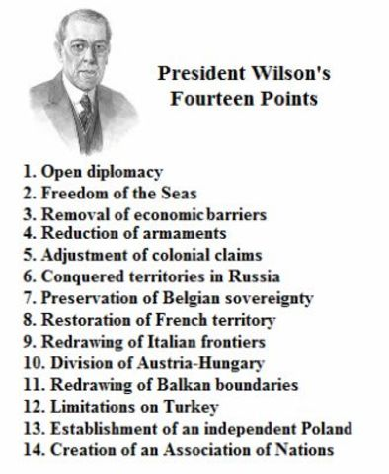
The Search for Securities in the 1920s
- Was referred to as the decade of peace for several reasons.
- After the war the Balance of Power was affected.
- Through 1920s a number of treaties were signed in an attempt to keep the peace (signing of treaties outside the League of Nations) USA undermined the League of Nations.
- However, the territorial changes had weakened the European powers like Germany and Austria.
- Unequal treaties gave rise to nationalists and extremists in countries like Germany.
- Too many new states were created that later led to many problems.
- United States emerged as a power. It became a superpower that was able to change the world order held by the European powers.

ACTIVITY: (Short Answers)

- Name the territory that was to be returned to France in the Fourteen Points.

- State the significance of demilitarising the Rhineland.

- State a factor that caused the imbalance of power in Europe after WWI.

- Outline the definition of reparations in relation to the Treaty that was
signed in 1919.

- Name one of the Great Powers that made up the Big Three during the Paris
Peace Conference.
Resource Interpretation
The Peace Settlement of the First World War
The peace settlement in Europe at the end of World War I was
achieved by the conclusion of treaties between the victorious allies
and each of the defeated nations. These treaties were negotiated and
signed in Paris during 1919 and 1920. The Treaty with Germany was
called the Treaty of Versailles. It was signed at the Palace of
Versailles just outside Paris in June 1919. This was the principal
settlement. It redrew the map of Europe and had far-reaching effects.
Source: Condon, C, “The Making of the Modern World”,
The Macmillan Company of Australia, 1987, p.177
- State how many years after World War I was the Treaty of Versailles signed and name the country where it was signed.

- Explain how the treaty caused the redrawing of the map of Europe.

Lesson:23
Strand: Time, Continuity and Change
Sub Strand: International Relations (Origins of WW2)
Learning Outcome: Discuss the formation of the League of Nations
LESSON NOTES
LEAGUE OF NATIONS  (1920) | -League of nations was formed at the Paris Peace Conference.  -The aim was to preserve peace and settle disputes. (Collective Security)  -The Covenant as signed by all member countries.  ROLE:  -Was to prevent future wars (maintain peace)  -Promote cooperation among nations economic and social areas to improve life for the peace of the world.  -To reduce arms  (Disarmament – reduction in arms, weapons, army and navy)  -Boarder disputes to be solved through negotiations and not by war.  -If fighting broke out, the member would be asked to punish the guilty party by cutting of all trade (Trade Sanctions)  -However, the problem laid with that three powerful countries were not part of League of Nations namely USA, Germany and Russia.

Activity: (Short Answers)
- State one purpose for the formation of the League of Nations and the year it
was formed.

- Define Disarmament.

- State what would happen if fighting broke out.
Lesson:24
Strand: Time, Continuity and Change
Sub Strand: International Relations (Origins of WW2)
Learning Outcome: Discuss the other ways treaties signed in the quest for security in the 1920s
LESSON NOTES
LÓrganisation de la Paix | -France formed a series of agreements with other European states namely Belgium, Poland and Yugoslavia  PURPOSE  -French security was increased with the construction of Maginot Line in 1927. The Maginot Line was a series of fortifications on the Franco – German Boarder.
Treaty of Rapallo (1920) | -Since Russia was excluded from the Paris Peace Conference because of its Communist Government, they signed an agreement with Germany  PURPOSE  -It made it possible for the secret construction of military equipment in Russian factories for the German military.
The Washington Treaties/ Naval Convention (1922) | Japan, Britain and USA signed this agreement.  PROVISION  -Establish a ratio (5:5:3) in the construction of naval warships, between the signatories (USA, Britain and Japan)  -To maintain an open door policy towards China (ensured that Chinese markets remained opened to all countries for trade).  -To settle disputes in the Pacific region through negotiations and not by war.  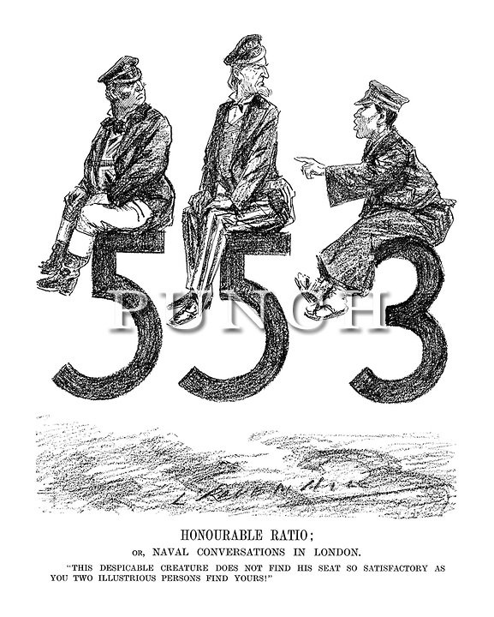  The above cartoon depicts one of the provisions under the Washington Treaties in 1922 that is to establish a ratio of 5:5:3 in the construction of naval warships between the signatories (USA, Britain and Japan). Also it shows that Japan was not happy with the ratio given to them on the construction of the naval warship and believed that they were treated unfairly by Britain and USA.

Lesson:25
Strand: Time, Continuity and Change
Sub Strand: International Relations (Origins of WW2)
Learning Outcome: Discuss the pacts that were made in the quest for security
LESSON NOTES
The Locarno Treaties (1925) | -Proposed by Austen Chamberlin (Foreign Minister of Great Britain), Aristide Brian (French Foreign Secretary) and Gustav Stresemann (German Foreign Minister)  -The treaties added to the growing good spirit of goodwill in Europe.  -It tried to bring about moral relaxation of tensions between nations.  Signatories:  Germany, Britain, France, Italy and Belgium  Provisions:  -Demilitarisation of Rhineland was confirmed. (Germany was not allowed to station their military in Rhineland)  -France and Germany guaranteed to recognise boarder between the two countries.  -Agreed never to go to war over boarder disputes.  -Germany accepted that changes to the boarders with Poland and Czechoslovakia would not take place by war, but by negotiations.  -Germany to join League of Nations.  -Britain to act as guarantor of the Treaties.
The Kellogg-Briand Pact (1928) | Kellog – US Secretary of State  Briand – French Foreign Secretary  Provisions:  -64 member nations vowed never to gp to war in the future. (It outlawed wars)  -Germany and Russia was also part of the Pact.
Dawes Report/Plan (1924) | Charles Dawes, An American Army General looked into German’s failure to meet reparation payments and examined its financial position.  Provisions:  -He recommended USA to give loan to Germany to help stabilise its economy and develop its industry and trade.  -Scale down reparation payments.  This was done in the hope that these would enable Germany’s currency to stabilize and reparations paid.
The Young Plan (1929) | Young was an American Banker.  The plan aimed to settle the remaining problems of reparations.  Provision:  -Reparation payment was reduced from 6600million pounds to 2000million pounds which was to be paid over the next 59years.
State the effects of the Dawes Report and the Young Plan:

-Both Plans ensured Germany to pay reparation
-It made already German economy to worsen
-Made German people suffer by paying reparations
Note: The period of hope and prosperity was short lived. When the US market crashed in October, 1929, the loans given (for instance to Germany) were recalled and the world was forced into what became known as the Great Depression. The USA stopped giving loans to Germany and made it more difficult for Germany to pay reparation.

Activity: Short Answers
- Explain a term of the Kellogg-Briand Pact of 1928.
- State two ways Germany benefited from the Dawes Plan.
- Explain a term of the Locarno Treaties of 1925.
- State the year the Young Plan was introduced and one of its terms.
- State one significance of the Dawes Report of 1924.

