STRAND: HEC 12.2
SUB STRAND HEC 12.2.6 FOOD PLANNING AND PRODUCT DEVELOPMENT
CLO: HEC 12 2.6.1 Recognize an ideal BMI and demonstrate skills of selecting, planning, preparing and serving meals
LESSON: 96
TYPES OF MENUS

i) 3 course - A full course dinner is a dinner consisting of multiple dishes, or courses. In its simplest form, it can consist of three or four courses, such as hors d'oeuvre, soup, entrée, main course and dessert.

a. A la carte – a list of food items each priced and served separately.
b. Table d’hote–a restaurant meal offered at a fixed price and with few if any choices
c. Cycle - A cycle menu is a series of menus planned for a particular period of time, for example 4 weeks. The menu varies for each day of the cycle. At the end of the cycle the menus are repeated.
d. Du Jour Menus – served in a restaurant as a special item on a particular day - Happening or popular at a particular time.

ii) TYPES OF SERVICE
a. Blue Plate
- a plate, often decorated with a blue willow pattern, divided by ridges into sections for holding apart several kinds of food.
- Also called blue plate special. A specially priced main course, as of meat and vegetables, listed as an item on a menu, especially in an inexpensive restaurant.

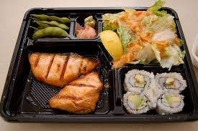

b. Silver service
- is a method of foodservice. This usually includes serving food at the table.
- It is a technique of transferring food from a service dish to the guest's plate from the left.
- It is performed by a waiter using service forks and spoons from the diner's left.
- Silver service food is always served from the left, drinks and plated meals from the right. Meals are served to the diner from platters, not plated in the kitchen.
- The guest to the host's right is served first. (Usually a female guest) Service continues anti-clockwise.
- Plates are cleared from the right, glasses from the right; again starting with the guest to the host's right. Glasses are stacked in a diagonal to the right and away, with wine (by course) in order, and then lastly, water glass in front.

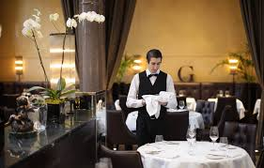
c. Counter Service
- food is served on the counter by counter service assistant in a café, restaurant or food out lets.
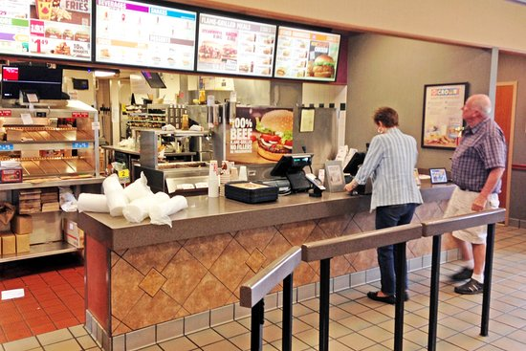

LESSON: 97

d. Guerdon Service
- is a form of food service provided by restaurants to their customers. This type of service encompasses preparing food (primarily salads, main dishes such as beef stroganoff, or desserts) in direct view of the guests, using a "guerdon".
- A guerdon typically consists of a trolley that is equipped to prepare, cook and serve food. There is a gas hob, chopping board, cutlery drawer, cold store (depending on the trolley type) and general working area.
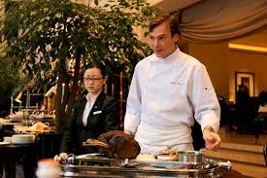
e. Carvery service
- A carvery is a restaurant where cooked meat is freshly sliced to order for customers, sometimes offering unlimited servings for a fixed price.
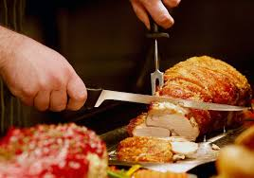

NAPKIN FOLDING
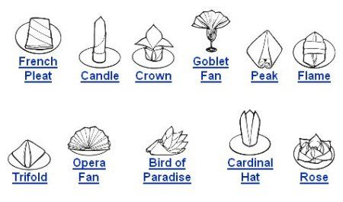

FOOD PLANNING AND PRODUCT DEVELOPMENT
LESSON: 98
Cooking Methods
Method of Cooking | Description | Rules for Cooking | Foods Suitable
Baking  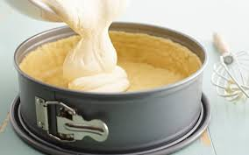 | Baking is a method of cooking food that uses prolonged, dry heat normally in an oven, but also in hot ashes or on hot stones. | Read your recipe carefully.  Use right ingredients and proper equipment. Measure the quantities correctly  Mix carefully. Spread batter evenly in pan; do not drop of knock pans to level. Use correct temperature | Chicken  Cake  Bread  Potatoes  Dalo  Palusami Etc.
Pastry Making  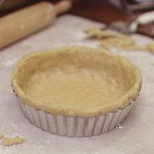 | Dough or paste consisting primarily of flour, water, shortening that is baked and used as a crust for foods such as pies and tarts. |  | Pies  Tarts  Pizza  Samosa  Spring rolls Etc.
Roasting  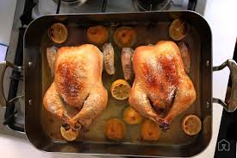 | Roasting is a cooking method that uses dry heat where hot air envelops the food, cooking it evenly on all sides from an open flame, oven or other heat source. It can enhance flavor through caramelization and maillard browning on the surface of the food. | Bring your roast 30mins before outing in the oven Always pat meat dry then season it with herb or as your desire. If it is red meat it is always wise to sear the entire surface in the pan first. Place the meat on a rack in the roasting that enables the hot air to circulate for an even roasting. | Red meat  Poultry Game  Pork Potatoes  Sweet potatoes  Parsnip  Carrots

Yeast cooking
Baker’s yeast is the common name for the strains of yeast commonly used as leavening agent in baking
bread and bakery products, where it converts the fermentable sugars present in the dough into carbon
dioxide and ethanol.
Tips for using yeast:
- Test the yeast before beginning. Dissolve 1 teaspoon of sugar in a 1/2 cup of warm water (110 to 115°F).
- In 3 to 4 minutes, the yeast should have absorbed enough liquid to activate and will come to the surface. If at the end of 10 minutes the yeast has multiplied to the 1-cup mark and has a rounded crown, it’s still very active and fresh and can be used in your recipe.
- . This process is sometimes referred to as proofing the yeast.
- Yeast is a living organism. If the liquid in which the dry yeast is dissolved is too hot, it will kill the yeast cells. If it’s too cold, the yeast will remain dormant and won’t raise the dough.
- Use very warm liquid (120 to 130°F) if the active dry yeast will be added to dry ingredients. If it’s to be added to liquid ingredients, use warm liquid (110 to 115°F).
- Place dough in a warm spot to rise. Yeast dough rises, or “proofs,” best when the temperature is 80 to 85°F. To make sure the dough is warm enough:
- Cover the bowl loosely with plastic wrap and/or a cloth towel. Place the bowl on a wire rack over a pan of hot water in a draft-free spot.
- OR place the bowl on the top rack of an unheated oven. Put a pan of hot water on the rack below it or turn the oven on at 400°F for 1 minute, then turn it off. Place the bowl on the center rack of the oven and close the door.
- Test the dough to make sure that it has risen sufficiently. When you think the dough has doubled in size, lightly poke two fingers about a 1/2 inch into the dough. If the indentations remain, the dough has risen enough.
LESSON: 99

Herbs and spices
BUYING, STORAGE, AND USAGE TIPS
- buy only what will fit into an average-size spice jar. In other words, don’t stock up.
- Most go a very long way and are at their optimal flavor for up to a year, after which they begin losing their potency.
- Keep dried herbs and spices in a place in your kitchen that is away from heat and moisture.
- When substituting fresh herbs for dry, use about three times the amount of fresh herb as the dry.
- Introduce dried herbs and spices into your recipe as early in the cooking process as possible, so that they have a chance to develop flavor.
- Add fresh herbs toward the middle or even the end of the cooking if you’d like to retain their pronounced flavor.
CULINARY SKILLS
Culinary Skills/ illustration | Description
Weighing/ measuring | Specific quantity of food that is determined by weighing or measuring using scale or spoons and cups.
Decorating  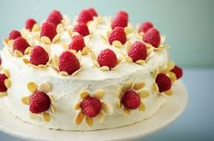 | Making food more attractive by using different colored ingredients.
Glazing  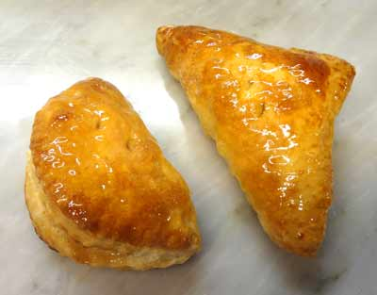 | To brush the surface of sweet or savory dishes to give a glossy surface or to assist in browning.
Greasing | Applying butter, ghee, oil or margarine on baking trays or tins.
Creaming  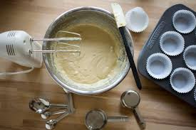 | Combining butter and sugar until light and fluffy.
Coating and Binding  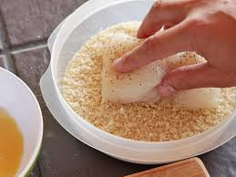 | To cover food with another ingredient or ingredients, for example, egg and breadcrumbs
Dusting  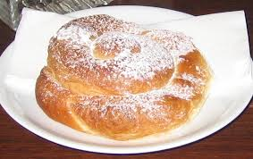 | Lightly sprinkling a fine layer of powdered or granulated ingredient of food e.g. sprinkling sugar on dough nuts.
Kneading  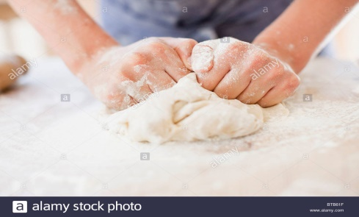 | To and press dough into a uniform mixture using palms and fingers.

FOOD PLANNING AND PRODUCT DEVELOPMENT
LESSON: 100

Proving  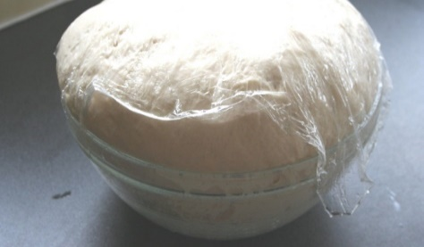 | It refers to a specific rest period within the more generalized process known as fermentation. Fermentation is a step in creating yeast breads and baked goods where the yeast is allowed to leaven the dough.
Rolling  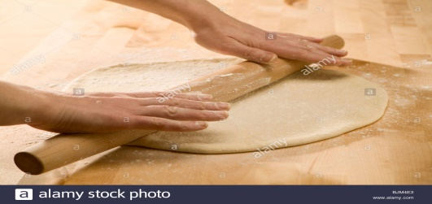 | To flatten dough using a rolling pin while making roti or any form of pastry.
Basting  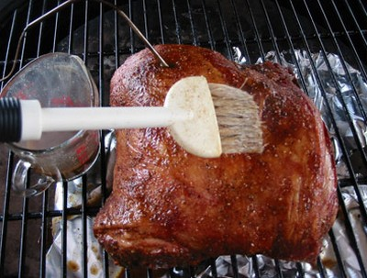 | Basting a technique for moistening the surface of roasting meat, roasted chicken or other roasted items, with pan drippings, stock, butter or some other liquid. In addition to preserving moisture, basting adds flavor to the surface of the meat.
Caramelize  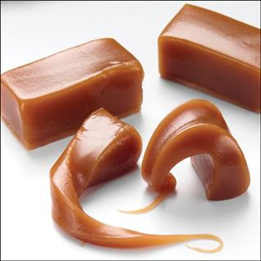 | caramelisation or caramelization) is the browning of sugar, a process used extensively in cooking for the resulting nutty flavor and brown color. As the process occurs, volatile chemicals are released, producing the characteristic caramel flavor.

REVISION QUESTIONS
1. Explain the following cooking methods:
a. Baking b. Pastry making
c. Roasting d. Yeast cooking

2. Discuss the effects of the following culinary skills on food:
a. Greasing b. Creaming
c. Decorating d. Glazing

3. Describe the following types of meal service.
a. A la carte b. Du jour menus
c. Table d’ hôte

4. Discuss the following service:
a. Blue plate b. Silver
c. Guerdon

5. List and explain the factors that affect BMI in humans.

6. Discuss why males have higher BMI compared to females.

7. Explain the importance of proofing in baking.

8. Body mass index (BMI) is measure of body fat based on height and weight. Explain the consequence on the individual when a person’s BMI is:
- Higher then 30
- Lower than 18.5

9. Describe how the following factors affect BMI?
- Weight
- Gender

10. Identify and explain the one important culinary skills and a method of cooking that will be suitable for making the cinnamon roll.

11. Use the illustration given below to answer questions in (i).
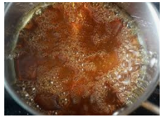
Concentrated sugar
Explain the cooking skill shown above.
12. Identify the type of napkin folding

- ii.
