**WEEK 6 YEAR 12 HOME ECONOMICS**

**STRAND: HEC 12.1 SUBSTRAND: HEC 12.2.3**

**CLO: HEC 12.2.3.1 Explore the utilization of micronutrients and the effects of malconsumption by**

**individuals.**

**DIET AND HEALTH**

**LESSON 81**

|  |  |  |  |
| --- | --- | --- | --- |
| DEFECIENCY DISEASES | EXPLANATION | NUTRIENT DEFECIENT | SYMPTOMS |
| RICKETS | Rickets is a childhood bones disorder. Osteomalacia or osteoporosis weakening of bones in adults. | Lack of Vitamin D  Not having enough calcium. | Soft spot on baby’s head is slow to close.  • Bony necklace.  • Curved bones.  • Big lumpy joints.  • Bowed legs (knees bent out) |
| NIGHT BLINDNESS AND KERATOMALACIA | A condition of the eye in which vision is normal in daylight or other strong light but is normally weak or completely lost at night or dim light. | The condition may result from deficiency of Vitamin A or hereditary factor called nyctalopia. | • Poor vision at night or in dim light. |
| BERIBERI | A deficiency disease which happens when the breakdown of pyruvic acid; a toxic by product of carbohydrate metabolism does not eventuate due lack of thiamine, | Deficiency of thiamine (vitamin B1). | • Transmission of impulses along nerves.  • Muscle wasting.  • Paralysis  • Death |
| Pellagra | A disease due to deficiency of niacin, a B complex vitamin. It is a disease of 4D’ S: Diarrhoea, depression, dementia, and death. | Deficiency of nicotinic acid | • Swollen red tongue.  • Diarrhoea  • Depression  • Dementia (madness)  • Dermatitis |
| SCURVY  Home Remedies for Scurvy, Causes, Symptoms | Is a disease caused by the diet which lacks vitamin C | Lack of vitamin C | • Sore  • Bleeding gums  • Loose teeth  • Fatigue  • Pains in the limbs |
| DENTAL CARIES  Dental caries, Shankar Dental Clinic, Cosmetic dentist in Ramnagar ... | Also known as tooth decay, cavities or caries. Is breakdown of teeth due to the activities of bacteria. The cavities may be in different colors such as yellow to black. | Is caused by the action of acids on the enamel surface. The acid is produced when sugars in foods or drinks react with bacteria present in the dental biofilm (plaque) on the tooth surface. The acid produced leads to a loss of calcium and phosphate from the enamel called demineralization. | • toothache  • tooth sensitivity – you may feel tenderness or pain when eating or drinking something hot, cold or sweet  • grey, brown or black spots appearing on your teeth  • bad breath  • an unpleasant taste in your mouth |
| ANEMIA  Anaemia Images, Stock Photos & Vectors | Shutterstock | Is a disease caused by shortage of hemoglobin, red cells in the blood.  . Frequent or heavy blood loss. (common in women) | Defective absorption of iron due to deficiency of Vitamin C and B12 or folic acid. Pernicious – more severe one and is caused by lack of chemical in gastric juice which is necessary for absorption of Vit. B 12 | Tiredness Restlessness Breathlessness  Lack of energy Headaches. |
| GOITER | Is a disease whereby there is an enlargement of the thyroid gland on the front and sides of the neck. | Lack of iodine | Problem of swallowing. Shortness of breath Hoarseness Wheezing sound (stridor) |

**DIET AND HEALTH**

**LESSON 82**

|  |  |  |  |
| --- | --- | --- | --- |
| Muscle Cramps  Muscle Cramps: Causes and Remedies Based on Latest Science | A muscle cramp is a strong, painful contraction or tightening of a muscle that comes on suddenly and lasts from a few seconds to several minutes. It often occurs in the legs. A muscle cramp is also called a charley horse. | • Exercising, injury or overuse of muscles.  • Pregnancy – decreased calcium, magnesium etc.  • Exposure to cold  • Medical conditions such as blood flow in the artery, kidney disease, thyroid, multiple sclerosis. • Standing for long on hard surface  • Not enough potassium, calcium etc. in blood.  • Taking certain medication like antipsychotics, birth control pills, steroids, diuretics and statins. | Sudden sharp pain  Severe discomfort  Leg swelling, redness & skin changes  Muscle weakness |
| Constipation/ hemorrhoids  Constipation feces in colon infographics Vector Image | Constipation is an acute or chronic condition in which bowel movement occurs less often than usual or consists of hard dry stools that are painful or difficult to pass. It is more common in women than men and especially apt to occur during pregnancy. Although this condition is rarely serious, it can lead to:  • Bowel obstruction  • Chronic constipation • Hemorrhoids • Hernia | Constipation usually result from:  • Not having enough exercise  • Not drinking plenty of water  • Not eating recommended amount of dietary fibre. There are other which may include fissure, kidney failure, colon cancer, depression, illness requiring complete bed rest and irritable bowel syndrome,hyperkalemia, hyperthyroidism | Feel bloated  • Headache  • Swollen abdomen  • Pass rock like feces; or strain  • Bleed  • Feel pain during bowel movement |
| Dehydration  Dehydration Stock Illustrations – 802 Dehydration Stock ... | A condition caused by excessive loss of water from the body, which causes a rise in blood sodium. | Excessive sweating  • Vomiting, diarrhea  • Water loss accompanied by a deficiency of electrolytes. | Increased thirst  • Dry mouth and swollen tongue  • Weakness & dizziness  • Palpitation (feeling that the is jumping)  • Confusion  • Sluggishness  • Fainting |
| Cancer | Is a disease cause by uncontrolled division of abnormal cells are formed in parts of the body Cancers are divided into groups according to the type of cell they start from. They include:  • Carcinomas  • Lymphomas  • Leukemia’s  • Brain tumors’  • Sarcomas | Most cancers start due to gene changes that happen over a person’s lifetime. • More rarely cancers start due to inherited faulty genes passed down in families. | Lump I breast – breast cancer.  • Coughing, chest pain and breathlessness.  • Changes in bowel. • Bleeding in urine, between periods, from back passage, when you cough, in vomit  • Unexplained weight loss. |

Fruits

It is any fleshy material covering a seed or seeds. Most fruits, from a horticultural (science of cultivating) perspective, are grown on a woody plant, with the exception of strawberries. Generally fruits are referred to as the edible part of the plant that contains the seeds. For example eggplant, tomato, cucumber and zucchini.

Vegetables

An herbaceous (green and leaf like in appearance or texture) plant cultivated for an edible part, as roots, stems, leaves or flowers.

Note : Both fruits and vegetables contribute a major part of the diet for others they are an accompaniment to meat, fish and poultry.

**DIET AND HEALTH**

**LESSON 83**

EFFECTS OF: HEAT, ACID AND ALKALI

|  |  |
| --- | --- |
| Heat | * Cellulose is somewhat softened upon cooking but appears indigestible for humans. * Upon boiling cellulose content is increased. * The pectic substances in the intracellular cementing material may be hydrolyzed to a certain extent so that there is some cell separation. * Gelatinization (swelling of starch grains upon heating in presence of water) of starch takes place. * Loss of vitamin B and C. * Change in color takes place |
| Acid | * Prevents softening. * Colour is enhanced * Browning on the broken, bruised or cut surfaces is prevented. |
| Alkali | * Sodium bicarbonate (baking soda) causes the hemicellulose to disintegrate, producing a soft texture in a short cooking period * Loss of Vitamin C * Oxidation (when oxygen combines and changes color/ appearance) of vitamins takes place particularly thiamine and vitamin C |

Oxidation Reaction and Enzymatic Browning

Why do some fruits and vegetables turn brown after you cut them?

* The cells of apples and other produce (e.g. pears, bananas, peaches, potatoes) containing enzyme (called polyphenol oxidase or tyrosinase) that, when contact with oxygen, catalyzes one step of the biochemical conversion of plant phenolic compounds to brown pigments known as melanin.
* Browning is seen when the fruit is cut or bruised because these actions damage the cells in the fruit, allowing oxygen in the air to react with the enzyme and other chemicals. This reaction is known as **enzymatic browning** and occurs at warm temperatures when the pH of the plant material is between 5.0 and 7.0.
* The reaction is sped up by the presence of iron (such as iron or rusted knife) or copper (such as copper bowl).
* The reaction of enzymatic browning can be slowed or prevented by inactivating the enzyme with heat (cooking), reducing the pH on the surface of the fruit (by adding lemon juice or another acid), reducing the reaction rate by storing the fruit in the refrigerator, reducing the amount of available oxygen (by putting cut fruit under water or in vacuum package), or by adding certain preservatives like sulfur dioxide.

Loss of nutrients in Preparation

* During preparation do not peel excessive skin because vegetable usually have valuable nutrients underneath the skin.
* Some vegetable discolor if prepared in advance unless covered with water.
* Cabbage shredded in advance losses vitamin C when it stands in room temperature for more than an hour.
* By use of sharp knife bruising is avoided thereby decreasing loss of vitamin.

FATS

Fats have many uses in food preparation and are important sources of energy in diet.

Uses

Fats are usually used in the following ways:

* Spreads – bread such as butter and margarine.
* Shortening – pastry such as lard and vegetable oil.
* Frying – deep and shallow frying such as lard, vegetable oil for deep frying and butter, margarine for shallow frying.
* Greasing – baking trays such as butter, ghee or any melted fat.
* Salad dressings – vegetable oil.
* Ice cream – vegetable oil.

Properties

* Fats are solid at room temperature and oils are liquid. This is due to the different in melting points because of type of fatty acids they contain.
* Generally the more saturated fatty acids a fat contains, the more solid it will be, and the more unsaturated fatty acids the more liquid it will be.

Rancidity

* It is the process of rancidity.
* Fats and oils, foods containing them, can develop ‘off’ flavors and odors due to the fat becoming rancid.
* Rancidity is caused by the action of enzyme lipase, or by oxidation. Lipase breaks down the fat molecules, and the ‘off’ flavors and odours develop because of the free fatty acids in the food.
* Heat can destroy both lipase and the micro – organisms in the food that produce lipase.

**DIET AND HEALTH**

**LESSON 84**

FRUITS AND VEGETABLES

Fruits

It is any fleshy material covering a seed or seeds. Most fruits, from a horticultural (science of cultivating)

perspective, are grown on a woody plant, with the exception of strawberries. Generally fruits are

referred to as the edible part of the plant that contains the seeds. For example eggplant, tomato,

cucumber and zucchini.

Vegetables

An herbaceous (green and leaf like in appearance or texture) plant cultivated for an edible part, as roots,

stems, leaves or flowers.

Note : Both fruits and vegetables contribute a major part of the diet for others they are an accompaniment

to meat, fish and poultry.

**EFFECTS OF: HEAT, ACID AND ALKALI**

|  |  |
| --- | --- |
| Heat | * Cellulose is somewhat softened upon cooking but appears indigestible for humans. * Upon boiling cellulose content is increased. * The pectic substances in the intracellular cementing material may be hydrolyzed to a certain extent so that there is some cell separation. * Gelatinization (swelling of starch grains upon heating in presence of water) of starch takes place. * Loss of vitamin B and C. * Change in color takes place |
| Acid | * Prevents softening. * Colour is enhanced * Browning on the broken, bruised or cut surfaces is prevented. |
| Alkali | * Sodium bicarbonate (baking soda) causes the hemicellulose to disintegrate, producing a soft texture in a short cooking period * Loss of Vitamin C * Oxidation (when oxygen combines and changes color/ appearance) of vitamins takes place particularly thiamine and vitamin C |

**LESSON 85**

**Oxidation Reaction and Enzymatic Browning**

Why do some fruits and vegetables turn brown after you cut them?

* The cells of apples and other produce (e.g. pears, bananas, peaches, potatoes) containing enzyme (called polyphenol oxidase or tyrosinase) that, when contact with oxygen, catalyzes one step of the biochemical conversion of plant phenolic compounds to brown pigments known as melanin.
* Browning is seen when the fruit is cut or bruised because these actions damage the cells in the fruit, allowing oxygen in the air to react with the enzyme and other chemicals. This reaction is known as **enzymatic browning** and occurs at warm temperatures when the pH of the plant material is between 5.0 and 7.0.
* The reaction is sped up by the presence of iron (such as iron or rusted knife) or copper (such as copper bowl).
* The reaction of enzymatic browning can be slowed or prevented by inactivating the enzyme with heat (cooking), reducing the pH on the surface of the fruit (by adding lemon juice or another acid), reducing the reaction rate by storing the fruit in the refrigerator, reducing the amount of available oxygen (by putting cut fruit under water or in vacuum package), or by adding certain preservatives like sulfur dioxide.

**Loss of nutrients in Preparation**

* During preparation do not peel excessive skin because vegetable usually have valuable nutrients underneath the skin.
* Some vegetable discolor if prepared in advance unless covered with water.
* Cabbage shredded in advance losses vitamin C when it stands in room temperature for more than an hour.
* By use of sharp knife bruising is avoided thereby decreasing loss of vitamin.

**REVISION QUESTIONS**

1. Identify the deficiency disease given in the picture below and answer the following questions.

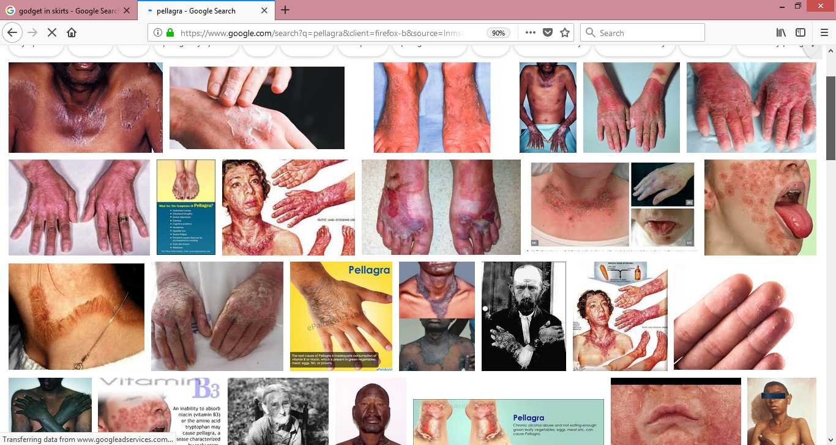

i) Name the above deficiency disease and list two symptoms of the disease.

2) Study the deficiency disease shown below and answer the questions that follow.

|  |
| --- |
|  |

(i) Describe the condition shown in the picture.

(ii) State the nutrient **deficient** leading to this condition.

3) For the following diseases, identify their names and state the nutrient deficient.

|  |  |  |
| --- | --- | --- |
|  | C:\Users\unicom\Pictures\imagesCA76ZZVC.jpg | C:\Users\Avikash\Desktop\download (2).jpeg |

4) Essay

Discuss the concept given below in relation to the prevalence and control of **either rickets, beriberi, dental caries or anemia in Fiji. (Choose any two deficiency diseases)**

* Contributing factors
* Signs and symptoms
* Prevention and treatment.