WEEK 3 YEAR 12 HOME ECONOMICS
STRAND 2 SUBSTRAND HEC12.2.1 KITCHEN SAFETY HYGIENE AND MANAGEMENT
CLO: HEC 12.2.1.1 Distinguish features of industrial kitchen and the use of advanced kitchen equipment.
LESSON 66
FEATURES OF INDUSTRIAL KITCHEN
- Architecture  Look at the bones of the building and consider whether architectural features, such as high ceilings, exposed beams, original floorboards and large windows, are present.  2. Wooden floorboards  Are an alternative to polished concrete floors and will suit the industrial theme well.  3. Stainless steel  It’s favored by professional chefs due to its hygienic nature and can be used for bench tops, cupboard doors and drawers, and shelving. It is prone to scratches and streaks but a good stainless-steel cleaner will assist.  4. Freestanding units’  Freestanding units are a great alternative to built-in cabinetry or islands. They are often used in industrial and commercial kitchens due to their flexible nature and the lack of wall cupboards ensures the focus is on the exposed brick wall.  5. Exposed brickwork and pipes  Consider leaving any pipes or ducting exposed, and also removing plaster to expose brickwork. Copper water pipes bring warmth and originality to the kitchen.  6. Vintage bar stools  For an industrial scheme, scour antique stores for original, prelove barstools, like the ones in this loft conversion. Look for materials such as wood and metal. | 7. Metal furniture  Industrial-style dining furniture includes pre-loved wooden tables – the more scratched and tarnished the better – and metal chairs.  8. Open shelving  Choose open shelving instead of wall cabinets to create a hardworking, industrial environment. They can be used to display treasures, vintage finds, or practical everyday items.  9. A bold use of black  Embraces the Industrial style – carry the theme through to all elements including the flooring, lighting, joinery, furniture and cabinetry/bench tops.  10. Pressed metal  Pressed metal is now easily available and adds to the industrial vibe of a kitchen. It can be left in its natural silver state or painted any colour.  11. Statement lighting  Industrial pendant lights are popular and easy to come by nowadays, and large metal lights can be sprayed in any colour to suit the overall scheme. The decision to hang four in a row here really makes a statement.  12. Large Windows  For industrial kitchen to allow light to enter the kitchen. It also assists in natural ventilation.

LESSON 67
INDUSTRIAL KITCHEN EQUIPMENT
There are three groups of industrial kitchen equipment:
1. FOOD PREPARATION
Knives is a cutting tool with a cutting edge or blade and is held by the hand. | 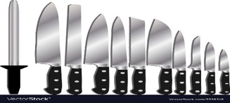
Food mixers industrial mixers and blenders are used to mix or blend a wide range of materials used in different industries including the food. They are mainly used to mix different materials using different types of blades to make a good quality homogeneous mixture. | 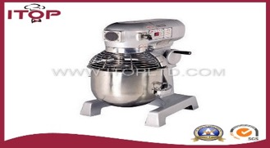
Meat slicer a meat slicer, also called a slicing machine, deli slicer or simply a slicer, is a tool used in butcher shops and delicatessens to slice meats and cheeses | 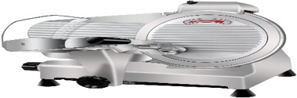
Stainless steel table tops is favored by professional chefs due to its hygienic nature. It is prone to scratches and streaks but a good stainless-steel cleaner will assist | 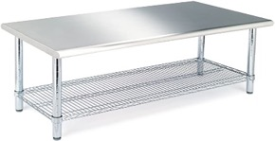
Salad spinner also known as a "salad tosser", is a kitchen tool used to wash and remove excess water from salad greens. It uses centrifugal force to separate the water from the leaves in order to keep the greens from going limp and enable salad dressing and oil to stick to the leaves. | 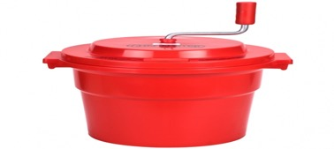
Digital scale A digital scale is a measurement device used to measure the weight or mass of an object or substances. They are generally quite accurate and consistent even when used over extended periods of time. | 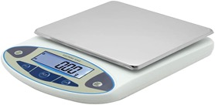
Digital cooking thermometer Remotely displays food's temperatures and time elapsed while it's cooking Programmable control panel for cooking by precise temperature or time Alarm sounds when cooking time or desired temperature reached. | 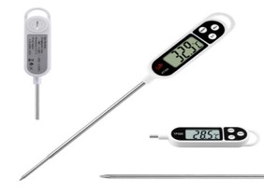
Kitchen knife sharpener  Honing is realigning the edge of the blade; stropping is fine sharpening the blade with a leather material without removing any metal material thereby producing a very sharp edge. | 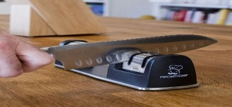
Stick blenders An immersion blender, or stick blender is a kitchen appliance to blend ingredients or puree food in the container in which they are being prepared.
Blast chiller Blast chilling is a method of cooling food quickly to a low temperature that is relatively safe from bacterial growth. | 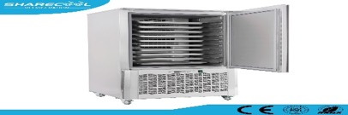
Dough sheeters are suitable for sheeting and stretching any kind of dough: yeast, croissants, puffed pastries, danish, flaky pastries, savory dough, soft pastry dough as well as stiff pizza or other kinds of dough to the required thickness. | 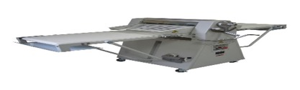
Ice-cream machine  this machine is used to make ice-cream of different flavors in an industrial kitchen. | 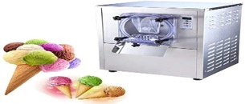
Chopping boards: used for cutting food. Different colors for different use | 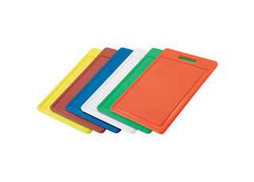
Saucer Portioner: This is used for portioning food such as sauce, desserts etc. | 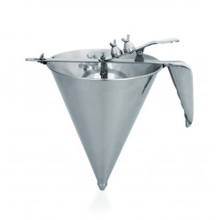
Coffee machine  Coffeemakers or coffee machines are cooking appliances used to brew coffee. | 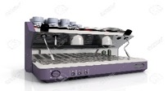
Melon baller A spoon like utensil with a sharp edge used especially for cutting ball-shaped pieces from the pulp of a fruit. | 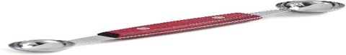
Blow Torch a blowtorch, or blowlamp , is a fuel burning tool used for applying flame and heat to various applications. | 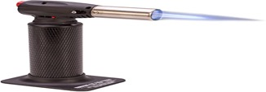
LESSON 68
2. COOKING
Commercial Brazier  A cooking device consisting of a container of live coals covered by a grill or thin metal top upon which the food, usually meat, is placed. | 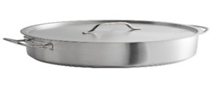
Commercial fry pans A shallow, long handled pan used for frying food. Also called skillet | 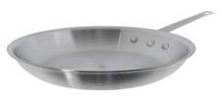
Commercial stock pot is traditionally used to make stock (cooking) or broth, which can be the basis for cooking more complex recipes | 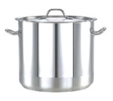
Double broilers a cooking utensil consisting of two saucepans fitting together so that the contents of the upper can be cooked or heated by boiling water in the lower | 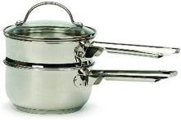
Commercial saucepans  A metal container of moderate depth, usually having a long handle and sometimes a cover for stewing, boiling | 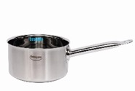
Stainless pots  A type of steel resistant to corrosion as a result of the presence of large amounts of chromium. It is also more stable and less prone to leaching | 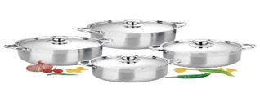

Kitchen Equipment
3. Serving - Types of Glasses

Old Fashion glass: This glass is a classic for serving spirits neat without ice or cocktails poured over ice (on the rocks). The glass is named after the old fashioned cocktail, which is whiskey or bourbon served over ice with lemon twist. High ball glass (center). These are used mainly for mixed drinks but they also work for soft drinks. | 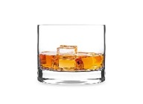
Brandy/Cognac/whiskey: Brandy glasses, also called snifters, are designed to have a short and stout tulip shape to help the drinkers take in aroma and flavor. | 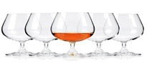
Beer glasses Robust beer is best served in large, wide glasses. Regular pint glasses, which are tapered like tumblers would also work well. Wheat beer glass (second from left) is tall and slender; the shape allows more room for the foamy head and makes the aroma much more pronounced. | 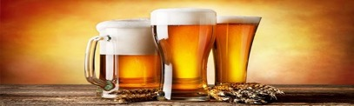
Sparkling wine/Champagne These drinks do best in glasses that hold in the bubbles, not the ones that let them escape. Ideally a white wine glass would work very well, because it helps with aroma, but the bubbles dissipate too quickly. | 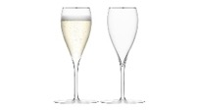
Red Wine/ White Wine The unique shape of wine glasses is for a reason-it’s there to help you notice aroma and flavor. The shape also allows you to swirl the wine to release the aroma compounds that contribute to flavor. | 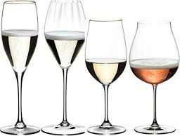

STRAND 2 SUBSTRAND HEC12.2.1 KITCHEN SAFETY HYGIENE AND MANAGEMENT
CLO: HEC 12.2.1.1 Distinguish features of industrial kitchen and the use of advanced kitchen equipment.
LESSON 69

Parts of a Glass  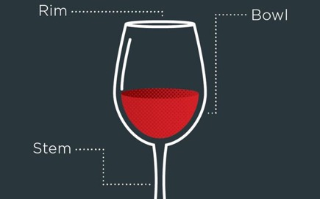 | SUSTAINABLE USE OF ENERGY EFFICIENT KITCHEN EQUIPMENT.  1. Many cooks prefer gas because it's easier to control temperatures; and doesn't waste much heat when the cooking is done.  2. With electricity, the most efficient stoves are those that use induction elements, which transfer electromagnetic energy directly to the pan, leaving the cook-top itself relatively cool and using less than half the energy of standard coil elements.  3. Energy Star rating, available for kitchen appliances including stoves, refrigerators, freezers, and dishwashers.

Table setting
Casual Breakfast/Lunch  Table setting should include a dinner fork, dinner knife and teaspoon. Start with a dinner plate, soup bowl, bread & butter plate (for toast or muffins), butter knife, water tumbler, juice glass and a cup and saucer for either coffee or tea. The napkin should be placed to the left of the fork. | 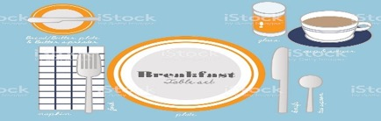
Dinner  Table setting should include a butter knife, salad fork, dinner fork, dinner knife and teaspoon. Start with a dinner plate, water glass, napkin and even a placemat for looks. The napkin should be placed to the left of the forks. | 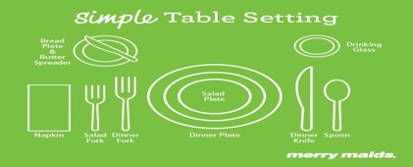
Formal Dinner  Table setting should include a butter knife, salad fork, dinner fork, dinner knife, soup spoon and teaspoon. Start with a dinner plate, napkin, water glass, wine glass, soup bowl and a bread & butter plate. The napkin should be placed to the left of the forks. The butter spreader may be placed on top of the bread and butter plate. A dessert spoon and dessert fork may be placed above the dinner plate. | 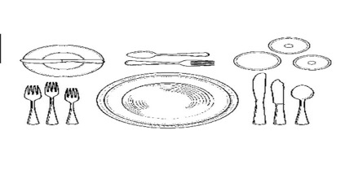
European  Table setting should include a butter knife, European-size dinner fork, U.S.-sized dinner fork, fish fork, fish knife, a European-sized dinner knife, soup spoon and teaspoon. Start with bread & butter plate, salad plate, water glass, red and white wine glasses, a champagne glass and a napkin, which should be folded and placed on top of the salad plate.  A European-style setting is intended especially for formal occasions. European-sized flatware is generally larger and heavier that traditional U.S. flatware. | 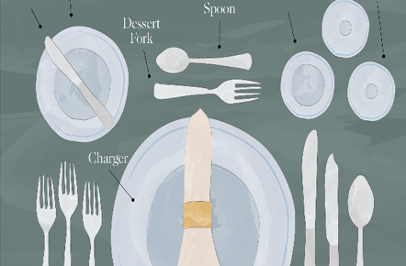
Banquet/Brunch  Table setting should include salad forks, dinner forks, dinner knives and teaspoons. Start with dinner plates, napkins, water glasses, salad bowls, vegetable bowls and candles for looks. Napkins should be placed on top of the salad plate. | 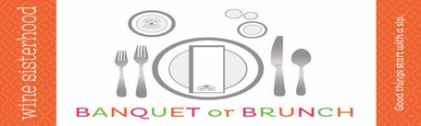

LESSON 70
Meal service
Meal service equipment | Picture
Bain-marie  A bain-marie ( also known as a water bath), a type of heated bath, is a piece of equipment used in science, industry, and cooking to heat materials gently and gradually to fixed temperatures, or to keep materials warm over. | 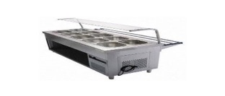
Chafing Dish  The chafing dish could be used at table or provided with a cover for keeping food warm on a buffet | 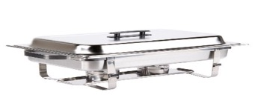
Carving station  Carving stations are designed to provide an appealing place to cut roasted meats in front of the guests. Carving stations also ensure that the meat stays fresh and juicy, as it does not need to sit out in the air for long before getting onto the plate. They come equipped with 0, 1 or 2 bulbs. The bulbs are designed to keep the meat warm. | 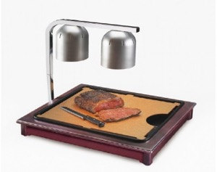
Salad bar  1. Most salad bars provide lettuce, chopped tomatoes, assorted raw, sliced vegetables (such as cucumbers, carrots, celery and green or red bell peppers), dried bread croutons, bacon bits, shredded cheese, and various types of salad dressing. | 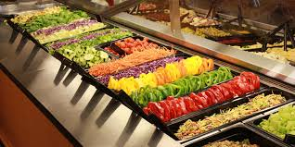
Tongs  Tongs are a tool used to grip and lift objects, of which there are many forms adapted to their specific use. | 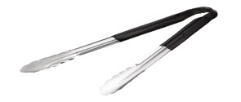
Glass cake stand  This Cake Stand is great display piece for all baked goods and the added glass lid to keeps them fresh | 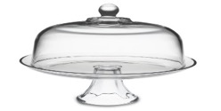

REVISION QUESTIONS
1. State the function of the following meal service equipment:
- Chafing dish
- Glass cake stand

2. List two kitchen appliances that has energy star rating available on them.
3. Explain the use of a carving station in food service.
4. Identify the type of table setting shown in the illustration below:
5. Study the diagram given below and answer the questions that follow.
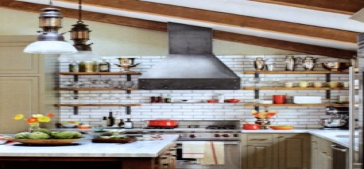

- Identify one industrial kitchen feature illustrated above. Explain the importance of the feature mentioned in (i) above in an industrial kitchen.
6. Briefly discuss as why stainless steel counter tops are ideal for industrial kitchen.
7. Identify the equipment that is ideal for stewing and boiling in the industrial kitchen.
8. State the advantage of free standing units in the kitchen
9. List 4 key architectural features of an industrial kitchen.

