YEAR 12
GEOGRAPHY
HOME LEARNING KIT
WEEK 7

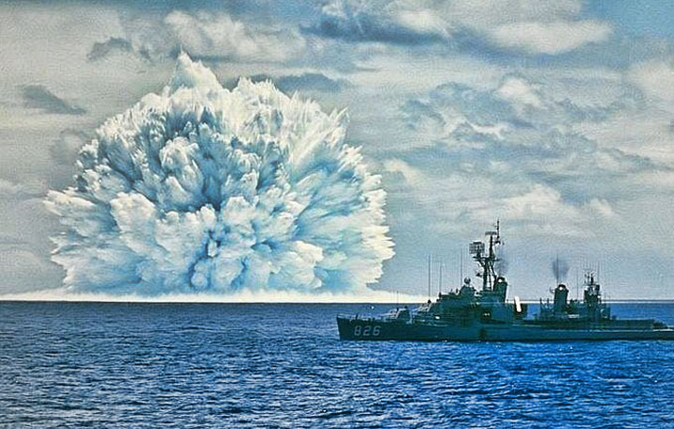

NAME
LEVEL
S/ID

Lesson # 74
Strand: Human Geography
Sub Strand: Marine Resources
Learning Outcome: examine the mangrove ecosystem
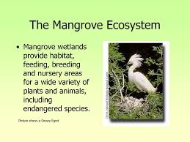

Activity Resource study
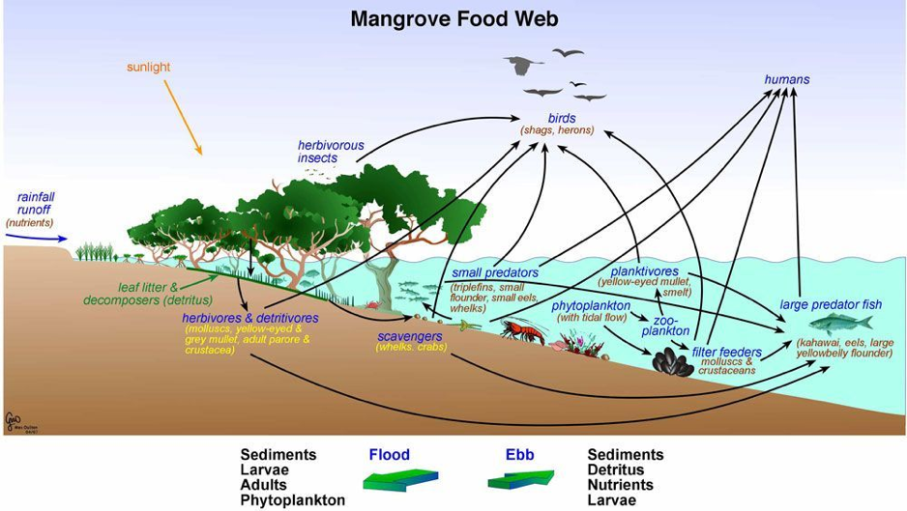

- State one example of food chain from the resource above
- Describe how deforestation of mangroves has a negative impact on food chain
- Examine two ways to conserve the mangrove ecosystem in Fiji.

Lesson # 75
Strand: Human Geography
Sub Strand: Marine Resources
Learning Outcome: describe the different types of reefs
Types of reefs
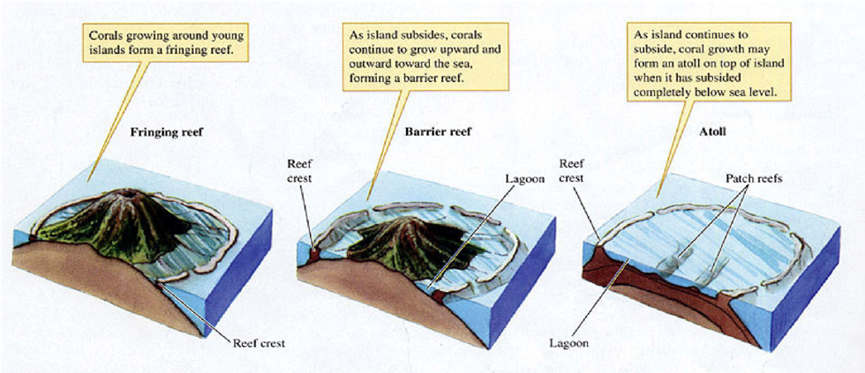

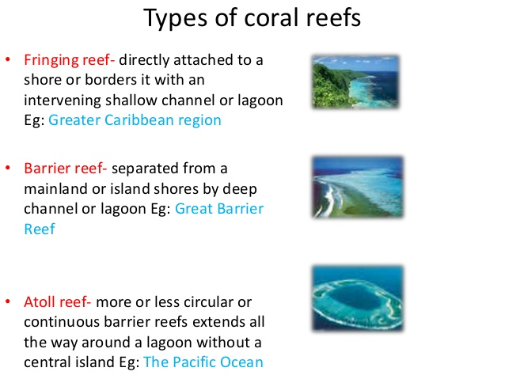
Activity
- State two importance of reef in marine ecosystem.
- Mention two ways man exploit the reefs.
- Describe one way in which we can protect our reefs.

Lesson # 76
Strand: Human Geography
Sub Strand: Marine Resources
Learning Outcome: Discuss the humans dependence on marine resources

IMPORTANCE OF THE MARINE RESOURCES AND FISHERY
- Source of food/ Food Security
Marine resources are an important part of the diet of coastal dwellers in most countries. The development of the fishing industry means food provisions and food security.
- Source of employment/ Income
The existence of the fishing industry means employment, income and livelihood for the people.
- Source of Export Earnings
Export of marine products means increased revenue for the country.
- Promotes development
Development comes with economic growth.
- Provides proteins, vitamins and minerals.
Fish products are sources of proteins, vitamins and minerals.
- Retains food chain and food web
Marine species are mainly very importanta parts of some food chains and food webs.
- Retains biodiversity
As the food webs and food chains are retained then extinction of species can be avoided to retain biodiversity.
- Sustains life and natural beauty.
The ocean or the sea has its own characteristics and beauty.

Activity
1. State two ways in which man benefit from marine resources.
2. Describe one environmental benefit from marine conservation.

Lesson # 77
Strand: Human Geography
Sub Strand: Marine Resources
Learning Outcome: Examine the size and scale of production and local participation
The laws governing the use of marine resources in Fiji are set out in Chapters 158 and 158A of the Laws of Fiji. Chapter 158 is also known as the Fisheries Act. The main features of the Act are that it:
- Defines the Fiji fisheries waters as all internal waters, archipelagic waters, territorial seas and all waters within the exclusive economic zone;
- Establishes a Native Fisheries Commission charged with the duty of ascertaining the customary fishing rights in each province of Fiji;
- Prohibits the taking of fish in Fiji fisheries waters by way of trade or business without a licence;
- States that every licence granted under the Act terminates on the 31st December next after the day of issue, licenses are personal to the holder, and licenses are not transferable;
- Empowers any licencing officer, police officer, customs officer, honorary fish warden and any other officer empowered by the Minister to enforce the Act;
- Empowers the Minister to appoint honorary fish wardens whose duties shall be the prevention and detection of offences;
- Empowers the Minister to make regulations (a) prohibiting any practices or methods, or employment of equipment or devices or materials, which are likely to be injurious to the maintenance and development of a stock of fish; (b) prescribing areas and seasons within which the taking of fish is prohibited or restricted, either entirely or with reference to a named species; (c) prescribing limits to the size and weight of fish of named species which may be taken; (d) prescribing limits to the size of ne

Activity
Define the term
- Quota
- Law of seas
Lesson # 78
Strand: Human Geography
Sub Strand: Marine Resources
Learning Outcome: Discuss the role of local participation in containing marine size and scale
Fiji is a member of the Secretariat of the Pacific Community (SPC), the South Pacific Forum Fisheries Agency (FFA) and the South Pacific Regional Environmental Programme (SPREP). Fiji is also party to a number of treaties and agreements relating to the management of regional fisheries, including:
- the Treaty on Fisheries Between the Governments of Certain Pacific Island States and the Government of the United States of America;
- the Convention for the Prohibition of Fishing with Long Driftnets in the South Pacific; and,
- the Niue Treaty on Cooperation in Fisheries Surveillance and Law Enforcement in the South Pacific Region.
Fiji was the first signatory to the United Nations Convention on the Law of the Sea UNCLOS). Fiji is also a signatory to:
- the Agreement for the Implementation of the Provisions of the United Nations Convention of the Law of the Sea of 10 December 1982 Relating to the Conservation and Management of Straddling Fish Stocks and Highly Migratory Fish Stocks;
- the Convention on the Conservation and Management of Highly Migratory Fish Stocks in the Western and Central Pacific Ocean;
- the Washington Convention on International Trade in Endangered Species of Wild Fauna and Flora (CITES).

Activity read and understand
Each provincial working group developed strategies for implementing the protected area recommendations, which broadly included tasks such as discussion of workshop outcomes during provincial meetings and consultations with resource owners and users. The working groups also identified many challenges and limitations to implementation of protected areas, which fell into the following major categories: lack of awareness of threats, existing data, and best practice for management; conflicting mind sets among stakeholders; increasing development and extractive industry; poor communication among stakeholders; lack of resources for monitoring and enforcement; and the need to strengthen management and compliance with national and local rules and policies. The PAC will now seek to work closely with the Provincial Offices across Fiji to overcome these challenges, support stakeholder engagement, and develop innovative financing solutions to enable site‐based implementation.

Nature at the Centre of Fiji’s Way of Life
Fijians have important traditional relationships with the sea, reflected in their lifestyles, customs, traditional knowledge and history. Around 80 per cent of the population live on the coast and rely heavily on marine resources for food, livelihoods and cash income. Marine resources are also used for minerals, pharmaceuticals, construction material and a vast range of useful products. The major sources of economic growth and livelihood are fisheries, the third largest export industry accounting for 1.5 per cent of GDP, and the tourism sector, which accounts for 17 per cent of the GDP.

  - State some challenges that villagers might face setting up “marine protected areas”.
  - State the importance of the sea in traditional societies and modern societies.

