YEAR 12
GEOGRAPHY
HOME LEARNING KIT
WEEK 3

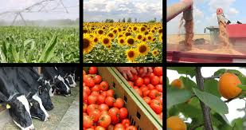

NAME
LEVEL
S/ID

Lesson # 54
Strand: Human Geography
Sub Strand: Agriculture and Food Supply (Fiji)
Learning Outcome: Examine the recent developments and plans in agriculture
Improvements Made to the Farming System
- Mechanisation of farms – appropriate technologies used by farmers/ new machines introduced. Example tractors, rotovators, cane harvesters, milking machines, refrigeration facilities, and greenhouse.
- Modern farming techniques – irrigation, hybrid seeds
- Land reform policies – agricultural tax free zone
- Government assistance – subsidies on seeds, fertilizers
- Diseases and pest control – assistance provided by Ministry of Agriculture, SPC
- Education – farmers are more educated
- Better transportation/ export and local markets
This leads to Increase Productivity
- Saves time and labour cost
- Crops can be produced all year round
- Incentives for farmers to invest more in farming
- Better quality seeds and pest control increases productivity
- Improved farming methods – higher productivity

Activity Resource interpretation
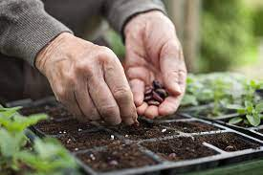

- State two new development plans made for agriculture in Fiji during the cirisis of COVID 19 pandemic.

- Describe how supersedes increase productivity.

- State two ways the government can maintain good productivity throughout the year.

Lesson # 55
Strand: Human Geography
Sub Strand: Agriculture and Food Supply (Fiji)
- Learning Outcome: Describe the Common/best agricultural practices
RESOURCE STUDY (use google for reading)
- Use of pesticides and chemicals
- 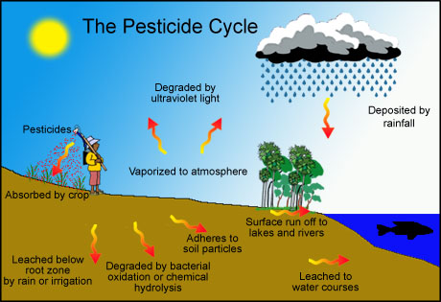

- State two advantages of using organic pesticides

- State one disadvantage artificial pesticides
- Technology
- 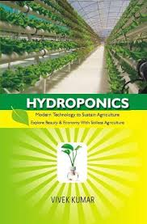

- 1. State two benefits of the method shown above in technology.
- 2. State one disadvantage of mono cropping.

Resource Interpretation Traditional practices
- 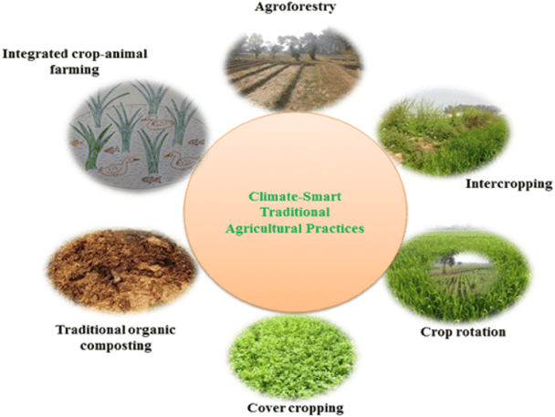

- 1. State two advantages of traditional composting.

- 2. Explain the term inter cropping

Lesson # 56
Strand: Human Geography
Sub Strand: Agriculture and Food Supply (Fiji)
Learning Outcome: Relate climate change to agriculture and food supply
How agriculture leads to climate change?
Modern agriculture, food production and distribution are major contributors of greenhouse gases: Agriculture is directly responsible for 14 per cent of total greenhouse gas emissions, and broader rural land use decisions have an even larger impact. Deforestation currently accounts for an additional 18 per cent of emissions.
In this context, a historical perspective needs to be considered: Dr. Rattan Lal, Professor of Soil Science at Ohio State University, has calculated that over the last 150 years, 476 billions of tonnes of carbon has been emitted from farmland soils due to inappropriate farming and grazing practices, compared with ‘only’ 270 Gt emitted from of burning of fossil fuels. A more frequently quoted figure is that 200 to 250 Gt of carbon have been lost from the biosphere as a whole in the last 300 years. Whatever the correct figure, these reductions of ‘living carbon potential’ have resulted from
- deforestation
- biodiversity loss
- accelerated soil erosion
- loss of soil organic matter
- salinisation of soils
- costal water pollution and
- acidification of the oceans

Activity
With reference to Fiji write an essay and discuss three ways agriculture leads to climate change and two ways in which climate change affects agriculture.
Note: their relationship is inter- dependent.

Lesson # 57
Strand: Human Geography
Sub Strand: Agriculture and Food Supply (Fiji)
Learning Outcome: Relate climate change to agriculture and food supply

How climate change affects agriculture and food supply?
Climate change and agriculture are interrelated processes, both of which take place on a global scale. Global warming affects agriculture in a number of ways, including through changes in average temperatures, rainfall, and climate extremes (e.g., heat waves); changes in pests and diseases; changes in atmospheric carbon dioxide and ground-level ozone concentrations; changes in the nutritional quality of some foods;^{[2]} and changes in sea level.^{[3]}
Climate change is already affecting agriculture, with effects unevenly distributed across the world.^{[4]} Future climate change will likely negatively affect crop production in low latitude countries, while effects in northern latitudes may be positive or negative.^{[4]} Animal agriculture is also responsible for CO
2 greenhouse gas production and a percentage of the world's methane, and future land infertility, and the displacement of local species.

Activity
  - Draw a flow chart to explain how the following affects agriculture directly.
Heat waves

High Carbon dioxide

Global warming

Green house effect

Lesson # 58
Strand: Human Geography
Sub Strand: Agriculture and Food Supply (Fiji)
Learning Outcome: Examine the future of agriculture sector
The future development of agriculture
- The use of modern scientific knowledge to improve of the quality or quantity per unit area, and to meet the specific demands of the consumers.
- The need to maintain and/or improve on the variety of agricultural products.
- The need to empower the people for food security and food sustainability.
- Resource Study
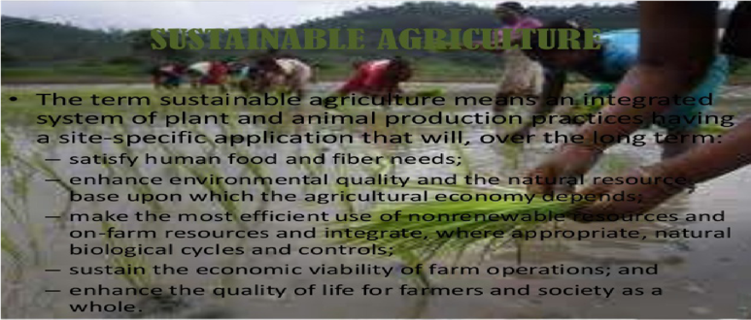

- Give two examples of sustainable practices in agriculture.

- Describe one way climate change would pose a risk to the future of agriculture.

- State how elderlies could help educate the society of traditional environmental knowledge.

