YEAR 12A
GEOGRAPHY
HOME LEARNING KIT
WEEK 4
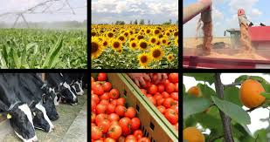

NAME
LEVEL
S/ID

Lesson 42
Strand: Human Geography
Sub Strand: Tourism
Learning Outcome:
- Revision – Essay Writing
LESSON NOTES

With reference to either Fiji or Australia, discuss four measures the government
can take to ensure that the tourism industry has a bright future.

Four measures the government can take to ensure the tourism industry has a bright future.
• Promote and invest in other types of tourism – Sports, Medical, Ecotourism, Business, Agri-tourism, Religious tourism, Domestic
• Promotion and marketing the country as a favourable tourist destination
• Funding tourism development - increased pressure not only on tourism and supporting infrastructure, but also on the budgets with responsibility for: i) marketing and promotion; ii) providing the necessary services and facilities to cater for tourists; iii) ensuring visitor safety and security; and iv) maintaining the natural environments that often attract them
• Infrastructure development
• Simplifying regulations and adjusting to growth of the sharing economy - Many countries are taking specific steps to simplify the regulatory framework supporting tourism, in order to create a more favourable business environment (particularly for SMEs), reduce bureaucratic obstacles, and provide appropriate financial and other incentives
• Fostering long-term investment - Another area where governments can strengthen strategic capacity and foresight to address multi-sectorial issues that affect tourism and improve overall competitiveness, is designing and implementing stable and predictable policies that aim to build business confidence and foster long-term private sector investment (both domestic and foreign). Country approaches include introducing mechanisms to improve the stability and reliability of processes necessary to obtain licenses, permits, concessions and other requirements for the installation and operation of tourism enterprises
• The digitalisation of tourism - The growing importance of digital technology and social media in tourism creates challenges and opportunities for national and regional tourism organisations and tourism enterprises. Tourists are increasingly connected to the internet, utilising any number of tourism-related mobile apps; accessing real-time news, transport and online booking platforms (e.g. travel agents, airlines, trains, rental cars, Uber), and; utilising social networks to review, assess and book accommodation (e.g. Airbnb, Trip Advisor), restaurants, and other tourism services; just to name a few. These trends in consumer behaviour and expectations in relation to the digital economy are necessitating a major shift towards digital marketing and promotion, but also in relation to capacity building and product development.
Assessing and developing the role of technology for data collection, impact measurement and communication.
• Stimulating domestic tourism - Many countries are developing actions to stimulate domestic demand . Domestic Tourism Growth Strategy to reduce dependence on international arrivals. The objectives are to increase domestic tourism revenues and volumes, to improve measures aimed at addressing seasonality and equitable geographical spread, and to promote a culture of travel among the locals.

Lesson 43
Strand: Human Geography
Sub Strand: Tourism
Learning Outcome:
- Revision – Short Answer Questions
LESSON NOTES
Short Answer Questions (FY12CE -2019)

- Explain a measure to reduce leakage in the tourism industry.

- Describe one way the locals have negatively contributed to the tourism industry

Short Answer Questions (FY12CE -2018)

- State two economic importance of the tourism industry.

- Explain one reason why overdependence on tourism is a risk.

Short Answer Questions (FY12CE – 2017)

(i) State two features that a host country needs to develop in order to retain
the target tourist markets.

(ii) Describe an environmental factor that can affect tourism development.

Short Answer Questions (FY12CE – 2016)

(i) Outline two factors that tourists need to consider when choosing
a destination.

(ii) State how climate change affects the tourism industry of Fiji
and give an example to illustrate this.

(iii) Explain one way in which Fiji Airways contributes to the development
of the tourism industry in Fiji.

Analyze | is asking a student to look closely at something, at each of its parts, and see if the parts fit together in a way that makes sense.
Compare | a student is asked to look at common characteristics and identify how things are alike or similar.
Contrast | student is asked to provide the characteristics that are not alike.
Describe | student to present a clear picture of a person, place, thing or idea.
Elaborate | a student must add more information or add more detail.
Explain | student toto provide information or evidence. Students can use five W’s (Who, What, When, Where, Why) and H (How) in the "explain" response,
Interpret | student to make meaning in their own words.
State | student to write down without an explanation.
List | student to list/ write in order.
Outline | Student to explain the relationship between each point. An outline should just be the main points, without any details.
Name | Student to name without an explanation

Factors
Features
Examples
Way
Reasons
Causes
Solutions
Measures
Impacts
Importance
Barriers
Difference
Effects

Lesson # 44
Strand : Human Geography
Sub strand : Agriculture and Food Supply
Learning Outcome: Examine the importance of agriculture
Agriculture means the cultivation of plants and animals for human use and purposes.
“the science and practice of cultivating for food and keeping or breeding animals for food”

The use of land in Fiji is influenced by a combination of factors such as physical and cultural factors. Physical factors include relief, climate and soil whilesocial and cultural factors include people’s use of the land (Individual farmers), land ownership and land tenure, transport availability and access to markets, marketing methods, and capital available for development and improvement, market demands and prices.

COMMERCIAL FARMING
The major commercial crops grown in Fiji are Sugarcane, Copra, Ginger, and Rice, although some are not exported but they are consumed locally and are sold in the local market
SUBSISTENCE FARMING - Growing food for own use
Resource study Activity
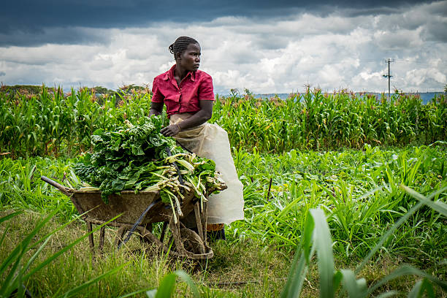
- State two advantages of subsistence farming during the crisis like CORONA VIRUS.
- Describe one way in which the government can ensure food security.
- Name few of Fiji commercial agricultural markets. State how Fiji can build better relationships in terms of trading

Lesson # 45
Strand : Human Geography
Sub strand : Agriculture and Food Supply
Learning Outcome: Examine the importance of agriculture

Agroforestry
- Is the farming and retaining parts of the forest.
- Agriculture incorporating the cultivation of the trees.

Advantages of Agroforestry
- It ensures forest cover is protected and maintained.
- It conserves and protects the soil.
- Improved soil quality
- Control runoff and soil erosion – reducing losses of water and soil materrial
- Crops cultivated are protected and sheltered from strong winds eg. During cyclones
- Increased crop production and economic gain

ACTIVITY
Describe the following examples in your own words
Some Examples of Agroforestry Practices
- Silvopasture: combine trees with forage and livestock production.
- Inter-cropping
- Polyculture
- Crop rotation
- Strip cropping
- Contour planting
- Fallowing
- Mulching

Lesson # 46
Strand: Human Geography
Sub Strand: Agriculture and Food Supply (Fiji)
Learning Outcome: Describe how physical factors affects agriculture.
Physical factors
- Relief and slope
  - Whether the land is high, hilly and rocky or low, flat lands and big plains it will influence the type of crop grown there and how successful a farmer is in utilizing this land.
  - Whether it is close or far from the water sources or rivers
- Climate
  - The amount of rainfall and solar radiation it receives
  - Regularity(how often rain-falls)
  - Seasonal distribution of rainfall (winter and summer)
- Soil Characteristics
  - Red dry and leached soil or dark, humid, rich and alluvial soil.
- Temperature-warm and cool
- Other factors • Sunshine hours.
  - Hurricanes
  - Floods
  - Other climatic extremes

Activity
- Explain one way in which climate affects agriculture.

- State two ways in which soil boost agriculture.

- Describe one way in which natural disasters affect agriculture in Fiji.

