HOME LEARNING KIT GEOGRAPHY – YEAR 12
WORKSHEET 7

Short Answer Questions

- Differentiate between pelagic and demersal species.

- Describe one human activity that can damage mangrove ecosystem.

DEFINITION
- terrestrial (Iii) echinoderms

- barrier reef (iv) fringing reef

Resource Interpretation

Use the photograph given below and your knowledge to answer the question that follows:
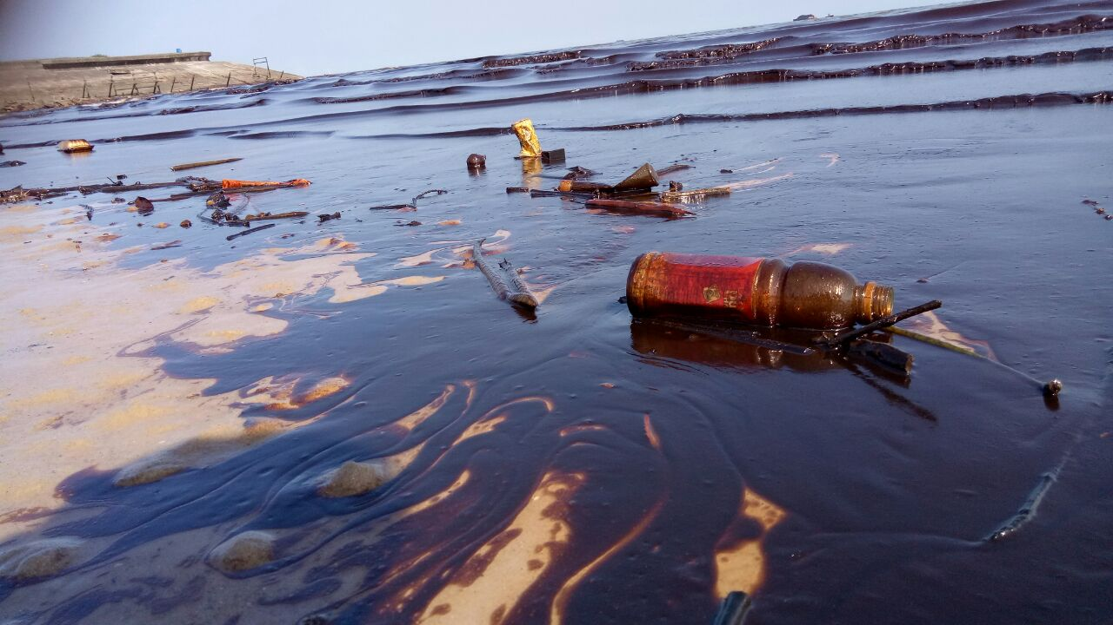
SOURCE: https://www.google.com/search?q=oil+spill+images&sxsrf=AL

  - Identify the human activity damaging marine life in resource above.

  - Describe the impact of human activity on marine life.

