HOME LEARNING KIT GEOGRAPHY – YEAR 12
WORKSHEET 6

- RESOURCE INTERPRETATION
Study the resource below
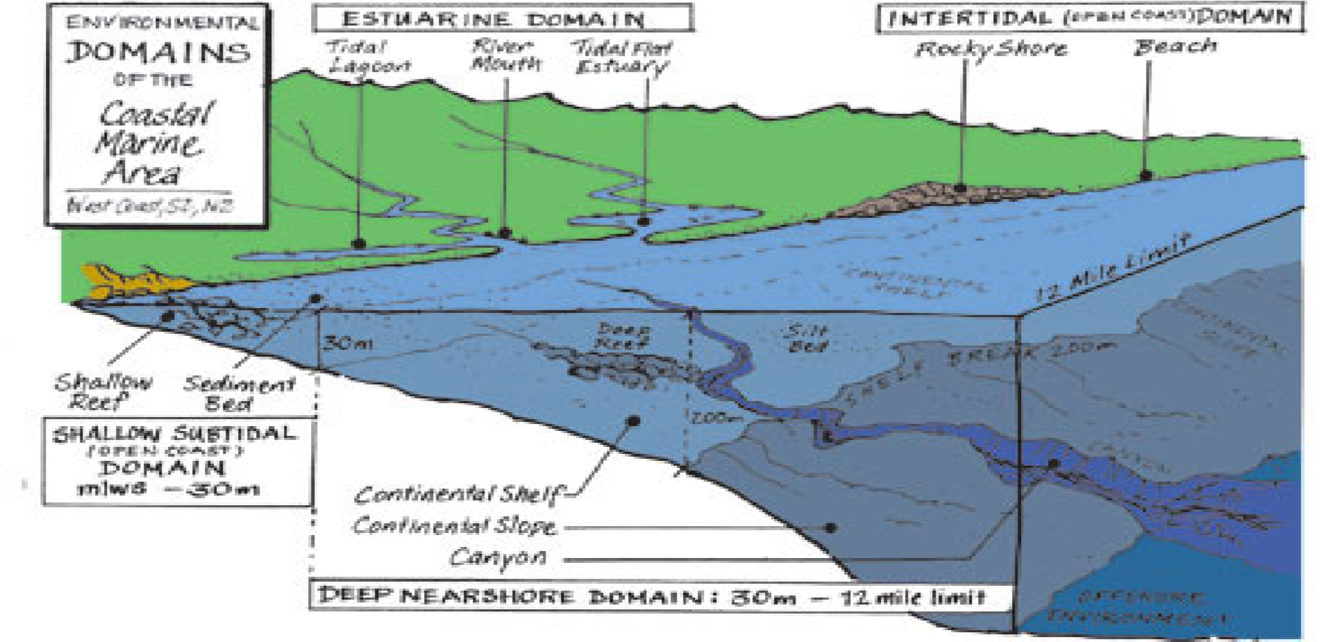
  - State two ways water pollution affects the marine life.
  - Describe the intertidal domain.

  - What do you understand by the term estuary?

B. Resource Interpretation
Use the process diagram given below and your knowledge to answer the question that follows:
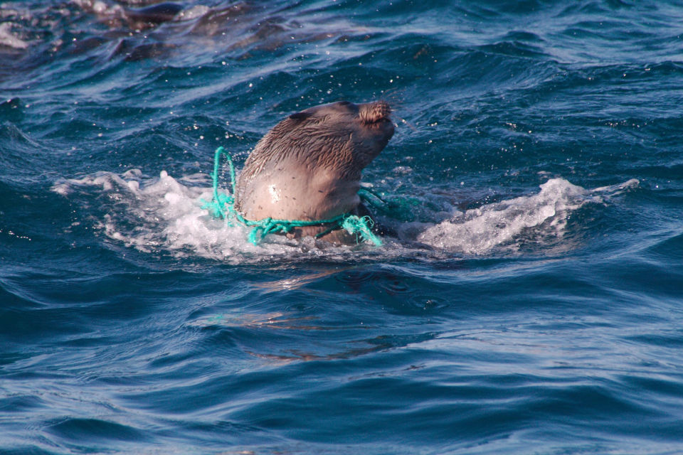
Source: https://www.elstel.org/PoisonousPlastic.html

- Differentiate between pelagic and demersal species.

- Describe one human activity that have endangered marine life as shown in the picture above.

