YEAR 12
GEOGRAPHY
HOME LEARNING KIT
WEEK 4

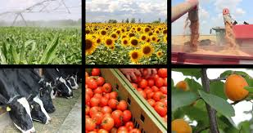

NAME
LEVEL
S/ID

Lesson # 59
Strand: Human Geography
Sub Strand: Agriculture and Food Supply (Fiji)
Learning Outcome: familiarize with agricultural terms
Important Terms

Term | Meaning
- Aeroponics | Method of growing plants with their roots suspended in the air and sprayed with cool nutrient solution at intervals.
- Agribusiness | Large scale control of farming process/capital intensive farming on a large scale.
- Agro - technology | Technology developed in relation to agricultural production of food and raw material, crops and livestock.
- Aquifers | Underground water stored in the pores and joints of permeable rock.
- Bobby calf | The unwanted male offspring of a dairy cow.
- Border dyke irrigation | Flood irrigation where water is diverted from the main channel which runs across the top of the paddock to be irrigated.
- Crop diversification | Increase the number of crops or plant different types of crops for commercial gain.
- Cross breed | An animal resulting from a cross between two different breeds.
- Diversification | The farming of different varieties of crops/livestock.
- Eutrophication | Process by which fertilizers reaching rivers and lakes cause algae and plant growth reducing oxygen for marine life.
- Fallowing | A practice whereby no crop id grown and all plant growth is controlled.
- Feed grain | Any of several grains mostly and commonly used for livestock or poultry feed including corn grains.
- Herbicide | An agent or chemical used to destroy plants especially weeds.
- Hydroponics | Growing of plants in water containing dissolve nutrients rather than in soil.
- Irrigation | Artificial watering of land
- Leachate | Water contain contaminates which has leaked from silage pits
- Organic farming | Sustainable type of farming that does not use chemical fertilizers or pesticides but uses cultural or green manure instead.
- Organic manure | Natural fertilisers such as animal and green manure without the use of any chemicals.
- Pastoral agriculture | The farming of animals based on grazing.
- Pastoralism | Farming of animals based on gross consumption.
- Pesticides | All chemicals applied to crops to control pests, diseases and weeds.
- Primitive tools | Pre-modern tools used for agriculture such as sticks, wood and stones.
- Rotational grazing | Moving of livestock from pasture to pasture for controlled grazing, conservation of pasture growth and to prevent pugging.
- Share milking | A dairy farmer who milks cows on a farm he does not own, under an arrangement of income sharing.
- Silage | Excess pasture which has been cut and stored while wet.
- Silviculture | Branch of forestry dealing with the development and care of forest.
- Sustainable agriculture | An agricultural practice that ensures plant and animal production practices are environmentally friendly.
- Crown Land | Land that is owned by the state
- Agriculture | The practice of farming, including cultivation of the soil for growing of crops.
Activity
Students are to learn the above terms related to agriculture, if parents could assist to give spelling and definition test of any 10 words from the list at a time

Lesson # 60
Strand: Human Geography
Sub Strand: Agriculture and Food Supply (Fiji)
Learning Outcome: familiarize with agricultural terms
Important Terms
- Commercial agriculture | Is a large scale production of crops for sale for widespread distribution.
- Food security | The state of having reliable access to a sufficient quantity of affordable nutritious food.
- Horticulture | Cultivation of medicinal plants, fruits, vegetables, nuts, seeds, herbs, sprouts, mushrooms, algae, flowers, seaweeds and non-food crops such as grass and ornamental trees and plants.
- Hybrid | Mixing two breeds of plants or animals
- Leaching | Washing away of minerals from the top soil
- Mulching | A covering as compost spread on the ground around plants to prevent excessive evaporation or erosion.
- Non-renewable resources | Resources which once used by man cannot be replaced.
- Quota | A fixed share of something that a person or group is entitled to receive.
- Transhumance | The practice of moving livestock from one grazing ground to another in a seasonal cycle.
- Pasture | Land covered with grass for grazing animals
- Hybrid crops | Is a result of two different varieties of plant cross-pollinated.
- Shelter Belts | Trees planted to give protection to crops and fruit trees from high winds that can damage fruit trees, crops, bruise fruit.
- Crop Rotation | Moving stock from pasture to pasture which allows a farmer to control grazing, conserve pasture growth and prevent pugging
- Insecticide | A substance used for killing insects Chemical/poison/pests
- Green Revolution | A significant increase in agricultural productivity beginning in the 1940s and resulting from the introduction of high yield varieties of grains, the use of pesticides, and improved management techniques
- Permaculture | The development of agricultural ecosystems intended to be sustainable and self-sufficient.
- Rotational Grazing | The practice of growing a series of dissimilar or different types of crops in the same area in sequenced seasons
- Silvopasture | Is the practice of combining forestry and grazing of domesticated animals in a mutually beneficial way
- Shifting Cultivation | involves the movement from one farm clearing to another, after a few seasons of cultivation

Activity
Students are to learn the above terms related to agriculture, if parents could assist to give spelling and definition test of any 10 words from the list at a time.

Lesson # 61
Strand: Human Geography
Sub Strand: Agriculture and Food Supply (Fiji)
Learning Outcome: Examine factors that drawback the development of agriculture.
Factors that can be Drawbacks to the Development of Agriculture

Activity
Discuss three examples faced by your local government especially during COVID 19 pandemic.

Lesson # 62
Strand: Human Geography
Sub Strand: Agriculture and Food Supply (Fiji)
Learning Outcome: Describe the Positive/Negative Impacts of Modern Technology on Agriculture

- Modern Technology
- Irrigation
- Agriculture research
- Hybrid seeds/ cross breeds livestock
- Setting fertilizer factories
- Advanced farming machinery
- Aerial topdressing
- Genetic engineering/ Organic farming/ High Tech farming
- Livestock breeding/ hydroponics/ pesticides/ fertilizers/ cross feeds
- Positive Impacts
- Increased crop production
- Increased food production
- Reduced labour costs/ reduced rate of maturity
- Saves time and energy
- Meets market demands/high productivity value
- Increase efficiency/encourage diversification of crops
- Negative Impacts
- Increases unemployment
- Machinery makes soil compact/damages soil
- Use of chemicals degrade soil
- Eutrophication takes place
- Expensive-repair of machines/electricity/water supply
- Loss of traditional or natural crop varieties
- Traditional farming methods are less expensive/more nutritious/environmentally friendly

Activity

Resource interpretation I
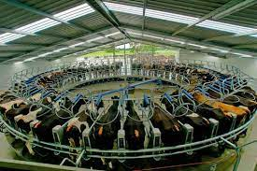

- State two benefits of modern technology in agriculture.
Resource interpretation II
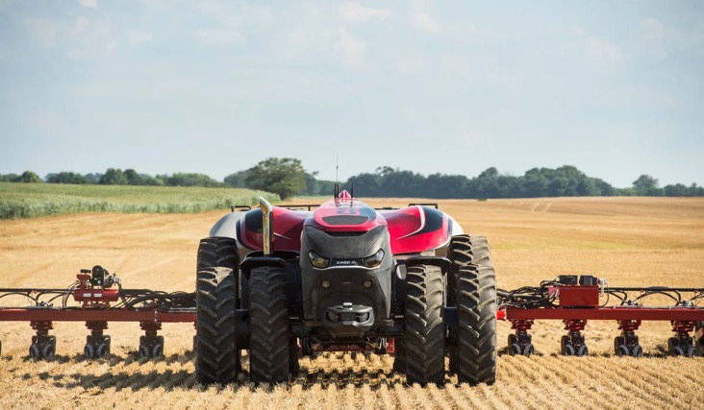

- State one positive effect of using modern technology in agriculture.
- List two negative impacts on the environment.
- Suggest one way to reduce the negative impact mentioned in (2) above.

Lesson # 63
Strand: Human Geography
Sub Strand: Agriculture and Food Supply (Fiji)
Learning Outcome: Define and describe the role of sustainable agriculture.
Activity
  - Describe one way in which modern agriculture is less sustainable than traditional.

  - State the advantage of rotational grazing methods.

  - State two ways that you would promote nutrient management amongst your farmers.

  - Relate the term sustainability to soil management.

