YEAR 12 LESSON NOTES AND ACTIVITIES COVID- BREAK 2021

WEEK 1

LESSON 43

STRAND: Reading and Viewing

SUBSTRAND: Language Features/ CONNECTIVES

LESSON OUTCOME: study the examples, identify the different usage and attempt the activities.

WHAT ARE CONNECTIVES?

-Connectives link parts of a sentence together or make connections between sentence and another.

TYPES OF CONNECTIVES

1. Causes and Effects -When the second part of a sentence helps explain the first

part. The second part happens as a result of the first.

Connectives use include *so,because,thus,therefore,consequently*

For example: **Helen missed her bus and consequently was late to school.**

**- The number of Covid cases escalated day by day so the school will remain closed.**

1. Contrasting - When two ideas in a sentence do not agree with each other.

*on the other hand..*

For example: **Charlie walked home, whereas Joji took the bus.**

* **I want to go to the party but on the other hand, I ought to be studying.**

1. Sequencing - Where ideas are listed in certain order.

Include *before,firstly,next,after,then,secondly,lastly,eventually,*

*meanwhile, finally*

For example: **Lilly went to the shop before going to school.**

* **You can set the table and meanwhile I’ll start cooking dinner.**

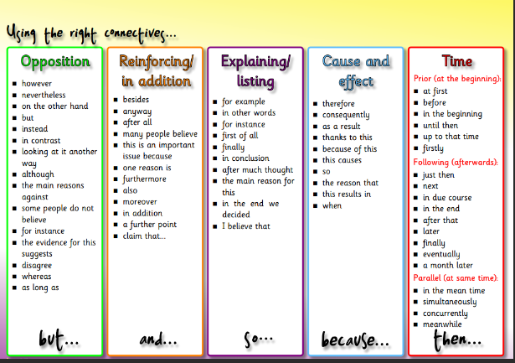

ACTIVITY

Use a suitable connective in the box for each sentence given.

|  |
| --- |
| as long as, because, before,even,till,even though,if,since, until,when,even,as though,  as much as |

1. Please stay home ________afternoon.
2. I was watching TV _________ she came in.
3. You can come ______________ you want.
4. I found the book __________ has the record of his work.
5. I waited for her __________ midnight.
6. I went to bed at 10pm ________ I had a plane to catch at 7am.
7. She usuall eats at home___________ she likes cooking.
8. My work must be finished ____________ afternoon.
9. He works hard everyday __________ on Sunday.
10. Let me know________ you go to school.
11. It seems _______________ she is in trouble.
12. ________________ it rained alot,we enjoyed the holiday.
13. I hate broccoli ______________I hate cauliflower.

ACTIVITY 2

Complete the sentences below

1. We hoped to go the beachside but ________________________________________________________________
2. You can go out shopping as long as _________________________________________________________________
3. John studied a lot yet _________________________________________________________________
4. He didn’t talk to his friends nor ________________________________________________________________
5. Pita was sick however_________________________________________________________________
6. We went to the football match while _________________________________________________________________.

LESSON 44

STRAND: Reading and Viewing

SUBSTRAND: Language Feature and Rules/TENSES

LESSON OUTCOME: study the table to know the different tenses in English and how each

type indicate time.

* apply the tense rules to the given activities.

TENSES

|  |  |  |
| --- | --- | --- |
| SIMPLE PRESENT TENSE  I/They *exercise* everyday | SIMPLE PAST TENSE  I/They *exercised* yesterday. | SIMPLE FUTURE TENSE  I *will exercise* everyday |
| PRESENT CONTINUOUS TENSE  I/They *are exercising* now | PAST CONTINUOUS TENSE  I/They *were exercising* yesterday | FUTURE CONTINUOUS TENSE  I/They *will be exercising* tomorrow |
| PRESENT PERFECT TENSE  I *have exercised* today | PAST PERFECT TENSE  I *had exercised* yeaterday | FUTURE PERFECT TENSE  I *will have exercised* tomorrow |

Try doing a number of exercises using different verbs

ACTIVITY

Identify the tense used in each of the following sentences:

1. She has lived in Nadi for more than 10 years now.
2. I finished all the worksheets
3. Salote will be leaving for Suva today
4. Have you ever been to Australia?
5. The little girl wakes up crying.
6. The car had been taken to the garage.
7. I have been doing this work since two years ago.
8. Mereseini took all her books home.
9. She will come with us
10. By this time tomorrow, I will have finished working on it.

ACTIVITY 2

Change the verb according to the tense given in the bracket.

1. My mum was furious with me. (Change to simple present)
2. I will plant all these tomato seedlings today. (Change to present perfect)
3. The boat is berthing at Savusavu wharf. (Change to future tense)
4. I had taken the task seriously. (Change to present continuous)

LESSON 45

STRAND- Reading and Viewing

SUBSTRAND - Language Feature/CONNOTATION AND DENOTATION

LESSON OUTCOME - Know the meaning of the concepts,their difference and usage.

WHAT ARE CONNOTATION AND DENOTATION??

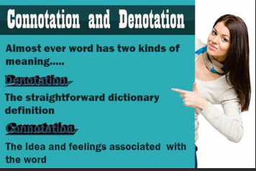

- It is very important to consider both denotation and connotation as you communicate.

EXAMPLES:

1. He is **childish**

Denotation - like a child

Connotation - immature [**Childish** is also referred to people who are said to be

immature or behaving like a child. This is negative connotation]

1. This is **cheap**

Denotation - low in cost

Connotation - poor quality

1. A **new** version

Denotation - made recently

Connotation - improved

Look at this:

|  |  |
| --- | --- |
| Positive Connotation | Negative Connotation |
| My cousin Carl is *clever*  He asks questions because he is *curious* | My cousin Carl is *sly*  He asks questions because he is *nosy* |

\**The dictionary definition of the word* ***clever*** *means almost the same as the dictionary definition of* ***sly****. The words have similar denotations. The words* ***curious*** *and* ***nosy*** *also have similar denotations. However, they have very different connotations.The words we use carry feelings. The reader uses these feelings to form opinions.*

ACTIVITY : The words in each of these pairs could refer to the same thing. In each pair, which one has a negative connotation.

1. Slim/skinny ______________
2. Cheap/inexpensive__________
3. Invest/gamble______________
4. Trailer/mobile home________________
5. Innocent/naive

ACTIVITY 2

Find the connotation and denotation of the following words

|  |  |
| --- | --- |
| Denotation | Connotation |
| home - |  |
| rose - |  |
| monkey- |  |
| Pest - |  |

LESSON 46

STRAND -Reading and Viewing

SUBSTRAND- Language Feature / CONDITIONAL SENTENCES

LESSON OUTCOME – Read the notes thoroughly to know the types of conditional sentences.

**5 Types of Conditional Sentences**

 Here’s a brief chart summarizing the 5 types of conditional sentences and how they’re used:

|  |  |  |  |
| --- | --- | --- | --- |
| **Conditional sentence type** | **When to use** | **Main clause** | **If-clause** |
| Types | Describing known facts | Simple present | Simple present |
| Type 1 | A possible situation and the result | Will + infinitive | Simple present |
| Type 2 | A hypothetical condition and its possible result | Would + infinitive | Simple past |
| Type 3 | An impossible past situation and its result in the past | Would + perfect infinitive | Past perfect |
| Mixed Conditionals | An impossible past situation and its result in the present | Past perfect | Present conditional |

**Type Zero Conditional Sentences (zero condition)**

This type of conditional sentence is used to describe scientific facts, generally known truths, events and other things that are always true.

I think it’s the simplest type of conditional sentence in English.

**The structure of Type Zero conditional sentences:**

Main part: Present Simple; *if* part: Present Simple

Examples:

* Water **boils if** you **heat** it to 100 degrees Celsius.
* A red light **comes** on **if** you **press** the main button.

In Type Zero sentences, *if* can be replaced by *when*.

Examples:

* **When** you heat ice, it **melts**.
* It **gets** dark **when** the sun **goes** down.

**Type One Conditional Sentences (open condition)**

This type of sentence expresses real and possible situations in the future; it is possible for the condition to be met.

**The structure of Type One conditional sentences:**

Main part: will + infinitive; *if* part: Present Simple

Examples:

* We **will stay** at home **if** it snows.
* She **will get** angry **if** I‘m late for the party.
* **If**we **get** the money for this job, we **will** buy a new car.
* **Will** you **help** Amanda **if** she asks you?

**Type Two Conditional Sentences (half-open condition)**

This type of conditional sentence describes an unreal situation with regard to the present or future; a hypothetical condition that can only be fulfilled in theory.

**The structure of Type Two conditional sentences:**

Main part: would + infinitive; *if* part: Past Simple

In conditional sentences, the past tense form of the verb *to be* is *were* for all persons; *was* is also used, although only in spoken or conversational English.

Examples:

* We **would stay** at home **if** it **snowed**.
* I **would buy** a new board **if** I **had** more money.
* If he **were** rich, he‘**d buy** an island.
* If you **left** now, you‘**d catch** the last bus.

Type two conditional sentences are also used when making polite requests.

Examples:

* I **would be** grateful **if** you **helped** me.
* He **would be** so pleased **if** you **came** to the birthday party.

The phrases *If I were you* or *If I were in your place* are usually used to give advice.

Examples:

* **If I were you** I would accept the offer.
* **If he were in your place** he would do it.

**Type Three Conditional Sentences (closed condition)**

Type three conditional sentences are used to express situations that cannot exist, such as actions or events that happened in the past. They are often used to indicate a missed opportunity.

**The structure of Type Three conditional sentences:**

Main part: would + perfect infinite; *if* part: Past Perfect

Examples:

* If you **hadn’t been late** for work, the boss **wouldn’t have gotten** furious.
* They **would have finished** earlier if the meeting **hadn’t been held** so late.
* If I **had won** the lottery, I **would have bought** a house by the sea.
* **Would** you have **helped** me **if I had asked** you?

**Mixed Conditionals**

This type of conditional sentence uses (mixes) different parts of the above-mentioned conditional sentence types.

There are a few combinations: the condition emphasizes the result of the action in the present in the past tense, or the present-day condition emphasizes the result of the action in the past.

Examples:

* If you **had taught** me how to make waffles (in the past), I **wouldn’t have to buy** them in a shop (now).
* I **would buy** a house by the sea (now or in the future) **if I had won** the lottery last week.
* Their team **would have scored** more in the match yesterday **if** they **were** good players.

**Important Grammatical Notes**

If the modal verbs **can/could**, **may/might** or **should** are used in the main part of the sentence, they take the place of **will**:

* We **can go** to the seaside **if** you **have** time tomorrow.
* **If**you **leave** now, you **may catch** the last bus.
* **If** you **want to pass** the exam, you **should** study much harder.

The words **will** and **would** are not usually used in the *if* part, except when they express willingness, for example, in requests (that is, when they carry a modal meaning):

* If you will phone the manager now, he will surely make an appointment with you. (willingness)
* I would be very thankful if you would help me with my homework. (very polite request)

The word **should** in the *if*part can mean “if perhaps” or “by any chance.”

* I would be very happy if he should turn up at the party. (He’s not at all likely to come, but perhaps…)

In negative sentences, **if…not** can be substituted with **unless**.

* You won’t pass the exam **unless** you study very hard. (= if you don’t study very hard)

**If** can be omitted from the sentence if the word order is changed. This is sometimes done in Type Three conditional sentences if the, if part is at the beginning of the sentence, or in Type Two sentences if the verb were, is used:

* Were I rich, I would buy a house by the sea. (= if I were rich)
* Had your cousin come earlier, I would have shown her around the house. (= if she had come earlier)

## Exercise **Conditional Sentences Type I**

Complete the Conditional Sentences Type I.

* If you (go)  out with your friends tonight, I (watch)  the football match on TV.



* I (earn)  a lot of money if I (get)  that job.



* If she (hurry / not) , we (miss)  the bus.



**Conditional Sentences Type II**

Complete the Conditional Sentences Type II.

* If he (try)  harder, he (reach)  his goals.



* I (buy)  these shoes if they (fit) .



* It (surprise / not)  me if he (know / not)  the answer.



**Conditional Sentences Type III**

Complete the Conditional Sentences Type III.

* If we (listen)  to the radio, we (hear)  the news.



* If you (switch)  on the lights, you (fall / not)  over the chair.



* She (come)  to our party if she (be / not)  on holiday.



LESSON 47

STRAND : Reading and Viewing

SUBSTRAND: Everyday Text

LESSON OUTCOME: Read and comprehend the text and write complete answers. COMPREHENSION (15 marks)

Read the passage carefully and answer the questions that follow.

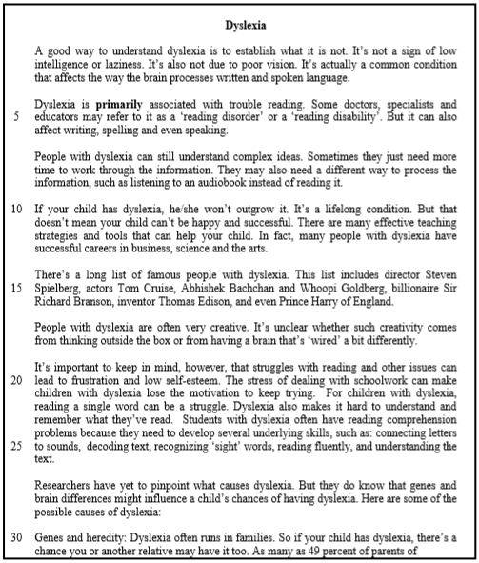

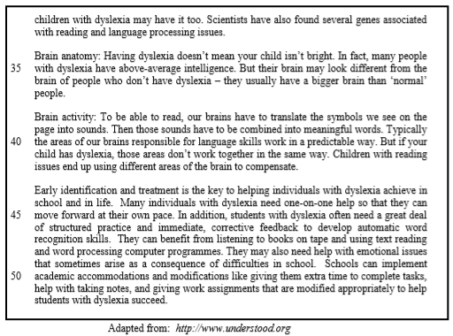

A. **Multiple-Choice Questions** (4 marks)

**Choose the best answer and cirle the best answer**

1. According to the first paragraph, **dyslexia** is

A. a sign of laziness. B. a brain condition. C. caused by poor vision. D. a sign of low intelligence.

2. The word **primarily** (line 4) is synonymous with

1. mainly. B. deliberately. C. strategically. D. advantageously.

3. Which one of the following statements about dyslexia is accurate?

A. It affects listening and speaking. B. It is a lifelong condition that can be cured. C. All children with the condition are creative. D. Children with the condition need time to process written ideas.

4. What is the overall tone of the passage?

1. Cynical B. Critical C. Objective D. Subjective

B. **Sentence Completion** (3 marks)

**Complete the following sentences in your Answer Booklet using the ideas given in the passage. Try to use your own word(s) where possible**.

1. According to the passage, dyslexia affects _____________________________________________________________________________________________________________________________________________________________________________________________. (1 mark)
2. For dyslexics one way of processing information is _____________________________________________________________________________________________________________________________________________________________________________________________. (1 mark)
3. ______________________________________________________________________________________________________________________________ can result in loss of motivation. (1 mark)

C. **Open-ended Questions**  (8 marks)

Use your own words as far as possible to answer the questions given below. Write complete sentences.

8. Give a reason why the author has included a list of famous dyslexics. (1 mark)

9. In your own words, describe one problem that children with dyslexia may have. (2 marks)

10. State the **three** causes of dyslexia. (3 marks)

11. Describe the importance of at least one of the solutions identified in the last paragraph. (2 marks)