WEEK 4 ENGLISH
YEAR 12 LESSON NOTES
LESSON 53
STRAND: Reading and Writing
SUBSTRAND: Literature Feature/Poetry
LESSON OUTCOME: listen attentively, read, interpret, and relate the poem
BACKGROUND TO PROGRESS IN THE PACIFIC:
Pacific writers of the 70s and 80s focused a lot on controversial lifestyle trends adopted by Pacific people through the process of change and modernization. Konai Helu Thaman, Albert Wendt, Vilisoni Heneriko and others wrote poems, short stories and plays to portray mirror images of their perceived reality of life in their Pacific communities.
In a lot of poems in Possibilities, the poets are lamenting the loss of Pacific Island cultural independence and traditional supremacy to the more attractive and more versatile “foreign” social system.
We have often heard that all societies change over time. We have also heard that all societies must develop and progress to avoid being left behind in this massive movement known as globalization. At what cost?
We as young people are now caught in a system that has elements of both world - the traditional cultural Pacific and modern internationally recognized island economies. What has resulted out of this dual existence is social inconsistencies, personal dilemmas and widespread hyprocrisy. While one hand is protectively covering culture and traditions, the other is groping to find progress and modernization.
One powerful tool of implementing change and progress is the modern education system.
The two poems we are studying are both about young people going through the system and learning it with sentiments.

In Konai Helu Thaman’s “Reality”, the poem ends with
An old man close by whispers
Come fishing with me today
For you have a lot to learn yet
Clearly, Thaman is stating that western, modern education is not “everything”. One needs the old and the new.
What about the poem “Kidnapped”, by Ruperake Petaia? What does it propose in relation to the topic of the role of western education in the lives of people in ‘developing, progressing’ Pacific societies?

POEM STUDY:
KIDNAPPED
This poem was published by Petaia in his 1980 collection of poems called “Blue Pain”
Petaia is of Samoan origin. His works have mostly been responses to the effects of colonialism and western influence on Samoan culture and society.
Kidnapped has been labelled a satirical poem raising concerns about the loss of traditional Samoan knowledge. Why? How? Everyone has been concentrating on the new education system. Just like the young man in Konai Helu Thaman’s poem “Reality’ who went off to pursue his modern education and came back home to be laughed at and to be told by the old man…”Come fishing with me….”

TITLE : KIDNAPPED
POET : RUPERAKE PETAIA

I was six when
Mama was careless
she sent me to school
alone
Five days a week

One day I was
kidnapped by a band
Of Western philosophers
armed with glossy-pictured
textbooks and
registered reputations
Holder of BA
and MA degree

I was held
In a classroom
Guarded by Churchill and Garibaldi
pinned up on one wall

and
Hitler and Mao dictating
from the other
Guevara pointed a revolution
at my brains
from his Guerilla Warfare

Each three-month term
they sent threats to
Mama and Papa

Mama and Papa loved
their son and
paid ransom fees
each time

Each time
Mama and Papa grew
poorer and poorer
and my kidnappers grew
richer and richer
I grew whiter and
Whiter

On my release
Fifteen years later
I was handed
(among loud applause
from fellow victims)
a piece of paper
to decorate my walls
certifying my release.

The Significance of the title Kidnapped
Petaia chose to call this poem “Kidnapped’. This is an emotive verb, with negative connotations. When one is kidnapped, he/she is taken against her will, leaving behind family and safety. So right from the beginning of this poem, Petaia establishes a critical tone for those that came to the society forcing the island children to leave the comfort of their own homes and enter an alien, unfamiliar education system, a system that kept them imprisoned for fifteen years.
Content Analysis
Stanza 1
This stanza describes the beginning of the persona’s involvement with western education. It happened when he was six and he blames his mother for allowing it to happen. Mama was careless.
Stanza 2
The person describes his secondary years as the kidnapping period. Teachers with university qualifications and western ideologies took over his education, overpowering him with attractive textbooks and glorious reputations.
One day I was
kidnapped by a banned
of Western philosphers
Stanza 3
In this stanza, Petaia allude(mention in passive) to the education curriculum and how foreign topics and subjects are taught to the Pacific mind. The names of famous world rulers Mao, Hitler, Churchill stress the onslaught of foreign elements on the islanders. The result is near insanity as the persona notes.
Guevara pointed a revolution
At my brains
Stanza 4
This stanza equates school fees to ‘ransom’ notes. When one is kidnapped, a ransom note contain the kidnappers demand as to how much the family has to pay to get their loved ones back.In the Pacific, most schools have three school terms and school fees are paid each term.

Stanza 5
Here, the persona summaries the effect of the years of western education on his family, his kidnappers and on himself. This is a very symbolic stanza, containing Petaia’s strongest comment on the process of change, westernization and social progress.
Stanza 6
The person refers to his graduation, the end of years of studying under the western education system. He gets a document (degree) and is congratulated by fellow Pacific islanders (or fellow victims). He has been released…
ACTIVITY PARAGRAPH WRITING (5marks)
Discuss what this poem is about.
_____________________________________________________________________
__________________________________________________________________________________________________________________________________________________________________________________________________________________________________________ _________________________________________________________________________________________________________________________________________________________________________________________________________________________________________________________________________________________________________________________________________________________________________________________________________________________________________________________________________________________________________________________________________________________________________________________________________________________________________________________________________________________________________________________________________________________________________________________________________________________________________________________________________________________.

LESSON 54
STRAND – Reading and Viewing/Writing and Shaping
SUBSTRAND – Literature Feature / KIDNAPPED
LESSON OUTCOME – justify the title of the poem.

ACTIVITY PARAGRAPH WRITING (5marks)
In a paragraph, explain how suitable is the title “Kidnapped” .Quote lines to support your points.
____________________________________________________________________________________________________________________________________________________________________________________________________________________________________________________________________________________________________________________________________________________________________________________________________________________________________________________________________________________________________________________________________________________________________________________________________________________________________________________________________________________________________________________________________________________________________________________________________________________________________________________________________________________________________________________________________________________________________________________________________________________________________________________________________________________________________________________________________

LESSON 55
STRAND: Reading and Viewing/Writing and Shaping
SUBSTRAND: Literature Feature: Poetry/KIDNAPPED
LESSON OUTCOME: relate the poem to their own society
RELATING THE CONTENT OF THE POEM TO LIFE IN THE PACIFIC (and in Fiji)
Social annihilation through modern education is a central focus in national development. Governments spent huge segment of their budget on the education sector in the belief that a successful society is one where the citizens are well educated. However, a lot of students fail in the system. They are labelled as failures and under achievers. But in their own environment, in the village, they are skillful. They carry out traditional skills that educated people cannot do. However, their knowledge and skills are not given prestige. This is a cultural lesson: Let us not see progress only in terms of Western practices. Give respect to the islanders and not ‘kidnap’ their lives and minds. Let them choose their type of education.
- Cultural Assimilation
When traditional people allow western lifestyle to dictate their lifestyle, the western culture will take over and become dominant. Progress and development will create the situation in stanza 5.
I grew whiter and whiter becoming ‘more like Europeans’ and less of an islander. Many Pacific people have this nature now. They are assimilated into the new introduced lifestyle.
Lesson: Do not abandon your culture for the sake of education. Be wise, to control both worlds.
- Progress and Poverty
In their traditional set up,islanders enjoyed a healthy,wealthy lifestyle. But when move to urban areas to pursue employment to pay for their new life, poverty and other social problems besiege them.Stanza 5 says:
Mama and Papa grew
poorer and poorer
Lesson : You will not die if you don’t gain the modern way.
There is nothing inferior about village life. If you are struggling in town, pack up and go back to the village.

- Progress and Globalization
One of the main causes of development and modernization is economic advancement. Acquiring material possessions and owning modern houses and gadgets seem to be the target for Pacific islanders, including Fijians.
Unfortunately with every step, someone benefits, someone loses. As Petaia wrote in Stanza 5 and “my kidnappers grew richer and richer.
This is also applicable at the global level. Some countries are getting richer and richer at the expence of smaller, less powerful nations.

ACTIVITY PARAGRAPH WRITING (5marks)
Discuss how the poem “Kidnapped’ is applicable to your society.
_____________________________________________________________________
________________________________________________________________________________________________________________________________________________________________________________________________________________________________________________________________________________________________________________________________________________________________________________________________________________________________________________________________________________________________________________________________________________________________________________________________________________________________________________________________________________________________________________________________________________________________________________________________________________________________________________________________________________________________________________________________________________________________________

LESSON 56
STRAND: Reading and Viewing
SUBSTRAND: Literature Feature/Poetry/KIDNAPPED
LESSON OUTCOME: identify the poetic styles used in the poem and their effectiveness.
POETRY STYLES USED BY PETAIA
NO | Feature of style | Significance and effects
1 | Narrative tone | This poem reads like a story each stanza a step in the story, from the beginning of the persona’s education to his graduation. The narrative style is illustrated by the first line of every stanza  I was six…  One day…  The style adds interest to the poem
2 | Sound appeal | The poem sound poetic and rythmic with Petaia’s choice of words and syllables.Stanza 1 is dominated by single syllable words and alliteration in the letter ‘s’.  The pattern of sound and rythm makes the poem enjoyable to read.
3 | Word Annotation | Example :  Mama was careless (stanza 1)  This is a metaphor to question the mother’s wisdom in allowing her son to become part of the new world.
4 | Powerful imagery | Stanza 2 describes those that educated the persona. The words used;  A band of western philosophers  Armed with glossy-pictured textbooks  Stanza 3 describes the curriculum guarded by Churchill and Garibald.These words create images in our minds that portray a very aggressive system.
5 | Repetition | In stanza 5, the persona repeats concepts  Mama and Papa grew  poorer and poorer..  and kidnappers grew  richer and richer  I grew whiter and whiter  This style emphasises ideas.
6 | Unique word conspirations | Petaia has used several creatively combined words to create suitable moods and emotions in his poem.In stanza 2, he calls the teachers as having registered reputations  In stanza 3, he wrote Guevara pointed revolution at my brain
 |  | These statements carry the poets sarcasm and criticisms of the way the Pacific people were ‘changed’ in the early periods of modernisation
7 | Allusion to famous names from world leaders | Stanza 3 contains names of past world leaders. Their international significance in world politics and economy add substance to the poem focus on ‘small’ societies bowing to the wishes and ways of ‘big’ powers.

ACTIVITY PARAGRAPH WRITING (5marks)
Discuss two poetic styles used by Petaia in his poem and discuss how effective they are.
_____________________________________________________________________
___________________________________________________________________________________________________________________________________________________________________________________________________________________________________________________________________________________________________________________________________________________________________________________________________________________________________________________________________________________________________________________________________________________________________________________________________________________________________________________________________________________________________________________________________________________________________________________________________________________________________________________________________________________________________________________________________________________________________________________________________________________________________________________________________________________________________________________________________ .

LESSON 57
STRAND – Reading and Viewing
SUBSTRAND – Language Feature/ IDIOMS
LESSON OUTCOME – have a better knowledge about idioms and usage.
MORE ON IDIOMS
RECAP
- Idioms are words, phrases or expressions which are commonly used in everyday conversation
- They are metaphorical to make the language more colorful.
- You can use them to express something more vividly and more briefly.
- They serve as an image or mental picture.
- Remember that idiomatic expressions are mostly used when speaking informally.
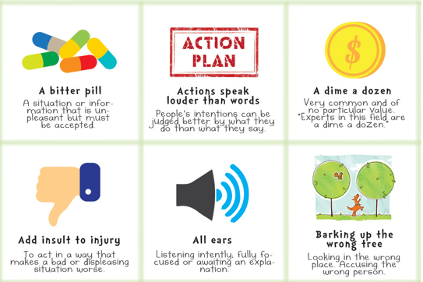
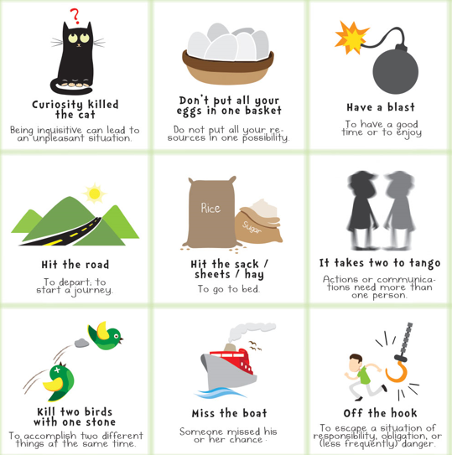
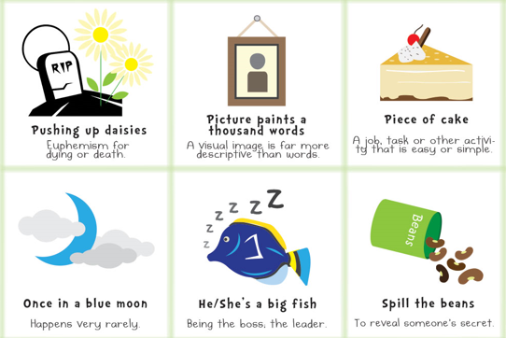E

Everyday Idioms
A grey area - Something unclear
A rip-off - Too expensive
Add fuel to the fire - To add more to an existing problem
As easy as ABC - Something is very easy
Call it a day - Time to quit
Cool as a cucumber - To be very calm under stress
Crack a book - Open up a book and study
Down to the wire - At the last minute
Draw a blank - Can't remember
Fill in the blanks - Provide more information
Get a kick out of it - Really enjoy/like something
Get your act together - Behave properly
Give it a shot - To try to do something
Have mixed feelings - Be unsure of how you feel
Have second thoughts - Have doubts
In hot water - Be in trouble
In the same boat - Be in the same situation
It's in the bag - It's a certainty
I've got your number - To say you can't be fooled by someone since you have them figured out
Miss the boat - You missed your chance
Mumbo jumbo - To call something total nonsense
Out of the blue - With no warning
Pass with flying colors - To succeed at something easily
Piece of cake - Something very easy
Read between the lines - Find the hidden meaning
Second to none - The best
The icing on the cake - Something additional that turns good into great

Body Part Idioms

Cross your fingers - For good luck

Fell on deaf ears - People wouldn't listen to something

Get cold feet - Be nervous
Giving the cold shoulder - Ignore someone
Have a change of heart - Changed your mind
I'm all ears - You have my full attention
It cost an arm and a leg - It was expensive
Play it by ear - Improvise
See eye to eye - Agree
Slipped my mind - I forgot
Speak your mind - Say what you really feel

Animal Idioms
A bull in a china shop - Someone who is very clumsy
A little birdie told me - Someone told me a secret
Bee in her bonnet - She is upset
Birdbrain - Someone who is not very smart
Busy as a bee - To be very active and working hard at something
Cat got your tongue? - Why aren't you talking?
Cry crocodile tears - To pretend to be upset
Curiosity killed the cat - Asking too many questions may get you in trouble
Different kettle of fish - Something completely different
Doggy bag - A bag to take home leftovers from a restaurant
Fish out of water - Being somewhere you don't belong
For the birds - Something that is not worth anything
Get off your high horse - Quit thinking you are better than others
Goose is cooked - Now you're in trouble
Hold your horses - Wait a minute
Horse of a different color - Something that is quite different, a separate issue
Hot dog - A person doing athletic stunts that are dangerous
Let the cat out of the bag - Tell a secret
Make a mountain out of a molehill - Make something unimportant into a big deal
Night owl - Someone who stays up late
Pig out - To eat a lot
Put a bug in his ear - Make a suggestion
Raining cats and dogs - It is raining very hard
Snail's pace - To move extremely slow
Stir a hornet's nest - To cause a lot of trouble
Teacher's pet - The teacher's favorite student
The world is your oyster - You can achieve whatever/go wherever you want
When pigs fly - To say something is impossible
Wolf in sheep's clothing - A person who pretends to be nice but is not
You can't teach an old dog new tricks - It's harder for older people to learn new things
Unique Expressions
Idioms are a unique way to get your point across, and show just how fun language can be. Now that you've seen some suitable examples of idioms for kids you can see that it's a piece of cake to show your witty side by using an idiom in writing or conversation.

ACTIVITY
Guess what it means.
- Mary has got a sweet tooth.
- My tooth hurts
- I have pretty teeth
- I like sweets

- Bob is pulling your leg.
- She makes me fall down
- She’s joking with me
- She’s pulling on my leg

- To have a heart of gold
- Someone is nice
- Someone is sad
- I’m going to give you money

- He’s a couch potato
- He watches tv and is lazy
- He likes potatoes
- He found a potato on the couch

- Don’t let the cat out of the bag
- Don’t let my cat escape
- Don’t give away the surprise
- The cat ran away

- Hold your horse
- Don’t let the horse run
- Find the horses
- Wait patiently

- That’s a piece of cake
- I like cake
- That’s easy
- There’s a piece of cake

- Hit the books
- Books are hard to hit
- It is better to hit books than people
- It is time to study

- You crack me up
- You make me laugh
- You hurt me
- You woke me

