Year 12 Computer Studies
Week 3 Lesson Notes and Worksheet.
Lesson 46
LO: discuss on the data transmission specifications
Data transmission specifications
- Specify the rules and speeds at which data is transmitted over the network.
- Protocols specify the rules and bandwidth specify the speed.

Protocols
- Rules for exchanging data between computers.
- The standard protocol for the internet is TCP/ IP (transmission control protocol/Internet protocol).
- TCP/IP is a two-layer protocol.
- Transmission Control Protocol- it is the higher layer, it assembles the message or file into smaller packets that are transmitted over the Internet and received by a TCP layer that reassembles the packets into the original message, the process is known as packetization.
- Internet Protocol- the lower layer, handles the address part of each packet so that it gets to the right destination. Each gateway (router/server) on the network checks this address to see where to forward the message. Even though some packets from the same message are routed differently than others, they will be reassembled in the original order at the destination.
- This process is known as identification.
- TCP/IP uses domain name servers (DNS) that converts the numeric based IP address into text based address
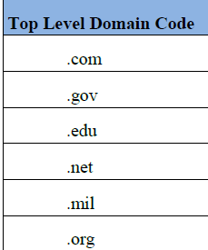

Lesson 47
LO: Define and differentiate the categories of bandwidth.

- Bandwidth is the capacity of the communication channel that determines the volume of data that can be transmitted in a given amount of time. (Speed).
- . Bandwidth is measured in bits per second (bps).
- The diagram below shows the bandwidth for each channel type 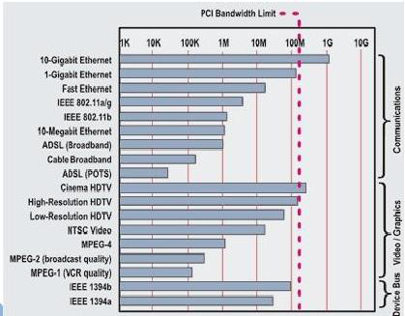

There are four categories of bandwidth.
- Voiceband also known as low bandwidth, is used for standard telephone communication.
- Medium band is used in special leased lines to connect servers as well as transmit data over long distances.
- Broadband is widely used for DSL, cable and satellite connections to the internet.
- Baseband is widely used to connect individual computers that are located close to one another.

Lesson 48
LO: Describe the types of telephone lines.

TYPES OF TELEPHONE LINES
- Communication outside a LAN can be made possible through the use of modems and telephone lines. There are two types
      - LEASED LINE (DEDICATED LINE)- A leased line is also called a dedicated line. It is a special telephone line that would be used solely for data communication by an organisation.
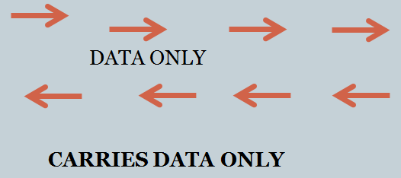
      - SWITCHED LINE- A switched line can be used for both voice and data communication. This line caters for only type of activity at any given moment, either voice or data communication.
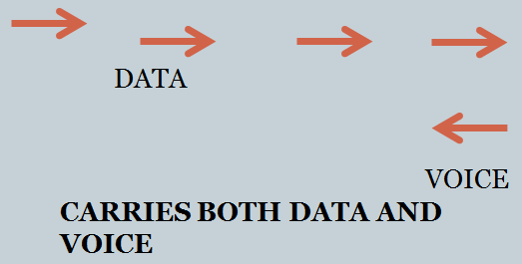

Lesson 49
LO: Describe the methods and modes of data transmission.

Methods and modes of data transmission
Methods by which signals are transferred:
- Asynchronous transmission- In asynchronous transmission, the method frequently used with microcomputers, data is sent and received one byte at a time.
Asynchronous transmission is often used for terminals with slow speeds.
ADVANTAGE-data can be transmitted whenever convenient for the sender.
DISADVANTAGE- relatively slow rate of data transfer.
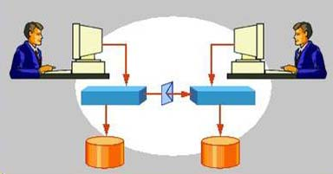
- Synchronous transmission - -is used to transfer great quantities of information by sending several bytes or a block at a time.
For the data transmission to occur, the sending and receiving of the blocks of bytes must occur at carefully timed intervals. Thus, the system requires a synchronized clock
ADVANTAGE- data can be sent very quickly.
DISADVANTAGE- the cost of the required equipment.
- These signals allow computers to transfer data between components within the computer or between the computer and an external network.

Lesson 50
LO: Describe the three directions of data transmission in communication system.
Direction of Data Transmission (Flow)
- There are three directions or modes of data flow in a data communications system.
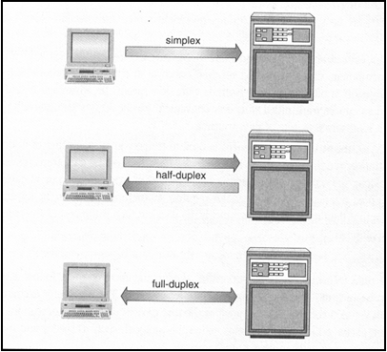
- Simplex communication -resembles the movement of cars on a one-way street. Data travels in one direction only
- Half-duplex communication, data flows in both directions, but not at the same time.
- Full-duplex communication – allows simultaneous message exchange in both directions.

Week 3 Worksheet
True/False
- In asynchronous communication, both the sending and receiving devices must work on the same clock rate. ____
- If you use a modem for your internet connection, the channel type is full duplex. ____
- Weather affects the transmission over the wireless medium. _______.
- A communication system is made up of sending and receiving devices only. ____

- Data specification transmission is usually referred to as protocols. ____
- Bandwidth is measured in bytes per second. _____

- Wi-Fi stands for Wireless Fidelity. ________.
Completion
- In a __________ communication, a connection must be established between the sending and receiving device before data transmission can occur.
- _________ duplex channel carries signal both ways but through separate wires.
- Asynchronous transmission is also known as _____________transmission.
- _________ is a short range RF that can transmit data in any direction.
- The signals carried over the telephone lines are __________ signals.
- A (n) __________ device that coverts digital signals to analog and vice versa.
- _____________ cables transmit data as pulses of light.

Short Answer Questions
- List some factors that affect the transmission through physical mediums?
________________________________________________________________________________________________________________________________________________________________________________________________________________________
- How can the factors mentioned in (a) be minimized?
________________________________________________________________________________________________________________________________________________________________________________________________________________________
- Give at least one advantage of asynchronous transmission over synchronous transmission?
________________________________________________________________________________________________________________________________________________________________________________________________________________________

- Give at least two weaknesses of wireless communication systems.
________________________________________________________________________________________________________________________________________________________________________________________________________________________

