Year 12 Computer Studies
Week 10: Lesson Notes*

Lesson 81
LO: Differentiating between variables and constants
-VB allows you to set up locations in memory and it gives location name.
- The memory location is called Maximum Integer.
- Memory locations that hold data that can be changed during project execution are called variables.
- Locations that hold data that cannot change during execution are called constants.
- VB reserves an area of memory and assigns it a name called an identifier.
- The declaration statements establish your project’s variables and constants gives them name and specify the type of data type they hold.
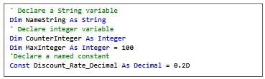

Lesson 82
LO: Discuss data types
- Data types shows what type of information will be stored in the allocated memory space like name/ dollar amount/ date or a total.
- Data types are referred to as classes and the variables are objects of the class.
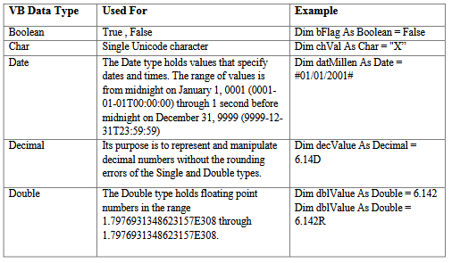
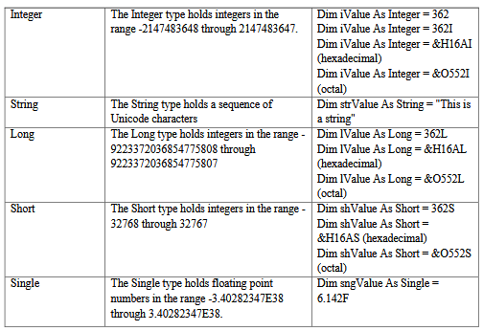
Lesson 83
LO: Discuss the variable naming conventions
- VB needs identifiers for variables and named constants to follow these rules
- Names may consist of letters, digits and underscores
- They must begin with a letter.
- They cannot contain any spaces
- They may not be reserved/ key words.
- We should follow some naming conventions:
- Identifiers must be meaningful
- Include the class (data type) of the variable.
- Begin with the data type and then capitalize. Always use mixed case for variables, uppercase for constants.
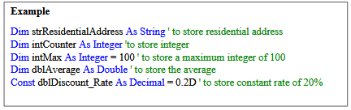
Lesson 84
LO: Discuss the assignment statement and expressions
- Assignment statement consist of a variable name followed by the assignment operator (=), followed by some expression.
- 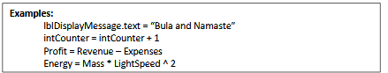
- The assignment statement stores information
- Statements take up a single line with no terminator.
- Statement can be stacked by using a colon (:) to separate them.
- E. g. StartTime= Now: EndTime= StartTIme + 10
- If statements are very long, it may be continues to the next line using the continuation character, an underscore (_).
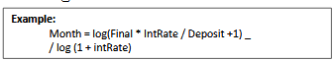
- Comments statements may begin with the keyword Rem or a single quote (‘)

Lesson 85

LO: Discuss the VB operators

- The simplest operators carry out arithmetic operations. These operators in their order of precedence are:
Operator | Operation
^ | Exponential
*/ | Multiplication and Division
\ | Integer division, Mod/ Modulus
+- | Addition and Subtraction
- There are six comparison operators in VB
Operator | Comparison
> | Greater than
< | Less than
>= | Greater than or equal to
<= | Less than or equal to
= | Equal to
<> | Not equal to

- The result of a comparison operation is a Boolean value (True or False)
- We use three logical operators
Operator | Operation | Effect
Not | Logical not | Simply negates an operand
And | Logical and | Returns a true if both operand is true Else it returns a false
Or | Logical or | Returns a true if either of its operands is true, Else it returns False.
Logical operators follow arithmetic operators in precedence.

Week 10: Worksheet
- Define the following:
- Identifier
______________________________________________________________________________________________________________________________
- Variables ______________________________________________________________________________________________________________________________

- Constants ______________________________________________________________________________________________________________________________

- Define and describe data types.
______________________________________________________________________________________________________________________________
______________________________________________________________________________________________________________________________

- List the four rules when naming variables.
______________________________________________________________________________________________________________________________
______________________________________________________________________________________________________________________________

- When naming variables, describe the three major rules.
______________________________________________________________________________________________________________________________
______________________________________________________________________________________________________________________________

- Discuss assignment statement.
______________________________________________________________________________________________________________________________

- State the operation or the operator for the following table.
Operator | Operation
 | Exponential
*/
\
+-
Operator | Comparison
>
 | Less than
 | Greater than or equal to
<=
=
 | Not equal to

