Year 12 Computer Studies
Week 9: Lesson Notes*

Lesson 76
LO: discuss the logical structures- iteration/ repetition structure
Iteration/Repetition (Loop) Structure
- The loop/ iteration structure describes a process that may be repeated as long as a certain condition remains true.
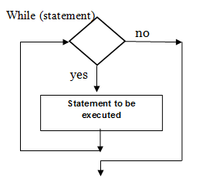

Lesson 77
LO: Discuss Pseudocode Writing
- Another technique called pseudo code (pronounced ―soo-doo-code‖) is rapidly increasing in popularity.
- Also known as Structured English, allows a programmer to use English like sentences to write an explanations of what the program is supposed to do.
- The programmer uses certain keywords in much the same manner as if writing in a structured programming language.
Example
The Pseudocode to calculate the average of three numbers will be similar to the following:
Start Procedure
Input three numbers
Calculate Total = Number 1 + Number 2 + Number 3
Calculate Average = Total / 3
Display Average
End of Procedure

Lesson 78

LO: create a program using visual studio IDE

Program specification

Example
You are required to draw a flowchart and create a simple application which will display the message- “Bula and Namaste to all Year 12 students” in a label when the user clicks the Push Me button and will terminate when the user clicks Exist button.

Steps to creating the Visual Basic Program
- Draw a flowchart
Begin

Bula and Namaste to all Year 12 students

End

- Sketch the User interface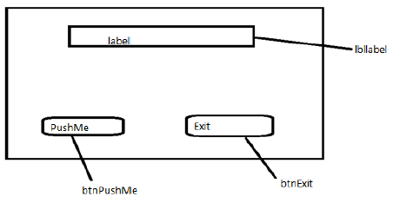
- Plan the Properties
Form | Name: frmHelloWorld  Text: Hello World by [Mere]
Label | Name: lblDisplay  Text: empty
Button1 | Name: btnPushMe  Text: PushMe
Button2 | Name: btnExit  Text: Exit

- Go to Start Menu click on 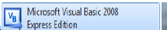 or Go to Start _
All Programs and select 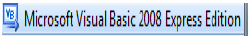
- When you launch VB2008 Express Edition the IDE will appear, as shown in Figure 6. 3
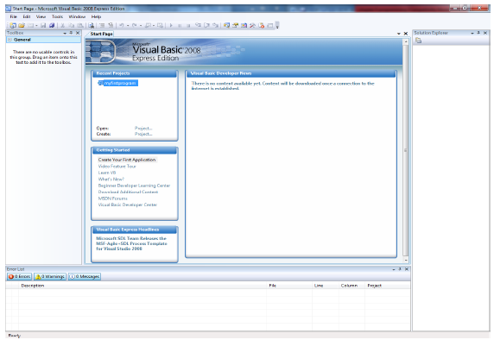

- To start your first application, you need to click on File- Select New Project. The VB 2008 New Project dialog will appear, as shown in Figure 5. 4
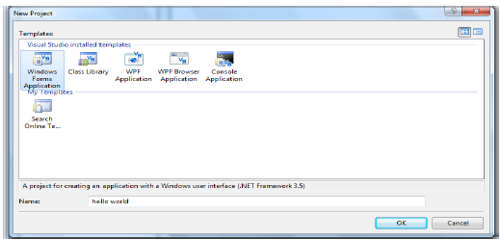
- The dialog box (Figure 5. 4) offers you five types of visual basic projects that you can create. For our purpose, we will select windows form application. At the bottom of this dialog box, you can change the default project name Windows Application1 to some other name you like, for example, Hello World. After you have renamed the project, click OK to continue.

- A new project will appear, as shown in Figure 5. 5. It consists of an empty form, the common controls toolbox, the solution explorer and the Properties Window. (Use the view menu to display the appropriate windows if they are not visible)

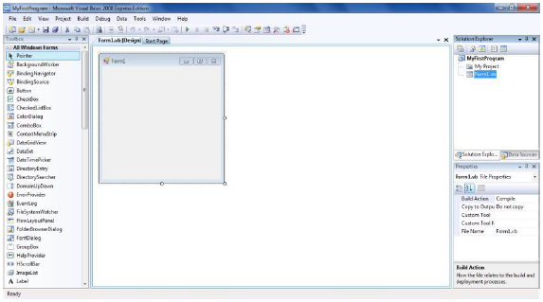

Note: form elements such as buttons, textboxes and labels are also known as Controls and are kept in the toolbox for ease of use. We will use the common control toolbox.
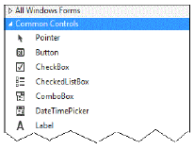

Lesson 79

LO: create a program using visual studio IDE
- Adding a Button
- To add a Button to the form with the Common Controls displayed, do the following: ·
- Locate the Button tool ·
- Drag and Drop or Double click the icon ·
- A button is added to your form
- To move the buttons hold your mouse over the button and drag to a new position. And you can also resize it
- To add a second button and a label to the form. The project should look like the following picture:
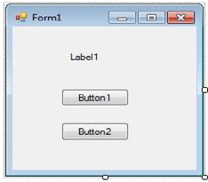
- Customizing user interface
To customize the interface for the user. Click on the control for which you intend to set the property and edit the name and text features Button 1 property is shown below
Form | Name: frmHelloWorld  Text: Hello World by [Mere]
Label | Name: lblDisplay  Text: empty
Button1 | Name: btnPushMe  Text: PushMe
Button2 | Name: btnExit  Text: Exit
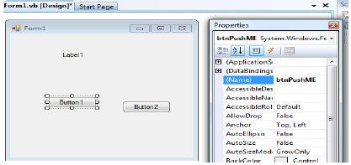
- After changing the property, the user interface should resemble Figure 6. 6
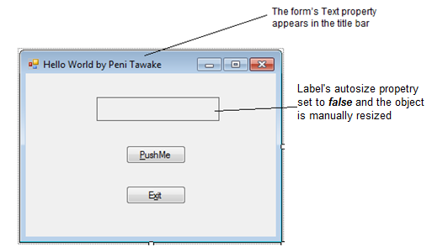
- To run the program, use one of the following three techniques
- From the menu bar click Debug – click start debugging
- Alternatively, click the run button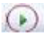 on the toolbar
- Press F5, the keyboard shortcut key to the start debugging command
Your program should now be launched
- Let’s now code the buttons(type only the highlighted line as the procedure should be created automatically on click event)
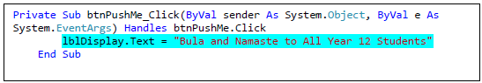
Double click the mouse on Exit button to create the procedure and type the following highlighted line.
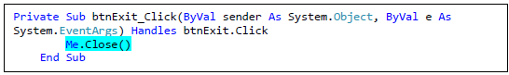
- When you completed, your final project will look like the figure below.
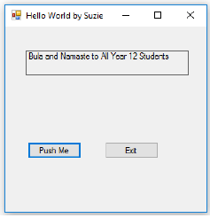
- To save your work, click File > Save All. Click on Browse to verify the location where the file will be saved.
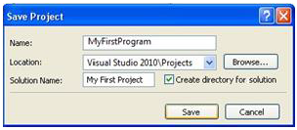

Lesson 80
LO: discuss text boxes
Text Boxes
- Use a text box control when you want the user to type some input.
- If you want to display some text in a text box during program execution, assign a string literal to the Text property:
Text Alignment
- You can set the TextAlign property of text boxes to change the alignment of text within the box. In the Properties window, set the property to Left, Right, or Center.
- In code, you can set the property using these values:
Masked Text Box
- You can only enter the data that conforms to the format of the data when designed.
- For example, the phone number and FNPF number masks do not allow input other than numeric digits.
Group Box
- Usually, groups of radio buttons or check boxes are placed in group boxes.
- Using group boxes to group controls can make your forms easier to understand by separating the controls into logical groups.
Check boxes
- Check boxes allow the user to select (or deselect) an option.
- The Checked property of a check box is set to False if unchecked or True if checked.

Radio Buttons
- Use radio buttons when only one button of a group may be selected.
- The Checked property of a radio button is set to True if selected or to False if unselected.

Picture Box
- A PictureBox control can be used hold an image.
- You can set a picture box‘s Image property to a graphic file with an extension of .bmp, .gif, .jpg, .jpeg, .png, .ico,.emf, or .wmf.

Week 9 Worksheet
- You can display program output in a text box or a label. When should you use a text box? When is a label appropriate?
__________________________________________________________________________________________________________________________________________________________________________________________________________________________________________
- What would be the advantage of using a masked text box rather than a textbox?
__________________________________________________________________________________________________________________________________________________________________________________________________________________________________________

- How does the behavior of radio buttons differ from the behavior of checkboxes?
__________________________________________________________________________________________________________________________________________________________________________________________________________________________________________
- Write the Basic statements to clear the text box called Company TextBox and reset the insertion point into the box.
__________________________________________________________________________________________________________________________________________________________________________________________________________________________________________

- What is the purpose of the Name property of a control?
__________________________________________________________________________________________________________________________________________________________________________________________________________________________________________
- What is the purpose of the Text property of a button? the Text property of a form?
__________________________________________________________________________________________________________________________________________________________________________________________________________________________________________
- Which property determines what appears on the form for a Label control?
__________________________________________________________________________________________________________________________________________________________________________________________________________________________________________
- What does PushButton_Click mean? To what does PushButton refer? To what does Click refer?
__________________________________________________________________________________________________________________________________________________________________________________________________________________________________________
i) Draw a flowchart to find the sum of two numbers and display the sum.

- Draw a flowchart that reads the age from the user and displays whether the person is eligible for voting or not. (Note that voting age in Fiji is 18 and above)

