Year 12 Computer Studies
Week 8: Lesson Notes*

Lesson 71
Lo: Write good visual basic applications.
Planning is a crucial step in programming. Before you start writing a Visual Basic program, a good programmer has to ensure the following:
- Have good design of the user interface
- Define the properties for the elements on the interface
- Design the solution for the problem (algorithm).
Design the user interface
- When planning the user interface, one has to draw a sketch of the screens the user will see when the project is running.
- On the sketch, all the controls that is planned to be used in the application is shown and labeled.
- It is also important to consult with the users and make sure that they agree on the look and feel of the project before proceeding any further.
Plan the properties
- For each object, write down the properties that you plan to set or change during the design of the form.
Plan the solution
- plan the classes and procedures that will execute when the project runs.
- determine which events require action to be taken and then make a step-by-step plan for those actions.
- The actual Visual Basic code will be written later.
- During this planning stage:
- you will write out the actions using Pseudocode-an English expression.
- Some people prefer describing the steps using a flowchart.

Lesson 72

Lo: discuss object naming convention

In the actual program implementation, the programmer does the following:
- Defines the user interface and objects using the IDE.
- Set the properties for the controls.
- Write the actual Basic code.

A convention has been established for naming Visual Basic objects. This convention is to use a three letter prefix (depending on the object) followed by a name you assign. A few of the prefixes are:
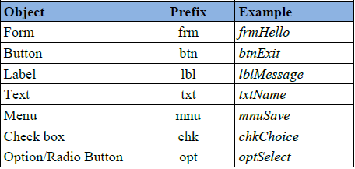
Tip:
When you select a name for an object, Visual Basic requires:
- the name to begin with a letter or an underscore.
- The name can contain letters, digits, and underscores.
- An object name cannot include a space or punctuation mark and cannot be a reserved word, such as Button or Close or End or Print etc.
Lesson 73
LO: describe flow chart symbols
- A flowchart is a diagrammatic representation of a program or a graphic representation of the steps needed to solve the programming problem.
- A flowchart is an outline that depicts (shows) events or actions and the sequence in which the actions must be taken to correctly solve the problem.
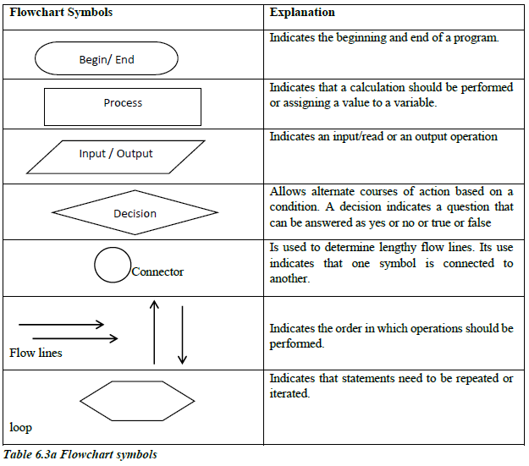

Lesson 74
LO: discuss the logical structures- sequence structure
Three arrangements are used in programming to write structured programs. These are:
- Sequence Structure
- Selection Structure
- Iteration (Loop) Structure
Sequence Structure
- In the sequence structure one program statement follows another. There are no decisions to be made the boxes logically follow one another.
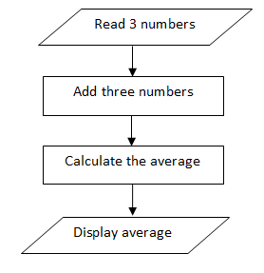
Lesson 75
LO: discuss the logical structures- selection structure
Selection Structure
- The selection structure represents a choice. It occurs when a choice must be made.
- The outcome of this structure offers two (2) paths to follow when a decision must be made by a program.
- If…then…else structure is used to determine which of the two available actions to choose depending on whether a condition evaluates to true or false.
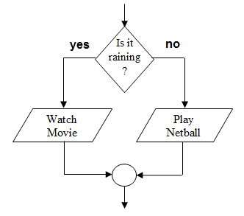

Week 8 Worksheet
- Planning is the most important step in programming, list three things a programmer will ensure before writing a VB program.
_____________________________________________________________________________________________________________________________________________________________________________________________________________________________________________________________________________________________________________________________________________________________________________________________________
- In the actual program implementation, state three things the programmer does.
____________________________________________________________________________________________________________________________________________________________________________________________________________________________________________________________________________________________________________________________
- For the following table write down the object names and an example for each prefixes.
PREFIX | OBJECT | EXAMPLE
frm | Form | frmHello
btn
lbl
txt
mnu
chk
opt

- State the three rules required for Visual Basic when selecting a name for an object.
________________________________________________________________________________________________________________________________________________________________________________________________________________________________________________________________________________________________________________________
- Define a flowchart.
________________________________________________________________________________________________________________________________________________________________________________________________________________________________________________________________________________________________________________________
- Differentiate between sequence structure and selection structure (draw a flowchart to describe the following structures)
______________________________________________________________________________________________________________________________________________________

