**Year 12 Computer Studies**

**Week 6: Lesson Notes\***

**Lesson 61**

**LO:** Describe network strategies

**NETWORK STRATEGIES**

A network strategy describes how resources and information is coordinated and shared.

The most common network strategies are:

1. **Terminal Network**- Processing power is centralized in one large computer (server), which can

handle a large number of connections.

* All nodes connected to this server are either terminals with no or little processing power or microcomputers running special terminal emulation such as Windows Remote Desktop.

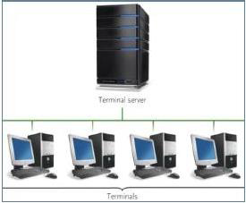

For example, most airline reservation systems are terminal server networks. The server maintains all airlines schedules including rates, seat availability, bookings and light arrival/departures. Travel agents use terminals to connect to the server to make reservations. Although the tickets may be printed along with travel itineraries at the agent‘s desk, nearly all processing is done by the server.

**ADVANATGE:** terminal network systems is the centralised location and the control of technical personnel, software and data

**DISADVANTAGE**: terminal systems do not use the processing power available with microcomputers.

**Lesson 62**

**LO:** Describe network strategies

1. **Client/server** **network**- -the host computer usually the server coordinates resources to other computers (clients) connected to it. The software running on the client requests for information and services from the server which then responds to individual clients. In a network, the client/server model provides a convenient way to interconnect programs that are distributed efficiently across different locations.



* Computer transactions using the client/server model are very common.
* **For example**, to check your bank account from your computer, a client program in your computer forwards your request to a server program at the bank. That program may in turn forward the request to its own client program that sends a request to a database server at another bank computer and to retrieve your account balance. The balance is returned to the bank data client in your personal computer, which displays the information for you.
* **ADVANTAGE:** IT HAS THE ABILITY TO HANDLE VERY LARGE NETWORKS EFFICIENTLY.
* The powerful network management software that monitors and controls the network’s activities.
* **DISADVANTAGE:** the cost of installation and maintenance.

**Lesson 63**

**LO:** Describe network strategies

1. **Peer-to-peer network (P2P)**--nodes have equal processing capabilities and can act as both the client and a server. It is a type of transient internet network that allows a group of computer users with the same networking program to connect with each other and directly access files from one another's hard drives.

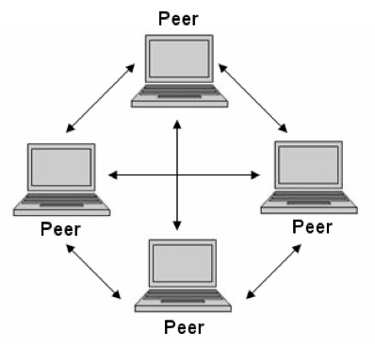

* Limewire and Freenet are examples of this kind of peer-to-peer software. Major producers of content, including record companies, have shown their concern about what they consider illegal sharing of copyrighted content by suing some P2P users.
* Meanwhile, corporations are looking at the advantages of using P2P as a way for employees to share files without the expense involved in maintaining a centralized server and as a way for business to exchange information with each other directly.
* **ADVANTAGE:** P2P network is inexpensive and easy to install, they work well for smaller system (less than 100)
* **DISADVANTAGE:** when the number of nodes increases, the performance of the network declines.

**Lesson 64**

**LO:** Describe network strategies

1. **Distributed processing Network** - processing capability is shared across multiple nodes usually servers dispersed at different locations.

* This strategy is common for very large organizations like banking industries

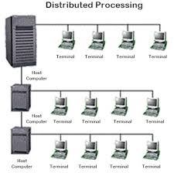

* For example, ANZ bank has it main server in Melbourne Australia, but for Fiji customers, ANZ house has its own server that does the processing for its Fiji customers. The account details are then replicated to the main headquarters servers in Melbourne.
* **ADVANTAGE**: this network has improved sharing, improved availability
* Data can be placed at this site close to the users who normally use that data.
* **DISADVANTAGE:**  increased complexity, cost and security issues, data integrity can be difficult.

**Note**: you cannot have a network setup without either of the network type, topology and strategy. If one is not implemented correctly, the entire network will collapse. So when designing networks, you must first describe the network type to be used, then the topology and finally the strategy. In most cases, the topology in fact indirectly clarifies which strategy and type is appropriate for a particular setup so choosing the topology first helps.

**Lesson 65**

**LO:** Describe organizational networks.

**Organizational Networks**

* An ***internet***provides the network connections that link computers together.



* An ***intranet*** is the name given to a private network that provides similar services to the

internet: e-mail, messaging, web pages, etc. However, these services are only for the users of the intranet – they are private, not public (unlike Internet services which are generally public). Businesses and other organizations often have intranets for use by their employees.

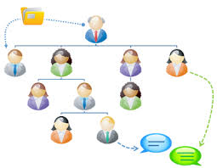

* An ***extranet***is a private network that connects more than one organization. It can be viewed as an extension for an organization ‘s intranet that is extended to users outside the organization.

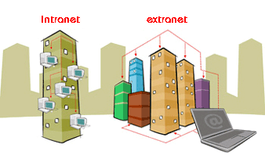

**Week 6: Worksheet\***

1. Define network strategies

__________________________________________________________________________________________________________________________________________

1. Describe terminal network and state its advantage and disadvantage.

_______________________________________________________________________________________________________________________________________________________________________________________________________________

1. Describe client/ server network and state its advantage and disadvantage.

_______________________________________________________________________________________________________________________________________________________________________________________________________________

1. Describe peer to peer network and state its advantage and disadvantage.

_______________________________________________________________________________________________________________________________________________________________________________________________________________

1. Describe distributed processing network and state its advantage and disadvantage.

_______________________________________________________________________________________________________________________________________________________________________________________________________________

1. Draw this four network strategies models: terminal, client/ server, peer to peer and distributed processing network.

|  |  |  |  |
| --- | --- | --- | --- |
| Terminal network | Client/ Server Network | Peer to Peer Network | Distributed Processing Network |
|  |  |  |  |

1. Discuss the three organization network: internet, extranet and intranet.

______________________________________________________________________________________________________________________________________________________________________________________________________________________________________________________________________________________________________________________________________________________________________________________________________________________________