Year 12 Computer Studies
Week 5: Lesson Notes*
Lesson 56
LO: discuss the types of network topology.
NETWORK TOPOLOGY
There are six different topologies that exist today. These are:
- Bus network - In this type of network, each device in the network handles its own
communication. There is no host computer or server and all communication travels along a common connecting cable called a bus.
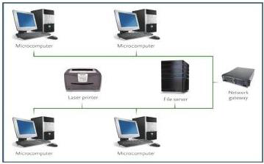

WHEN TO USE BUS NETWORK TOPOLOGY?
- When only a few microcomputers are to be linked together. The networks efficiency decreases as the number of microcomputers connected on the network increases. (<10) recommended.

Advantages
- It is cheap and easy to install
- It allows different microcomputers to share data and information

Disadvantages
- A bus network is not as efficient as the star network because it does not contain a direct link to the resources.
- Performance decreases as the number of computers increases.

Lesson 57
LO: discuss the types of network topology.

- Ring network -Ring network is where each device is connected to two other devices, forming a ring. In this configuration, there is no central server or host computer.
- Communication- Messages are passed around the ring until they reach their correct destination.
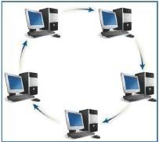
WHEN TO USE RING NETWORK TOPOLOGY?
It is often used to link mainframe computers (servers/ host computers) over wide geographical areas.
A ring network is useful in a decentralised organisation because it makes possible a distributed data processing system. In this system, computers can perform processing at their own dispersed locations, however, they can also share programs, resources and information with each other at all times.

Lesson 58
LO: discuss the types of network topology.

- Star network - In a star network topology, a number of small computers or peripheral devices are linked to a central computer/switch. This central computer may be host computer or a server or a switch.
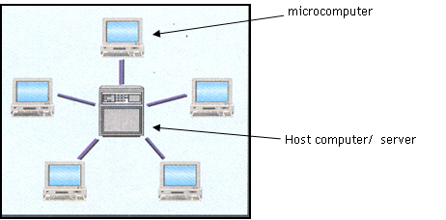

- All communications pass through the central unit. Control in communication is maintained through polling.

WHAT IS POLLING?
In this system, each device is asked (POLLED) to check whether it has a message to send in its own turn. Each device is then allowed to send its messages but only when it is polled.
FEATURES AND ADVANTAGES
- One major advantage of a star form of network is that is can be used to provide a time-sharing system i.e. several users can share resources (time) on a central computer.
- It is efficient and allows information and resources to be shared with other terminals

DISADVANTAGE
- It is expensive
- If the host computer is down, the entire network is down.

Lesson 59
LO: discuss the types of network topology.

- Tree network (Hierarchical Network) - Each device is connected to another device which may be connected to other devices. It forms an upside down tree where the root device is usually the most powerful.
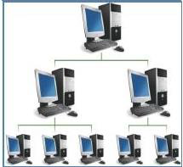

A hybrid network topology is useful in centralised organisations e.g. different departments may have individual microcomputers connected to departmental minicomputers (servers). These minicomputers, in turn, may be connected to the organisations mainframe (host computer), which contains data and programs to be accessed by all.

ADVANTAGE
The hierarchical topology allows various computers to share databases, processing power and different output devices and resources.

Lesson 60
LO: discuss the types of network topology.
- Hybrid network - is a mixture of all other topologies.
- Big organizations have lots of smaller networks based on differing topologies which are then interconnected.
- For example, USP has twelve member countries and in each campus there are several computer labs. Each of these labs are setup using the star configuration which then is connected via a backbone cable, microwave dish and satellite forming a tree and mesh network as well.
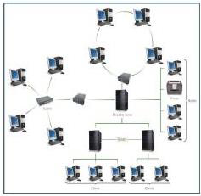
- Mesh network- There is no particular configuration;
- Rather the devices are connected to each other on the fly especially in the wireless domains. It is best suited for WLANs and PANs
- 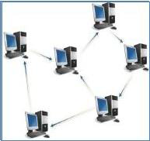

Week 5: Worksheet

True/False
- The architecture of the network describes its topology and strategy. _______
- In a hierarchical network, a computer serving other computers can also be hosted by other computer. __________
- Messages are usually passed from one computer to another till it reaches its destination in a star network. ____________
- Mesh network can be considered as an ad hoc network. __________.
Completion
- A __________ is a device that usually forwards packets to the correct computer in the star network.
- Large organizations usually have a __________ network setup.
- Network that is formed mostly by wireless devices on the move is called ________ network.
Short Answer Questions
- Describe how a PAN is formed? ____________________________________________________________________________________________________________________________________________________________________________________________________________
- Which topology is the most common and why?
____________________________________________________________________________________________________________________________________________________________________________________________________________
- What is the main reason some large organizations have to implement a hybrid network?
____________________________________________________________________________________________________________________________________________________________________________________________________________
- Identify which network topology relates to which network type.
____________________________________________________________________________________________________________________________________________________________________________________________________________
- Draw the diagram of the topology used in your school computer lab or office. Properly name the sending and receiving devices, channel, connection devices and protocols used.

