**Year 12 Computer Studies**

**Week 4 Lesson Notes\***

**Lesson 51**

**LO:** Describe and discuss terms on computer networks

**Computer Networks**

A **computer network** is formed when two or more computers are connected to each other either to exchange data, share information and resources.

Network connections between computers are typically created using cables (wires). However, connections can be created using radio signals (wireless/wi-fi), telephone lines (and modems) or even, for very long distances, via satellite links.

**Advantages**

* Easily share files and data
* Share resources such as printers and Internet connections
* Communicate with other network users (e-mail, instant messaging, video-conferencing, etc.)
* Store data centrally (using a file server) for ease of access and back-up .
* **Keep all of our settings centrally so we can use any workstation In particular, if we use a computer connected to the internet, we can:**
* Make use of on-line services such as shopping (e-commerce) or banking
* Get access to a huge range of information for research
* Access different forms of entertainment (games, video, etc.)
* Join on-line communities (e.g. MySpace, Facebook, etc.)

**Specialized terms that is used to describe computer networks**

* ***Network Interface Card (NIC)*** these are expansion cards located within the system unit that connect the computer to a network.

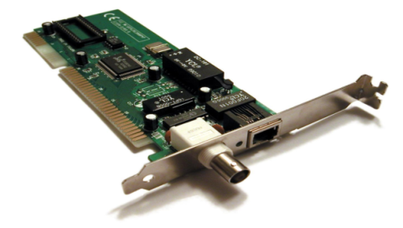

* ***Network Operating System (NOS)*** control and coordinate the activities of all computers and other devices on a network.
* ***Client*** *–* a node that **requests** and uses resources available from other nodes.
* ***Server*** *–* a node that **shares** resources with other nodes.
* ***Host*** *–* any computer system that can be accessed over a network.
* ***Switch***– a central node that coordinates the flow of data by sending messages directly between sender and receiver nodes.

**Lesson 52**

**LO:** differentiate between a router and a bridge.

**Routers**

* A *router* is a network device that connects together two or more networks.
* A common use of a router is to join a home or business network (LAN) to the Internet (WAN).
* The router will typically have the Internet cable plugged into it, as well as a cable, or cables to computers on the LAN.

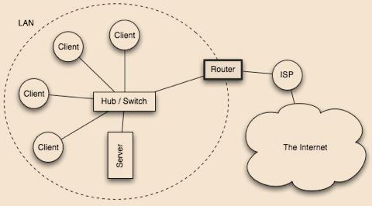

* Alternatively, the LAN connection might be wireless (WiFi), making the device a **wireless** **router**. (A wireless router is actually a router and wireless switch combined).

**Bridge**

* A *bridge* is a network device that typically links together two different parts of a LAN.
* Whereas a router is usually used to link a LAN to a WAN (such as the internet), a bridge links independent parts of a LAN so that they act as a single LAN.



**Lesson 53**

**LO:** Describe the types of network.

**TYPES OF NETWORK**

1. **LAN- Local Area Network** . In a LAN all computers are connected together in a limited area, e.g. a building. LANS can be spread within a radius of one hundred metres from the main building.

- It is typically owned or controlled by a single organization.

- LANs are now commonly used by individuals in their homes and apartments.

-

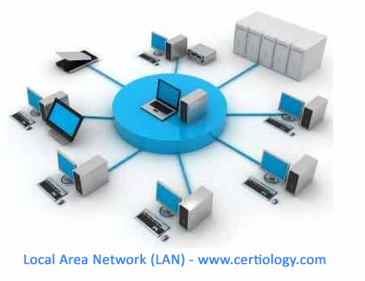

**ADVANTAGES OF LAN**

* A LAN enables users to share equipment, which would otherwise be too expensive to be secured, lowering the cost of equipment.
* LAN allows information to be shared with other computers on the network
* LAN is cheaper to setup and easy to control.

**DISADVANTAGE OF LAN**

* Covers a small geographical region
* Networks are difficult to set up and need to be maintained by skilled technicians.

1. **WLAN (*Wireless LAN)***is a LAN that uses radio signals (Wi- Fi) to connect computers instead of cables. At the centre of the WLAN is a wireless access point or base station that interprets incoming radio frequencies and routes communications to the appropriate devices.

* ADVANTAGE: WLAN is mobility together with installation flexibility
* DISADVANTAGE: WLAN is cost and environmental conditions

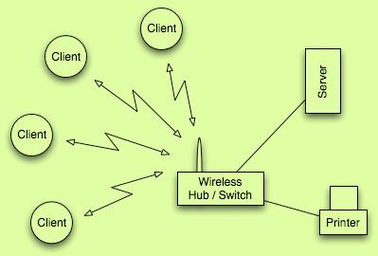

1. **MAN (METROPOLITAN AREA NETWORK)-** It usually connects offices that are spread around a city or even across multiple cities within an approximate distance of one hundred and fifty kilometres. MAN is typically owned by a group of organizations who set/select the protocols and bandwidth in place for data transmission to take place.

* **ADVANTAGE**: MAN increases the efficiency of handling data and increase the speed of transferring data
* Cost effective and enhances sharing of resources.
* **DISADVANTAGE:** difficult to manage the network once it becomes large and requires more cables for connection.

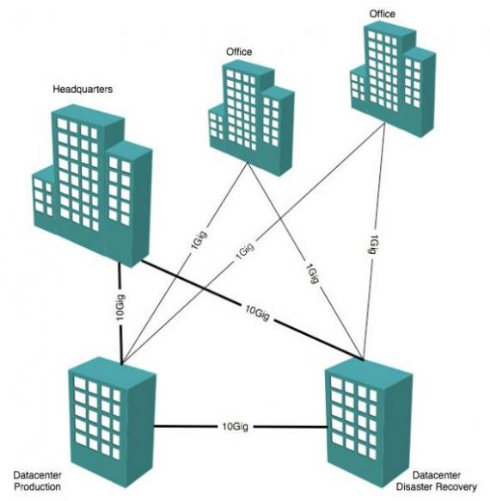

**Lesson 54**

**LO**: describe the types of network

1. **WAN (WIDE AREA NETWORK)**- Computers are connected over wide geographical areas through the use of modems, optic fibre (glass) cables, satellites radio links and microwaves to communicate.

* **ADVANTAGE:** Allows sharing of peripherals.
* Setting up the equipment could be expensive.
* **DISADVANTAGE:** Security becomes an issue when many different people use information from other computers.

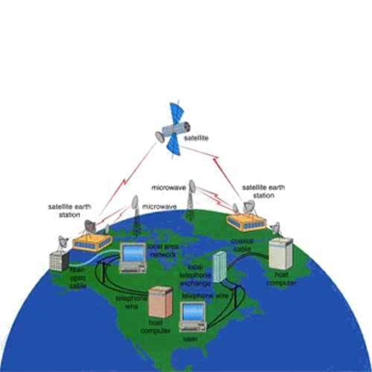

1. ***Personal Area Network (PAN)***is a wireless network formed spontaneously within a very small area.

* It can be formed by devices like our laptop, mobile phone and cordless mouse and keyboards which can be connected to each other spontaneously.
* This can also be regarded as an ad-hoc network which sets *Bluetooth RF* for data transmission.
* **ADVANATGE**: PANs are efficient, cost- effective and convenient.
* It is more secured because it is controlled by one person
* **DISADVANTAGE:** It covers a short distance, up to 10 meters only and data rate is low compared to other networks.

*Bluetooth* devices contain small, low-power radio transmitters and receivers. When devices are within a maximum range of 30 feet of other Bluetooth devices, they detect each other and can be 'paired' (connected).

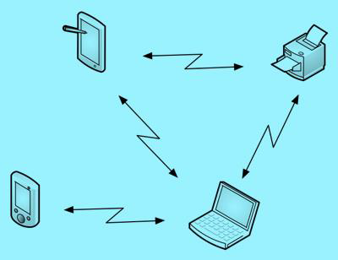

* The primary difference between a LAN, MAN, WAN, WLAN and PAN is the geographical range. In a LAN, computers are connected together within a limited area such as in a building while a MAN connects office buildings in a city whereas in WAN, computers are connected over wide geographical areas. WLAN and PAN are also used to connect computers within a small area.

**Lesson 55**

**LO:** Differentiate between network architecture and topology.

**NETWOR ARCHITECTURE**

* Network architecture describes how a network is arranged and how the resources are coordinated and shared. It is divided into two parts:
* Network topology describes how a network is configured and arranged.
* Strategies define how resources are shared

**Week 4 Worksheet**

**True/False**

a) PAN can also be regarded as LAN. _________

b) Internet is an example of WAN. __________

c) In a LAN environment a network gateway device can connect several groups even if their configurations are different. __________.

**Completion**

a) _________ connects several cities even regions.

b) A printer is a device that is usually shared in _________environment.

c) _________ any device that is connected to a network.

d) __________________is a computer specialist responsible for efficient network operations and implementation of new networks.

**Short Answer Questions**

1. What is the difference between LAN and WLAN?

____________________________________________________________________________________________________________________________________________________________________________________________________________

1. Give at least two advantages and two disadvantages of a LAN, a MAN, a WAN and a PAN.

____________________________________________________________________________________________________________________________________________________________________________________________________________

1. Discuss network types including local area, home, wireless, personal, metropolitan, and wide area networks.

____________________________________________________________________________________________________________________________________________________________________________________________________________