Year 12 Computer Studies
Week 7: Lesson Notes
Lesson 66
LO: Describe the types of network security
NETWORK SECURITY
- A proxy server is a computer setup to share a resource, usually an Internet connection. Other computers can request a web page via the proxy server. The proxy server will then get the page using its internet connection, and pass it back to the computer who asked for it.
- Proxy servers are often used instead of router since additional software can be easily installed on the computer such as anti-virus, web filtering etc.
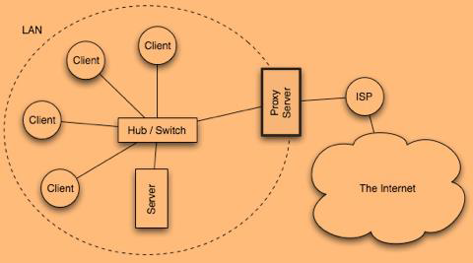
- A firewall is a device, or a piece of software that is placed between your computer and the rest of the network (where the hackers are!)

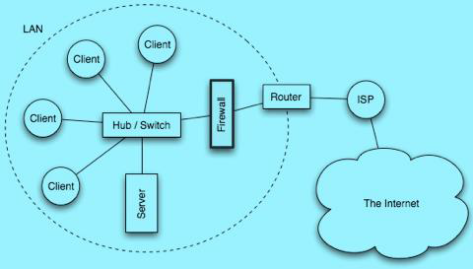
- Intrusion detection systems (IDS) work with firewalls to inspect all incoming and
outgoing network traffic and identifies suspicious patterns that may indicate a network or system attack from someone attempting to break into or compromise a system.
- Virtual private networks (VPN) create a secure private connection between a remote user and an organization‘s internal network. It enables a computer to send and receive data across shared or public networks as if it is directly connected to the private network, while benefiting from the functionality, security and management policies of the private network.
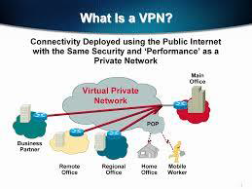

Lesson 67
LO: Discuss some careers in this field
Network administrators
- Oversee the computers in the company’s system.
- They manage and ensure the network runs smoothly and uninterrupted.
- They connect all hardware and software and set up all programs such as everyone’s emails to the computer system.

Networks system Engineers
- Responsible for setting up the network infrastructure and administrator oversees.
- Engineers maintain and watch over the security systems the administrator set up and work with them to develop firewalls and backup systems to the main network server.
Network computer programmers
- They create and design critical data structures for each computer.
- They analyses the system’s software requirements, develop new applications and maintain existing ones.
- They prepare proper codes and communicate well with perfect understanding.
Network System Managers
- They guide, manage and supervise the entire Internet and computer operation.
- They are in charge of the workplace, assign projects and programs to their employees and give reports to upper management.
Network Service Technician
- Identify and fix network problems.
- They must have an extensive knowledge on internet connections and linking computers within a network.
- They analyses and plan the cost for the company’s computer network system.
Lesson 68
Strand CE 12. 2: Application Package
S/ Strand CE 12. 2. 1: Visual Basic. Net Programming (VB. Net)
LO: Introduce visual basic programming
- Visual Basic is event-driven, meaning code remains idle until called upon to respond to some event (button pressing, menu selection … etc.).
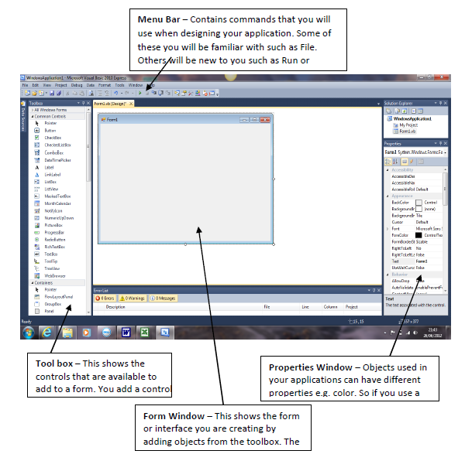
- A Visual Basic application, called a solution, can consist of one or more projects. Each project can contain one or more form files.
Application (Project) is made up of:
- Forms - Windows that you create for user interface.
- Controls - Graphical features drawn on forms to allow user interaction (text boxes, labels, scroll bars, command buttons, etc.) (Forms and Controls are objects).
- Properties - Every characteristic of a form or control is specified by a property. Example properties include names, captions, size, color, position, and contents. Visual Basic applies default properties. You can change properties at design time or run time.
- Methods - Built-in procedure that can be invoked to impart some action to a particular object.
- Event Procedures - Code related to some object. This is the code that is executed when a certain event occurs.
- General Procedures - Code not related to objects. This code must be invoked by the application.
- Modules - Collection of general procedures, variable declarations, and constant definitions used by application

Lesson 69
LO: discuss the file extensions that are created in Visual Basic Application
- .sln- a solution file that holds information about the project. This is the only file that is opened
- .suo- a solution user options file that stores information about the selected options
- .vb- a .vb file that holds the definition of a form.
- .resx- a resource file for the form
- .vbproj- a project file that describes the project and lists the file included
- .vbproj .user- a project user option file that holds project option settings

Lesson 70
LO: discuss Integrated Development Environment
- An Integrated Development Environment (IDE) is software that facilitates application development.
- It contains all the features needed to create, run, and test programs.
- It has an editor for entering program instructions, compiler for running and testing program and allows creation of Web-based and Windows-based

Year 12 Computer Studies
Week 7: Worksheet
- Why is Visual Basic such a popular programming language?
__________________________________________________________________________________________________________________________________________________________________________________________________________________________________________
- What are some of the standard elements that can be placed on a Windows Form?
__________________________________________________________________________________________________________________________________________________________________________________________________________________________________________
- What are objects and properties? How are they related to each other?
__________________________________________________________________________________________________________________________________________________________________________________________________________________________________________
- What is the purpose of these Visual Basic file types: .sln and .vb?
__________________________________________________________________________________________________________________________________________________________________________________________________________________________________________

- Visual Basic is event-driven. What does this mean?
__________________________________________________________________________________________________________________________________________________________________________________________________________________________________________

- What is the purpose of an IDE?
_________________________________________________________________________________________________________________________________________________________________________________________________________________________________________
- Describe how a GPS works.
____________________________________________________________________________________________________________________________________________________________________________________________________________

- Explain the process of modulation and demodulation
______________________________________________________________________________________________________________________________________________________________________

- Describe the differences between the three major physical connection mediums: twisted pair cables, coaxial cable and fiber optic cable
______________________________________________________________________________________________________________________________________________________________________

