YEAR 12 - BIOLOGY WORKSHEETS (WEEK 2)
LESSON 46
STRAND 1: Structure and cell processes
SUBSTRAND 1.4 Comparative form and function in plants and animals
LEARNING OUTCOME: Discuss Excretion and Osmoregulation in Invertebrate Animals
Excretion and Osmoregulation in Invertebrate Animals
I. Aquatic Invertebrates: Cnidarians and Mollusc (Bivalves)
Excretion and Osmoregulation
-Sessile aquatic animals in which ammonia diffuses out into the surrounding water.
- These organisms are small and create metabolic wastes slowly. Therefore, they do not need a special excretory system.
Water Conservation
-They live in water; therefore do not worry about dehydration.
II. Terrestrial Invertebrates: Insects
Excretion- Excretory organ of the insects are known as Malpighian Tubules. These are tube extensions of the gut which float in the open blood cavity (haemocoel).
-Excretory products of insects are uric acid. The Malpighian tubules absorb nitrogenous wastes form the blood and convert it to uric acid.
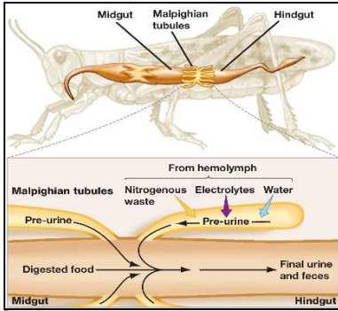
Water Conservation - Insects are terrestrial animals which face the constant threat of dehydration. Their water conserving adaptations include:
1. Excretion of solid uric acid crystals instead of urea which needs to be diluted in water
2. Closing of spiracles when they are inactive.
3. The hind gut reabsorbs water from the faeces.

LESSON 47
STRAND 1: Structure and cell processes
SUBSTRAND 1.4 Comparative form and function in plants and animals
LEARNING OUTCOME: Discuss Excretion and Osmoregulation in vertebrate Animals
Excretion and Osmoregulation in Vertebrate Animals
All vertebrates share similar excretory systems which include:
(1) Liver- which deaminates excess amino acids; and
(2) Pair of kidneys- which filter the resulting nitrogenous wastes out of the blood.
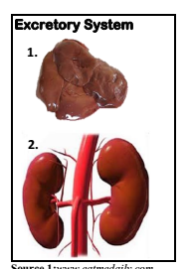
I. Aquatic Vertebrates: Fish
Excretion and Osmoregulation
- Both fresh and saltwater fish excrete ammonia directly into water therefore no energy is spent on converting it to urea.
-However, fish face osmotic problems. Water constantly moves into freshwater fish’s cells and move out of a saltwater fish’s cells.
Freshwater Fish- The solute concentration in the cells of a freshwater fish is higher than that of the surrounding water and therefore water constantly moves into the fish’s gill cells and the fish loses a lot of salts.
Saltwater Fish-The salt water surrounding ocean fish has a higher solute concentration than that inside fish cells. Thus saltwater fish constantly lose water by osmosis. To solve this problem, ocean fish constantly drink salt water and then excrete excess salt through special cells in their gills.
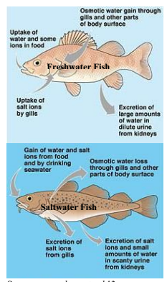
LESSON 48
STRAND 1: Structure and cell processes
SUBSTRAND 1.4 Comparative form and function in plants and animals
LEARNING OUTCOME: Discuss Excretion and Osmoregulation in vertebrate Animals
II. Terrestrial Vertebrates:
1. Amphibians (Example: Frog)
Excretion, Osmoregulation and Water Conservation
- Adult life spent on land but the body not well adapted for conserving water.
- Amphibians partly breathe through their skin and therefore the skin needs to be moist for gases to dissolve and diffuse. Since breathing takes place via skin; the skin lacks additional protective coverings.
2. Reptiles (Example: Gecko/Lizard; Turtles)
-Well adapted for conserving water.
- Ability to excrete solid uric acid crystals (also known as: urates) and urea.
- Excreted uric acid is white in color while urine is colorless.
- To conserve water, reptiles have scales covering their skin and exchanging of gases uses lungs.
3. Birds -Also excrete uric acid.
To prevent dehydration:
- Feathers cover the body. - Scales on legs (where there is no feathers)
- Gas exchange via lungs
Advantages of Excreting Uric Acid
(Insects, Reptiles and Birds)
1. Reduces water loss since it does not require dilution.
2. Solid uric acid is lighter than liquid urine - aids in flight since it does not add extra weight.
3. Embryos developing in eggs do not poison themselves with their own wastes.

LESSON 49
STRAND 1: Structure and cell processes
SUBSTRAND 1.4 Comparative form and function in plants and animals
LEARNING OUTCOME: Discuss Excretion and Osmoregulation in vertebrate Animals. (Mammals)
Mammals -Excrete urea diluted in water.
- To replace the amount of water lost urine, by evaporation and by exhalation, most mammals must drink water quite regularly.
-The feeling of thirst caused by hormones is an adaptation to remind the mammal to rehydrate.
-Osmoregulation in kidneys occurs at loop of Henle. Here, most of the body fluids and essential nutrients are reabsorbed.
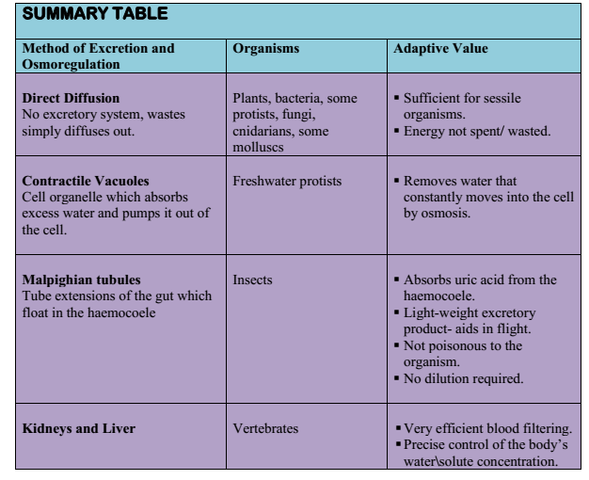
LESSON 50
STRAND 1: Structure and cell processes
SUBSTRAND 1.4 Comparative form and function in plants and animals
LEARNING OUTCOME: Discuss Excretion in vertebrate Animals.
Excretory systems of Vertebrates
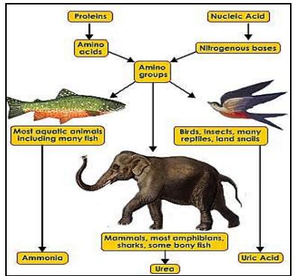

Evolutionary Trends
1.Excretion varies greatly between invertebrates and vertebrates, depending on the complexity of the organism.
2. Excretion in invertebrates varies from protozoa that are by diffusion through the membrane, the
Porifera from cells that specialize in this function, and arthropods which have specialized excretory organs- malpighian tubes.
3. Excretion in vertebrates is characterized by the presence of an excretory organ located mostly in
dorsal, posterior end of the vertebrae, which are called the kidneys.

TERM 2 WEEK 2 WORKSHEET
1. Explain the difference between osmoregulation and excretion.

2. How is homeostasis different from excretion and osmoregulation?

3. Identify the function of the liver as part of the excretory system in vertebrates.

4. Name three nitrogenous waste products produced by animals.

5. Identify some water conservation adaptations of terrestrial plants.

6. Identify four ways in which insects reduce water loss.

7. What is the advantage of excreting uric acid rather than urea in the egg-laying terrestrial
reptiles and birds?

8. Identify the major disadvantage that fish would face if it instead of excreting ammonia it
converted and excreted urea.

9. Compare excretion of a jellyfish with that of a terrestrial mammal. Explain with reference
to their lifestyle, the adaptive value of the excretory method to them

