YEAR 12 BIOLOGY - WEEK 1
LESSON 41
STRAND 1: Structure and cell processes
SUBSTRAND 1.4 Comparative form and function in plants and animals
LEARNING OUTCOME: Discuss the transport processes in animals.
Transport in Vertebrates
- Vertebrates’ animals are generally larger and more active than invertebrates so they need more
efficient transport systems.
Transport in Fish (closed, single – loop circulation)
- Fish have the simplest circulation system with two chambers – one auricle and one ventricle.
-The heart pumps the blood in only one loop, from ventricle to gills to body cells back to the heart.
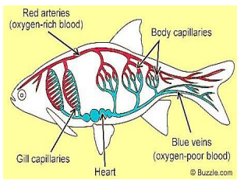
Transport in Amphibians and Reptiles - Closed, partial double-loop circulation.
-Amphibians (toads) and reptiles (snakes, lizards, etc) both have three- chambered heart with two auricles and one ventricle.
-They have a closed partial double loop circulatory system.
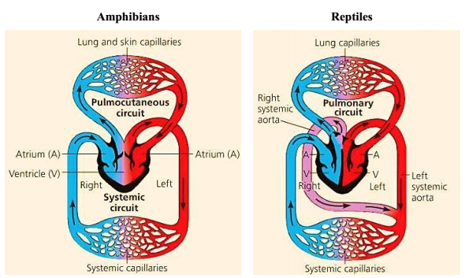

LESSON 42
STRAND 1: Structure and cell processes
SUBSTRAND 1.4 Comparative form and function in plants and animals
LEARNING OUTCOME: Discuss the transport processes in animals.

Transport in Mammals and Birds - Closed, double-loop circulation
- Mammals and birds have four-chambered hearts – two auricles and two ventricles.
- Their blood circulates in two loops. One loop is between the heart and the lungs. The other is between heart and the rest of the body.
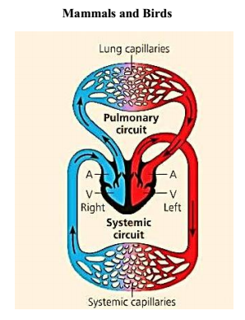
Adaptive Value
- Mammals and birds have the most efficient transport system of all organisms.
-Their deoxygenated and oxygenated blood is completely separated into the right and left sides of the heart.
- The heart pumps blood to the body forcefully since blood returns to the heart for a second push after it passes through the lungs.

Mammals and birds need efficient transport for:
1) They are warm blooded.
2) They are very active.
3) Flight in particular consumes energy very quickly.

Warm – blooded versus Cold – blooded
1.Mammals and birds are warm-blooded.
2.They keep their body temperatures constant regardless of environmental temperature. For e.g., humans keep their body temperature at 37°C.
3. All other animals, including fish, amphibians and reptiles, are cold-blooded.
-Their body temperatures vary with the environmental temperature.
-Cold- blooded animals consume less energy than warm- blooded animals

LESSON 43
STRAND 1: Structure and cell processes
SUBSTRAND 1.4 Comparative form and function in plants and animals
LEARNING OUTCOME: Discuss the transport processes in animals.

ADAPTATIONS FOR TRANSPORT
1. All cells need a constant supply of nutrients and oxygen and removal of metabolic
wastes.
2.Direct diffusion is suitable for that have large surface area - area to volume ratios.
3.Larger, active organisms need a special transport system to carry materials to and from
their cells.
4.The transport system of larger animals may interact with the following systems:
The digestive system to get nutrients.
- The respiratory system to exchange gases.
- The excretory system to remove nitrogenous wastes and excess salts.

SUMMARY TABLE
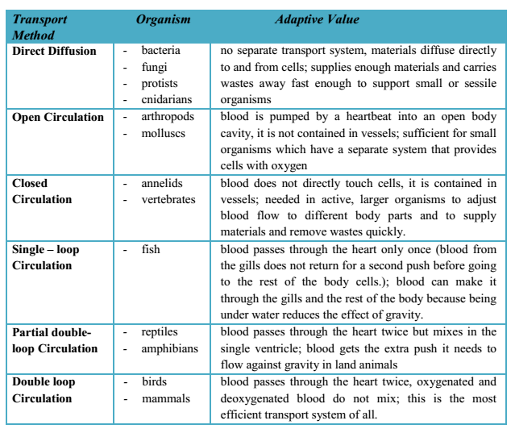
LESSON 44
STRAND 1: Structure and cell processes
SUBSTRAND 1.4 Comparative form and function in plants and animals
LEARNING OUTCOME: Discuss the excretion and osmoregulation processes in animals.

EXCRETION AND OSMOREGULATION
Homeostasis means to maintain a constant stable internal environment/condition. Some common
homeostasis processes in organisms to maintain stable environment includes:
(1) Regulation of blood pH.
(2) Regulation of blood sugar level. Mammals use insulin and glucagon.
(3) Regulation of excess water and ions by kidneys and liver in vertebrates.
(4) Regulation of constant body temperature in warm-blooded animals.
(5) Regulation of oxygen content in blood.
Two processes which play an essential role in homeostasis are:
(1) Excretion and (2) Osmoregulation.

1. Excretion is the process of removing metabolic waste products from the body.
-Excretion is different from egestion. Egestion is removal of undigested waste material from the body via alimentary canal (Example: Faeces).
- Metabolic waste products can be harmful to the organisms and therefore needs to be excreted (removed) from the body.

2.Osmoregulation is the process of maintaining the solute concentrations constant in the fluid in and around cells to avoid it from becoming excessively flaccid or turgid.
-Too much or too little of any solute can kill an organism.
-Excretion intertwines closely with osmoregulation as it gets rid both water and solutes.
- For terrestrial organisms, osmoregulation requires adaptations for water conservation.

LESSON 45
STRAND 1: Structure and cell processes
SUBSTRAND 1.4 Comparative form and function in plants and animals
LEARNING OUTCOME: Discuss the excretion and osmoregulation processes in plants

PLANTS: EXCRETION AND OSMOREGULATION
- Plants use most of the waste products they produce, including CO₂, O₂ and ammonia.
- CO2 is used in photosynthesis; O2for plant respiration and ammonia for nitrogen.
-Those gases which are not immediately required by the plant for photosynthesis or respiration are diffused out.
Water Conservation in Terrestrial Plants
-Water is needed by plants for two things: (1) photosynthesis and (2) maintaining cell turgidity.
- Terrestrial plants need transpiration to pull water up from their roots and to cool their leaves.
Adaptations of Plants to Reduce Water Loss
1. Waxy Cuticle- covers stems and the top surface of leaves to prevent water evaporation.
2.Stomata- present mainly on the bottom-side of the leaves in order to reduce transpiration.
3.Guard Cells- closes stomata at night and whenever the plant does not have enough water.

Additional Water Loss Adaptations
Some plants have the ability to survive in very dry environments. Some additional adaptations which they have to conserve water are:

1.Succulence–plants store water in fleshy leaves, stems or roots in gel-like compounds and cells from which it is not easily lost. Example: cactus and aloe vera.

2. Thick Cuticle- reduces water loss via transpiration.
-Plants excrete some waste through diffusion.
- During the day, excess oxygen gas produced by photosynthesis is released through the stomata.
- Carbon dioxide produced by respiration is normally used up during photosynthesis. At night, carbon dioxide is not used up as fast as it is produced and is released as a waste product.

STUDENT WORKSHEET

1. Transport systems often link with the following systems: digestive, gas exchange, and urinary. Explain the reasons for each of these connections.

2. What three factors are believed to help water move up through xylem? Describe how each force works.
3. How do plants absorb water from the soil? How do they absorb minerals?

4. Describe how food is transported in vascular plants.

5. What two kinds of cells make up phloem? What is the function of each?

6. Describe how xylem cells and sieve cells are specially adapted for their functions.

7. What is the difference between open and closed circulation? Give an example of an organism with each kind of circulation.

8. Why don’t large organisms have open circulation?

9. In animals with closed circulation, the blood does not actually touch the animal’s cells. How do the materials move between the cells and the blood?

10. What is the difference between single-loop and double loop circulation? Is circulation in
these loops closed or open?

11. State how many chambers the heart of each of the following animals has: a frog, a mynah, a dog, a fish.
12. In spite of having only single loop circulation, a fish’s circulatory system is able to supply
cell nearly as quickly as the double-loop circulatory system of a mammal. Why?

