YEAR 12 BIOLOGY - WEEK 4
LESSON 56
STRAND 1: Structure and cell processes
SUBSTRAND 1.4 Comparative form and function in plants and animals
LEARNING OUTCOME: Discuss protection, support and movements in plants.
Support in Woody Plants
- Woody plants have evolved strong support mechanisms to enable them to grow tall without using other plants as support.
-These plants live for long and therefore they make big investments in their support mechanisms.
Features:
1. Lignin- a very strong carbohydrate that strengthens cell walls.
2. Heartwood- dead xylem at the centre of the stem which has filled with hardened sap.
3. Root System- which is deep and extensive to anchor the plants in the ground.
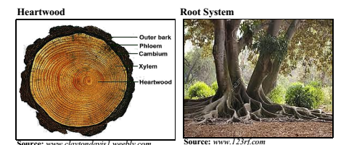
SUMMARY TABLE FOR PLANTS
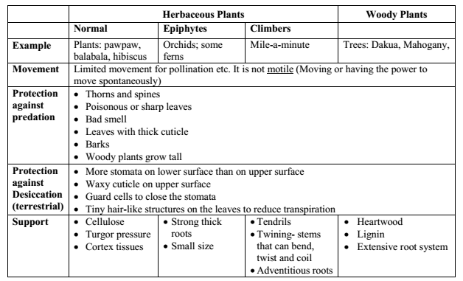

LESSON 57
STRAND 1: Structure and cell processes
SUBSTRAND 1.4 Comparative form and function in plants and animals
LEARNING OUTCOME: Discuss protection, support and movements in animals.
ANIMALS: PROTECTION, SUPPORT AND MOVEMENT
Movement, Support and Protection
- Not all animals can move, some are sessile (can’t move).
- Those animals that can move invest in structures that will help them best to move in their
environment. For example: Fish invest in fins to swim in aquatic environment.
Example
Sponges are sessile and therefore the food enters the body with the water current. As water moves in and out of the body, microvilli,lining the inner part of the body traps food.
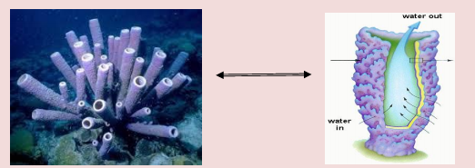
Movement, Support and Protection in Invertebrates
1. Invertebrates are animals which lack a backbone.
2. The invertebrate animals belong to phylum:
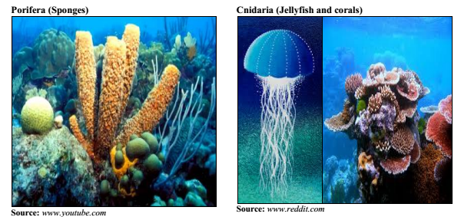
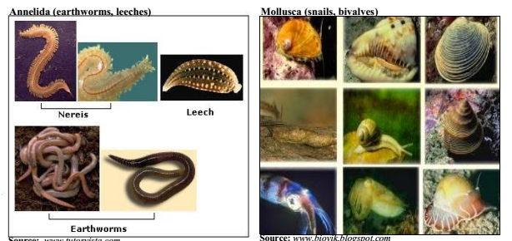

LESSON 58
STRAND 1: Structure and cell processes
SUBSTRAND 1.4 Comparative form and function in plants and animals
LEARNING OUTCOME: Discuss protection, support and movements in animals.
1. Hydrostatic Skeleton: Cnidarians and Annelids
- Cnidarians (jelly fish) and annelids (earthworms) do not have a skeleton.
- Instead, they support their bodies with a hydrostatic skeleton.
- A hydrostatic skeleton is a fluid filled body cavity.
Protection
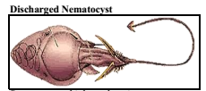
-All cnidarians are aquatic and therefore do not face a dehydration problem. For protection from predators and for killing prey (obtain food), many cnidarians have poisonous stingers called nematocyst.
-Terrestrial annelids protect themselves from both dehydration and predators by staying underground. Earthworms have rigid hairs (bristles) on their bodies which can grip tightly onto the soil, making it difficult to be pull out of the ground.
Support and Movement
-The hydrostatic skeleton gives shape to the cnidarian’s body. For movement, they rely on the contraction of the muscle to and the internal fluid to move.
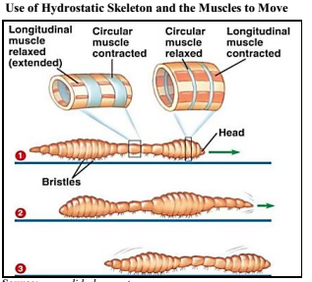
-To move, it pushes its internal fluid forward by contracting circular muscles in one body region and relaxing the muscles in another. The worm contracts the muscles in a wave down its body, moving itself forward. The bristles on the bottom side help it grip the soil as it pushes its body forward.

LESSON 59
STRAND 1: Structure and cell processes
SUBSTRAND 1.4 Comparative form and function in plants and animals
LEARNING OUTCOME: Discuss protection, support and movements in animals.
2. Exoskeleton: Arthropods
- Exoskeleton is the skeleton outside the body. - It is the hard outer covering.
- Arthropods (insects, crabs, prawns, spiders) have exoskeleton.
Advantage of exoskeleton | Disadvantage of exoskeleton
Exoskeletons provides protection against:  - predation  - damage of the internal tissues  - dehydration in terrestrial  animals | 1.Exoskeletons cannot grow and therefore the animal needs to shed the exoskeleton (moult; ecdysis) in order to grow.  2.During the moulting period the animal is prone to diseases, predation and terrestrial animals to  dehydration.  3. Animal has to invest a lot of energy into making new exoskeletons.  4. Exoskeletons are very heavy and therefore the animal has to spend a lot of energy to carry it around.

Protection
- Apart from the exoskeleton, the arthropods also possess other structures which aid in their protection.
Some such structures are:
1. Wings to fly away in most of the insects.
2. Jointed appendages to escape predators and catch prey efficiently.
3. Fierce mouth parts with poisonous stings (bees, centipedes),
Support and Movement
1.Support to the body provided by exoskeleton.
2. Movement is via jointed appendages (limbs).

LESSON 60
STRAND 1: Structure and cell processes
SUBSTRAND 1.4 Comparative form and function in plants and animals
LEARNING OUTCOME: Discuss protection, support and movements in animals.
3. Endoskeleton in Vertebrates
-Vertebrates have internal skeletons (endoskeleton).
-Hard skeletons of bone and cartilage are inside the body.
-The endoskeleton provides support, places for muscle attachment and protects the internal organs.
- All vertebrates share similar bone structure - a skull, a rib cage and a vertebral column.
The vertebrate animals are:
1. Fish 2. Amphibians (frogs) 3 Reptiles (snakes, lizards, iguanas and crocodiles)
4 Aves (Birds) 5. Mammals
Advantage of endoskeleton | Disadvantage of endoskeleton
-Light yet strong and flexible to allow  quick escape from predators or to  catch prey.  - Lighter than the exoskeleton  - Can grow as the organism grows (no  need to moult). | -Endoskeleton cannot be moulted  therefore any fatal damage to it is  almost permanent.

1. Fish
- All fish are aquatic therefore they do not need adaptive structures which prevent dehydration.
Protection
1. Scales- first line of defence just like our skin.
2. Some have poisons, sharp teeth, camouflaging ability, electric, stings and spines.
3. Operculum (bony gill cover) to protect the tender gills
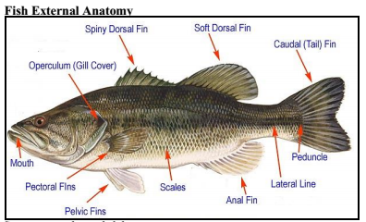
Support
1. Buoyancy (upthrust of water) reduces the pull of the gravity experienced by fish.
2. Fish do not need a skeleton as strong as those of terrestrial vertebrates. Sharks have skeleton composed of cartilage which is light-weight.
Movement
1.Fish skeletons are very well adapted for swimming.
2. Most fish propel themselves forward by swishing their caudal fin back and forth. Their dorsal, caudal and fins help keep the fish from rolling. The pectoral, pelvic, and caudal fins steer.
3. Most fish are shape for speed.

YEAR 12 BIOLOGY
WEEK 4 WORKSHEET
1. How are the support needs of aquatic organism different from those of terrestrial organisms?
What are the reasons for these differences?

2. Why do plants have limited movement abilities in comparison to active animals?

3. Plants produce more food than they consume. What may have selected for this overproduction?

4. Compare and contrast the support systems of herbaceous and woody plants. Explain the adaptive value of their differences.

5. What disadvantages might climbing plants face because they depend upon other structures forsupport?

6. How do epiphytes support themselves?

7. Explain turgidity and flaccidity of a cell with reference to osmotic movement of water.

8. Compare and contrast between hydrostatic skeleton, exoskeleton and an endoskeleton. For each type of skeleton, identify an organism which possesses it and the adaptive value of that skeleton to that particular organism

9. Using the diagram below, explain how movement takes place in annelids?
