BIOLOGY - YEAR 12 - WEEK 3
LESSON 51
STRAND 1: Structure and cell processes
SUBSTRAND 1.4 Comparative form and function in plants and animals
LEARNING OUTCOME: Discuss protection, support and movements in Animals and plants
PROTECTION, SUPPORT AND MOVEMENT
The adaptive structures often include those that provide protection from dehydration, disease and predators; support against gravity; and movement for finding food and escaping predators.
Example
1.Centipedes have poisonous bites which they use to defend themselves, their food and their habitat.
2. Land plants have the shiny waxy cuticles to reduce transpiration.
3.Tall trees have heartwood and lignin to strengthen their stems. Birds and bats have extremely light-weight bodies and broad wings.
Factors Affecting Protection, Support and Movement
1. Aquatic and Terrestrial Habitat- organisms dwelling in aquatic habitats have totally different requirements in terms of support, movement and protection
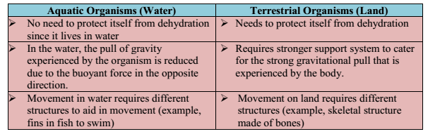

LESSON 52
STRAND 1: Structure and cell processes
SUBSTRAND 1.4 Comparative form and function in plants and animals
LEARNING OUTCOME: Discuss protection, support and movements in plants.
PLANTS: PROTECTION, SUPPORT AND MOVEMENT
Movement in Plants- Plants do move but since they make their own food, they have limited movement capabilities.
- Plant movements are not extensive because they do not have to travel from one place to another in search of food.
Nastic Movement -Movement due to changes in turgor or changes in growth. These movements are non-directional.
1. Nyctinasty- movement in plant organ in response to the onset of darkness. Also known as
‘sleep movement’. Example: many leguminous close leaflets at night and also the ‘vaivai’ or ‘mocemoce’plants.
2. Photonasty- movement of plant organs in response to light. Example: opening and closing of flowers.
3. Chemonasty- movement of plant organs in response to chemical/nutrients. Example: Dragon fly and Venus fly trap.
4. Thigmonasty- movement of plant organs in response to vibration or touch. Example: Sensitive grass
Examples of Plants that Move
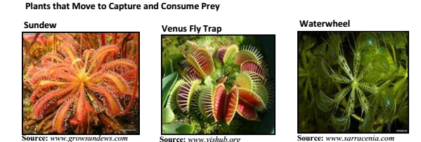

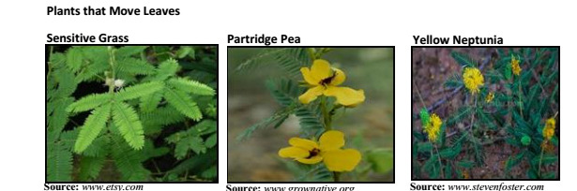

LESSON 53
STRAND 1: Structure and cell processes
SUBSTRAND 1.4 Comparative form and function in plants and animals
LEARNING OUTCOME: Discuss protection, support and movements in plants.
Protection in Plants
Protection in Plants- From being Eaten, Pulled and/or Torn -In order for the plants to protect their stored food for later use in growth and reproduction, they have certain adaptive features which prevent the consumers (herbivores and omnivores) from eating it.
Ways in which plants protect themselves can be categorised into three groups.
(1) Structural Defence (2) Chemical Defence (3) Behavioural Defence
1. Thorns and Spines (Structural Defence)
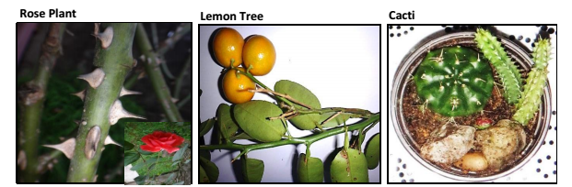
2. Poisonous Leaves(Chemical Defence)
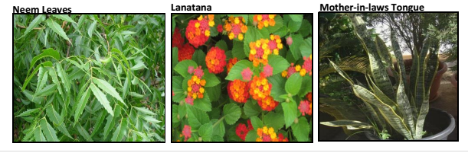
3. Sensitive Grass (Behavioural Defence)
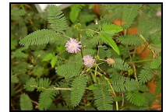

LESSON 54
STRAND 1: Structure and cell processes
SUBSTRAND 1.4 Comparative form and function in plants and animals
LEARNING OUTCOME: Discuss protection, support and movements in plants.
Protection in Plants- From Dehydration/ Desiccation
The adaptive features of land plants which protect from desiccation are:
(1) More stomata is present on the lower surface of the leaf than on the upper surface.
(2) Waxy cuticle on the upper surface of the leaves reduces the water loss via transpiration from the top surface.
(3) Presence of tiny hair-like structures on the leaves also helps reduce transpiration.
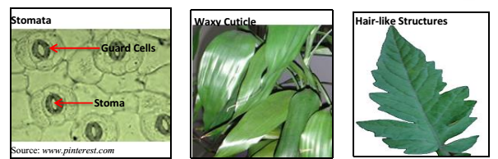
Aquatic Plants -Aquatic plants do not have to conserve water and therefore have different adaptive features and mechanisms from the land plants.
-For the floating plants, the stomata are present on the upper surface of the leaves to enable exchange gases with the air.
- submerged plants lack waxy cuticles or have a very thin layer of the waxy cuticle to aid in efficient gas exchange
- some floating aquatic plants have the thick waxy layer to repel water and keep the stomata clear.
Example 1
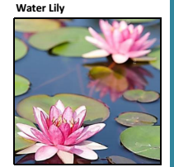
LESSON 55
STRAND 1: Structure and cell processes
SUBSTRAND 1.4 Comparative form and function in plants and animals
LEARNING OUTCOME: Discuss protection, support and movements in plants.
Support in Plants
-The main role of the plants as producers is to photosynthesise. In order to do carry out this
role effectively, plants need mechanisms which enable them to gather the key ingredients
required for photosynthesis.
(i) Support in Plants to Acquire Adequate Sunlight
In order to maximise the amount of the sunlight received, many plants grow upwards and outwards.
(ii) Support in Herbaceous Plants
- Herbaceous plants are “soft-stemmed” plants such as herbs and other small plants.
- Herbaceous plants do not live for long.
These plants support themselves in three ways:
1. Cellulose in plant cell walls – cellulose is a tough carbohydrate that makes plants cell walls
rigid.
2. Turgor Pressure –pressure created when fluid is tightly filled in each cell. In presence of
sufficient water, the cells remain turgid. When plants lose too much water, the cells become
flaccid (limp) from water loss and wilts.
3. Cortex tissue – cortex cells are the unspecialized cells lying between the epidermis and the
vascular tissues.
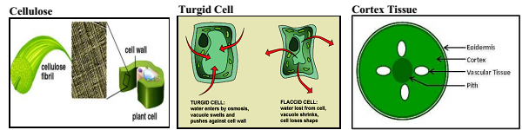

YEAR 12 BIOLOGY
WORKSHEET 3
FY12CE 2019
1. The advantage of gas exchange surfaces being extremely thin is so that
A. gases dissolve easily through the surface. B. adequate quantity of gases are transmitted.
C. more cells are accommodated in the organ. D. the transmission of gases occurs at a faster rate.
2. In plants, root pressure is described as the
A. force of water moving into the root cells.
B. pull of water from root cells to the xylem.
C. difference in mineral concentration in the soil and root cells.
D. process causing leaves to lose water so more is taken through roots
3. Which of the following is not an adaptation of plants to reduce water loss?
A. Having wide leaves B. Having waxy cuticle
C. Adjusting of the leaf angle D. Stomata present on the underside of leaves

(4) State how the closing of stomata is advantageous to a plant?

(5) The pictures given below show different protection mechanisms in plants.
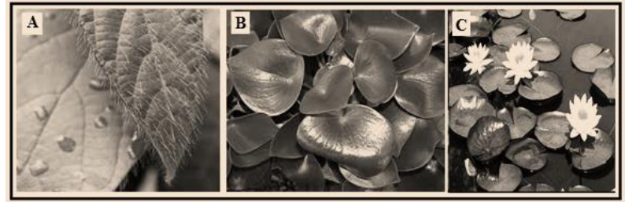
(i) Name the mechanisms shown in A and B.
(ii) Describe how these mechanisms named in
(i) above protect the plants that have them.
Plant C is an aquatic plant and does not need to conserve water.
(iii) State one adaptation Plant C would have that differentiates it from land plants.

