WEEK 9 YEAR 12 APPLIED TECHNOLOGY
STRAND: WELDING & FABRICATION

LESSON 51: SHEET METAL WORK PROCESSES

LEARNING OUTCOME: IDENTIFY THE TYPES OF SHEET METAL WORK PROCESSES

Basic sheet metalworking actions are cutting operation, bending, drawing.

- CUTTING OPERATION- those in which a piece of sheet metal is separated by applying a great enough force to cause the material to fail.

- SHEARING
- This shearing force is applied by two tools, one above and one below the sheet.

- A small clearance is present between the edges of the upper & lower tools that make the cutting of material possible

- The size of this clearance is usually 2-10% of the material thickness
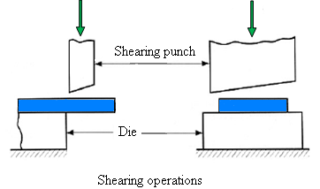

- BLANKING & PUNCHING
- Similar to sheet metal cutting operations

- If the part that is cut out is the desired product, the operation is called blanking & the product is called blank

- If the remaining stock is the desired part, the operation is called punching

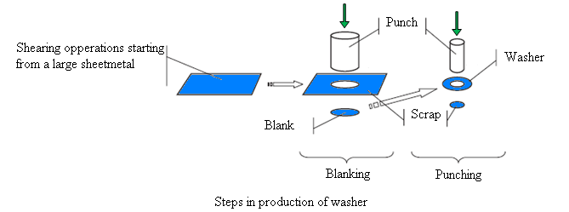

- DRAWING & BENDING
- Drawing is a sheet metal forming process in which a flat sheet metal blank is drawn into a forming die by a punch to achieve the desired shape by drawing without failure

- Bending is a forming process causes the sheet metal to undergo the desired shape change by bending without failure or breaking
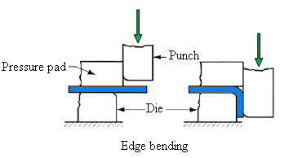
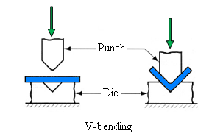
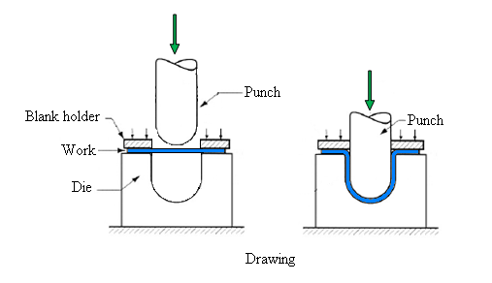

LESSON 52: OXY-ACETYLENE WELDING

LEARNING OUTCOME: IDENTIFY THE PARTS & FUNCTIONS

An oxy-acetylene welding plant comprises the following main elements:
- Gas cylinders
- Oxygen (black)
- Acetylene (maroon/brown)

- Regulators
- Flashback arrestor
- Hoses
- Welding torch and tips
- Appropriate trolley
- Flint cleaners
- Welding goggles
- Cylinder key
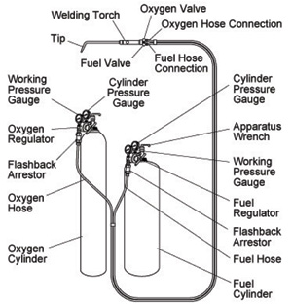

- Oxygen cylinders are painted black and used to support combustion and its presence allows different types of flames to be set. The valve outlet has a right-hand thread and is fitted with a valve spindle to turn the pressure ‘off’ and ‘on’. Oxygen cylinders have right-hand threaded connections which are plain.

- Acetylene cylinders are painted maroon. The valve has a left-hand thread and is fitted with a valve spindle to turn the pressure ‘off’ and ‘on’. Acetylene cylinders have left-hand threaded connections which are notched or grooved

- Regulators are instruments that reduce the pressure from the cylinder to the torch. Each regulator has an adjusting knob that is turned to adjust the pressure of gas to the hand piece. They are fitted to the cylinder valve with threaded fittings.

- Two gauges are fitted, one indicates the pressure remaining in the cylinder, and the second indicates the working pressure.

- Hoses are used to connect the cylinder to the torch. It is important that only approved welding hoses be used on oxy-acetylene welding plants. Acetylene hose connections are also notched to help differentiate between the oxygen hose.

- Trolleys are used to support the cylinders and light enough moving the plant.

- Cylinder key is used to turn the pressure on and off at the cylinders. The key should be attached to the trolley and left on the acetylene cylinder during operation. This allows the pressure to be turned off quickly in case of an emergency.

- Flashback arrestors are connected between the regulator and the hose and, between the torch and the hose. Flashback arrestor prevents any flame to travel down the hose of an oxy-fuel welding and cutting system.

\

LESSON 53: WELDING & CUTTING TORCH

LEARNING OUTCOME: IDENTIFY THE TYPES OF TORCH & PROCEDURES

- Welding torch- A welding torch head is used to weld metals

- Cutting torch- A cutting torch head is used to cut materials.

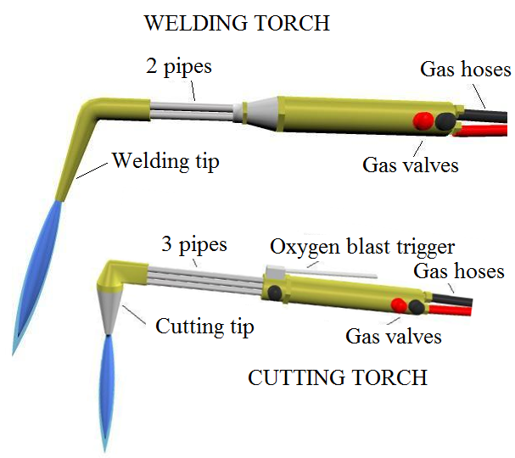
- Fusion welding is the melting of two surfaces or edges of metal to be joined, completely fusing them together without pressure, to form a new structure

- Non-fusion welding does not melt the surfaces or edges to be joined but they are held together by a molten filler metal drawn by capillary action to the two surfaces.

LESSON 54: FLAME SETTING

LEARNING OUTCOME: IDENTIFY THE THREE TYPES OF FLAME IN WELDING

- If the cut has been started properly, a shower of sparks will fall from the opposite side of the work

- Move the torch at a speed which will allow the cut to continue penetrating the work

- A good cut will be clean & narrow

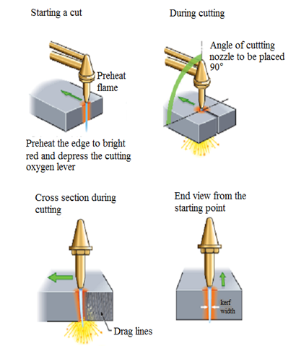

LESSON 55: WELDING CONDITIONS

LEARNING OUTCOME: IDENTIFY THE THREE TYPES OXY-ACETYLENE WELDING CONDITIONS

Correct Condition
Speed too slow | 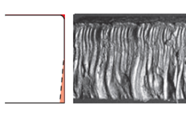
Nozzle too low | 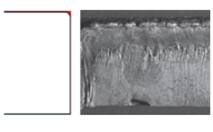
Preheat flame too large | 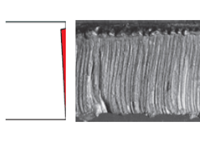
Nozzle too high above work | 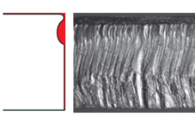
Pressure of cutting oxygen too high | 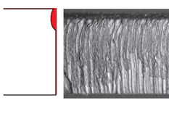
Speed too fast | 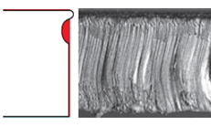

ACTIVITY

- Identify the types of operation of cutting sheet metal

- Differentiate between welding torch & cutting torch

- Define the following:
- Fusion Welding

- Non-Fusion Welding

- Regulators

- Trolleys

- Identify the three types of flames in welding

- State some causes of welding conditions

WORKSHEET
Name the following

Label the following:

(iv)
(iii)
(ii)
(i)

