WEEK 7 YEAR 12 APPLIED TECHNOLOGY
STRAND: WELDING & FABRICATION

LESSON 46: FORMING PROCESS-BENDING SHEET METAL

LEARNING OUTCOME: IDENTIFY THE PROCEDURE FOR BENDING THROUGH HAND PROCESS

- SIMPLE BENDING- HAND PROCES

- A bench with a square edge can be used. If not available, square the edge of a piece of hardwood and clamp it on top of a bench or other solid support.

- Place the metal to be bent on the piece of hardwood and then follow the correct bending procedure.
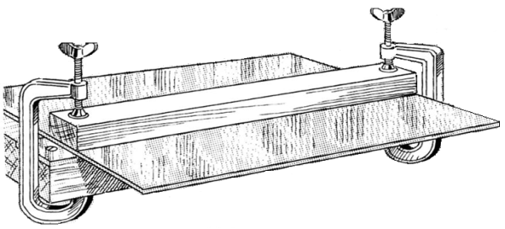

Procedure for Bending
- Select, layout, and cut the stock to size.

- Lay off the position at which the bend is to be made and mark with a scriber. Use a pencil if a scriber mark on the metal is objectionable.

- Turn the marked side down, and then place the sheet of metal on the edge of a bench having a square edge, preferably faced with metal.

- Adjust the sheet of metal so that scribed line is exactly even with the e’ of the bench, then place a strip of on the metal and clamp it in position.

- Starting at one end, begin bending metal down by striking light blows with mallet along the full width of the sheet. Work back and forth making a grail bend, until the metal is forced down against the edge of the bench.

LESSON 47: FORMING PROCESS-BENDING SHEET METAL-PIPE BENDING

LEARNING OUTCOME: IDENTIFY THE PROCEDURE FOR PIPE BENDING OPERATION

- Swing the short handle up so it is above the bender die.
- Open the tube latch
- Place the tube in the groove of the bender die with the reference mark to the left of the tube latch.
- Close the tube latch over the tube just enough to hold the tube in place. This restricts movement of the tube during initial positioning but still allows for additional alignment.
- Carefully lower the short handle until the roll dies rest gently on the tube while keeping the link straight and parallel to the long handle.
Note: Premature bending may occur if the link is not straight and parallel to the long handle
- Align the zero on the roll support with the zero on the name plate. Align the bend mark with the mark on the roll support that corresponds to the bend angle.
- Push the tube latch firmly over the tube to secure the tube in the bender die.
Note: Excessive pressure on the tube latch may damage soft tubing
- Push the tube latch firmly over the tube to secure the tube in the bender die.
Note: Excessive pressure on the tube latch may damage soft tubing.
- Slowly push the short handle down until the 0 on the roll support reaches the desired degree mark on the name plate.
- After completing the bend, swing the short handle up and away from the tube.
- Pull the tube latch off the tube and remove the tube from the bender groove.

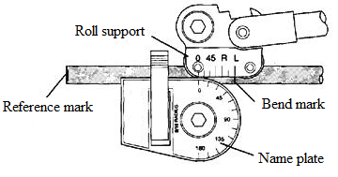
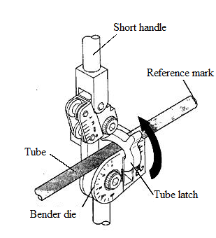
Steps 5-6
Steps 1-4

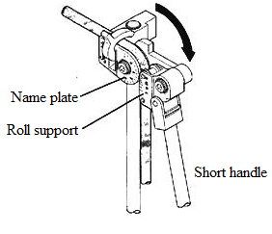
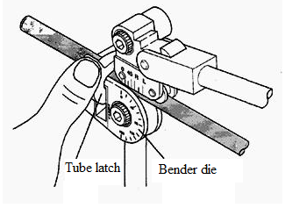
Steps 7-9

Steps 10-11

LESSON 48: STIFFENING OF FABRICATED MATERIAL-EDGES
LEARNING OUTCOME: IDENTIFY THE TYPES OF EDGES
- EDGES
- Edges are formed to enhance the appearance of the work, to strengthen the piece, and to eliminate the cutting hazard of the raw edge.
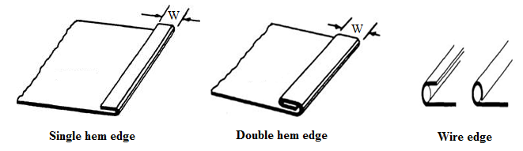

- The Single hem edge is shown can be made in any width. In general, the heavier the metal, the wider the hem is made. The allowance for the hem is equal to its width.

- The Double hem edge is used when added strength is needed and when a smooth edge is required inside as well as outside. The allowance for the double-hem edge is twice the width of the hem.

- A Wire edge is often specified in the plans, Objects, such as ice-cube trays, funnels, garbage pails, and other articles, formed from sheet metal are fabricated with wire edges to strengthen and stiffen the jobs and to eliminate sharp edges. The allowance for a wire edge is 2 ½ times the diameter of the wire used.
LESSON 49: STIFFENING OF FABRICATED MATERIAL-SEAMS
LEARNING OUTCOME: IDENTIFY THE TYPES OF SEAMS
- SEAMS
- There are many types of seams are used to join sheet-metal sections. When developing patterns, ensure to add adequate material to the basic dimensions to make the seams.

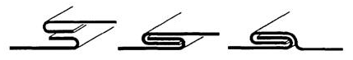
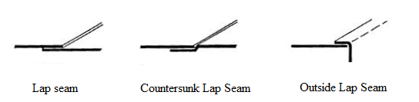
- The folds can be made by hand; however, they are made much more easily on a bar folder or brake. The joints can be finished by soldering and/or riveting.

- Lap seams can be joined by drilling and riveting, by soldering, or by both riveting and soldering.

- Grooved seam joint consists of two folded edges that are locked together with a hand groover.

- The Cap strip seam is often used to assemble air-conditioning and heating ducts.

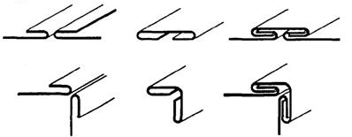
Locked corner seam

Cap strip seam

- A variation of the joint Locked corner seam is widely accepted for the assembly of rectangular shapes.

- Standing seams are used for joining metals where extra stiffness is needed, such as roofs, air housing and ducts. is a cross section of the finished standing seam. Dimensions and rivet spacing will vary with application.
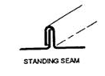
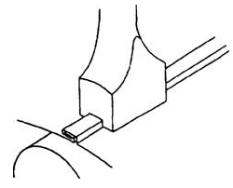

LESSON 50: STIFFENING OF FABRICATED MATERIAL-NOTCHES
LEARNING OUTCOME: IDENTIFY THE TYPES OF NOTCHES

- NOTCHES
- Before you can mark a notch, you will have to lay out the pattern and add the seams, the laps, or the stiffening edges.

- If the patterns are not properly notched, you will have trouble when you start forming, assembling, and finishing the job.

- No definite rule for selecting a notch for a job can be given. But as soon as you can visualize the assembly of the job, you will not have any trouble determining the shape and size of the notch required

- If the notch is made too large, a hole will be left in the finished job. If the notch is too small or not the proper shape, the metal will overlap and bulge at the seam or edge.

- A square notch is likely the first you will make. It is the kind you make in your layout of a box or drip pan and is used to eliminate surplus material. This type of notch will result in butt comers. Take a look around the shop to see just how many different kinds of notches you can see in the sheet-metal shapes.

- Slant notches are cut at a 45° angle across the corner when a single hem is to meet at a 90° angle.
- ‘V’ notches are used for seaming ends of boxes. You will also use a full V notch when you have to construct a bracket with a toed-in flange or for similar construction

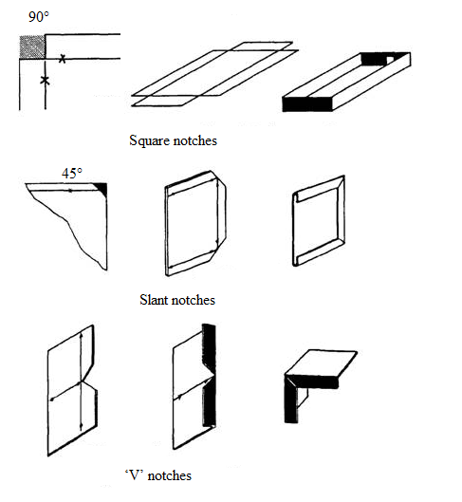
ACTIVITY
- Name the tool used to clamp down sheet metal while sheet metal bending

- State the first process before bending sheet metal

- Identify the tool used in marking out sheet metal

- What is the purpose of edges in metal fabrication?

- State the types of edges

WORKSHEET
1. Name the following

