WEEK 6 YEAR 12 APPLIED TECHNOLOGY
STRAND: APPLIED ENGINEERING
CARPENTRY & JOINERY
LESSON 36: BUTT HINGES

LEARNING OUTCOME: IDENTIFY THE TYPES OF BUTT HINGES
- May have wide or narrow flanges called broad butts of narrow butts depending on thickness of timber.

- Butt hinges are used for hanging doors and hinging lids, where the flanges are let into recesses (grains) cut into the abutting edge of the doors and cabinet car case
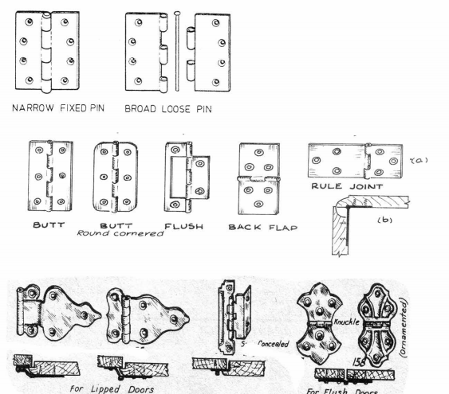
LESSON 37: BACK FLAP

LEARNING OUTCOME: IDENTIFY THE TYPES OF BACK FLAP HINGE
- Strap & Tee
- Screwed to the face of the job and are used for external jobs such as garage doors, ledge and brace doors, gate & step ladders

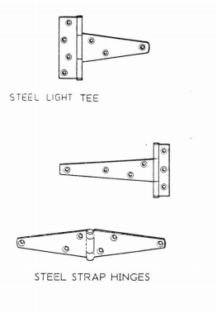

- Double Action Screen
- For folding screen allowing 360◦ rotation

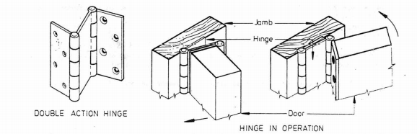

- Ornament & Semi Concealed
- All or portion of the hinge is screwed to the face and is visible, for lip or flush doors of kitchen and bathroom cabinets
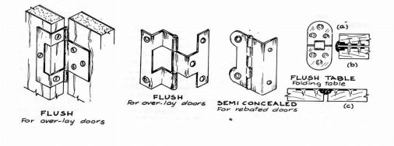
LESSON 38: FITTING HINGES

LEARNING OUTCOME: IDENTIFY THE PROCESS OF FITTING HINGES
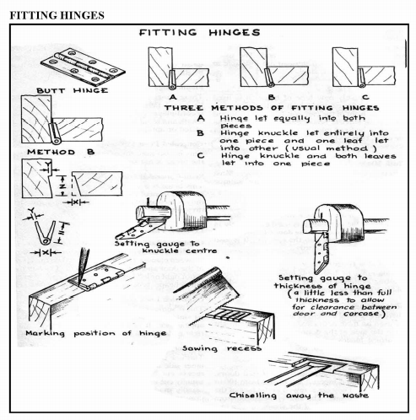
LESSON 39: LOCKS

LEARNING OUTCOME: IDENTIFY THE TYPES OF LOCKS
- Straight Lock
- A cheap type with screw flat on the inside face of the drawer or door

- Cut Lock
- Stronger & neater, being let into cut recesses in the back of the drawer or the door

- Mortise Locks
- Fitted into a mortise cut in the edge of the door or drawer

- Box Lock
- Used for lids of boxes & desk tops

- The key operates two plungers which engaged in slot of projecting lugs on the strike plates

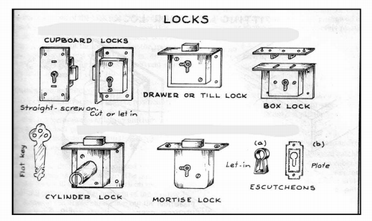
LESSON 40: FITTING A DRAWER LOCK

LEARNING OUTCOME: IDENTIFY THE PROCESS IN FITTING A DRAWE LOCK
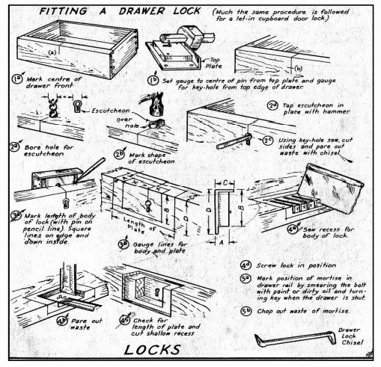

ACTIVTIY
- Name any two types of hinge

- State the two types of back flap hinge

- What hinge is suitable for a ledge & brace door?

- Name the four types of locks

- Identify the lock that is fitted in a mortise

WORKSHEET
Name the following
