WEEK 5 YEAR 12 APPLIED TECHNOLOGY
STRAND: APPLIED ENGINEERING
CARPENTRY & JOINERY
LESSON 36: PARTS OF A PANELLED CABINET DOOR

LEARNING OUTCOME: IDENTIFY THE PARTS OF A PANELLED CABINET DOOR
Parts of a panelled cabinet door
- The frame of a panelled cabinet door surrounds the panel and should not be the same width all around.

- For balance of design the width of the stile should be slightly less than the top rail and the top rail again slightly less than the bottom rail.

- Stile - are the outside vertical piece of a door and in a small cabinet they should be approximately 40 mm wide.

- Top rail - is the horizontal top member of a door and should be slightly wider than the stile, about 44 mm.

- Bottom rail - should be slightly wider than the top rail, about 48 mm.

- Muntin - is the name given to the centre up right piece. Small doors do not usually contain a muntin, but if included it should be slightly narrow than the stiles. One purpose of the muntin is to break-up a large area so that there is less likelihood of panel bulging or in the case of solid timber panels, so that there is less shrinkage.
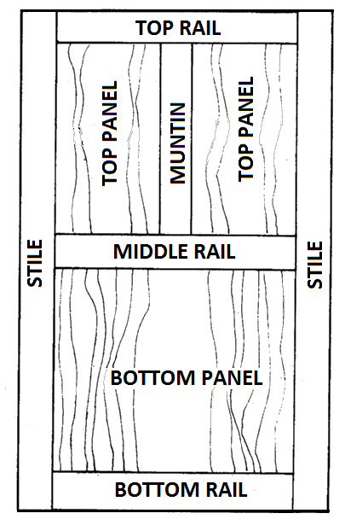
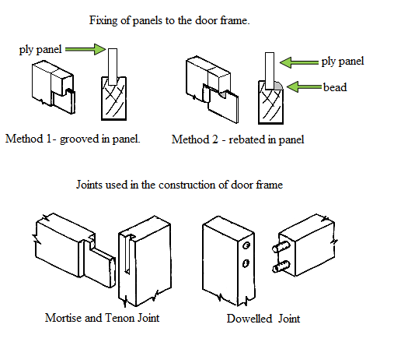

LESSON 37: PARTS OF A DRAWER

LEARNING OUTCOME: IDENTIFY THE PARTS OF A DRAWER

Parts of a Drawer
- Every drawer has the same basic parts: front, back, sides, and bottom.

- But these parts can be assembled in a variety of ways to produce different types of drawers.

- The Drawer Front
- The drawer front is usually 20 to 22 mm thick with a 5 x 5mm groove run along the bottom inside edge.

- The Side
- Are usually 13 mm thick and they may be grooved in the same way as the front, while this is quite a normal practise, a stronger and better method is to provide “drawer slips”.

- The Back
- It’s usually thinner than the sides and approximately 10 mm thick.

- It is also narrower to allow the plywood to slide underneath.

- It should stand down a little below the side so that planning the drawer side when fitting the completed drawer is easy.

- The top edge is usually rounded off.

- The Bottom
- Is usually 5 mm thick and made either of plywood or hardboard.

- Solid timber is rarely used for drawer bottoms because of shrinkage.

- The Slip
- Are pieces of wood, grooved and fixed to the drawer side to take the drawer bottom.

- The drawer slips serve two purposes, when nailed and glued to the drawer side they give greater strength and wider wearing surfaces to the drawer sides.

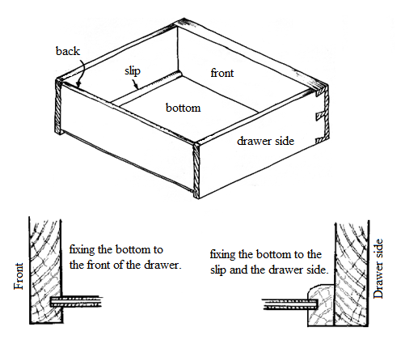

LESSON 38: DOORS- INTERIOR DOORS

LEARNING OUTCOME: DENTIFY THE TYPES OF INTERIOR DOORS
Types of Interior Doors
- For interior situation or entrances, a door of better appearance than the braced and ledged door is generally required and this is usually provided by a flush door or a panel door.

- Panelled Door
- Although the panel door has been outdated by the modern flush door, they are still preferred by many.

- The panel of this door is best made of plywood to avoid the shrinkage or timber movement likely with solid timber.

- The panel may be grooved into the rails and stiles and framed with the door.

- Glazed Door
- There are many different designs of these doors these doors are designed to admit light through the entrances.

- The rails and stiles are rebated with a moulding on the face, a plain bevel moulding been the most used.

- The glass usually 3 to 4 mm thick, is puttied into the frame.

- It may be clear glass or translucent (obscured) in a number of decorative patterns. In heavier doors the glass may be beaded in to the frame.

- Flush Doors
- The main advantages of flush doors are ease of cleaning, cheapness of construction and lightness.

- The use of special veneers on the face of the door can make it very decorative.

- There are two types of flush doors; Solid Core Flush Door and Hollow –Core Flush Door.

- Solid Core Flush Door
- This door is constructed in the same way as core board except that it is of a much thicker timber core.

- A solid core of the door is arranged with growth rings alternating.

- The inner veneers are laid across the direction of the slats and the face veneers are laid in the direction of the slats.

- In some cases the face may be formed by pressing a sheet of three-ply to each side instead of holing veneers.

- Hollow –Core Flush Door
- This is constructed with a simple outside frame usually held together at the joint by simple tongue and groove or simply by corrugated fasteners.

- The inside of the fastener is formed by fixing light slats spaced at about 150mm centres or it is packet with light spiral shavings specially made or with one of the several types of cardboard honeycomb packing.

- These keeps the plywood skins perfectly flat and parallel but do not add greatly to the weight. A block of wood is fitted in to take the door lock.

- A facing of skin of plywood is glued to each side of the frame and the edges tipped or clashed with a thin strip of solid timber.

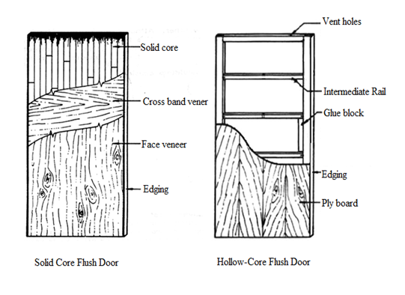

LESSON 39: DOORS- EXTERIOR DOORS

LEARNING OUTCOME: DENTIFY THE TYPES OF EXTERIOR DOORS
Types of Exterior Doors
- Ledged and Braced Door
- These types of doors consist of tongue and groove boards held together by ledges nailed across their width.

- The joint at the face of the door are used to hide the small gaps which develop when the board shrinks.

- The door must be braced to prevent sagging.

- This is done by cutting and nailing diagonal braces between the ledges.

- These braces must be sloped upwards from the hinge side of the door.

- These types of doors are usually hinged to the frame by ‘T‘ hinges and fixed with a Rim or Night Latch lock

- Framed Ledged and Braced Door
- This type of exterior door has a better appearance than the Ledged and Braced door.

- It consists of a frame, held together with mortise and tenon joint with a centre panel or sheathing of tongue and grooved boards.

- The top rail and stile are rebated to receive the panel.

- These boards pass over the face of the middle and bottom rails.

- The tongue and groove board are planned on the front side to form a double vee at the edges and are usually about 13 mm thick and are nailed in place.

- The top rail is joined into the stile with a haunched mortised and tenon joint and is the same thickness as the stile.

- The middle and bottom rail are thinner to allow for the thickness for the tongue and groove boards and are mortised into the stile using a barefaced mortise and tenon joint.

- These doors are sometimes made with the glass panel to admit light. The glass is puttied into the rebate machined for the tongue and groove boards

LESSON 40: DOORS FRAME

LEARNING OUTCOME: DENTIFY THE DOOR FRAME PARTS
- Door Frames
- Door frames consist only of the rebated jambs and head.

- The door opening in the low concrete wall is cemented smooth with a slope towards the front to provide weathering and to form a sill.

- The frame is made by checking the jambs into the head and nailing.

- The projecting horns are cut off later to suit the door opening between the studs.

- A temporary spreader is also necessary at the bottom of the frame.

- Door jamb
- It Is the vertical portion of the door frame onto which a door is secured.

- Most types of door fasteners and deadbolts extend into a recess in the door jamb when engaged, making the strength of the door jambs vitally important to the overall security of the door.
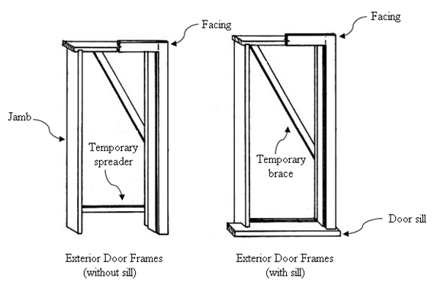

ACTIVITY

- State the four parts of a drawer

- Name two types of interior doors

- Name the material used in making panels in panel doors

- Name two types of exterior doors

- Identify the difference between a ledge brace door & a frame ledge brace door

WORKSHEET

- Draw a drawer & label all parts

- Describe how the drawer bottom is attached to the drawer front

- Sketch a ledge & brace door

- Why is plywood mainly used in the production of panel doors

- Name the joint commonly used in ledge & brace door

- Define Door jamb

