**RATU NAVULA COLLEGE**

**YEAR 12 NOTES AND ACTIVITY WEEK 1 – 2021**

**AGRICULTURAL SCIENCE**

**SUB- STRAND AS 12.3.2 HORTICULTURE**

**LESSON 29: INTRODUCTION**

**Lesson outcome:** Discuss the history and importance of plant improvement.

**Role of crops threatened by:**

1. the increasing need to feed the world's population,
2. an ever greater demand for a balanced and healthy diet
3. the limited availability of farm land for crop production,
4. the fact that much of the world's best soils are already in use and others are protected because of environmental concerns

|  |
| --- |
| Plant improvement began when people began farming.  Due to the need of the growing world population, plants have been selected and modified to improve the quantity and quality of harvest from the same area of land. |

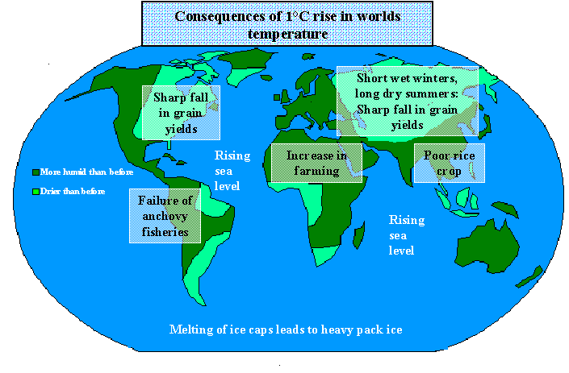

**STUDENT ACTIVITY**

|  |
| --- |
| Discuss the role of plant improvement in in human history. |

**LESSON 30: PLANT IMPROVEMENT**

**Lesson outcome:**

Discuss the main methods used to produce superior crops.

**Germ plasm** - the genetic material of a plant and animal species or other related group of organisms, collected for use in study, conservation, and breeding such as seeds or tissue .

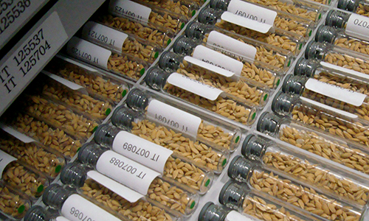

**Heterosis** - hybrid vigor, or outbreeding enhancement, is the improved or increased function of any biological quality in a hybrid offspring

**Gene redundancy** - two or more genes are performing the same function and that inactivation of one of these genes has little or no effect on the biological phenotype

**Characteristic of superior crops**

1. High yield

2. Better quality of products

3. Increased tolerance to environmental stress

4. increased tolerance to pests

5. Range of products e.g.grain,fodder,fertilizer

6. Resistance to pathogens .

7. Resistance to lodging.

8. Reduced growing period.

9. Adaptability to climate change.

**METHODS USED FOR IMPROVING PLANTS IN AN AREA:**

1. **Altering growing crops**

* Altered by trimming off unproductive parts.

2. **Improving existing crops**

* By Grafting and budding (join parts with desired phenotypes )

**Result**

* desired foliage, flowers and fruit
* - desired robust rooting system

**EXAMPLE**

|  |  |
| --- | --- |
| 1. One bougainvillea plant with grafted branches bearing different coloured flowers. |  |

1. A farmer has two rose plants.

* Plant **one** produces large flowers but has a weak root system.
* Plant **two** produces small flowers but has a strong root system.

The farmer wishes to have a plant with large flowers and a strong root system and decides to join the scion from root one with the root stock of plant two through grafting, as illustrated.

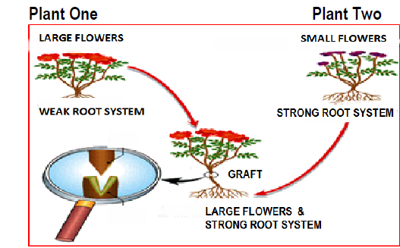

The **resulting** daughter plant now has large flowers and a strong root system.

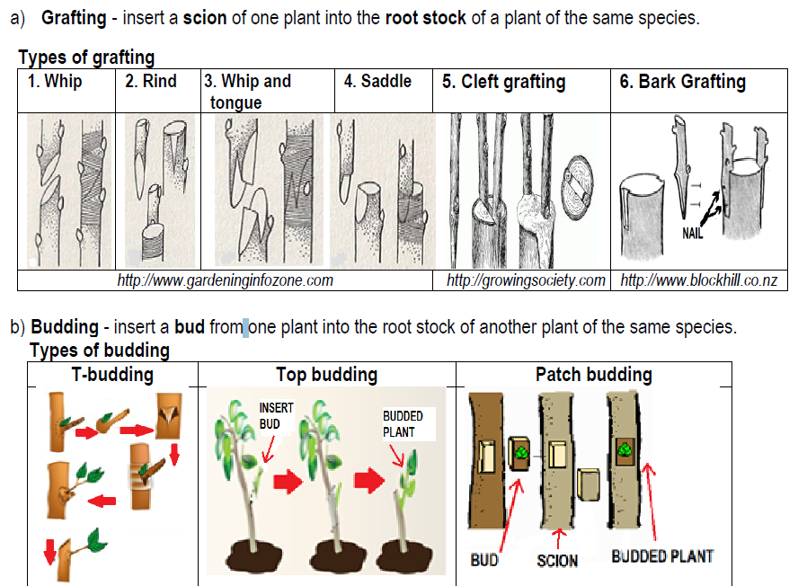

1. **Introduction and preservation of plants with traits which are considered better.**
2. **Domestication**

* Adapting wild plants and animals for human use.
* hardier in nature

1. **Germplasm collection**

* samples of plant and animal tissue are preserved

c) **Plant introduction** – introducing a new plant species or variety to an area where it acclimatises.

d) **Tissue culture –** an asexual method of plant propagation where cells derived from living tissue are grown in an artificial medium. The progeny are identical.

1. **Plant breeding** –the purposeful manipulation of plant species in order to create desired plant types that are better suited for cultivation, give better yields and are disease resistant.

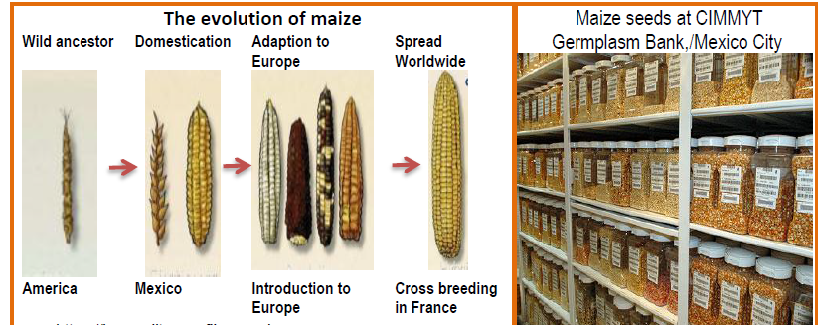

**Student activity**

1. Define conventional plant breeding

|  |
| --- |
| 2. Why have successive generations of farmers improved crops? |

**FORESTRY & AGROFORESTRY**

**LESSON 31: TYPES OF FORESTS**

**LESSON OUTCOME:** differentiate among the types of forests in Fiji.

**Forest -** a large area covered chiefly with trees and undergrowth.

**Primary forest -** untouched, pristine forest that exists in its original condition

**Secondary forest** - forest that has been disturbed in some way

**TYPES OF FORESTS.**

Forests may be classified according to:

* Reproduction and management purpose
* Mangroves and agroforestry

**1. Classification by reproduction and management:**

**A. Natural Forest**

* generated itself in an area
* logging can be done

**B. Plantation Forest**

* planted by humans
* single species planted and managed
* harvested and sold
* e.g pine, mahogany and teak forests.

1. **Classification by purpose**

**A . Production forests**

* Produce goods for subsistence or commercial use.
* Includes plantation forests e.g. Caribbean pine,

coconut groves, mahogany and teak.

* Also Sandalwood forests

**b. Protection forestry**

* control soil degradation like erosion and loss of fertility.
* prevent the impact of a natural hazards, including rock falls, erosion, landslides,
* mitigate the effects of climate change e.g. mangrove forests planted to build up the coastline and for protection from sea spray, rising sea levels and sea flooding.
* preserve the water catchment area.
* provide habitats for the conservation of fauna and fauna.

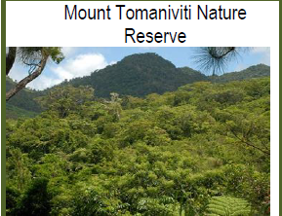



**c. Amenity forestry**

* managed for recreation purposes
* Include bird watching, photography, painting, observing organisms in their natural habitat, walking, hiking, cycling, zip lining, picnics, camping and white water rafting, among others.



**Student activity**

|  |
| --- |
| 1. Discuss the difference between natural and plantation forests. |

**LESSON 32: ROLES OF FORESTS**

**LESSON OUTCOME:** Discuss the role of forest

**ROLES OF FOREST**

1. **Source/conservation of resources** – including food, fodder, medicine, water, timber
2. **Source of cultural non-material benefits** – spiritual enrichment, cognitive development, reflection, recreation, green space and visual aesthetics
3. **Supporting services to the ecosystem** – recycling of air, water and minerals; soil formation and conservation
4. **Influences** temperature, quality of air and water, odour, dust and noise reduction
5. **Habitat for wildlife**; endemic flora and fauna, biodiversity and gene pool
6. **Adaptation to climate change** - carbon sequestration.

**LESSON 33: MANGROVES**

**LESSON OUTCOME**: discuss the importance of mangrove forests in relation to agriculture in Fiji.

Mangrove - a shrub or small tree that grows in coastal saline or brackish water.

**Importance of mangroves**

**1. Form a natural wind break** –reduces impact of strong winds and sea spray on agricultural crops and buildings too.

**2. Retain sediments** – soil particles washed down from land and brought in by waves are trapped by the roots of mangroves. This results in the buildup of the coast line in direct response to rising sea levels.

**3. Form a natural breakwater** – waves are broken by the roots of mangroves, reducing their impact on land.

**4. Provide a habitat and nursery for many organisms**

**5. Provide other materials** -like dye, fuel and medications as well as fodder for animals like goats

ACTIVITY

1. Discuss 3 importance of mangroves.