RATU NAVULA COLLEGE
YEAR 12 NOTES AND ACTIVITY WEEK 10 – 2021
AGRICULTURAL SCIENCE
LESSON 73: DISEASES OF HONEY BEES

LESSON OUTCOME: Discuss the main diseases which affect honey bees.

Perforated- having a hole or series of holes.
Beekeepers must be vigilant to prevent, identify and control diseases because honey bee brood and adults are attacked by bacteria, viruses, protozoa's, fungi and parasitic mites.

Some of these diseases include:

DISEASE | DESCRIPTION | CAUSES | SYMPTOMS | CONTROL
VIRAL DISEASE  Sac brood | Commonly seen in poorly managed and stressed bee hives. It is spread within the hive by nurse bees that contract the virus while trying to remove dead brood. | virus Morator aetatulas | Perforated sealed brood, pupa present with undeveloped head and the colour develops from pearly white to pale yellow to brown and eventually to black. When it is in scale form it is brittle and easily removed. | Re-queen the hive and remove stress factors as strong hives can recover
Fungal Diseases  Stone brood | a rare disease of brood and adult bees | fungi Aspergillus flavus, Aspergillus fumigatu and Aspergillus niger which are found in soil. | Ingested spores germinate in the alimentary canal, causing breathing problems.  Infected larvae become white and fluffy and die after the cells are capped.  Fungus erupts from the larval remains and forms a false ‘skin’ which turns first yellow and then green as the bee’s body becomes covered with powdery fruiting fungal spores. | There is no control so infected hives are burnt. Keep frames off the soil.
Chalkbrood | a disease of 3 to 4 day old brood.  fungus Ascosphaera apis. This disease, though not present in Fiji apiaries, is serious in New Zealand. | fungus Ascosphaera apis | The infected larvae die when the cell is capped, turn a chalky  white color and rattle when the comb is shaken.  Chalkbrood is most frequent during damp conditions. | Colonies usually recover but it is recommended that infected hives be burnt.
Nosema | a disease of adult bees. . It thrives in hives with poor ventilation. | fungus called Nosema apis which is ingested by adult bees during wet and cold weather | Bees appear weak and may crawl around the front of the hive, have increased girth of the abdomen, missing sting reflex and wet yellowish dysentery. | Treat Nosema by feeding the drug Fumidil® B in sugar syrup.  Do not feed the medication immediately before or during a nectar flow.
Bacterial Diseases American Foulbrood  (AFB) | disease of young larvae and pupae which rapidly spread through spores carried by adult bees and on  contaminated equipment. | bacterium Paenibacillus larvae | Infected larvae emit a foul smell, change color from a healthy pearly white to dark brown and die after they are capped. Cappings of dead brood sink inward and are often perforated. | Colonies with AFB must be burned.  Check for AFB by thrusting a small stick or toothpick into  the dead brood, mixing it then withdrawing the mass.  Dead larvae are stringy.
European Foulbrood  (EFB) | is a disease of larvae which is not believed to be in  Fiji. Unlike with AFB, larvae infected with EFB die before they are  capped. | caused by  the bacteria Melissococcus pluton | Infected larvae are twisted in the bottoms of their cells, change to a creamy color which gradually turns rubbery and have a smooth"melted" appearance. Because EFB bacteria do not form persistent spores, this disease is not as dangerous as AFB.  Colonies with EFB will sometimes recover after a good nectar flow begins. | treat colonies with Terramycin® as described  above.
STUDENT ACTIVITY
Differentiate among the 4 diseases of honey bee brood mentioned above.

LESSON 74: PESTS OF HONEY BEES

LESSON OUTCOME: How some pests are attracted to honey, wax and pollen

i. Wax moths – come in two main types

ii. Grater wax moth
Galleria mellonella – which is pale brown to grey, 20mm long with grey wings. Lays pinkish white eggs in clusters in hive.

iii. Lesser wax moth
Achroia grisella – which is silver grey to yellow, slender 13 mm long. Lays solitary eggs in the hive.

WHAT MOTHS DO?
- Enter the hives at night and lay eggs near wax combs.
- Larvae hatch and begin burrowing through the combs to eat honey, pollen, beeswax and debris in the cells.
- Moth larvae ruin combs and plaster them with webbing and faeces.

HOW TO PROTECT COLONY FROM MOTH LARVAE?
- Clean the hives and destroy all eggs and burn infected comb.
- Moth damage is most common in stored supers of comb
- Protect stored supers by stacking them no higher than five hive bodies.
- Tape shut all cracks; put Paradichlorobenzene crystals at the top of the stack then cover the stack with a lid. Replenish the crystals as they evaporate. Do not place Paradichlorobenzene crystals inside the hives as it kills bees too.

2. Tracheal Mites – Acarapis woodi are microscopic mites that enter the tracheae (breathing tubes) of young bees. Inside the tracheae, mites block air exchange and pierce the walls of the tubes to suck blood.

SYMPTOMS -resemble those of Nosema. Bees become weak, crawl at the hive entrance and sometimes uncouple their wings so that all four wings are visible.
Colony death rates are highest during winter.
Infested colonies are treated with Miticur® or special formulations of menthol.

3. Varroa Mites - Varroa destuctor mites are about the size of a pin head and are copper in color. Female mites cling to adult bees and suck their blood. Females then enter a bee brood cell and produce several offspring which, in turn, suck the blood of the developing bee. Infested colonies almost always die within three to four years unless they are treated. Colonies are treated with Apistan®, a formulation of fluvalinate.

4. Toads, lizards and birds – usually wait outside the hive and eat bees at the entrance. Keep the bees out of reach of the pests so raise hives about knee height off the soil. Keep the apiary free of weeds so there are less hiding places for these pests. Fence the apiary or hives with chicken mesh and remove toads from the area.

Some pests are curious
- Cattle, goats, horses, pigs – are attracted to the smell of honey, use the hives to scratch against or are just plain curious. They knock over the hives especially if stung, causing the bees to swarm.
- Children – play games which anger the bees and will often end in stings and unnecessary stress for the bees. Education, fences and experience helps.

STUDENT ACTIVITY
- Name the substance which honey bees use to mummify pests, like rats, which enter the hive.
- Describe one symptom which a farmer would observe in a bee hive that is infested with wax moth.
- Discuss the process of requeening a bee hive.

LESSON 75: EXTRACTING HONEY

LESSON OUTCOME: Discuss when honey is ready for harvesting.

Curing honey - reducing the moisture content of nectar from 80% to 18% or less to produce honey.

Honey is cured nectar and is made by worker bees.

Worker honeybees visit thousands of flowers, and collect nectar from them, storing it inside their bodies in a special “honey stomach”. While inside the bee, the nectar mixes with a number of proteins and enzymes produced by the bees, starting the honey-making process. When the worker honeybees return to the hive, they transfer the nectar into the beeswax comb, and repeat the process until the combs are full. The bees then fan the air around the stored nectar with their wings, drying the moisture out of it and preparing it for long-term storage: during this process the nectar thickens and eventually transforms into what we recognize as honey. When this is done, the bees cap the honeycomb with wax and move on to the next empty combs, beginning all over again.”

Honey is harvested from hives which are strong.
Harvesting from weak hives results in starvation of the colony members.

Honey can be harvested from the honey suppers if:
Combs are capped – this honey has been cured and stored by the bees for future use, so is ready for extraction.
Uncapped honey is cured – turn the frame so that the uncapped cells of honey are facing the ground and tap gently.

Cured honey will not leak out and can be harvested, although this is not advisable. If the content of the cell leaks out, it is nectar that hasn’t been cured. The water content is too high for it to be considered honey. Attempting to bottle this nectar results in watery syrup that is likely to ferment and spoil.

Harvesting honey from capped combs

STEPS | DIAGRAM
- Open the Hive  Beekeepers use smokers around the entrance of the beehive to subdue the bees.  The beekeeper then removes the top of the hive and smokes the bees down to the lower end of the hive. This results in fewer bees on the frames of honey. | 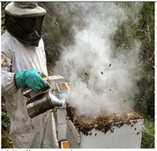
- Choose capped frames and remove bees  Each frame in the honey super is inspected and frames of capped honey are brushed clean of bees and placed in an empty super.  Uncapped honey and frames from the brood chamber are left untouched. | 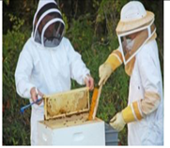
- Uncap the Honeycomb  The super of selected frames are taken to the honey house for extraction of honey.  The honeycomb is uncapped using a sharp knife or an electric knife.  The wax is stored separately. The honey is removed usually by squeezing the wax and the wax is rendered. | 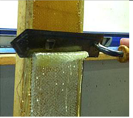
- Extract the Honey from the Honeycomb  The uncapped frames of honeycomb are placed in baskets in an extractor. Using centrifugal force, the frames are spun, removing the honey from the combs and throwing it against the walls of the extractor, where it runs down and collects at the bottom of the extractor. The frame baskets are turned and then spun again so all honey is removed. | 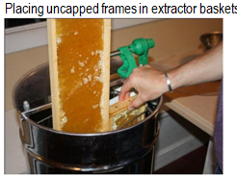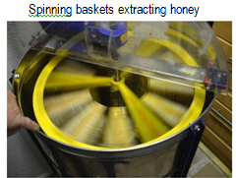
- Filter honey  Most extractors have a spigot at the bottom for draining honey. The honey is strained in order to remove any debris, such as wax, bee parts, etc. | 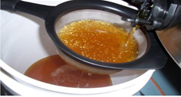
- Stand extracted honey  Leave the honey in a closed container for around 12 hours to expel air bubbles before bottling. | 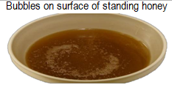
- Bottle honey  Honey is filled into sterilized containers which are closed, labeled and packed ready for use or sale. | 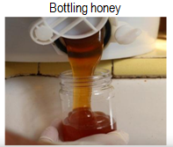
7. Return the frames to the hives
The frames are returned to the honey supers from whom they were taken.

STUDENT ACTIVITY

- Discuss why apiculturist cures the honey?
- Explain the purpose of the following:
- Using smoker while opening the hive.
- Filter honey
- How does apiculturist know that the honey is not cured?

LESSON 76: HARVESTING

LESSON OUTCOME: Discuss how harvesting honey from flow hives

1. Determine which frames are ready for extraction  The beekeeper views that frames through a glass window to determine which frames are ready for extraction. [N.B. frames are not removed from hives] | 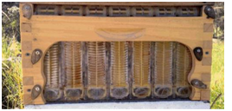
2. Attach the tube  Remove the tube cap from the flow frame and insert one end of the tube with the other end placed in the collection container. | 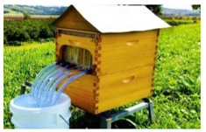
3. Insert the tool  Remove the tool cap from the flow frame which is inside the hive. Insert the tool into the slot. | 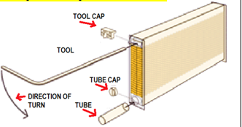
4.The flow frame is adjusted to release honey.  The tool is turned 90 degrees, causing the comb to realign and allowing the honey to flow down the centre of the comb and out the pipe, into a collection container. | 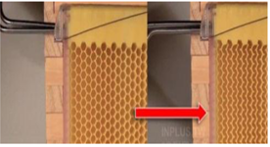
5.The honey is collected  The collected honey can now be taken for settling to remove the air bubbles and for bottling too. | 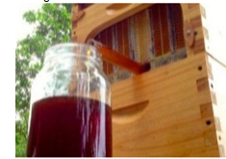
6. The flow frame is readjusted
The tool is turned back so that the comb is returned to its original shape.
The bees can now uncap the combs and begin to refill it with honey

STUDENT ACTIVITY
- Compare harvesting honey from a conventional frame and a flow frame

LESSON 77: PRODUCTS AND BY-PRODUCTS OF APICULTURE

LESSON OUTCOME: Discuss the uses of the products and by-products of apiculture.
.
Beekeeping produces many primary products with the main one being honey.
The lower the water contents, the higher its quality.

1. Raw honey in its natural form:
- Is a rich source of natural sugars as it contains 80% fructose and glucose.
- Can last for a long period of time as honey with water content of 18% or less will not ferment.
- Contains 2% minerals, vitamins, proteins and pollen.
- Contains vitamins B6, thiamine, niacin, riboflavin, pantothenic acid
- Contains the minerals calcium, copper, iron, magnesium, manganese, phosphorus, potassium, sodium and zinc.
- Contains no fat nor cholesterol

Honey is used for:
- food and as a food ingredient and preservative
- Medicine and as a medicine ingredient
- Improving and preserving the aroma and humidity of tobacco;
- Cosmetics as a skin treatment, moisturiser, softener; in creams, soaps, shampoos and lipsticks.
- Embalming in ancient civilisations.

- Beeswax
- Is a natural secretion from wax glands on the undersides of the body of honey bees.
- It is used primarily as a building block for the bees' honeycomb cells in which the young are raised and honey and pollen are stored. To stimulate the production of beeswax, the honey bees eat honey and huddle together to raise the temperature of the cluster.

After honey is extracted, beeswax is collected and cleaned and used for many purposes including:
- making candle cosmetics and hygiene items
- food processing including coatings on cheese
- lubricants on zips, hinges, metal and wood joints
- varnishes and polish for granite, metals, leather and wood surfaces
- preventing metals rusting and tarnishing
- coating nails and screws to prevent wood splintering
- printing in fabric [batik] and egg art
- medicines
- Art supplies including crayons, modeling wax etc.
- embalming and many more

- Bee pollen
- Is the male gamete of a flower blossom which is collected by honey bees and mixed with the bees' digestive enzymes.
- It is low in calories but rich in proteins, amino acids, vitamins, minerals, enzymes, beneficial fatty acids, carbohydrates; high in bioflavonoids which are anti-viral, antibacterial, anti-fungal, anti-inflammatory and antioxidant; helpful in lowering cholesterol as well as stabilising and strengthening capillaries.

It is harvested from hives and used in:
- medicine
- food supplement
- hygiene products
- cosmetics
- feed supplement

- Propolis
- Is a resinous mixture that honey bees have made by combining sap from trees and flowers with saliva and beeswax.

They use propolis to:
- reinforce the structural stability of the hive;
- reduce vibration;
- make the hive more defensible by sealing alternative entrances and cracks;
- prevent diseases and parasites from entering the hive v) inhibit fungal and bacterial growth;
- Prevent putrefaction within the hive. Bees usually carry waste out of and away from the hive.

However, if a small lizard or mouse, for example, finds its way into the hive and dies there, bees may be unable to carry it out through the hive entrance.
In that case, they would attempt instead to seal the carcass in propolis, essentially mummifying it and making it odorless and harmless.

Propolis is harvested from the hive and used for:
- food like propolis chewing gum
- car wax
- varnish for the strings of musical instruments
- local anesthetics
- cosmetics
- medicine kills bacteria, virus, fungi and yeast

- Royal jelly
- Is a milky-white viscous substance which worker bees produce by mixing honey and bee pollen with enzymes in the glands of their throats.
- They secrete royal jelly from the pharyngeal glands and feed it to all larvae during their first few days. However, it is continually fed to larvae selected to be queens.
- Royal jelly contains high concentration of vitamins B5, B6, and amino acids and is believed to be a potent antioxidant.

Royal jelly is harvested from the hive and used for:
- medicines
- cosmetics
- energy tonics
- food supplements

- Pollination services – where colonies of bees from beekeepers are hired by farmers for the purpose of pollinating their crops.

7. Hive stock – the raising of queens and nuclear colonies for sale.

8. Apitoxin is the bitter colorless honey bee venom, which causes local inflammation and acts as an anticoagulant. Honey bees produce this venom when they sting, as a form of defense.
This venom can be collected and injected to treat rheumatoid arthritis, neuralgia [nerve pain], multiple sclerosis [MS], desensitising against bee stings, tendonitis [swollen tendons], and muscle conditions such as fibromyosis [inflammation] and enthesitis [inflammation of the sites where tendons or ligaments insert into the bone].

STUDENT ACTIVITY
- Describe each of the following and give two uses of each.

- Bee wax b. bee pollen c. propolis d. royal jelly

