RATU NAVULA COLLEGE
YEAR 12 NOTES AND ACTIVITY WEEK 8 – 2021
AGRICULTURAL SCIENCE

LESSON 64: HISTORY OF APICULTURE

LESSON OUTCOME: Outline the history of apiculture.

Apiculture - the maintenance of honey bee colonies, commonly in hives, by humans.
Apiarist- a person who cares for and raises bees for commercial or agricultural purposes. Also called beekeeper.
Apiary -A collection of hives or colonies of bees kept for their honey.
Apiology- The study of honey bees.
Colony- A group of honey bees, usually the descendants of one queen, which inhabit the same hive.
Pantothenic acid- a vitamin of the B complex, found in rice, bran, and many other foods, and essential for the oxidation of fats and carbohydrates.

HISTORY OF BEE FARMING
Origin
- Originated in eastern tropical Africa and spread to Northern Europe .
- Humans collected honey from wild bees date to 15,000 years ago.
- 9,000 year old Middle Eastern poetry provides evidence of beekeeping activities.
- Efforts to domesticate honey bees are shown in 4,500 year old Egyptian art.
- Simple hives and smoke were used to extract honey from wild hives and honey was stored in jars.
- It wasn't until the 18th century and the advancement of apiology that bee farming began.
- European understanding of the colonies allowed the construction of the moveable comb hive so that honey could be harvested without destroying the entire colony. So began apiculture.
- European missionaries probably first introduced honey bees to the Pacific in the mid-19th century, for the production of honey and wax and to pollinate their crops.
- There is evidence of bee keeping activities in 1872.
- Importation of queen bees in 1924.

STUDENT ACTIVITY

- Why did early missionaries introduce bee keeping to Fiji? Where do you think they got the first colonies of bees?

LESSON 65: ADVANTAGES AND DISADVANTAGES OF APICULTURE

LESSON OUTCOME: Discuss the advantages and disadvantages of apiculture

Allergy- a damaging immune response by the body to a substance.
Antihistamine- drugs that combat histamine which is released during an allergic reaction by blocking the action of the histamine on body tissue.

The advantages of beekeeping in the Pacific are:
1. Relatively low technology requirements
2. Beekeeping basics are easy to master
3. Low initial costs for set up
4. Men, women, elderly and youth can participate
5. Provides employment
6. There is opportunity for quick return on investment
7. Minimal land requirements
8. Environmentally acceptable farming practice
9. Promotion of greater viable food crop yield through bee pollination
10. Most bee products have a long shelf life

THE DISADVANTAGES OF BEEKEEPING IN THE PACIFIC ARE:
1. Allergies to stings.
2. Land ownership may be an issue as bees may become a nuisance.
3. Weak hives are often subjected to “theft.
4. Bee diseases are a concern as many bee diseases are contagious (none affect humans) .
5. Predation from wasps, birds and toads.
6. Strong winds can knock over hives and damage the bees’ nectar sources, as honey crops may be affected for up to one year after a cyclone.

7. Infestation and robbing by mice, ants, hornets, termites and wax moths occur if the hive is weak.
8. Rotting of hive parts.
9. Transport is always a concern in the Pacific and as beehives, honey and wax weigh a lot
10. Swarming bees become a nuisance when people lose interest in beekeeping and neglect hives.

STUDENT ACTIVITY
- Discuss 2 advantages and 2 disadvantages of bee keeping in Fiji.

LESSON 66: BREEDS OF HONEY BEES

LESSON OUTCOME: identify and describe the characteristics of four breeds of honey bees.

Temperament- disposition of an animal.
Comb- a back-to-back arrangement of a series of hexagonal wax cells in a bee hive.
Swarm- a group of worker bees and a queen that leave the hive to establish a new colony.

4 BREEDS OF DOMESTICATED HONEY BEES

BREEDS | CHARACTERISTICS | ADVANTGES | DISADVANTGES
Italian honey bee  Apis mellifera ligusticais  a sub-species of the western honey bee (Apis mellifera) | >produces good comb  >has a large brood & quick  growth of the colony  >Over the winter, the colony -requires a lot of food.  >this is probably the most  >common type of honey  bee kept by beekeeper | >great beginner bee  >gentle  >good honey producer | >Swarms easily if pollen scarce.  >brood rearing decreases  dramatically
Carnolian honey bee  Apis mellifera carnica | >originally from Austria and  Yugoslavia.  >swarms readily  >maintains a small winter  colony, so requires less  food than other types to  get through the winter | >quick buildup  >extremely gentle  >good comb  producers  >can forage on  colder and  wetter days | >prone to robbing  other hives  >sometimes drift  between hives  and can't find  their home
Caucasian honey bee  Apis mellifera caucasia is a  sub-species of the western  honeybee. | >originally from Caucasian  Mountains near the Black  Sea.  >Caucasians are very  adaptable to harsh  weather  >use lots of propolis, and like to rob honey from other hives. | >large, strong population  >longer tongue allows them to make use of  more nectar sources  >forages earlier and  on cooler days | >slow spring startup  >produces a lot of  propolis  >although generally  calm, when  alarmed they do  not calm back  down easily
Russian honey bee  Apis mellifera is a hybrid that  originated in the Primorsky  Krai region of Russia | >in the 1990s, while trying to  develop a strain of bees  resistant to the Varroa  mite  >Russians produced this breed. | >natural resistance to Varroa mites and tracheal mites  >quick buildup in  spring  >winter well in colder climates | >extremely prone to  swarming  >can be very  expensive

STUDENT ACTIVITY
- Compare the four breeds of bees highlighted in the notes.

LESSON 67: CASTES OF HONEY BEES

LESSON OUTCOME: discuss the different castes of honey bees.

Caste-a different form, morphologically or reproductively, within the same sex of a species
Undertaking-removing corpses of their nest mates from inside the hive
Corbiculum- pollen basket
Spermatheca- a specialized bag on the queen bee which stores sperm after mating.

Honey bees are social insects that live in colonies which consist of:
- a single queen
- hundreds of male drones
- 20,000 to 80,000 female worker bees
- eggs
- larvae
- pupae.

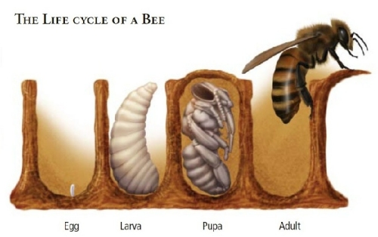

Three castes of bees live in a hive:
- queen,
- worker
- drone

WORKER DRONE QUEEN
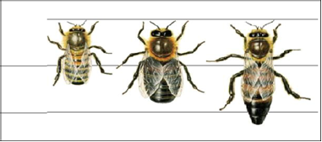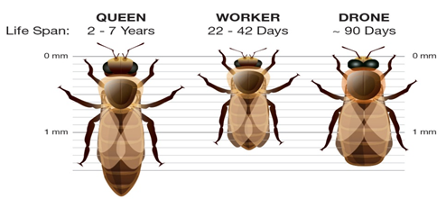
CM
CM

Each of the three castes of bees has a role to play in the bee colony.
QUEEN | WORKER | DRONE
>reproductive female.  >created by feeding larva only royal jelly throughout its development.  > produced in oversized cells and develop in only 16 days.  >has a functional set of ovaries, and a spermatheca.  >stings are not barbed.  >queens lack the glands thatproduce beeswax.  >once mated, queens may lay up 1 million eggs.  [2,000 eggs per day for 5 to 6 years]  >produces a variety of pheromones, called the queen substance, which regulates behavior of workers and helps a swarm track the queen's location during the migratory phase | >Are female bees which are produced from eggs that the queen has fertilized from stored sperm  > develop in 21 days.  Duties 1-2 days  cleans brood cell  3-11 days  Feed royal jelly to queen larva while drone larvae receive worker jelly for 1 to 3 days then honey and pollen.  12–17 days -honey bees use wax to build cells, repair old cells and to store nectar and pollen brought in by other workers. Eight paired glands on the underside of the abdomen of the youngest bees produce wax droplets, which harden into flakes when exposed to air and is used by older bees to construct comb in the hive  >nectar receivers  >pollen packers  >honey sealing  >cleaners  >propolizers -the walls of the hive are covered with a thin coating of propolis, a resinous substance obtained from plants in combination with enzymes added by the worker. Propolis has antibacterial and antifungal properties and is used to aid with ventilation and at the entrances of hives.  >temperature controllers -33C  >queen's attendant workers -bathe and feed her  >construction workers -soften the wax flakes in their mouths into a workable construction material for building the comb in which the queen lays eggs and the workers store honey and pollen  >guards – protect the hive from predators and thieves  >foragers -collect and carrying water and pollen back to the hive in their corbiculum to feed the entire colony  >undertakers – carry the dead from the hive  a worker may develop ovaries and lay eggs that produce drones if the hive is queen-less | >males are typically haploid.  >Drones are  produced by the queen if she chooses not to fertilize an eggor by an unfertilized laying  worker.  > take 24 days to develop  >do not have a sting  >have large eyes used to locate queens during mating flights.  >Only purpose: fertilize queens from other hives  >about a week after emerging from their cells, the drones are ready to mate. Once they have fulfilled that purpose, they die.

LESSON 68: ROLE OF HONEY BEES IN AGRICULTURE

LESSON OUTCOME: Discuss the role which honey bees play in agriculture

Sting - a bee’s chief weapon; venom is injected through the modified ovipositor resulting in a burning, itching, swollen lesion.
Carbon sinks - anything that absorbs more carbon that it releases.

Why bees are beneficial insect
- Bees are pollinators vital to our food chain.
- Pollination by bees is important for genetic biodiversity and sustainability.
- Bees, like other insects, are part of a food chain. They are a source of food for predators including toads, birds, spiders and lizards.
4. The limbs and mouthparts of bees have been studies by engineers and concepts used to develop many tools and machines.
- Honey bees produce honey, pollen, wax and propolis which are harvested for nutritional, craft, manufacturing and medical applications.

STUDENT ACTIVITY
- Discuss the relationship between honey bees and biodiversity.

- Elaborate on the importance of honey bees to Fiji.

