RATU NAVULA COLLEGE
YEAR 12 NOTES AND ACTIVITY WEEK 2 – 2021
AGRICULTURAL SCIENCE
SUB- STRAND AS 12.3.2 HORTICULTURE

LESSON 34: ADVANTAGES AND DISADVANTAGES OF AGROFORESTRY
LESSON OUTCOME: discuss the advantages and disadvantages of agroforestry.
Agroforestry - the deliberate incorporation of trees and other woody species of plants into other types of agricultural activities.
AGROFORESTRY:
1) Combines production of multiple outputs with protection of the resource base
2) Places emphasis on the use of multiple indigenous trees and shrubs
3) Is particularly suitable for low input conditions and fragile environments
Agroforestry practices have multiple impacts in a land-use system:
1) Protection of topsoil, crops, animals and people
2) Increase in productivity of crops
3) Reduction of chemical, physical and biological energy inputs
4) Diversification of local and regional economies
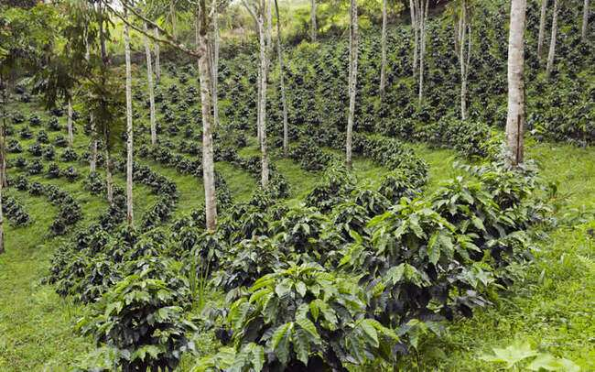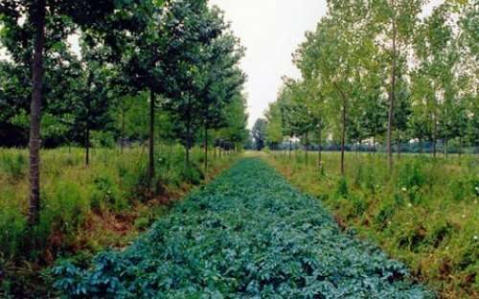

Advantages
A) Environmental benefits
2) More efficient recycling of nutrients by deep rooted trees on the site
3) Better protection of ecological systems
4) Reduction of surface run-off, nutrient leaching and soil erosion through the impeding effect of tree roots and stems on these processes
B) Economic benefits
1) Increment in an outputs of food, fuel wood, fodder, fertilizer and lumber
2) Increase in levels of farm income due to improved and sustained productivity
3) Sustained, year-round production
C) Social benefits
1) Improvement in rural living standards from sustained employment and higher income
2) Improvement in nutrition and health due to increased quality and diversity of food outputs
3) Stabilisation and improvement of communities through elimination of the need to shift farming sites

Disadvantages
1) Trees viewed as permanent
2) Long-term returns from trees difficult to predict
3) New systems often less readily adopted by farmers
STUDENT ACTIVITY
- Discus the role of agroforestry in the conservation of Fiji’s biodiversity.

- Discuss the advantages and disadvantages of agroforestry from: a) a conservation point of view b) a commercial point of view

LESSON 35: AGROFORESTRY SYSTEMS
LESSON OUTCOME: Compare agroforestry systems.
Agroforestry can be divided into three main systems:
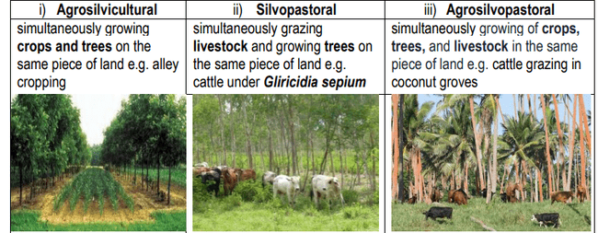
SOME OTHER SYSTEMS INCLUDE:
- Apiculture with trees - various nectar producing trees .
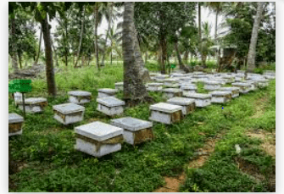
- Aqua forestry – trees provide shade, the leaves is used as feed for fish while roots stabilise bunds.
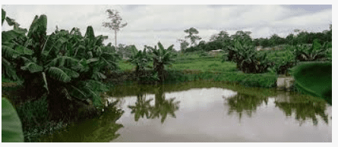
- Riparian forest buffers - forests along the side of streams to reduce the impact of pollution from agricultural operations, reduce river bank erosion and enhance wildlife and increase biodiversity.
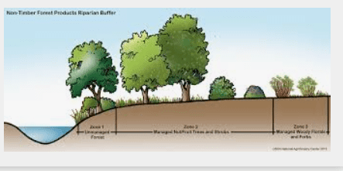

- Forest farming - the cultivation of non-timber crops under the protection of a forest canopy that has been modified to provide the shade level appropriate for the special crop e.g. cocoa, wild decorative or edible ferns.

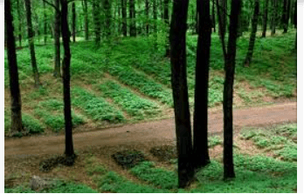
Agroforestry systems have two functions:
1. Productive functions – where goods are produced for harvesting e.g. food, fodder, fuel wood, lumber
2. Protective function – for the conservation of resources e.g. water and soil conservation, windbreaks, shelter belts
ACTIVITY
- Differentiate between agro-silvicultural and agro-silvopastoral.

LESSON 36: HARVESTING PLANTATION FORESTS
LESSON OUTCOME: Discuss the harvesting of plantation forests.
Lumber -timber sawed or split into planks, boards, etc.
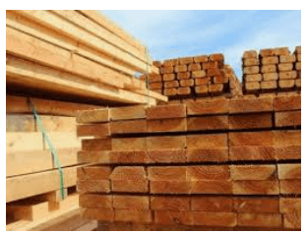
Saw timber - trees large enough to be cut into lumber.
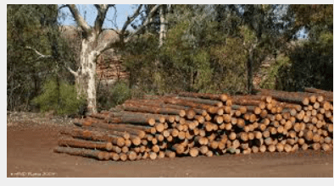
Understory - a layer of vegetation beneath the main canopy of a forest.
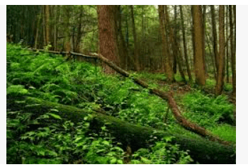
METHODS OF HARVESTING TREES FROM PLANTATION FORESTS.
1. Thinning Harvest

- Forest is ‘thinned’ by taking out a certain percentage of the trees.
- The remaining trees will grow faster, stronger and larger.
- There will be less competition for sunlight, nutrients and water.
- referred to as a “pre-commercial” harvest

2. Clear-cut Harvest
- Clear-cutting removes all the trees in a given area.
- used most frequently in pine and mahogany forests

Clear-cutting
Characteristics:
- it causes a sudden environmental change
- it removes the seed source from the regeneration area
- it begins a new rotation

Clear-cutting

Advantages.
It allows:
- rapid restocking of the site
- the introduction of a selected species,
- uniformity in the new stand

3. Shelter wood Harvest
- Mature trees are removed in two or three harvests over a period of 10 to 15 years.

THREE BASIC PURPOSES:

i) To prepare the stand for production of abundant seed
ii) To modify the environment in a way that promotes germination and survival of the selected species
iii) To build up the amount and size of advance regeneration to ensure the prompt restocking of the new stand following over story removal.

4. Seed Tree Harvest

- Five or more scattered trees per hectare are left in the harvested area to provide seeds for a new forest stand.

- Group Selection Harvest
- Small-scale clear-cut where groups of trees in a given area are harvested over many years so that the entire stand has been cut within 40 to 50 years.

6. Single-Tree Selection Harvest
- Removes individual trees that are ready for harvest, of low value or in competition with other trees.

Student activity
Which of the tree harvesting methods listed above would you prefer to be used in Fiji and explain why?

LESSON 37: FORESTRY POLICIES

LESSON OUTCOME: Discuss the reasons for forestry policies in Fiji.
Forest policy - is what a government chooses to do or not do about forests within their jurisdiction
Act - a bill which has passed through the various legislative steps required for it and which has become law
Forestry Policy
- Laid in 1950
- Included the protection and development of Fiji’s forests.

This policy aimed to:

1. Continue with the planting programmes for future benefits
2. Encourage private planting schemes
3. Increase timber exploitation and increase exports
4. Encourage better processing of lumber
5. Encourage the use of a wider range of local timber species

1953 Forest Act,

- Placed forestry primarily in the context of forest management for lumber production.

A new Forest Policy for Fiji was endorsed by Cabinet in November 2007.

Its main thrusts are as follows:
- change from forest sector planning to integrated natural resources management
- transition from lumber exploitation to sustainable forest management
- empowerment of land owners to adopt sustainable management practices

Based on the 2007 policy, new forestry legislation was formulated to replace the existing Forest Decree 1992.
STUDENT ACTIVITY

- Why was a Forestry Policy developed in 1950 and renewed in 2007?

- Discuss the advantages and disadvantages having a Forestry Policy in Fiji.

ORNAMENTAL HORTICULTURE

LESSON 38: INTRODUCTION

LESSON OUTCOME: Discuss the origins of ornamental horticulture.

Forest gardening -trees and plants have been replaced by fruit and nut trees, bushes, shrubs, herbs and vegetables which have yields directly useful to humans.
Ornamental horticulture - growing, arranging and marketing plants for decorative and aesthetic purposes including floriculture, floral arrangements and landscaping
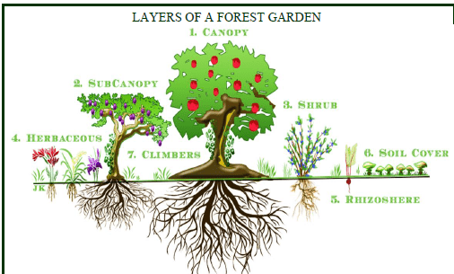
ACTIVITY:
- Define forest gardening and ornamental horticulture?

