RATU NAVULA COLLEGE
YEAR 12 NOTES AND ACTIVITY WEEK 3 – 2021
AGRICULTURAL SCIENCE
SUB- STRAND AS 12.3.2 HORTICULTURE
LESSON 39 : CLASSIFICATION OF HORTICULTURAL PLANTS

LESSON OUTCOME
Discuss some ways in which horticultural plants are classified.

Xerophyte- plant which stores water in its leaves and stems so is adapted to live in arid environments.

Hydrophyte- a plant that grows only in or on water.

Mesophyte-a plant needing only a moderate amount of water

Classification of plants

- BY GROWTH HABIT

a) Herbaceous or herbs - succulent seed plants possessing self-supporting stems

b) Climbing plant - a climbing or trailing plant. It may be soft stemmed [vine] or hard stemmed [liana].
c) Trees - plants having a single central axis
d) Shrubs - plant having several upright stems

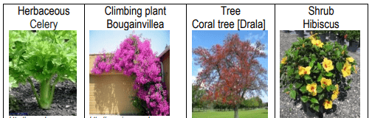

2. by leaf drop:
a) Deciduous - plants which seasonally lose leaves e.g. Kapok tree
b) Evergreen - plants which retain functional leaves throughout the year e.g. Sandalwood
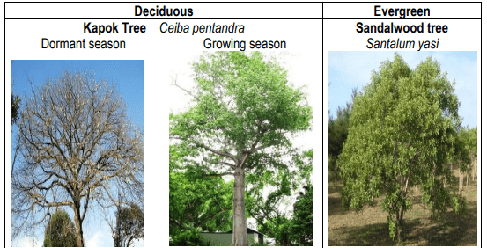

3. BY LIFE SPAN:

a) Annual - a plant that completes its life cycle, from germination to the production of seed, within one year, and then dies. (lettuce, watermelon, marigold)

b)Biennial - a flowering plant that takes two years to complete its biological lifecycle
c) Perennial –a plant that lives for more than two years

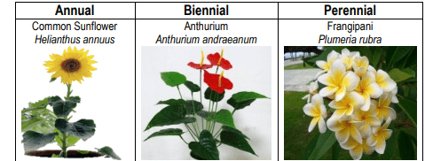

4. BY TEMPERATURE TOLERANCE:

a) Tender plant - damaged or killed by large temperature variations.

b)Hardy plant – a plant that withstands changes in temperature.
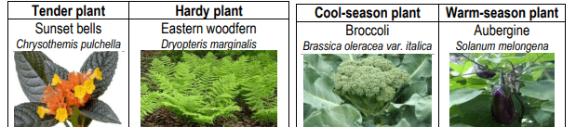

5. BY TEMPERATURE REQUIREMENTS:
a) Cool-season plant - prefers cool temperatures (peas, lettuce, cole crops)
b) Warm-season plant - prefers warm temperatures (pepper, eggplants (aubergine))
6. by sunlight intensity requirements
a) Photophilous Plant- is receptive to, seeks and thrives in direct sunlight.
b) Sciophilous Plant- is receptive to, seeks and thrives in less direct sunlight or shade
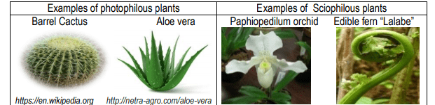
7. BY HABITAT OR SITE PREFERENCE:
a) Xerophytes – plants that have adapted to survive in an environment with little water, such as a desert or an ice- or snow-covered region. The xerophytes are succulents.
Cacti are a group of succulents but are often discussed as a separate group.
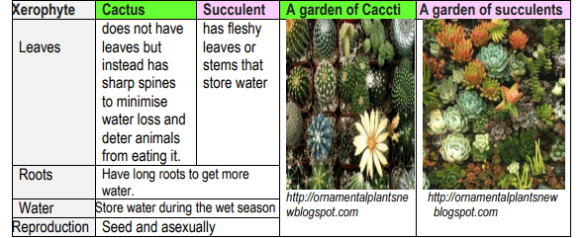
b)Hydrophytes - plants that grow partly or wholly in water whether rooted in the mud, as a lotus, or floating without anchorage.
The hydrophytes can be divided into the following categories:
floating plants, deep water plants, marginal plants and oxygenating plants.
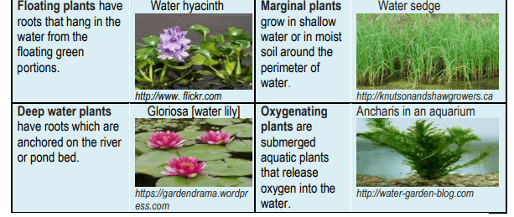
c) Mesophytes - terrestrial plants which are adapted to moderate water conditions: neither a particularly dry nor particularly wet environment.
i) Tree – a woody perennial plant, typically having a single stem or trunk growing to a
considerable height and bearing lateral branches at some distance from the ground.
ii) Palm - any plant of the family Palmae having an unbranched trunk crowned by large
pinnate or palmate leaves.
iii) Grass – monocotyledonous, usually herbaceous plants with narrow leaves growing
from their bases.
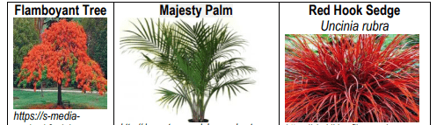
8. PH PREFERENCE
The majority of plants grow best in neutral soil. However, some plants prefer soil of specific pH levels.
- ACID TOLERANT – certain plants tolerate a range of soil pH values.

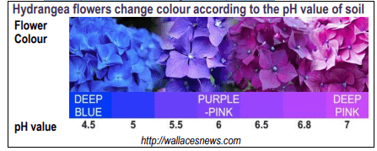
B) SALT TOLERANT PLANTS
i) Halophytes - plants that grow in waters of high salinity, coming into contact with saline water through roots or by salt spray, such as in saline semi-deserts, mangrove swamps, marshes, sloughs and seashores.
- Glycophytes – plants that will only grow healthily in soils with low content of sodium salts
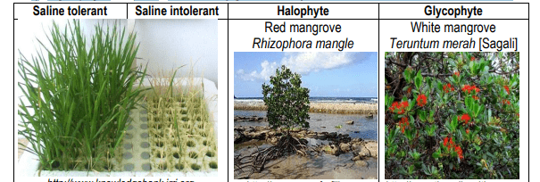
ACTIVITY: Differentiate between Hydrophytes and xerophytes.

LESSON 40: TYPES OF ORNAMENTAL PLANTS
LESSON OUTCOME; Describe the types of ornamental plants used in Fiji.
FLORICULTURE - the cultivation of flowers.
FLORISTRY - the production, commerce and trade in flowers.
HORTICULTURE - the science and art of growing fruits, vegetables, flowers, or ornamental plants
OLERICULTURE - The science and practice of growing, harvesting, storing, processing and marketing vegetables.
ORNAMENTAL HORTICULTURE -CATEGORIES:
a) Florist crops - the cultivation of flowering and ornamental plants for gardens and for floristry.
i) Cut flower plant – plants are grown for the production of flowers or flower buds (oftenwith some stem and leaf) for use in vase displays, wreaths and garlands.
ii) Pot plant - a plant grown in a pot or container, usually indoors.
iii) Foliage plant - any plant grown chiefly for its attractive leaves.
iv) Bedding plant - any plant that has been grown to blooming or near-blooming size before being planted in a garden for the display of colorful flowers or foliage.
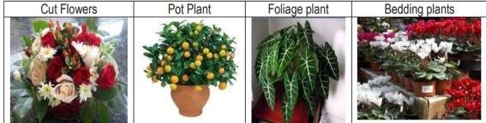
B) LANDSCAPE PLANTS – plants which are used to improve the esthetic value of a landscape e.g. trees, shrubs, flowering plants, herbaceous plants, climbing plants and ground cover plants.
C) LAWN AND TURF PLANTS – plants, like grass, which are planted in an area of soil-covered land, which are maintained at a short height with a lawnmower and used for aesthetic and recreational purposes.
STUDENT ACTIVITY
- Differentiate among cut plants, landscape plants and lawn and turf plants.

LESSON 41: COMMON ORNAMENTAL TREES
LESSON OUTCOME: IDENTIFY SOME TYPES OF ORNAMENTAL TREES.
Ornamental trees are species cultivated for gardens, parks and landscape settings, for their shade, flowers, texture, form, shape, and other aesthetic characteristics.
Weeping Ornamental Trees
Any tree which has a bent crown and pendulous branches that can cascade to the ground.
- Vossi Golden Chain Tree
- Nokonoko tree
- 3. False Ashoka Tree

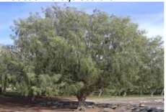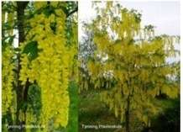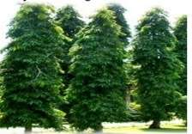
Evergreen Ornamental -Trees any tree having green leaves throughout the entire year, the leaves of the past season not being shed until after the new foliage has been completely formed.
1. Screw pine
2. Rain tree
3. Banyan tree
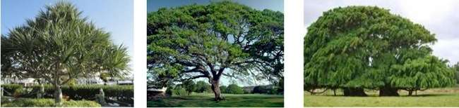
Seasonal Ornamental -Trees any tree producing leaves and flowers in different seasons in relation to favorable climatic conditions.
1. Flamboyant tree
2. Golden showers tree
3. Yland-Ylang tree “Makosoi”
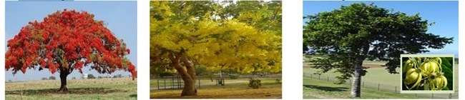

STUDENT ACTIVITY
GIVE ONE EXAMPLE OF THE FOLLOWING:
- weeping ornamental trees

- evergreen ornamental

- seasonal ornamental

LESSON 42: COMMON ORNAMENTAL PALMS
LESSON OUTCOME: IDENTIFY SOME TYPES OF ORNAMENTAL PALMS.
Palms are perennial monocotyledons belonging to the family Palmaceae. Palms, which make beautiful ornamental plants,
FIVE GROUPS
1. Solitary palms
2. Clustering
3. Aerial branching palm
4. Subterranean branching
5. Climbing palm

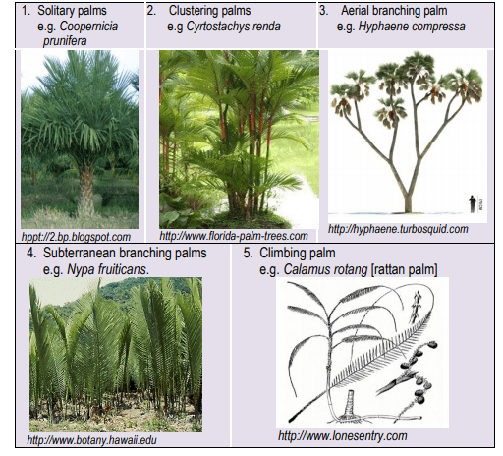
FALSE PALMS
1. Panama Hat palm
2. Sago palm
3. Palm lily or Ti palm
4. Palm grass
5. Travelers palm
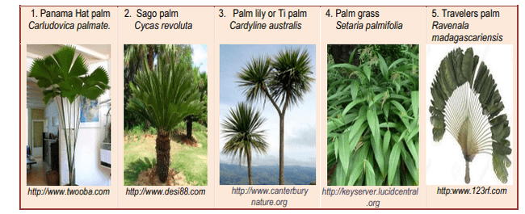
SOME PALMS USED FOR ORNAMENTAL PURPOSES IN FIJI ARE:
PALMS USED FOR ORNAMENTAL PURPOSES IN FIJI ARE:
1. Fiji Fan Palm 6. Cabbage palm
2. Lipstick Palm 7.Beetle nut palm
3. Areca Palm 8. True Date Palm
4. Royal Palm 9. Coconut palm
5. Cuban petticoat palm
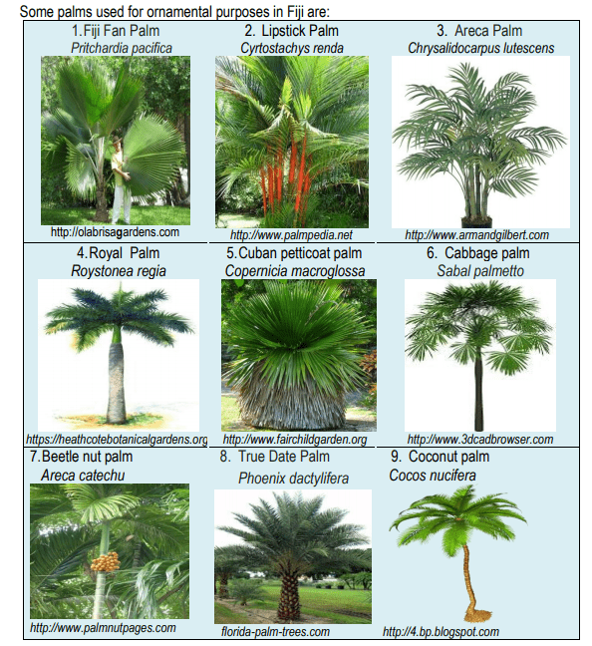
Student activity
1. Identify species of palms in the school compound or surrounding area.
2. Classify and describe the palms.
3. Discuss how palms are propagated.
LESSON 43: COMMON ORNAMENTAL SHRUBS AND HERBS
LESSON OUTCOME: Identify some ornamental shrubs and herbs grown in Fiji.
Herb -any seed-bearing plant that does not have a woody stem and dies down to the ground after flowering.
Shrub -woody plant that is smaller than a tree and has several main stems arising at or near the ground.
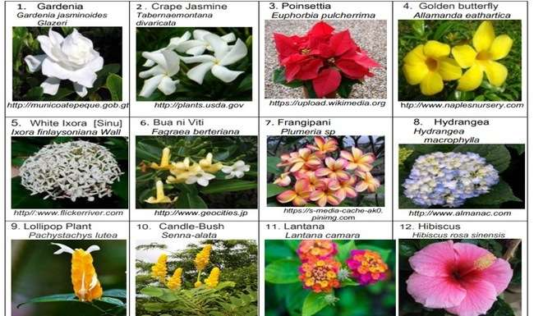
Many shrubs are also cultivated for their leaves.
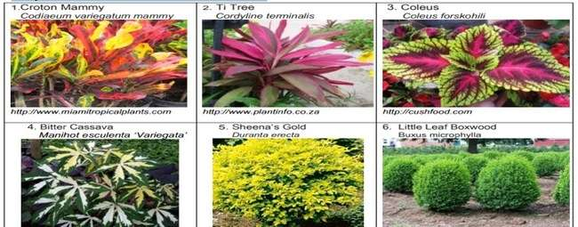
Herbaceous plants (in botanical use frequently simply called herbs) are plants which have no persistent woody stem above ground. Herbaceous plants may be annuals, biennials or perennials.
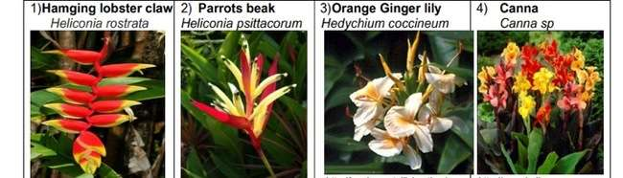
Edible herbs and flowers - plants with leaves that are used as medicines, for seasoning dishes, as fragrance in perfumes, candles, dried floral arrangements, sachets etc.
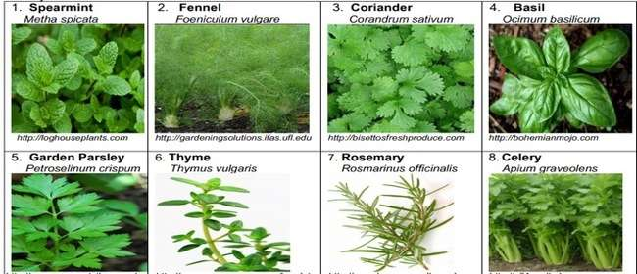
STUDENT ACTIVITY
1. Differentiate between a shrub and an herb.
2. Differentiate between an herb and an edible herb.

