YEAR 11
HISTORY
HOME LEARNING KIT
WEEK 10

CULTURAL INTERACTION- RACE RELATIONS
SOUTH AFRICA 1919 – 1961

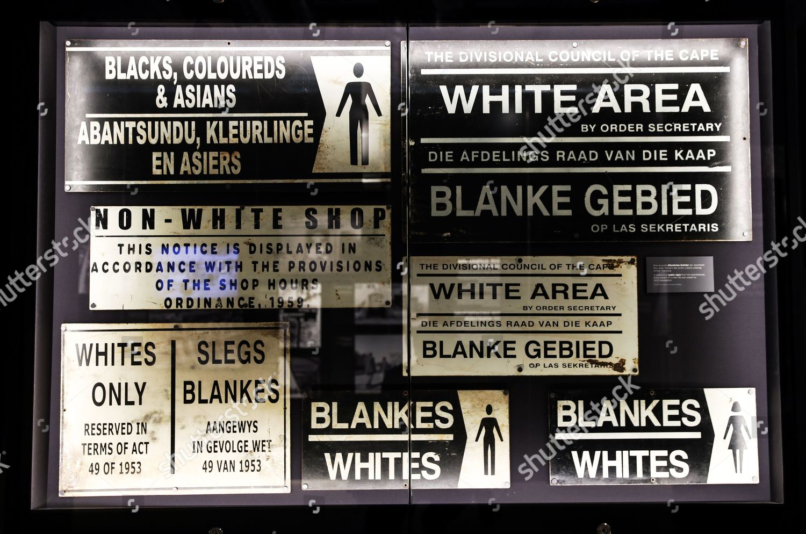

Lesson 74
Strand- Cultural Interaction and Integration
Sub- strand- Race Relations
Lesson Outcome- Discuss the WW11 problems

World War II
- WWII brought another division in the Afrikaner ranks.
- Smuts wanted to enter South Africa on the British side while Hertzog and Malan wanted South Africa to be neutral.
- Smuts proposed a motion calling for an immediate declaration of war on Germany and won by 80 voters to 67.
- Hertzog resigned and Smuts formed a new evaluation ministry.
- South African forces were again involved in a warfare on the African continent
- For South African troops they were fighting for democracy, liberty, equality and fraternity.
- After the war these ideals were taken up by an ex-servicemen organization – Torch Commandoes but were not really practiced in South Africa.
- South African industry expanded into iron, steel, engineering and textiles as imports fell short.
- There was an expansion of traditional industries such as mining.
- A large number of White women were employed but most of the expanded warfare was provided by non-whites.

Transformation of African Life
- Africans who had served in WWII were unwilling to settle back into the constricted life of the reserves.
- Most of them joined the urban movement.
- They were frustrated with the Pass Laws, discrimination in employment and public services political restriction was unbearable.
- Urban areas were becoming overcrowded.
- New slums of corrugated iron, packing cases and cardboard were becoming common.
- These areas were not serviced and not provided proper sewage system.
The Smut’s government could not do anything about these problems

Activity
- State the motives of Smuts and Hertzog during WW11
- How did the Africans life transform after WWII.

Lesson 75
Strand- Cultural Interaction and Integration
Sub- strand- Race Relations
Lesson Outcome – explain the establishment of apartheid policy

Apartheid system
The years of apartheid are undoubtedly one of the darkest moments in South Africa’s history. The period which spanned from 1948 to 1994 was characterized by racial segregation, white minority rule and the oppression of the rights, movements, and freedom of the blacks. The word ‘apartheid’ literally means “the state of being apart” or “separateness”.

Source: https://buzzsouthafrica.com/apartheid/

The apartheid system was implemented by the then governing party in South Africa, National Party (NP). However, the segregation in South Africa did not begin then; it began during the colonial era of the Dutch Empire and persisted when the British came to power in 1795. It, however, became an official government structure after 1948’s general election.

Apartheid Enters Politics
- After the war, Smuts seemed to be secure.
- He had played an important role in the establishment of the United Nations.
- In 1947 he delighted the English speaking population by sponsoring a royal tour by George IV, Queen Elizabeth and the two princesses.
- In 1948 his opponents played the race card. They gave the old segregation policy new name “apartheid” (apartness) and a new urgency.
- The choice between ‘us’ was their election manifesto declared “is one of the two divergent courses either that of integration which in the long run amounts to national surrender on the part of the Whites or that of apartheid”.
- The National Party won the elections.
- Dr. Daniel Malan the National Party leader formed a coalition with the Afrikaner Party and took office.

Is Apartheid Justifiable?
- Whites arrived first in South Africa
- Different races and ethnic groups have a natural desire to live apart and independent of each other.
- The Bible (Psalms 105) justifies apartheid stating some people are born to rule.
- South Africa is a barrier against the further spread of communism in South Africa.
- The colour bar has always been part of the South African way of life.
- Blacks have the highest standards of living of all Blacks south of the equator.
- The record of African countries since gaining independence is poor e.g. civil wars, coup d’etats (takeover)
- Countries should resolve their own racial problems instead of criticizing South Africa.
Key Words
- Apartheid – literally apartheid means separate development of races.
- Repatriation – to return to country of origin, in this case India.
- Kaffir Boeties – nigger lovers (slang)
- The Broederbond – Afrikaner secret society that wanted to preserve Afrikaner culture

Activity

- Who was Dr Daniel Malan.

Lesson 76
Strand- Cultural Interaction and Integration
Sub- strand- Race Relations
Lesson Outcome- explain the establishment of apartheid policy

Prime Ministers of South Africa
1910 – 1919 Louis Botha
1919 – 1924 Jan Smuts
1924 – 1940 James Hertzog
1940 – 1948 Jan Smuts
1948 – 1954 Dr. Daniel Malan
1954 – 1958 Johannes Strijdom
1958 – 1966 Dr. Henrik Verwoerd
1966 – 1978 Dr. John Voster
1978 – 1984 Pieter Botha

Apartheid in Action
Social – Prohibition of Mixed Marriages Act
  - Immorality Act
  - Population Registration Act
  - Reservation of Separate Amenities Act
  - Native Law Amendment Act

Political – Suppression of Communism Act
  - Separate Registration of Voters Act
  - Bantu Authorities Act

Labour – Native Labour Act
  - Industrial Conciliation Act

Education – Bantu Education Act
- Extension of Universities Act

Residential – Group Areas Act
  - Resettlement Act
  - Bantu Law Amendment Act

- This is not a rigid or exclusive classification of legislation.
- There is considerable overlap as some laws belong in more than one category.
- Legislations passed before 1948 are not included.

Activity
- What was the Bantu Education Act.

Lesson 77
Strand- Cultural Interaction and Integration
Sub- strand- Race Relations
Lesson Outcome- explain the establishment of apartheid policy

How Was Apartheid System Introduced and Consolidated?
Social
- The maintenance of racial purity is essential to apartheid

Prohibition of Mixed Marriages Act (1949)
- Prohibited marriages between Whites and non-Whites
- Extended to include other races

Immorality Amendment Act (1950)
- Prohibited sexual relations between Whites and non-Whites
- Both Acts were aimed at overcoming gaps or loopholes in the Immorality Act of 1927
- Mixed marriages have occurred where couples have left South Africa and married in neighbouring states or overseas.
- These marriages are not recognized if the couples return to South Africa.
- The combined effects of these acts, the Population Registration Act and the Group Areas Act were to severely disrupt marriages and families that had occurred prior to 1949.
- Every South African is to register according to their race.

Population Registration Act (1950)
- All residents are classified as Whites, Coloureds or Native.
- Natives and Coloureds are further classified according to their tribal groups.
- Natives are also to provide personal details:
  - Name, sex, district of residence
  - Citizen (i.e. tribal grouping)
  - Date of birth and district where born
  - Marital status
  - A recent photograph
- Registration was undertaken by a Racial Classification Board
- Because of its reliance on physical appearance mistakes occurred in classification
- Many Coloureds and some natives passed as Whites
- Most of these have been reclassified as Coloured or native
- All Coloureds must carry a “Reference Book” with them. This is commonly known as a Pass Book [In 1986 this requirement was abolished]

Natives Act (1952) [Abolition of Passes and Coordination of Documents Act]
- Blacks over the age of 16years must carry “Reference Books” that contain detailed information about themselves
- The act was extended to include women in 1956.
- The books must be produced on demand.
- The reference book provides an important means of controlling the movements of Blacks in urban areas.
- The Blacks regard the reference book as a vital part or cornerstone of apartheid.
- It severely restricts their freedom of movement outside their own “homeland”.
- Blacks refer to it as the “dompass”.

Reservation of Separate Amenities Act (1953)
- Public amenities were segregated by this act.
- When it was introduced many referred to it as “petty apartheid”
- Segregated most public facilities from park benches to restaurants
- Since 1976, some integration of sporting facilities has occurred at provincial level and above.
- Residential segregation prevents greater integration.
- In reforms since 1986 many of the amenities included in this act have been integrated.

Native Law Amendment Act (1957)
- Gave the local authorities the power to prohibit Blacks attending meeting in White Areas.
- Official permission was required for Blacks to be admitted to clubs in White areas.

Activity
- Discuss the Immorality Amendment Act (1950)

Lesson 78
Strand- Cultural Interaction and Integration
Sub- strand- Race Relations
Lesson Outcome- explain the establishment of apartheid policy

Political
- The union of South Africa Act 1910 denied Blacks the right to vote in the Transvaal and the Orange Free State (Boer States)
- Voting rights in Natal and the Cape Province were based on property qualification.
- In 1936 less than 1% of those enrolled on the Cape Province electoral roll were Blacks.
- Blacks were removed from the common electoral roll in the Cape Province in 1936.
- Coloureds were removed from the common electoral roll by the “Separate Representation of Voters Act, 1951.
- Coloureds were placed on separate electoral roll.
- They would elect White MPs to represent them.
- Four to the House of Assembly
- Two to the Senate
- The National government fought a 5yr battle to pass this legislation.
- In 1951, the National Party did not have the 2/3 majority necessary to change the constitution of 1910.
- The Act was declared illegal by the Supreme Court.
- The government bypassed the Supreme Court by establishing a High Court of Parliament.
- The Act took effect from 1956.
- Black representation was to occur through the Bantu Authorities Act, 1951.
- Re-establishment a tiered structure (several ranks and levels) of political authorities
- Based on traditional tribal authority
- Tribal chieftans have to be approved by the government
- Chief Matanzima if the Transkei is an example.

6
Territorial
Authorities

27
Regional
Authorities

454
Tribal and
District Authorities

- Opponents of apartheid have criticized the act for encouraging tribal division that led to the menace in the 19th century.
- Separate political development is encouraged by the promotion of “Bantu Self Government Act, 1959”
- Created 8 homelands
- Each would be encouraged towards independence
- In 1963, the Transkei became the first homeland to become independent.
- By 1985, five homelands were independent
- Political unrest controlled the Suppression of Communism Act (in 1976 and 1982 it had been amended and strengthened under the title the Internal Security Act)
- The act is aimed at individuals and/or groups who furthered the aim of communism, terrorism or endangered the security of the state or the maintenance of order
- Its terms are deliberately vague
- The act gives authorities the power to declare organizations illegal, compile lists of supporters of such organizations, ban meetings and newspapers
- A wide range of penalties and punishments is set down
- In addition to the police, the Bureau of State Security (BOSS) is responsible for upholding the act.
- In 1985, separate parliaments were established for Whites, Coloureds and Asians.
- The White parliament and President remain the mast powerful
- No provision was made for a Black parliament

Activity

- Discuss the bases of voting rights in Transvaal and Orange free state

