YEAR 11
HISTORY
HOME LEARNING KIT
WEEK 9

CULTURAL INTERACTION- RACE RELATIONS
SOUTH AFRICA 1919 – 1961
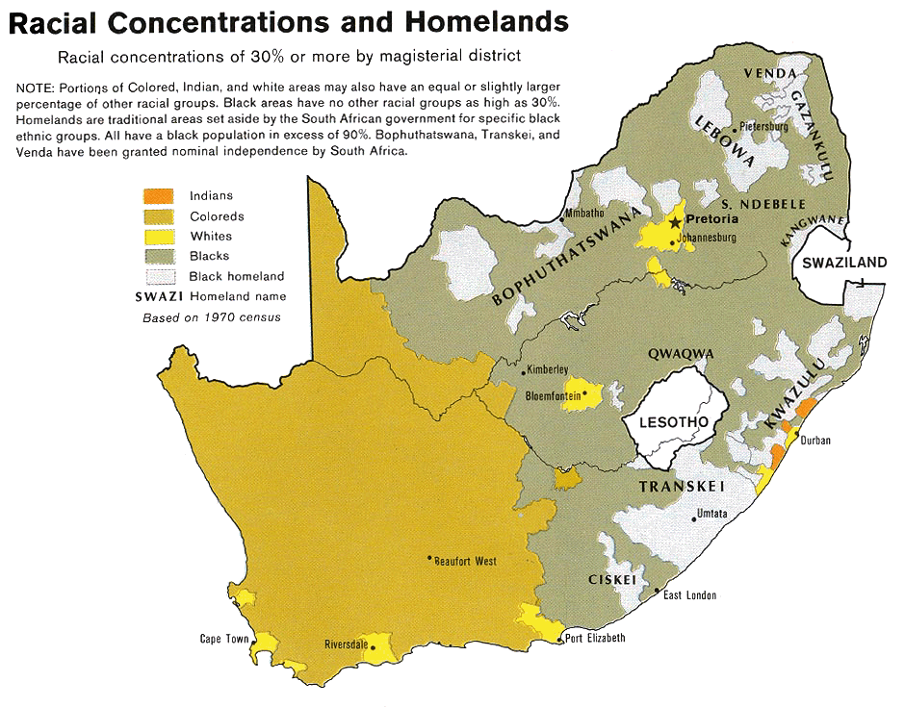

Lesson 69
Strand- Cultural Interaction and Integration
Sub- strand- Race Relations
Lesson Outcome- identify the origin of south African society and how slavery began

The Original Inhabitants
- South Africa had been occupied by the San, Khoi and Bantu before the Dutch arrived and settled at the Cape in 1642.
- Some company servants set up farms near the Cape using slave labour.
- Some of the Dutch followed the lifestyle of the San hunters and Khoi herders.
- They became trekboers.
- They went on tracks into the interior lasting many months and covering several hundreds of kilometers.
- The interaction between the trekboers and the African tribes were sometimes peaceful and benefited both sides.
- Sometimes there was bitter warfare between the two groups.
- The wars between the trekboers and the Bantu were known as “kaffir wars”.

Slavery
- Slavery was introduced by the Dutch at the Cape.
- Coloured worked as slaves for their white masters.
- The Dutch Reform Church reinforced the idea of trekboers being superior to the Coloured and Blacks.

The British
- The arrival of the British challenged the Boer way of life.
- The British tried to stop Boer (Dutch) advancing into Bantu countries.
- They also introduced the principle that all were equal before the law.
- Some British missionaries evangelized among the Coloured and African communities and defended them against Boer exploitation.
- Rev. John Phillips of the London Missionary Society fought for equality.
- He was responsible for the 1828 Ordinance providing equality for all inhabitants of the Cape Colony.
- The Boer did not want to apply it to their Black and Coloured servants.
The Great Trek (1835 – 1838)
- This consisted of several treks in which various Boer parties under various leaders set off into Natal or into Orange and Vaal rivers into the high veldt of the interior.
- The British wanted to stop the Boers form getting access to a port, annexed Natal in 1843.
- Many of the Boers in Natal turned around and trekked back across the Drankensbergs.
- This was different from the earlier movement of trekboers because the Boers who took part in the ‘Great Trek’ did so because of political and cultural factors against British rule in the Cape.
- They and other trekkers set up the independent republics of the Orange Free State and Transvaal.
- This was achieved with less resistance from the Bantus were involved in tribal warfare called the ‘mfecane’ – where over 2 million of them died.

Activity
- Name the group of people that occupied the land before Dutch arrived.
- Define ‘kaffir wars’
- Identify the race that introduced slavery and who worked for them.

Lesson 70
Strand- Cultural Interaction and Integration
Sub- strand- Race Relations (Apartheid)
Lesson Outcome- Identify the major economic discoveries and its impact
By the 1850’s
- The British controlled the Cape and Natal while the Boers controlled Orange Free State and Transvaal.
- Africans – some retained their independence.
- Some were on land occupied by Europeans.
- They worked as labourers, servants in European farms and homes.

Mineral Discoveries
- Minerals (gold and diamonds) were discovered in Boer republics or in the territories claimed by them.

Impact of Mineral Discoveries
- The British tried to control the Boers.
- Foreign diggers and speculators called Uitlanders from Britain and British colonies, Europe and America went to South Africa.
- The city of Johannesburg rose.
- European population doubled.
- Africans flocked to the mines. They were used as diggers. They performed the hard work of underground mining. They spent long shifts underground and received low wages. Europeans became mine managers and supervisors of African labourers.
- Transvaal became the most prosperous of South African territories.
- Conflict arose between the Boers and the British which led to the Anglo-Boer War (1899 – 1902)

Causes of the Anglo-Boer War (1899 – 1902)
- Uitlanders in Transvaal wanted voting rights hoping that they will outnumber the Boers.
- President Krugger of Transvaal refused to give them voting rights until they have been residents for 14 years.
- The British at the Cape tried to force President Krugger to grant immediate franchise or go to war.
- President Krugger offered to grant it to those who had been in Transvaal for 5 years and Britain to stop interfering with the affairs of Transvaal.
- The Governor of the Cape (Sir Alfred Milner) rejected this.
- Britain sent troops to South Africa.
- Transvaal and Orange Free State declared war and attacked British position in Natal and the Cape.

Anglo-Boer War (1899 – 1902)
- Britain, Canada, Australian colonies and New Zealand sent troops.
- The war spread from the Transvaal and Orange Free State to the Cape and Natal
- Fighting was not confined to soldiers only but to civilians as well.
- The Boers adopted guerilla tactics.
- The British burned and destroyed Boer homes and farms to the ground (scotched earth policy) and rounded up women and children in concentration camps.
- Many died of disease and neglect.

Peace Settlement
- At Vereeniging in May 1902, the Boer Commandoes agreed to accept British terms.
- The two Boer republics were to remain in the British Empire but they were to be granted self-government later.
- A system of government was introduced which would lead to self-rule for the Afrikaners.
- There were no voting rights for Africans. They had been betrayed as they had helped the British during the war.

Activity
- Discuss the impact of gold and diamonds.
- State the causes of Anglo-Boer war 1899-1902.
- What was the Vereeniging treaty

Lesson 71
Strand- Cultural Interaction and Integration
Sub- strand- Race Relations (Apartheid)
Lesson Outcome- List events after the Anglo-war
Post War Years
- Lord Alfred Milner became the new master of South Africa.
- British migrants left South Africa because of the “depression”.
- The British remained a minority of the White population in Transvaal, Orange Free State and the Cape.
- In Natal the British were divided
- The British attempt to denationalize the Boers failed.
- The Boer (Afrikaners) became a stronger force.
- In the elections in Transvaal, Orange Free State and the Cape the Afrikaner parties won the election.
- Only in Natal the British were dominant.
- Louis Botha and Jan Christian Smuts were two Afrikaner political leaders in Transvaal.
- Steps to form a union government (to un tie the two Boer republics and the two British states)
- After the Treaty of Vereeniging (peace treaty) was signed, attempts were made to unify the four territories (Transvaal, Orange Free State, Cape and Natal)
- A draft constitution was drawn up by the British government and came into force on ’31st May 1910’
- At the first union election of September 1910, Louis Botha became PM, Jan Smuts became Minister of the Interior Mines and Defense while James Hertzog became Minister of Justice.

Activity
- Who were Jan Smuts and Louis Botha?

Lesson 72
Strand- Cultural Interaction and Integration
Sub- strand- Race Relations (Apartheid)
Lesson Outcome- discuss the segregation in industry
DISCRIMINATORY LEGISLATION
Mines and Works Act (1911)
- Skilled jobs in the mines were reserved for Europeans.

Native Labour Act (1911)
- It was a criminal offense for African contract labourers to go on strike.

Native Labour Act (1913)
- 73% of union territory was reserved for African occupation.

1902
- Coloureds and Africans set up an African political organization with branches in the Cape, Orange Free State and Transvaal.
- African Native Congress was formed in the Cape, Natal and Transvaal.
- In 1912 the ANC (African National Congress) was formed to unite all Africans, irrespective of tribe in the quest for political and legal equality.
- In 1894, Mahatma Gandhi had formed the Natal Indian Congress to oppose discriminations against Indians in the colony.
- Later Gandhi extended the campaign to the Orange Free State and Transvaal (Satiyagra – non violent resistance)

World War I
- Both and Smuts involved the South African troops on the British side.
- Some Afrikaners wanted South Africa to join the Germans.
- The actions of Botha and Smuts increased their stature.
- After WWI there was a growing sense of nationalism among Africans and Afrikaners.
- Afrikaners wanted political power while the Africans wanted equality.
- After the war Afrikaner farmers faced problems:
    - prices of farm produce were low.
    - many farms were overcrowded and inefficiently farmed
    - Afrikaner San could no longer search for land.
    - the world depression and natural hazards also added to their problems. As a result of all these problems faced, poor Afrikaners moved to town to search for jobs.
Activity
- List the two Acts for workers
- State the role of Mahatma Gandhi in support for coloureds in South Africa.

Lesson 73
Strand- Cultural Interaction and Integration
Sub- strand- Race Relations (Aparthied)
Lesson Outcome- list the changes by Smuts and Hertzog into power

Smuts in Power (1919 – 1924)
- Smuts became the PM when Botha died in 1919.

Crises in the Mines (1922)
- In the 1920’s 75% of the mines were run by Afrikaners.
- When the price of gold fell, mine owners tried to cut costs by employing more Black labour for it would be cheaper.
- They earned 10 times more than the Afrikaner labourers.
- The wages of some Whites were also reduced.
- The White shift workers went on strike in 1922 and were joined by White gold miners in what was known as the ‘Rand Revolt’.
- PM Smuts supported the idea of White supervision but his government was on the side of the mine owners and the country’s economy depended on gold.
- Smuts brought in troops to break the strike but miners retaliated by calling for a general strike and harassed African mine workers who worked the supervision of White officers.
- In 5 days of bitter fighting 230 people were killed including 30 Africans and thousands were arrested.
- In the 1924 elections, Smuts was defeated.
- His opponents urged voters to segregate the Blacks and save the poor Whites.
- Hertzog became PM in 1924 until 1939.

Hertzog in Power
- Hertzog passed laws that brought about segregation through the Civilised Labour Policy.
- He reserved skilled jobs for Europeans and removed Coloureds and Africans form any skilled position they had obtained.
- In some skilled jobs, Whites were given higher wages.
- The Government’s view was that the Blacks could find a living in the reserve.

The Effects of Westernization
- In 1921, 589,000 Africans were living in urban areas.
- By 1936, their number had increased to 1,141,643 and there were more men than women.
- This created social problems such as high rates of prostitution and violence in African locations.
- Since there were no health and social services, there were high rates of sickness, diseases and death.
- Whites began to demand social segregation.
- There was a fear amongst the Whites that the closeness of Africans to them was a threat them as a race.
- In 1937, an Immorality Act was passed to promote extra-marital affairs between Europeans and Whites.
- This only led to interracial marriages.

Changing African Lifestyle
- Most Africans became Christians.
- Traditional changes like bride price was now paid in cash or avoided.
- Polygamy gives way to monogamy.
- Migrant labourers after spending long periods away from their wives often had mistresses.
- European style clothing replaced the traditional clothes.
- Bicycles became available to Blacks.
- Africans working for Whites were introduced to the latest of household goods
- Africans were introduced to the cinemas which were run by Indians
- African men often gathered at the Shebeen, the drinking den which supplied kaffir beer. This is one place where they could live out their illusions of status and wealth which they could not achieve in their real life.
- There was a growth of African independent churches. They offered their followers the Africans a place to feel at home and to many of them hope of deliverance from the oppression of the Whites.

Activity
- Define Rand Revolt.
- What was known as the civilized labor policy of Hertzog.

