YEAR 11
HISTORY
HOME LEARNING KIT
WEEK 8

CULTURAL INTERACTION
SOUTH AFRICA 1919 – 1961
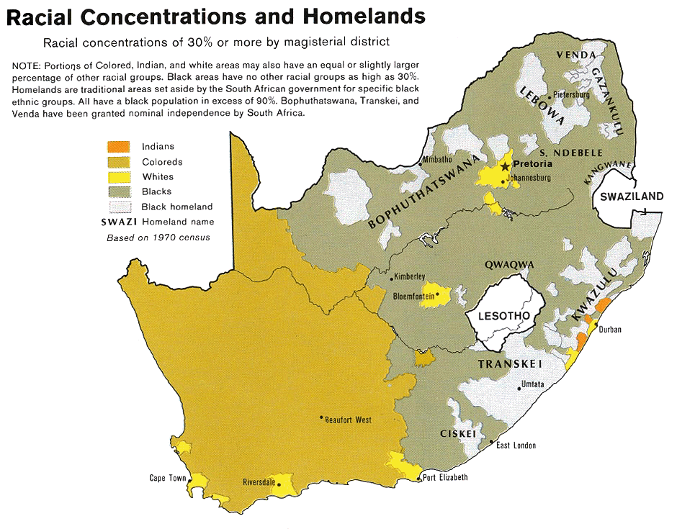

Lesson 64
Sub strand: Race Relations South Africa 1919-1961
L/0: state the four racial group in south Africa

Introduction
The South Africa population is made up of four main racial groups:

- Africans – Blacks
- Europeans – (a) those of Dutch ancestry. They speak Afrikaan language.
  - those of British ancestry. They speak English.
- Coloured – those of mixed ancestry (of European and Black ancestry)
- Asians – Indians and Chinese who were descendants of indentured labourers.

The Original Inhabitants
- South Africa had been occupied by the San, Khoi and Bantu before the Dutch arrived and settled at the Cape in 1642.
- Some company servants set up farms near the Cape using slave labour.
- Some of the Dutch followed the lifestyle of the San hunters and Khoi herders.
- They became trekboers.
- They went on tracks into the interior lasting many months and covering several hundreds of kilometers.
- The interaction between the trekboers and the African tribes were sometimes peaceful and benefited both sides.
- Sometimes there was bitter warfare between the two groups.
- The wars between the trekboers and the Bantu were known as “kaffir wars”.

Slavery
- Slavery was introduced by the Dutch at the Cape.
- Coloured worked as slaves for their white masters.
- The Dutch Reform Church reinforced the idea of trekboers being superior to the Coloured and Blacks.

The British
- The arrival of the British challenged the Boer way of life.
- The British tried to stop Boer (Dutch) advancing into Bantu countries.
- They also introduced the principle that all were equal before the law.
- Some British missionaries evangelized among the Coloured and African communities and defended them against Boer exploitation.
- Rev. John Phillips of the London Missionary Society fought for equality.
- He was responsible for the 1828 Ordinance providing equality for all inhabitants of the Cape Colony.
- The Boer did not want to apply it to their Black and Coloured servants.

The Great Trek (1835 – 1838)
- This consisted of several treks in which various Boer parties under various leaders set off into Natal or into Orange and Vaal rivers into the high veldt of the interior.
- The British wanted to stop the Boers form getting access to a port, annexed Natal in 1843.
- Many of the Boers in Natal turned around and trekked back across the Drankensbergs.
- This was different from the earlier movement of trekboers because the Boers who took part in the ‘Great Trek’ did so because of political and cultural factors against British rule in the Cape.
- They and other trekkers set up the independent republics of the Orange Free State and Transvaal.
- This was achieved with less resistance from the Bantus were involved in tribal warfare called the ‘mfecane’ – where over 2 million of them died.

By the 1850’s
- The British controlled the Cape and Natal while the Boers controlled Orange Free State and Transvaal.
- Africans – some retained their independence.
- Some were on land occupied by Europeans.
- They worked as labourers, servants in European farms and homes.

Class Activity

1. Define apartheid and state the term used to refer to people of mixed origin.
2. Name the two groups of Europeans in South Africa.
3. Define:
- Afrikaners
b. Coloured
c. Africans

Lesson 65
Sub strand: Race Relations South Africa 1919-1961
L/0: identify the major events that took place from 1487-1910

Chronology
1487 The first Europeans to discover the tip of Africa were the Portuguese.
1652 British and Dutch ships began to stop over for fresh water.
- The Dutch East India Company was responsible for the first European settlement.
- It decided that the Cape would make a good refreshment station for its ships and sent Jan van Riebeck to establish a base.
1679 Simon van der Stel, commander of the colony, began to increase the numbers of permanent settlers, acting on the instructions of the Dutch East India Company, which was keen to build a larger population in order to enforce its claims to the area . The Cape had become a place of strategic importance in linking Europe to Asia.
1795 Britain took over the Cape.
1806 British authority was once again established, after a brief takeover by Holland.
1814 British control of the Cape was formalized when six million pounds was paid to Holland.
1820’s The Mfecane (or unlimited war).
- King Shaka’s (Zulu) campaigns were wars of extermination.
- Over two million Bantus died.
- Zulu power was firmly established through a large area of the interior.
- Large-scale disruption occurred and many areas were abandoned, particularly in today’s Orange Free State and the Transvaal.
- The scattering of people caused by the mfecane resulted in small communities developing outside the major kingdoms. These groups were likely to offer friendship to white settlers.
1828 King Shaka was murdered by his half-brother Dingane.
1834 Slavery abolished in all British colonies. The Boers started to resent the British for this action.
1835-40 The Great Trek .
- A series of treks (migrations) as the Afrikaner farmers or ‘Voortrekkers’ attempted to move in search of land, out of war-torn eastern Cape, outside areas of British control, and to be free to speak their own languages and control their own affairs .
- They moved into the Transvaal and Orange Free State.

1838 The Battle of Blood River.
- On 15 December, a group of trekkers led by Andries Pretorius defeated the Zulus in an area alongside the Umslatos River in Natal.
- They had pledged that if God gave them success they would forever celebrate the day.
- In Afrikaner tradition this day became known as the Day of the Covenant.
- Dingane (Zulu king) was forced to pay huge fines in cattle and land, and the trekkers began the process of settlement.
1843 Britain annexed Natal.
1848 Britain took over Orange Free State.
1856 A parliament was established in the Cape Colony.
1866 A diamond was found near Hope Town in the North of Cape Colony.
1868 Diamonds were discovered at Kimberley.
1869 This find had sparked a full scale rush and the Cape had been transformed from a poor, struggling colony into a very rich one.
1871 The British took over Griqualand West, an area close to, if not in, the Orange Free State. This territory contained the diamond fields and in compensation the British gave the Free State ninety thousand pounds.
1877 The independent Boer Republic of Transvaal was annexed by Britain. The British did not give any compensation to Transvaal.

1880-81 1st Anglo-Boer War
- The Transvaal Government protested and rose in revolt.
- The final Boer victory was at Majuba Hill in February 1881.
1884 Transvaal was once more a free Republic, now battle hardened and prepared to fight to maintain its status.
1886 Gold was discovered on the Witwatersrand near Pretoria in Transvaal.

1890 Cecil Rhodes became Prime Minister of the Cape Colony.
- He was determined to gain control of the Transvaal.
- Rhodes hoped to extend the British Empire from Cairo (Egypt) to the Cape.
1894 Natal Indian Congress formed
- Created to oppose discrimination against Indians.

1895 The Jameson Raid.
- A plan was put together which would bring the Transvaal firmly under British control. Cecil Rhodes, Hercules Robinson (British High Commissioner to the Cape), and Joseph Chamberlain (Secretary of State for the Colonies) aimed to provoke an uprising in the Transvaal among the Uitlanders. British forces would then move into the republic to ‘restore order’. The revolt was a disaster, the leader Leander Jameson set off to Johannesburg but his troops were forced to surrender without getting there.

1899-1902 2nd Anglo-Boer War.
- Fought between the British and Boer descendants in South Africa.
- The Boers feared British attempts to gain control of Transvaal.
- President Kruger of the Transvaal misinterpreted sympathy from Europe as support for the Boers .
- Fighting broke out in October 1899 with early Boer successes but by June 1900, Britain had occupied the Boer capital of Pretoria.
- The ‘scorched earth’ policy ordered by the leader of the British forces, General Kitchener that had destroyed their farms and the death of 25,000 women and children in concentration camps had left the Boers bitter and resentful.
- The war was concluded by the Treaty of Vereeniging, 1902.

1910 Union of South Africa Act.
- The British colonies (Cape Colony and Natal) and the former Boer republics (Orange Free State and Transvaal) were joined in a political union.

Important Terms :
Apartheid – an Afrikaner word which directly translates as ‘apartness’. It refers to the racial segregation policy of the Nationalist Party in South Africa.

Authoritarian government – describes a government which controls society with strong laws and tough policing eg. Nazi Germany.

Colonial government – control of a nation by an overseas power .

Labour system – the structure of work . This includes wage levels, job choice and conditions of work .

Majority rule – government which represents more than half the people of a country .

Pan-Africanism – a movement to unite black majority – rule nations in Africa .

Race – our biological inheritance and decides our physical appearance . It does not decide how a person thinks or behaves .

Culture – means the group that we belong to in terms of main attitudes, ideas, beliefs . We grow up in a culture or come into contact with other cultures and this decides how we think and behave .

Nationality – means which country we belong to and are citizens of .

Reserves / Bantustans / Homelands – are terms which have been used to describe land officially set aside for the sole residence of specific Black nations eg. Transkei .

Baaskap – in practice it means white supremacy .

Broederbond – a secret white Afrikaner organization whose goal is the maintenance of white supremacy .

Repatriation – to return to country of origin .

Uitlanders / Outsiders – diggers and fortune seekers .

Annex – take over.

Protectorate – one country has political control of another area or territory .

Decolonization – when colonial governments are replaced by governments representing the residential inhabitants.

Relocation – the process of shifting racial groups to designated living areas.

Lesson 66
Sub strand: Race Relations South Africa 1919-1961
L/0: discuss the various government legislation and developments discouraged racial activity

SOUTH AFRICAN PARTY (1910-1924) .

General Louis Botha .
1910 The first government of the Union of South Africa was led by Louis Botha as Prime Minister.
His deputy was J.C. Smuts and both were members of the South African National Party.
This party represented a broad cross-section of white society and linked Afrikaner and English in a common political grouping.
Botha and Smuts believed that the differences between Afrikaner and English should be forgotten and that all whites should unite to form one nation.
They wanted South Africa to remain within the British Empire.

JBM Hertzog, Minister of Justice in Botha’s government, was not happy with the idea of one white nation. He wanted to preserve Afrikaner language and culture and, in his support of these ideas, clashed with Botha. This conflict eventually saw Botha resign and then form another government, without Hertzog.

1910 Passes Act.
- Blacks needed to possess a number of different documents, such as travel passes, work passes, residential passes or curfew passes.
- If they failed to produce them when challenged by officials, they were punished.
- These pass laws were bitterly resented.

1911 Mines and Works Act
- Established the principles of job reservation in the mines.
- Skilled jobs were reserved for whites.

1911 Native Labour Act
- Prohibited strikes by Africans .

1913 Native Lands Act
- Set aside 7% of land for African occupation .
- Aimed at preventing Africans from renting farms or buying farms in European areas .
- Forbade the Blacks to practice share-cropping – ie. A practice whereby tenants farmed the land and gave back a proportion of the crops to the landlord as a form of rent .

1914-1918 World War 1
Most South Africans supported the British war effort .

1919 Botha died and was replaced by Smuts as party leader .

Class Activity
- Who was General Louis Botha?
- State the role of south African national party.

Lesson 67
Sub strand: Race Relations South Africa 1919-1961
L/0: discuss how the south African society interacted through the leadership of Hertzog

The Hertzog Era .
1866 James Barry Munnik Hertzog, better known as JBM Hertzog was born on April 3, near Wellington, Cape Colony .
Received his law degree from Victoria College in Stellenbosch, Cape Colony and the University of Amsterdam .
Throughout his life, he encouraged the development of the Afrikaner culture, determined to protect the Afrikaner from British influence .
Hertzog was a republican who believed strongly in promoting the independence of the Union of South Africa from the British Empire .

1892 He had a law practice in Pretoria .

1895 He was appointed to the Orange Free State High Court .

1899 – 1902 During the Anglo-Boer War he rose to the rank of General, becoming the assistant chief commandant of the military forces of the Orange Free State .

1902 Eventually, convinced of the futility of further bloodshed, he signed the May Treaty of Vereeniging which ended the second Anglo-Boer War .

1914 He set up the National Party .

1914-1918 World War 1
- Some South Afrikaners opposed supporting the British .
- This included future Prime Minister James Hertzog

1918 Broederbond created – secret Afrikaner organization to promote Afrikaner (white) supremacy .

1924 Election .
- National Party defeated the South African Party of Jan Smuts and became Prime Minister from 1924 to 1939 .

1924 Industrial Conciliation Act .
- Introduced as part of Herzog’s ‘civilized labour policy’ .
- Prohibited Blacks from forming trade unions .
- Established a ‘colour bar’ in the mines – Blacks were limited to unskilled jobs .

1926 Mines and Works Amendment Act .
- Outlawed the use of Africans and Asians in skilled work .

1927 Native Administration Act .
- Gave the government full authority over all Africans , apart from those in the Cape .

1927 Native Amendment Act .
- Gave government power to resettle Blacks in rural areas .

1927 Immorality Act .
- Unless they were married, Blacks and Europeans were prohibited from having sexual relationships .

1929 Election .
- Gained an overall majority in the election .
- The election issue was a simple matter of scare-mongering, with the threat of a ‘black peril’ as the main weapon – to preserve white South Africa .
1930 White women over 21 were given the vote, largely to dilute the small Black vote and make it ineffective .

1932 Native Service Contract Act .
- Laid down working conditions for Africans who were tenants on white-owned land.

1932 Carnegie Commission.
- Was set up to examine the extent of poverty amongst whites.
- It found that over 20% of Afrikaner males had no means of providing a livelihood for themselves and their wives and children.
- South Africa had to acknowledge that it had a ‘poor white’ problem.

1934 Hertzog and Smuts joined the National Party and the South African Party in a coalition.
- Thus forming the United Party.
- Some former members of the National Party objected.
- They formed the Purified Nationalist Party.
- Their leader was Daniel Malan.

1936 Representation of Natives Act.
- Placed Blacks who lived in the Cape Province on a separate electoral roll.
- Blacks were to elect 3 white Members of Parliament to represent them.

1936 Native Trust and Land Act.
- Land set aside for Black reserves was increased from 7% to 13%.
- Trust fund set up to buy land.
- By 1963 less than 3% had been purchased.

1939-1945 World War 2.
- A split occurred between Smuts and Hertzog.
- Hertzog opposed the use of South African troops.
- He resigned when Parliament voted 80 to 67 to support Britain in the war.
1942 Hertzog died November 21.

Activity
- Explain an impact of the Mines and Workers Act on the natives was about.
- Describe the reason why the leader of the United Party disagreed with Hertzog on the participation of South Africa in WWII.

Lesson 68
Sub strand: Race Relations South Africa 1919-1961
L/0: discuss how the south African society interacted through the leadership Smuts

THE SMUTS ERA (1919-1924 & 1939-1948) .
Field Marshal Jan Christian Smuts was born on May 24, 1870 and died on September 11, 1950.
He was a prominent South African and British Commonwealth statesman, military leader, and philosopher.
In addition to various cabinet appointments, he served as Prime Minister of the Union of South Africa from 1919 until 1924, and from 1939 until 1948.
He served as a British Field Marshal in both the in World War I and the Second World War II.
Deputy in the first government of the Union of South Africa in which Botha was Prime Minister, and member of the South African Party .
During his second term as Prime Minister, he was member of the United Party.

1914-1918 World War 1.
- Smuts emerged from World War 1 as a major world figure.
- He was involved in the British and Imperial War cabinets and was a leading supporter of the League of Nations.

1919 Became the sole leader of the South Africa Party, when Botha died .

1920 Elections .
- Smuts was able to hold on to power with the support of the Unionist Party and various independents .
1921 Fresh elections were held and with the Unionist Party incorporated fully into the South Africa Party, Smuts managed an absolute victory, but there were clear signs that he was a representative of the English and wealthy investors .

1922 Rand Riot .
- White miners in the Rand mining area went on strike in response to mine owner tactics of employing Blacks and Coloureds .
- A general strike was called .
- Prime Minister Jan Smuts used the army to crush the strike .
- More than 230 people were killed .

1923 Urban Areas Act .
- Established segregated residential areas in towns .
- Each race had their own suburbs and residential areas .

1924 Industrial Conciliation Act
- Introduced as part of Hertzog’s civilized labour policy
- Established in the Mines

1924 Election .
- Smuts lost the election to Hertzog and the National Party .
- This was partly due to the Government action in the Rand Riots .

1934 Hertzog and Smuts joined the National Party and the South African Party in a coalition .
- Thus forming the United Party .

1939-1945 World War 2 .
- Supported Britain in the war .
- During the war, Smuts crushed Nazi sympathizers who attempted to undermine the government .
- After the war, Smuts played a vital part in the establishment of the United Nations .
1943 Election .
- Solidly supported by the English .
- Still commanded much Afrikaner loyalty .
- Won a virtual bloc vote from the troops on active service .

1946 Miners Strike .
- On the Witwatersrand there was a well organized strike by African mine workers .
- The African Miner’s Union called for higher wages and better conditions ‘in accordance with the new world principles’ .
- The gold mining industry of the Rand was brought to a complete halt .
- The Smuts government found that it had to make use of War Measure 145 which had declared strikes by Blacks as illegal .
- Under this the government sent in police and troops to break up the strike, killing 9 and injuring 1,200 .

1948 Election
- Lost the election to Daniel Malan of the National Party .

Activity
- Explain the Boer war
- State the function of urban areas act

