YEAR 11
HISTORY
HOME LEARNING KIT
WEEK 6
- COURT
- APPEAL
- LAW
- LAWYER
- JUDGE
- JUDICIARY
- LEGAL OFFICER

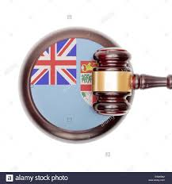

Lesson No: 54
Strand: GOVERNMENT AND GOVERNANCE
Sub-strand: UNIT 6 – FIJI’S LEGAL SYSTEM
Lesson Outcome: Identify the different courts.
Definitions
Court The building, hall, or room in which such cases are heard and determined Justice The upholding of what is just, especially fair treatment and due reward in accordance with honor, standards, or law.
Appeal The judicial review by a superior court of the decision of a lower court
Legal Officer a public official employed to administer or advise in legal matters
Law The system of rules which a nation or community recognizes as regulating the actions of its members and which it may enforce by the imposition of penalties
Civil Society Non-governmental and not-for-profit organizations that express the interests and values of their members or others, based on ethical, cultural, political, scientific, religious or philanthropic considerations.
Trial Examination of evidence and law by a court to determine the charges or claims
Judiciary A system of courts of law for the administration of justice
Introduction
- The earliest iTaukei relied on decision making by their chiefs, but after the British colony began, courts were established to solve legal disputes.
- After annexation in 1874, Courts of Law were established by the British for a variety of decision-making.
- During the British colonial period several courts or advisory councils were established across Fiji
- Bose Ni Tikina (District Council)
- Bose Ni Yasana (Provincial Council)
- Bose Vakaturaga (Council of Chiefs
- In 1987 the Supreme Court was renamed as the High Court of Fiji.
- A new Supreme Court was created at the same time as the final Court of Appeal in Fiji.
- This legal decision making is called the legal system or sometimes the judiciary.
- A legal system involves a constitution which lists the basic principles of the system.
- A legal system includes set of laws, Judges and Magistrates who “hear” cases, lawyers who argue for their clients and in some cases a jury that is called to hear the evidence and advise the Judge of innocence or guilt.
ACTIVITY
- Define: a. Law b. judiciary
- State the year Supreme Court was renamed as the High Court of Fiji
Lesson No: 55
Strand: GOVERNMENT AND GOVERNANCE
Sub-strand: UNIT 6 – FIJI’S LEGAL SYSTEM
Lesson Outcome Describe Fiji’s legal system

Fiji’s Court System
- Fiji has a Supreme Court, a High Court, a Court of Appeal, and a Magistrates Court.
- Other Courts pass judgments on special cases such as the Juvenile Court, Family Court, and a Small Claims Tribunal.
- Fiji’s legal system is described usually as a common law system based on the English model.
CIVIL DIVISION
CRIMINAL DIVSION
FAMILY DIVISION

SUPREME COURT

COURT OF APPEAL

CIVIL DIVISION
HIGH COURT
SMALL CLAIMS TRIBUNAL
TAX DIVISION
EMPLOYMENT RELATIONS DIVISION
MAGISTRATES COURT
CRIMINAL DIVISION
JUVENILE COURT

ACTIVITY
- List the four major courts in Fiji

Lesson No: 56
Strand: GOVERNMENT AND GOVERNANCE
Sub-strand: UNIT 6 – FIJI’S LEGAL SYSTEM
Lesson Outcome Describe the role of officers and people present inside the court room

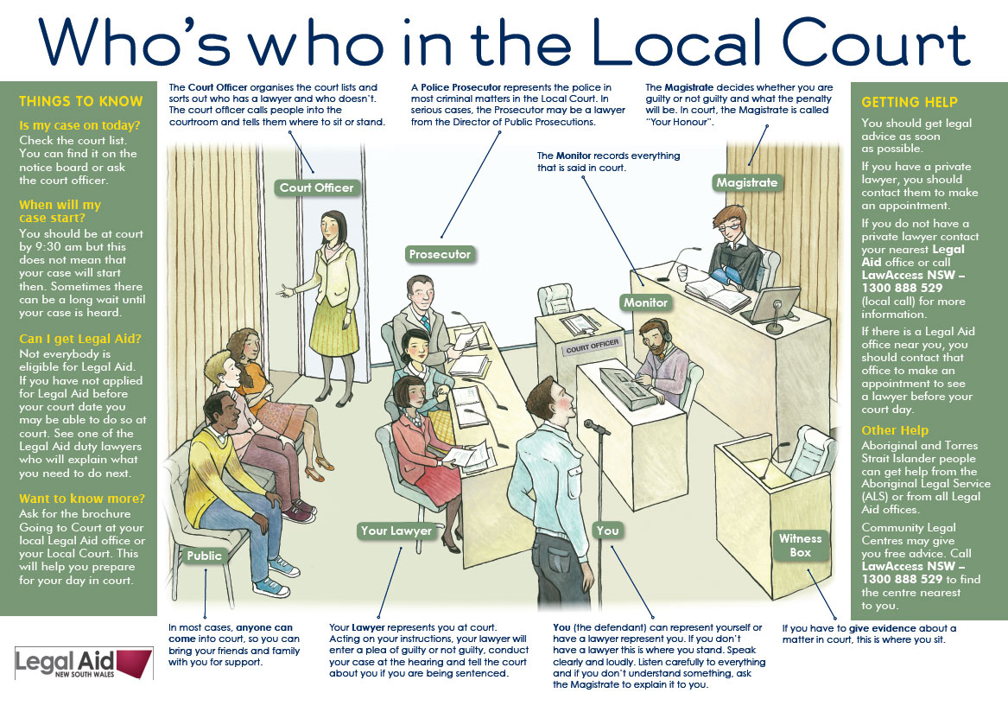

Resource Interpretation
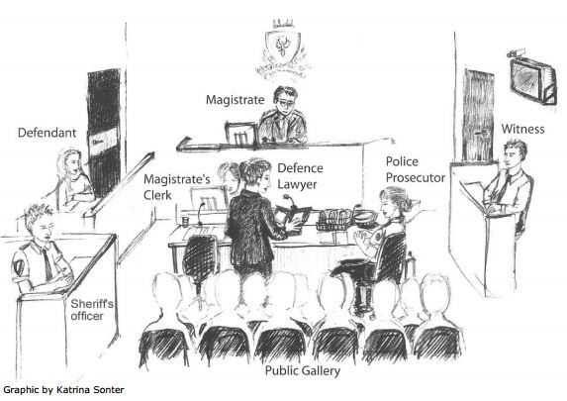

ACTIVITY
- What do you think the defence lawyer is asking?
- State the difference between the role played by police prosecutor and defence lawyer
- Who would normally sit in the public gallery?

Lesson No: 57
Strand: GOVERNMENT AND GOVERNANCE
Sub-strand: UNIT 6 – FIJI’S LEGAL SYSTEM
Lesson Outcome: Know the roles of Fiji Independence Commission Against Corruption
Fiji Independent Commission Against Corruption
- The Fiji Independent Commission against Corruption (FICAC) was suggested in 1987 but not established until May 2007.
- It is a part of the legal system because it is able to receive complaints, and investigate
crimes and corruption within the government’s administration.
- It can initiate a prosecution.
- It is a public organization because it is independent of the government.
- The government can ask FICAC to investigate crime and corruption within the government.
- The FICAC can also respond to a public complaint and start an investigation into the government’s administration.
- FICAC has a powerful influence on the legal system because it is a completely independent organization.

The role of legal officers
- The Prosecutor  - is the State’s chief legal representative in the court  - They are lawyers and are recognized as legal professionals by the court.  - Their job is to represent the state (the  government and society).  - Prosecutors present the case in a trial against an individual accused of breaking the law. | Prosecutor’s role is to:  - Convince a judge and a jury that law enforcement has brought the right person to trial  - Make accurate and fair summary of the offence, the evidence and the charge  - Modify or add charges based on the evidence  - Decide to cancel a trial if there is no likelihood of gaining a conviction  - Gather evidence independently or rely on law enforcement (police) or other agencies  - Be responsible for administering all rules on how evidence is gathered, examined and presented  - Ensure all witnesses are available during the trial.
- Director of Public Prosecutions (DPP)  - DPP is appointed, not elected and is subject to varying degrees of control by the Attorney General, usually by a formal written directive. |  | The role of the DPP is to:  - Be the head of the prosecuting authority.  - Respond to the police, during the course of the investigation, to advise them on the validity and  accuracy of the evidence.  - Represent the government's interest in criminal trials

- Attorney General (AG)  - AG, is appointed by the President on the advice of the Prime Minister.  - The AG is the only member of Cabinet, apart from the Prime Minister and Speaker, specifically mentioned in the Constitution.  - The AG can take part in Cabinet, and can sit in the Parliamentary sessions but is not eligible to vote.  - The AG’s role is to give legal advice to Parliament.  - The normal practice in Fiji has been that the AG is also the Minister for Justice.  - The AG is required to be a qualified lawyer. | The AG’s role is to:  - Be the main legal advisor to the government.  - Be responsible for law enforcement and public prosecutions.  - Represent the state, especially in criminal prosecution.  - Provide essential legal expertise and support to the Parliament including,  - legislative drafting  - legal aid  - “the prerogative of mercy” (advising the President),  - liquor licensing  - Film censorship.  - Be responsible for all legal needs of government departments, statutory bodies, and state-owned enterprises.

- Ombudsman  - The 2013 Constitution in Fiji does not include the office of the Ombudsman.  - Ombudsman is appointed for a term of four years by the President on the advice of the Prime Minister, the Leader of the Opposition and any other leaders of parties in the House of Representatives.  - The Ombudsman cannot hold any other public office.  - The Ombudsman has a significant degree of  independence from the Parliament and the government. | The role of the Ombudsman is to:  - Investigate any action taken by any officer or government authority.  - Be responsible of investigating breaches of any fundamental rights protected by the Constitution of Fiji, in relation to the administration.  - Represent the interests of the public by investigating and addressing complaints reported by individuals.  - Investigate complaints by voters and attempt to resolve them, through recommendations or  mediation.  - Exercise the same powers as the High Court in relation to attendance and examination of  witnesses.

Activity
In a paragraph state the role of a legal officer you would like to be.

Lesson No: 58
Strand: GOVERNMENT AND GOVERNANCE
Sub-strand: UNIT 6 – FIJI’S LEGAL SYSTEM
Lesson Outcome: Know the roles of the legal officers.
- Magistrates  - Magistrates are officers of the state.  - They are like a Judge, but work only in the lower Courts | Their roles are to:  - Act fairly and impartially  - Listen to the evidence and make a decision on that evidence  - Ask questions only to clear up ambiguities.  - Issue a search warrant or a warrant for arrest.  - Grant bail or remand accused persons in custody pending trial  - Check paperwork and deal with bail  - Arrange the date for appearance at the Magistrates Court.  - Impose 6 months in jail for a single offence and up to 12 months when a defendant is convicted  of two or more offences.

- Judges  - Judges are entitled to a wide degree of freedom in the way in which he or she conducts proceedings in the court and deals with cases justly.  - They must not give legal advice, but may speak in public about the law and the administration of justice.  - Judges are regularly asked to chair important public enquiries. | The role of judges are to:  - To check on the misuse of power  - To conduct judicial review (of the legal system)  - To improve the effectiveness of the justice system  - To sentence an accused person  - To review and correct a sentence imposed by a lower court (Magistrates court)  - To be solely responsible for passing a sentence

- Solicitors  - Solicitors are lawyers but they are not allowed to present arguments in a trial or Court Room. | Role of Solicitors are to:  - Solicitors prepare legal documents for their clients, for example:  - business contracts  - sale of land  - Transfer of titles  - General advice on legal matter  - Marriage contracts  - Divorce settlements  - Wills / Adoption  - Certified documents (Oaths)  - Solicitors, Lawyers and Barristers can also be a Commissioner for Oaths.

- Lawyers  - The Ministry of Justice directly supervises the admission, licensing, and regulation of lawyers.  - Lawyers have a wide range of responsibilities and duties in the Courts.  - They represent a client in a trial or court room. | In the Court Room the role of lawyers is:  - To defend a person or organization in legal proceedings  - To act on behalf of their client  - To act in a manner which is in their client’s best interest

Other Roles within the Nation’s Legal System
- Bailiffs
A law officer whose job is to take possessions and property of people who cannot pay their debts as
determined by a Court Order.

- Fiji Police Force
Apprehend criminals, gather evidence and prepare cases to present to the DPP and the Courts.

- Fiji Corrections Service
Ensures that convicted person serve their sentence as determined by the courts

- Military Police
Is independent of the legal system but operates as a legal system within the military service regarding
breaches of military law.
- Official Receiver (Bankruptcy)
A legal officer that examines bankrupt persons under the direction of the Court.

- Registrar of Titles
A legal office that Registrar of Births, Deaths and Marriages
Keeps an official record of all births, deaths and marriages.
- Justice of the Peace
A legal officer appointed their own community to witness and certify documents.
- Fiji Land and Titles Court
Keeps record and makes judgements on matters affecting land titles (this is a unique and an important historical part of the legal system)
- Juvenile Courts
It makes judgements on cases related to children (between 13-18 years of age)
- Small Claims Tribunal
- It makes judgements on claims less than $5000 such as debt recovery, service charges, damage to property, consumer claims and work order.
- The Small Claims Tribunal is important because it enables citizen to solve legal problems without the high cost and time of going to the court

ACTIVITY
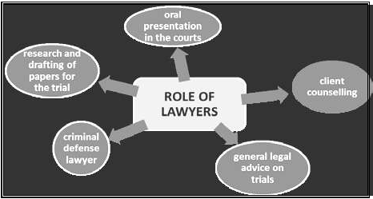
- Resource Interpretation

- Define the term client in relation to a trial process.
- Explain the significance of research before the trials for lawyers.

B. Short Answer Questions

- State two ways in which the Legal Aid Commission helps Fijians.
- State two benefits of having a general election in Fiji.
- State two changes that were carried out in the voting system in the 1960s.

