YEAR 11
HISTORY
HOME LEARNING KIT
WEEK 5
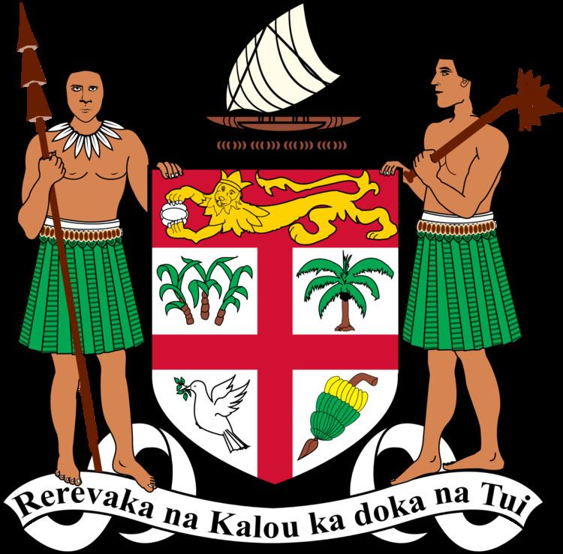 | 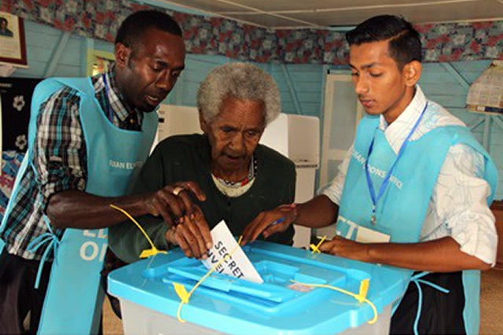
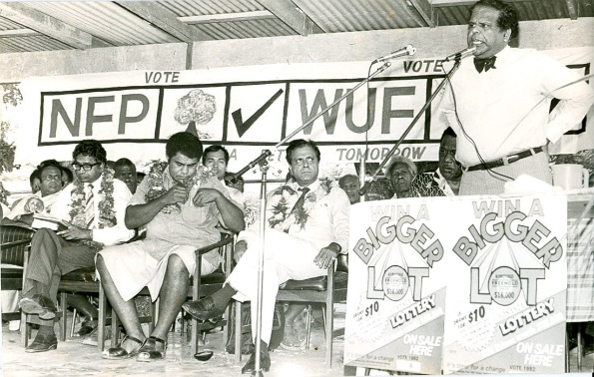 | 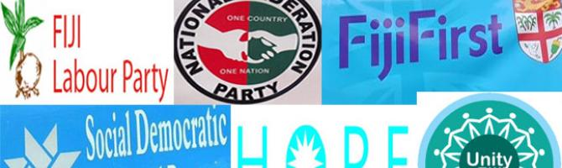

NAME
LEVEL
S/ID

Lesson: 49
Strand: Government and Governance
Sub-strand: Fijis Political Parties
Lesson Outcome: Explain and identify the key events of the history of the political parties in Fiji.

Unit 5 - Fiji’s Political Parties

Introduction
History of Political Parties in Fiji

- In April 1970, a constitutional conference in London finally agreed that Fiji should become a fully sovereign and independent nation within the Commonwealth.
- Fiji became independent on October 10, 1970.
- Political parties had already begun to emerge in the ten years before independence.
- The first political party was the Federation Party (which later became the National Federation Party), established from the Farmers’ Union (Kissan Sangh).
- The Alliance Party was the second party. It was headed by Ratu Sir Kamisese Mara, who became the first Prime Minister after independence.
- These two parties dominated the political arena until the 1980s.
- The world’s first political parties were formed in ancient Greece. Political Parties were formed to promote and represent the interests of groups and communities.
- These interests became the ideas and driving force of the political parties. For example the Federation Party represented the interests of the sugar cane farmers in the western Fiji.
- The Alliance Party was formed with the idea of promoting multiculturalism. Other parties appeared during elections and then disappeared after elections and often reappeared at the next election.
- There are various reasons for the formation of political parties such as religious beliefs and special interests like the workers’ union and environment.
- Any political party’s success depends on its membership and particularly its leadership.
- As we have seen in an earlier unit on Leadership, leaders must be strong, educated, popular, consultative and must show integrity. When leaders fail to show strong leadership, the party suffers.
- So a good political party will ensure the best leaders are appointed.
- Therefore both the leader and the political party are equally important because they are dependent on each other.
- Some Political Parties often split and form new parties because of differences among members over opinions and ideas, and styles of leadership. Political parties also change their names to appeal to a wider range of voters and members.
- For instance, the United General Party then to United People’s Party to appeal to the general voters. Single issue political parties are those that promote one agenda, which are common in overseas countries such as the Green Party in New Zealand, which addresses environmental issues.
- Campaigns are important features in the lead up to an election. An election campaign promotes the political party’s ideas, beliefs and values, as well as persuading the voters to vote for its candidates

Activity

- State the year Fiji became Independent.
- Name the first political party after independence.

Lesson 50
Strand: GOVERNMENT AND GOVERNANCE
Sub-strand: FIJI’S POLITICAL PARTIES
Lesson Outcome: Identify the political ideologies and achievements of the party leaders.
Ideology
- Political parties are always associated with a specific list of ideas.
- These ideas are often expressed as policies. These ideas stand behind the Party and determine how it will advertise itself.
- Ideologies also can change over time.
- They change because the party in government, the party in opposition, or the party contesting an election needs to tell voters why they are different, what they would do if they are in power, and very broadly what they think the nation needs.
- A political party usually has a manifesto, or vision about the future of the nation.
- This is a public declaration of what the political a party would do if they win an election
Ideology has two characteristics
- A set of beliefs that guide the party (and the actions of the party in parliament).
- It can also mean the mechanics of governing – how decisions are made for the nation.
Party Leadership
PARTY LEADER | POLITICAL PARTY | YEARS | ACHIEVEMENTS
Ratu Sir Kamisese Mara | Alliance Party | 1966-1987 | PM(1970-1992)
Jai Ram Reddy | Federation Party | 1977-1983  1987-1999 | Attorney-General (1987),  Opposition Leader(1977-1983)
Sitiveni Ligamamada  Rabuka | Soqosoqo  Vakavulewa ni Taukei | 1991-2000 | PM (1991-1997)
Mahendra Pal Chaudary | Fiji Labour Party | 1995-2012 | PM (1999-2000)
Laisenia Qarase | Soqosoqo Duavata ni  Lewenivanua | 2001-2012 | PM(2001-2006)
Timoci Bavanda | Fiji Labour Party | 1985-87 | PM (1987)
Josefata Kamikamica | The Fijian Association  Party | 1994-6 | Member of Parliament and Cabinet Minister
Adi Kuini Bavadra (aka  Adi Kuini Speed) | Fiji Labour Party  Fijian Association  Party | 1998-2000  2000+ | 1998-2000  2000+  FLP Leader, Deputy Prime Minister  Member of FAP
Mick Beddoes | United General Party | 2000-2006 | Leader of the Opposition (2001-6)
Sakeasi Butadroka Fijian  Party Leader (but not an MP) | Fijian Nationalist Party  Nationalist United  Front Party  Party Leader (but not an MP) | 1977-87  1999-2001  Party Leader (but not an MP) | Founder and MP  Party Leader (but not an MP)
Activity
- State the two characteristics of ideology

Lesson 51
Strand: GOVERNMENT AND GOVERNANCE
Sub-strand: FIJI’S POLITICAL PARTIES
Lesson Outcome: Identify the political ideologies and achievements of the party leaders.

Reading

Jai Ram Reddy
Jai Ram Reddy (born 12 May 1937) is an Fijian statesman, who has had a distinguished career in both the legislative and judicial branches of the Fijian government. In 1998, he received Fiji's highest honour, the Companion of the Order of Fiji, in recognition of his services to his country. As leader of the National Federation Party (NFP), he was Leader of the Opposition from 1977 to 1983, and again from 1992 to 1999.
He went on to serve as President of the Fiji Court of Appeal. He held this post briefly in 2000, and again from 2002 to 2003. On 31 January 2003, the United Nations General Assembly elected him as a member of the International Criminal Tribunal for Rwanda, which is responsible for the prosecution of war crimes.
He was a lawyer by training from 1960 to 1997. Reddy entered politics when he was appointed to the Senate, in 1972, after being chosen by the then Leader of the Opposition, Sidiq Koya. In 1976 he was instrumental in unifying the NFP by bringing the factions (Dove and Flower) of the party together.
Reddy replaced Sidiq Koya as leader of the NFP in September 1977. Under his leadership, the NFP made substantial gains in the election of 1982, but fell short of ousting the long time Prime Minister Ratu Sir Kamisese Mara. Reddy was subsequently deposed as party leader in favour of Koya in 1983. Reddy briefly served as Attorney-General and Minister for Justice in the Bavadra government in April and May 1987. Following the military coups of 1987, however, he again took over the leadership of the NFP, and continued to lead the party throughout the 1990s. He was the first non-iTaukei to address the Great Council of Chiefs.
Reddy negotiated with the Prime Minister, Sitiveni Rabuka, on amending the 1990 constitution. His leadership was questioned after this event as his followers felt that he was not representing their interests. After losing the 1999 Elections, Reddy's parliamentary career of some twenty years had come to an end. In a biography of Jai Ram Reddy, the historian Brij Lal praised Reddy’s leadership and his contribution to his party and to the nation.

Activity Questions
- List their main leadership quality.
- State the achievements of the leader.

Lesson No: 52
Strand: GOVERNMENT AND GOVERNANCE
Sub-strand: UNIT 5 – FIJI’S POLITICAL PARTIES
Lesson Outcome: Know the political party campaigns
Campaigns
- A political campaign is an organized effort by a political party which seeks to influence the
decision making process within a nation
- Campaigns start from several months to several years before Election Day.
- The first part of any campaign is when a political party chooses the candidate to run in the election.
- Political Parties sometimes launch expensive media campaigns during this time to introduce the candidate to voters, although most political parties wait until closer to Election Day
Components of Political Campaigns
- Campaign message is the message of the campaign contains the ideas that the political party wants to share with the voters.
- Candidates are:
- chosen by the political party because they live in the electoral constituency
- sometimes sports stars, millionaire business people or celebrities
- Campaign finance:
- Fundraising techniques include having the candidate call or meet with large donors.
- Political Parties approach interest groups, companies, businesses, corporations who could end up spending millions on the elections if it is significant to their interests.
Activists and Members
- Activists are the ‘true believers’ in the party will take part in activities such as door-to door visits, putting up posters and banners and making phone calls on behalf of the campaign.
- Act as lobbyists to promote a particular policy or agenda or election promise
Absentee Ballots
- Vote-by-mail prior to the election, previously known as 'absentee ballots' have grown
significantly.
- Political Parties pay attention to these voters so they can gather all supporters together in the election
Polling Booths and Polling Day
- On polling day political parties really ‘swing’ into action
- Volunteers distribute ‘how to vote’ cards
- Candidates rush around from Polling Booth to Polling Booth meeting voters and attracting the attention of the media.
- After the voting closes, volunteers from the political party scrutinize the counting of the votes
Activity
- Define:
- Campaign
- Activist
- State the component of political campaign
Lesson 53
Strand: GOVERNMENT AND GOVERNANCE
Sub-strand: FIJI’S POLITICAL PARTIES
Lesson Outcome: Know the political party campaigns
Campaigning Techniques
- A campaign team must consider how to communicate the message of the campaign, to recruit
volunteers, and raise money. These techniques are often limited by the law. These techniques
are combined into a formal strategy known as the campaign plan.
Campaign advertising
- Campaign advertising is the use of paid media (newspapers, radio, television, etc.) to
influence the voters.
- Members of the Political Party carry out most of the local advertising – sticking up
posters, dropping pamphlets in letter boxes and helping at campaign rallies
Mass meetings, rallies and protests
- Holding protests, rallies and other similar public events may be a very effective campaign tool.
- Holding mass meetings with charismatic speakers is powerful as it shows visually, through the number of people in attendance, the support that the voters are giving to the political party.
Modern technology and the internet
- The internet is now a core element of modern political campaigns.
- Communication technologies such as e-mail, and party web sites, enable faster communications by
citizen movements and deliver a message to a large audience.
- Social websites, utilized a low cost and efficient method of mobilizing voters and increasing participation among various voter populations.
Other techniques
- Writing directly to members of the public (either via a professional marketing firm or, particularly on a small scale, by volunteers)
- By distributing leaflets or selling newspapers
- Through a whistle-stop tour - a series of brief appearances in several small towns
- Using endorsements of celebrities party members to boost support
- Sale of official campaign merchandise (buttons, t-shirts, stickers and caps)

Activity

- Why do political parties campaign before elections?
- List three strategies that parties employ to have successful election campaign?

