YEAR 11
HISTORY
HOME LEARNING KIT
WEEK 4
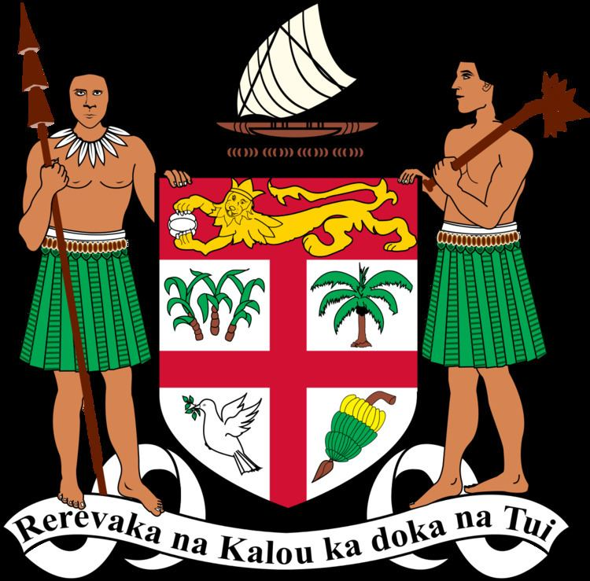 | 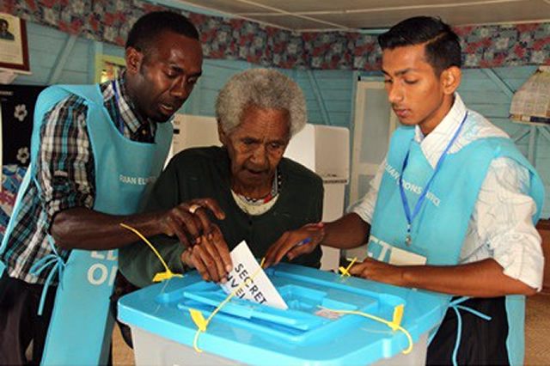
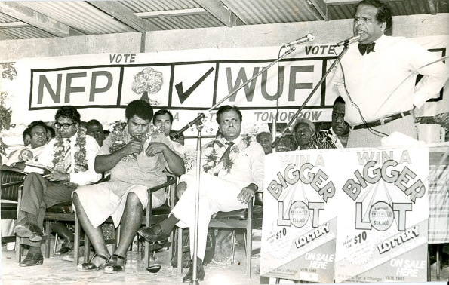 | 

NAME
LEVEL
S/ID

Lesson: 44
Strand: Government and Governance
Sub-strand: Voting System
Lesson Outcome: Explain the purpose and role of elections

Unit 4: Voting System
Topic | Objectives and Outcomes
Purpose and Role of Elections | - Define election.  - Explain the purpose and role of elections. | - Activity 1: Short Answer Questions.
How the Fiji Islands Electoral System Works. | - Discuss the electoral system in Fiji  - Have an understanding of the Electoral Commission and its role. | - Activity 2: Short Answer Question and Research
Election Campaign | - Describe the processes or procedures involved in an election campaign. | - Activity 4: Class Activity.
Elections Day | - Follow through the different stages of voting. | - Activity 2.3
Representations | - Discuss the concept of representation.  - Analyse the importance of having a fair representation | - Activity 5: Reading

Important Terms
- Electorate: refers to the people in a country who are eligible or have the right to vote
- Representation: the act of making citizens' voices, opinions, and perspectives” present” in the public policy making processes.
- Political Party: an organisation whose members have the same aims and ideas, which people can vote for during an election.
- Election: is the process of choosing a person or a political party for a position, especially in parliament.
- Democracy: a system of government where all the people in that country who are eligible to vote can vote to elect their representatives in government.
- Electoral Roll: The list of people who have registered and are eligible to vote.
- By-election: an election for a seat held separate from the national General election
- General Election: a national election for seats in the parliament
- Common Roll: a single list of voters (not based on ethnic or cultural identity)
- Communal Roll: a list of voters based one ethnic or cultural identity – and allowing only a vote for your own ethnic or cultural candidates
- Polling booth: the place where voters indicate their choice of candidate, (in secret), usually a school or public hall
- Pre-selection: The process when a political party chooses the candidate who will stand in the election. (Can be chosen by the Party’s local or village committee or by the Party’s Central Executive committee)

The Purpose and Role of Elections
- Election is the formal process of selecting a person for public office or of accepting or rejecting a political proposition by voting.
- It is contested by two or more political parties representing the different interests of various members of the communities in Fiji.
- Each candidate represents a political party and contests a seat in the various constituencies or voting boundaries.
- The purpose of any election is to select the representatives of the people into a country’s parliament.

- Electoral Commission
- The Electoral Commission is an independent constitutional authority which consists of a
- Chairman appointed by the President.
- Electoral Commission is given the responsibility to supervise the registration of voters for the election of members of the House of Representatives.
- The Commission is also tasked to supervise the conduct of elections of the members of the Lower House.
Class Activity:
- Differentiate between a common roll and a communal roll.
- Discuss the purpose of elections in Fiji.

Lesson: 45
Strand: Government and Governance
Sub-strand: Voting System
Lesson Outcome: discuss the electoral system in Fiji

HOW THE FIJI ISLANDS ELECTORAL SYSTEM WORKS

- First of all, election of members is done under a preferential voting system. The system is called the "Alternative Vote".
- Fiji always used the simple majority voting system of "First Past the Post."

An Election Campaign
- The Fiji Electoral Commission begins by;
- selecting polling booths,
- checking electoral boundaries
- checking the electoral roll
- registering people who want to vote
- printing the voting papers,
- appointing officials to take charge of booths and the vote counting
- providing secure transport and storage of votes
- Meanwhile the political parties begin the pre-selection of candidates who will stand for the seats in the parliament to be contested.
- These preparations include:
- Announce policies the candidate would follow if they won the election,
- Hold rallies and meetings across the countryside,
- Form sub-committees for fund-raising (to pay for the campaign)
- Leaders join public debates on radio (with their opposing candidates)
- Speak to followers in well-attended public meetings.
- Campaign badges are distributed,
- Posters are stuck up everywhere
- Banners made and hung across roads or on buildings.
Class Activity
- Discuss how the electoral system in Fiji works.

Lesson: 46
Strand: Government and Governance
Sub-strand: Voting System
Lesson Outcome: discuss the electoral system in Fiji
Elections Day
- Voters queuing to enter the poling station 2. Voters have to check their names in the Roll.
- Ink is put onto a voter’s finger before receiving 4. Voting – Secret Ballot
the ballot papers

- Ballot papers put into the ballot boxes 6. Ballot boxes are sealed and transported to
the Counting Centers

Class Activity

- Why do they have to put ink on a voter’s finger when he or she goes into to vote?
- State a reason for a voter using a booth in Picture 4 to vote.

Lesson: 47
Strand: Government and Governance
Sub-strand: Voting System
Lesson Outcome: Analyse the concept of having a fair representation
Reading 4.5
Party politics was introduced to Fiji in the 1960s, before political independence in 1970. It continued the Colonial Government’s system of representation through the Executive and Legislative Councils. The membership system in the Legislative Council was organised along ethnic lines according to the major ethnic groups in Fiji, namely Fijians, Indo-Fijians and Europeans. This system of representation reflected colonial compartmentalisation of races in Fiji. It was an administrative leadership strategy of divide and rule, which was characteristic of leadership in the colonies of the British Empire. The specifics of such political leadership depended on the nature of the society in which colonisation was imposed….

The formation of a coalition to form multi-party Cabinet is a provision in the 1997 Constitution. Specifically, the 1997 Constitution states that the Prime Minister must form multi-party Cabinet according to the relevant requirements of the Constitution, which includes an obligation to the fair representation of all parties with members in the House of Representatives. Such political parties are to be included in Cabinet according to the proportion of their numbers in the House. If a party with more than 10 per cent membership in the House of Representatives declines the offer from the Prime Minister to join the Cabinet, then the seats allocated to it can be offered to another party in proportion to its respective entitlement. In the case where all other parties have declined the invitation to the coalition, the Prime Minister can look to his own party or at a coalition of parties to fill the places in Cabinet. In selecting members from other political parties for Cabinet positions under the 1997 Constitution, the Prime Minister is required to consult with the leaders of the respective parties before making appointments.38 In the case of the People’s Coalition Government, the invitation that was extended to the SVT after the 1999 general elections was rejected by the FLP because of the conditions the SVT wanted the FLP to fulfill….

After four decades of party politics in Fiji, a number of outstanding features have emerged. Firstly, political parties have reflected the nature of pre-colonial and colonial societies in Fiji. For indigenous Fijians, modern political parties have been more than organisations for political representation in government; they have also been a means of expressing dissent and independence, reflecting the nature of pre-colonial society. Despite the attempt by the Fijian establishment to impose unity through party politics, diversity has continuously been expressed through the formation of alternative political parties in different regions since the 1960s. The military coups of 1987 exacerbated party formation, fully exposing the diversity and complexity of Fijian culture and society.

(Durutalo Alumita: pg 166, 177, 179)

- Identify the type of representation was used in Fiji before the 1970 independence?
- State what was reflected in the system of representation before independence?
- How could a fair representation of all political parties be achieved beyond 1997?

Lesson: 48
Strand: Government and Governance
Sub-strand: Election Campaign
Lesson Outcome: Describe the processes or procedures involved in an election campaign.
- Election Campaign Once the announcement has been made that an election will be held, usually every 3, 4 or 5 years, a flurry of activity begins.
The Fiji Electoral Commission begins by;
- selecting polling booths,
- checking electoral boundaries
- checking the electoral roll
- registering people who want to vote
- printing the voting papers,
- appointing officials to take charge of booths and the vote counting
- providing secure transport and storage of votes .

- Meanwhile the political parties begin the pre-selection of candidates who will stand for the seats in the parliament to be contested. The Political parties become active at the centre (the Party Office or central committee) and locally in each electorate across the country.
These preparations include
- Announce policies the candidate would follow if they won the election
- Hold rallies and meetings across the countryside,
- Form sub-committees for fund-raising (to pay for the campaign)
- Leaders join public debates on radio (with their opposing candidates)
- Speak to followers in well-attended public meetings.
- Campaign badges are distributed,
- Posters are stuck up everywhere
- Banners made and hung a cross roads or on buildings.
- Candidates travel their electorate knocking on the door of every house trying to convince voters of their suitability for taking up a seat in parliament.
Class Activity
In a paragraph describe the procedures involved in an election campaign.

