YEAR 11
HISTORY
HOME LEARNING KIT
WEEK 3
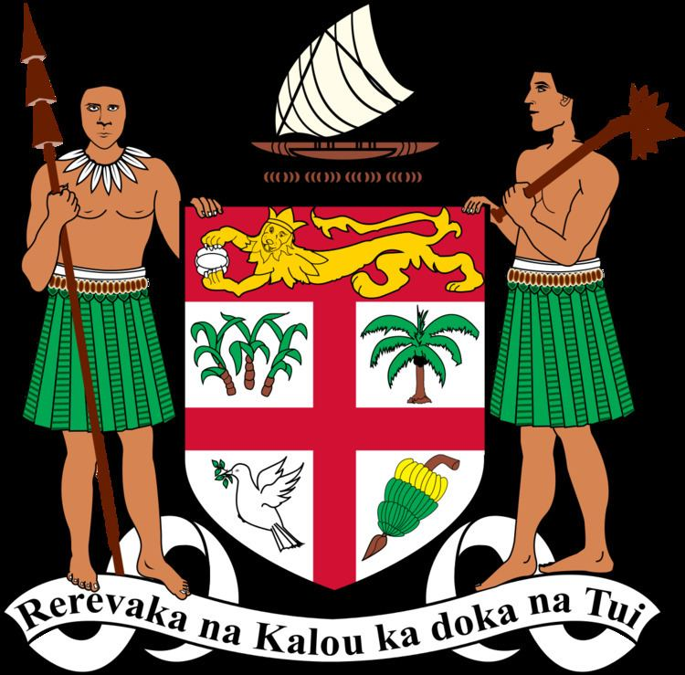 | 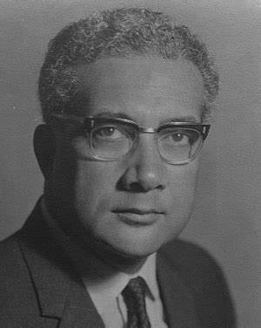
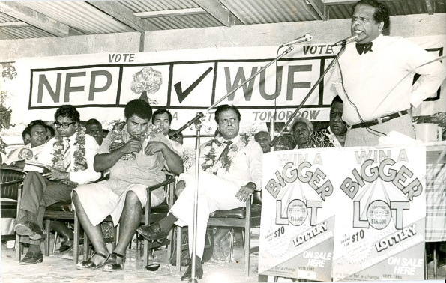 | 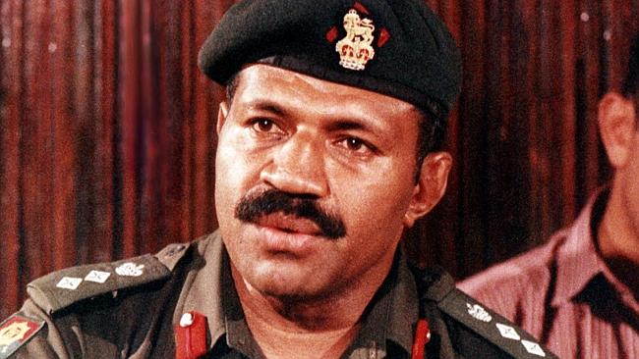

NAME
LEVEL
S/ID

Lesson: 39
Strand: Government and Governance
Sub-strand: Constitutional development
Lesson Outcome: Explain the need for constitution in Fiji
Unit 3: CONSTITUTIONAL DEVELOPMENT
Changes, Amendments and Consultation
Topic | Objectives and Outcomes | Task
 | After completing this unit, you should be able to:
1970 CONSTITUTION | - Define the term ‘constitution’.  - Explain the need for a constitution in Fiji.  - Identify the key issues surrounding the creation of this constitution.
1990 CONSTITUTION | - Identify the reasons for changes between the 1970 and 1990 constitutions.  - Identify the cause for the abrogation of the 1970 constitution.  - Explain the reactions to the 1990 constitution- at home and abroad. | Activity 2.1
1994 CONSTITUTIONAL REVIEW | - Identify the changes in Fiji between the 1990 and 1994.  - Identify the members of the review commission.  - Explain the steps taken to review the 1990 constitution. | Activity 2.2
1997 CONSTITUTION | - Identify the changes in Fiji between the 1997 and 2006.  - Identify the cause for the abrogation of the 1997 constitution. | Activity 2.3
What is a Constitution?
- Are a set of rules and regulations that guide a country and its citizens so that all may benefit.
Constitutions in Fiji
- Fiji has had three constitutions ever since it became independent in 1970:
- The 1970 constitution. (changes made after the coup by Rabuka)
- 1990 Constitution was not accepted by many within Fiji and outside of Fiji.
- 1990 constitution underwent major changes in 1997.
- 2010, the constitution was again changed.
- 2013 constitution is currently being followed
The 1970 Constitution

- Agreement on the kind of voting system that Fiji was to have between the Alliance Party and National Federation Party
- By 1963 everyone over the age of 21 had the right to vote.
- Voting had been carried out under separate communal rolls.
Communal Roll -Electors voted in their racial groups or communities with Fijians electing Fijians, Indians electing Indians and Europeans voting for Europeans.
- The 1970 constitution recognised the principle that the highest priority should be given to iTaukei interests (including preservation of land ownership, culture and system of administration).
Communal Electoral Voting

Activity
- State the current constitution Fiji is following.
- Define the term Constitution.
- State the type of voting system used before independence.

Lesson: 40
Strand: Government and Governance
Sub-strand: Constitutional Development
Lesson Outcome: identify the reasons for changes in the 1970 constitution
Governments under the First Constitution - 1970
- The Alliance Party won the first election
- Remained in power for the next 17 years under the leadership of iTaukei high chief, Ratu Sir Kamisese Mara.
- The Alliance Party members were a mixture of Fijian leaders, some Indians, and people of other races (who at the time were called “General Voters”).

- In 1987, the Alliance government lost power.
- It was defeated by a coalition of two opposition parties; the Indian-based National Federation Party and the multiracial Labour Party.

Coup d’etat 1987 – First coup

- One month after the election, on 14th May, 1987, Major Sitiveni Rabuka led a coup.
- Coup is a sudden and often violent overthrow of a government. (are usually senior army officers, politicians who have lost their seat in a recent election, dissatisfied members of Cabinet or Parliament, or senior civil servants)
Coup by Rabuka
- When Rabuka took power, he announced that:
- The 1970 constitution was suspended;
- An interim government (council of Ministers) was established, which included members of the Alliance Party; and
- The country would eventually return to “democratic government” under a revised constitution.

Activity
- Name the party that won the first election.
- State the names of the parties that contested the election in 1987
- Define Coup and state how it affected the Indians in Fiji.

Lesson: 41
Strand: Government and Governance
Sub-strand: Constitutional Development
Lesson Outcome: State and explain the impact of the 2nd Coup by Rabuka
Impact of the 2nd Coup by Rabuka

- Second coup destroyed the chances of a negotiated settlement between the different political parties. This time, Rabuka:
- Revoked (cancelled) the 1970 constitution;
- Declared himself to be head of an interim military government; and
- Declared Fiji to be a republic.
- His actions removed the authority of the Governor General, who later resigned his position.
- Fiji’s link with the British crown was abolished.
- Fiji’s membership of the Commonwealth was also terminated.
The 1990 Constitution

- In 1989, a committee was set up by the interim government and it undertook a review in order to establish a new constitution.
- Committee presented a new constitution to President Ratu Sir Penaia Ganilau in 1990.
- Its main purpose was to return Fiji to constitutional government, while at the same time “privileging” (i.e. giving preference to) the political, economic and cultural rights of the iTaukei over the rights of other ethnic and cultural groups, and ensuring that the iTaukei would always have a majority in parliament.
Provisions under the 1990 Constitution:
- An overall majority of seats in the parliament was reserved for ethnic Fijians and all voting was based on communal rolls – that is, voters could only vote for people of the same ethnic group.
- The cross-voting system was abolished.
- Parliament had the power to adopt policies of “affirmative action” for iTaukei. For example, they could reserve positions in government, other jobs, scholarships and business permits and opportunities for iTaukei.
- The Prime Minister and President had to an iTaukei.
Lesson: 42
Strand: Government and Governance
Sub-strand: Constitutional Development
Lesson Outcome: Explain the impact of 1990 constitution
Impact of the 1990 Constitution

- The political system adopted under the 1990 constitution discriminated in favour of the iTaukei and against others.
- The new constitution caused much insecurity among non iTaukei as many were now excluded from public office.
- A growing number of people (mainly skilled professionals) had emigrated from Fiji, and this trend (called the brain drain) continued after 1990.
- It increased divisions among the different ethnic and cultural groups in Fiji.
- It also created rifts among the iTaukei themselves including those elected to parliament.
- There was a lack of confidence in the economy, partly due to Indian fears and insecurity, and partly due to the policies of the government which at times were inconsistent and lacked good judgement.
- People also lost confidence in the public service sector as they increasingly saw evidence of mismanagement and corruption.

Lesson: 43
Strand: Government and Governance
Sub-strand: Constitutional Development
Lesson Outcome: Explain the constitutional problems
Resulting Constitutional Problems
- Brain-Drain - negative effect on many industries in Fiji.
- Divisions were created among the different ethnic and cultural groups in Fiji. It also created rifts among the iTaukei themselves.
- Lack of confidence in the economy, partly due to Indian fears and insecurity, and partly due to the policies of the government which at times were inconsistent and lacked good judgement. People were not prepared to risk their money to invest which limited Fiji’s prospects for economic growth.
- Mismanagement and Corruption became evident in the public service sector.
For example, it was revealed that National Bank of Fiji (owned by government) had lost over F$100 million in bad loans (i.e. loans that the bank had made and could not recover), and so the bank was declared insolvent (i.e. it could not pay its own debts).
- Land Tenure problems arose. Long term or future land leases were not resolved. This issue existed because, in Fiji, iTaukei family groups or mataqali own most of the land, which most Indian farmers lease, through arrangements managed by a government institution, the Native Lands Trust Board.
Review of the 1990 Constitution
- The 1990 Constitution included a provision that it would be reviewed within seven years. Most support for a review came from Indians. In October 1994, the Rabuka led government decided that a three-person commission should conduct the review. The three members were to be:
• An independent chairperson;
• A person chosen by the government; and
• A person chosen by the main opposition parties.

- It was agreed that the chairperson would be someone from outside Fiji. Former New Zealand Governor General (and first Maori Governor General), Sir Paul Reeves, was appointed to this position. The government nominated Tomasi Vakatora (a former Minister and Speaker of the House of Representatives, from Rewa) and the opposition parties nominated Professor Brij Lal a distinguished historian of Fiji whose family came from Labasa.

- In June 1995 the Constitutional Review Commission (CRC) was sworn in. For the next four months, it heard and received about 470 submissions from the public, including individuals in urban and rural Fiji, political parties, non-government organisations, church groups, ethnic and community groups, and labour unions. These submissions reflected a diverse cross-section of opinion about the constitution, some supporting the existing constitution, others wanting changes.
Activity
- State the impact of the 1990 constitution
- Explain two of the constitutional problems in Fiji
- Name the ethic group that supported the review of constitution

