YEAR 11
HISTORY
HOME LEARNING KIT
WEEK 2
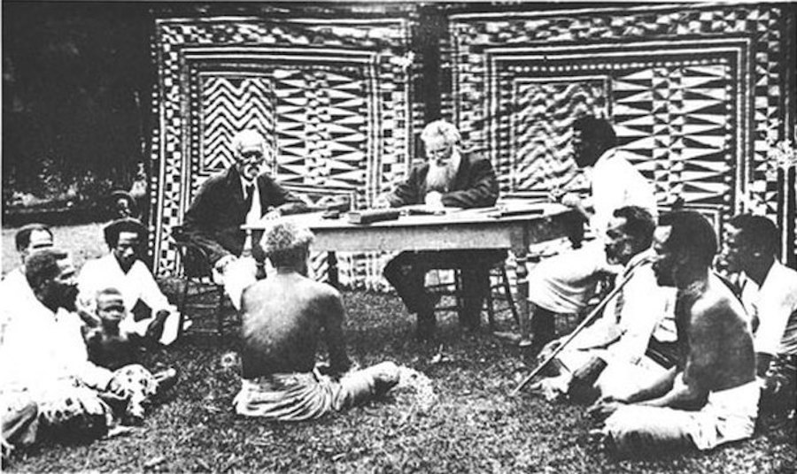 | 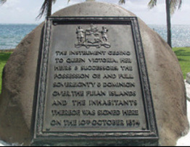

NAME
LEVEL
S/ID

Lesson: 34
Strand: Government and Governance
Sub-strand: Administration
Lesson Outcome: identify the important development of the Fijian
UNIT 2 – ADMINISTRATION
(TRADITIONAL AND MODERN)

Topic | Objectives and Outcomes | Task
Administration | After completing this unit, you should be  able to:
Native / Fijian  Administration | - Identify the important developments of the Fijian  - Administration. explain reasons for establishment | 2.1 – Personality Study  2.2 – Group Activity  2.3 – Reading Activity
Modern Administration (Parliamentary System) | - Identify the important developments of the Modern Administration.  - Explain the reasons for the establishment. | 2.4 – Photograph  Activity  2.5 – Reading Activity
Co-Existence of the  Two Administration  Systems | - Discuss the purpose of the coexistence of the two administration systems | 2.6 – Diagram  Interpretation

Definitions
- Bill - A new law that will be discussed and passed in Parliament in order for it to become an Act.
- Buli - The officer who is in charge of the District Council
- Chiefdom - A system of government where the leader is the chief.
- Communal Roll - Voting system where citizens vote for representative along racial line.
- Executive Council - A small group of senior advisors chosen by the Governor.
- Individualism - The idea that individual people have the right to make their decision.
- Legislative Council - The parliament that advised the Governor in making laws, usually during the colonial government.
- Open Roll - Voting system where citizens vote for any representative regardless of race.
- Ordinance - A formal law
- Roko - A hereditary chief who is in-charge of a Provincial Council.
- Scribe - A person who made copies of written documents at the Council meetings.
- Stipendiary Magistrate - A judge of the lower courts who is paid for his work.
- Turaga ni Koro - The village headman
- Senate: is a deliberative assembly, often the upper house or chamber of a bicameral legislature or parliament.
- Unicameralism: is the practise of having one legislative or parliamentary chamber or house.
- House of Representatives: was the lower chamber of Fiji's Parliament from 1970 to 2006.
- Hansard: Skilled writers record all that is said in the Parliament. These written records are called Hansard and are available for anyone to read.
- Veto: is the power (used by an officer of the state, for example) to unilaterally stop an official action, especially the enactment of legislation.

The Development of the Native Administration since 1876

Native Affairs Act was established in 1876, when Fiji was under the leadership of Sir Arthur
Gordon, which led to the creation of the Native Administration.

Councils were formed. (Council of Chiefs, Provincial Council, District Council and the Village Council).
    - Council leaders included the President for the Council of Chiefs, Roko for the Provincial Council, Buli for the District Council, and the Turaga Ni Koro for the Village Council.

Native Land Ordinance of 1880 was passed, which made firm the communal land ownership. This had laid the foundation for the Native Administration system.

1921: Office of the Secretary of Native Affairs was abolished and its responsibilities transferred to Colonial Secretariat. District Commissioners were placed in charge of provincial matters.

1940: creation of Native Land Trust Board

1945 changes came about through the Fijian Affairs Ordinance, and also under the responsibility of Ratu Sukuna, which included:
- the Fijian Affairs Board replaced the Fijian Regulation Board
- Officer responsible for Fijian Affairs changed from Adviser to Secretary of Fijian Affairs.

1948: GCC extended its membership to include the Rokos, 6 chiefs nominated by the
Governor and 2 representatives of provinces of over 10000 people.

Between 1956 and 1960 – there were many reports presented to the Fijian Administrations based on the investigations. The two famous ones were made by Spate and Burns, who stated both that a lot of changes needed to be made to the Fijian administration.

Lesson: 35
Strand: Government and Governance
Sub-strand: Administration
Lesson Outcome: Explain Native Administrative Council and their role

Sir Arthur Gordon | Ratu Sir Joseva Vanayaliyali Lalabalavu Sukuna

The Post-Colonial period to the 1970s: Native Administration Councils and their Roles
Council of Chiefs
- To make recommendations and proposals for the benefit of the Fijian and to give advice relating to the Fijian people
- Has a purely advisory role.
Fijian Affairs Board
- The link between the Great Council of Chiefs and the Parliament
- Make recommendations to the Governor / President for the benefit of the Fijians.
- After 1948, it made laws called the Fijian Affairs Regulations (rules for running the Fijian administration)

Provincial (Yasana) Council
- The Council could make by-laws for carrying out the Fijian Regulations. (by laws have to be approved by the Fijian Affairs Board)
- Levying of rates in the provinces.

District (Tikina) Council
- It can make orders to be obeyed by all the inhabitants of the Tikina / District.
- Draw up programs for communal services as directed by the Provincial Council.
Village Council
- It was never an official body.
- Ensures that the village programs are carried out in line with the requirements of the District and Provincial Council.

Lesson: 36
Strand: Government and Governance
Sub-strand: Administration
Lesson Outcome: Explain Native Administrative Council and their role
READING
Government was to be by the Fijians and for them, with traditional institutions kept intact. Rather than governing the Fijians directly, the British would govern through the chiefs and give Fijian customs the force of law. No single Fijian tradition of governing themselves existed. Chiefs enjoyed greater status and power in the East than in the West, for example, an extensive chiefdom like that of Bau had never existed in the Western parts of Viti Levu or in the hill country. So for the sake of administrative uniformity, Gordon disregarded regional differences and imposed a single system, largely inspired by the way things worked in Cakobau’s Bauan chiefdom. He divided Fiji into twelve provinces, each governed by a Fijian chief called Roko Tui. The first Roko Tui Tailevu and Naitasiri, for example, was Ratu Epeli Nailatikau, the son of Cakobau. Each province had a Scribe and two or three Stipendiary Magistrates. Gordon further sub-divided the colony into 84 districts, each under a Buli, and placed a Turaga Ni Koro or village chief in charge of each village. The Roko Tuis met each year in the Great Council of Chiefs, an institution that remains part of Fiji’s constitutional arrangements.

The Fijian Administration kept Fijians in the villages under their chiefs, who were given great powers over commoners. Fijians were not given the individual rights of Britishsubjects. They were subject, instead to their chiefs. Taxation was in kind, so that Fijians would not be compelled to become Labourers for cash. The only alternative, Gordon thought, was the disaster then occurring in many other colonies, where traditional people were uprooted to become than a free floating labour force for Europeans. He thought he was going to give Fijians time to adjust to modernity and individualism, time that other colonized people did not have.

Activity
- How many provinces did Gordon create?
____________________________________________________________________________
- What did Sir Gordon do to overcome the differences between the regions in Fiji?
__________________________________________________________________________________________________________________________________________________________________
- Name the title of the Officers who are in charge of the Provinces and Districts.
__________________________________________________________________________________________________________________________________________________________________
- Describe a disadvantage for the Fijians under the Fijian Administration.
__________________________________________________________________________________________________________________________________________________________________
- What benefit was Sir Gordon hoping to give the Fijians from this Native Administration?
Lesson: 37
Strand: Government and Governance
Sub-strand: Administration
Lesson Outcome: identify the important development of the Modern Administration

Inside a Parliament

- In relation to Picture, what element of Fijian custom can be seen in the picture?
________________________________________________________________________________________________________________________________________________________________
- Describe from Picture where the Speaker sits.
________________________________________________________________________________________________________________________________________________________________
- Why is the Parliament divided into two major seating groups?
__________________________________________________________________________________________________________________________________________________________________

Parliament of Fiji
- is the unicameral legislature of the Republic of the Fiji.
- consists of 50 members elected every 4 years using open-list proportional representation in one multi-member nationwide constituency.
The Speaker
- is the presiding officer of the Fijian House of Representatives.
- House members elected a Speaker and a Deputy Speaker.
- Role is to ensure impartiality, the Speaker was not allowed to be a member of the House.

- The Senate was less powerful than the House of Representatives; the Senate could not initiate legislation, but it could reject or amend it. The Senate's powers over financial bills were more restricted: it could veto them in their entirety, but could not amend them. The House of Representatives could override a Senatorial veto by passing the bill a second time in the parliamentary session immediately following the one in which it was rejected by the Senate, after a minimum period of six months.
- The House of Representatives was suspended by the 2006 military coup. The 2013 Constitution abolished it and replaced it with a single chamber Parliament.

Lesson: 38
Strand: Government and Governance
Sub-strand: Administration
Lesson Outcome: identify the important development of the Modern Administration
Fiji’s Parliament.
Reading

In June 1871, Ratu Seru Cakobau, Fiji’s paramount chief, established the first western style form Government in Fiji at Levuka. This led to the establishment of the first parliamentary type body in Fiji, the Legislative Assembly, consisting of indigenous Fijian Chiefs and early European Settlers, which was opened in November 1871. In October 1874 Fiji was proclaimed a British Colony and was subsequently administered by a Governor General, through the Legislative Council, as a possession and dependant of the British Crown.

In 1964, the Membership System of Government was first introduced in Fiji with elections for Members of the Legislative Council who were given specific portfolios. In July 1965, a constitutional conference was held in London to discuss further progress towards independence and self-government. A ministerial system of government was introduced in Fiji in 1967 and Ratu Sir Kamisese Mara was appointed the Chief Minister with the Executive Council of the Legislative Council becoming the Council of Ministers.

In April 1970, Fiji’s Legislative Council, led by the Chief Minister, Ratu Sir Kamisese Mara met in London to discuss framing a new constitution and a move towards independence. On 10 October 1970 Fiji gained independence from Great Britain and established itself as a parliamentary democracy. As a former British Colony, Fiji adopted a bicameral Westminster Model parliamentary system. On 27 November 1970 the Governor General Sir Robert Sidney Foster, G.C.M.G., K.C.V.O, addressed a joint sitting of the House of Representatives and the Senate to officially open Fiji’s first ever new national Parliament.

Fiji’s Parliament largely follows the procedures and customs of the British where there are an elected House of Representatives and a nominated Senate. The House of Representatives comprised 71 members - 25 MP’s elected on open rolls, and 46 MP’s elected on communal (ethnic) rolls. The candidates for the 25 open seats came from any ethnic group. The candidates for the 46 Communal seats were distributed as follows: Fijians 23, Indians 19, Rotumans 1 and Others 3. The Upper House or the Senate consisted of 32 members of whom: 14 are appointed by the President on the advice of the Bose Levu Vakaturaga, 9 are appointed by the President on the advice of the Prime Minister, 8 are appointed by the President on the advice of the Leader of the Opposition and 1 is appointed by the President on the advice of the Council of Rotuma.

The Senate complemented the work of the House of Representatives through the scrutiny and revision of Bills coming to it. Whilst the Senate had limited powers in respect to Money Bills, it guided opinion and clarified issues in general debate and by motions, petitions and adjournment speeches. The Constitution makes it compulsory that all citizens, 21 and over and who have been a resident in Fiji for the two years immediately before applying for registration to vote. The Constitution (1990) adopted the first past the post system under which the winning candidate is the person who secures the greatest number of votes. The 1997 Constitution introduced a preferential voting system known as the Alternative Vote where the winning candidate is the person who obtains more than half the number of votes or the ‘absolute majority’.
(http://www.parliament.gov.fj/about/index.aspx)

